THE PROMOTING HUMAN RIGHTS IN PALM OIL SUPPLY CHAIN IN NIGERIA PROJECT 2025
About the Project: The Promoting Human Rights in Palm Oil Supply Chain in Nigeria Project was implemented by African Law Foundation (AFRILAW) in collaboration with Zero Tolerance Initiative (ZTI) and the National Human Rights Commission (NHRC) with partnership and funding support from the True Cost Initiative (TCI) USA. The aim and objective of this project is to engage with palm oil host communities and industry stakeholders and carry out legal advocacy, sensitization and training with the Community-Based Research on Human Rights Violations in the Palm Oil Supply Chain in Edo State of Nigeria Report toward advancing the protection of human rights of palm oil host communities and promotion of corporate responsibility to respect human rights in the palm oil supply chain in Nigeria. The project is a follow-up to the Community-Based Research on Human Rights Violations in the Palm Oil Supply Chain in Nigeria Project implemented by African Law Foundation (AFRILAW) in partnership with the Forest People Programme (FPP) UK and Zero Tolerance Initiative (ZTI) through funding support from the Climate Justice Resilience Fund (CJRF) from July-November 2022. The Project activities is being implemented from January to April 2025, a 4 months’ period in Benin, Edo State Capital and across the local government areas of the 5 palm oil host communities.
PROJECT ACTIVITIES:
- DESIGN AND PUBLICATION OF THE COMMUNITY-BASED RESEARCH ON HUMAN RIGHTS VIOLATIONS IN THE PALM OIL SUPPLY CHAIN IN EDO STATE REPORT:
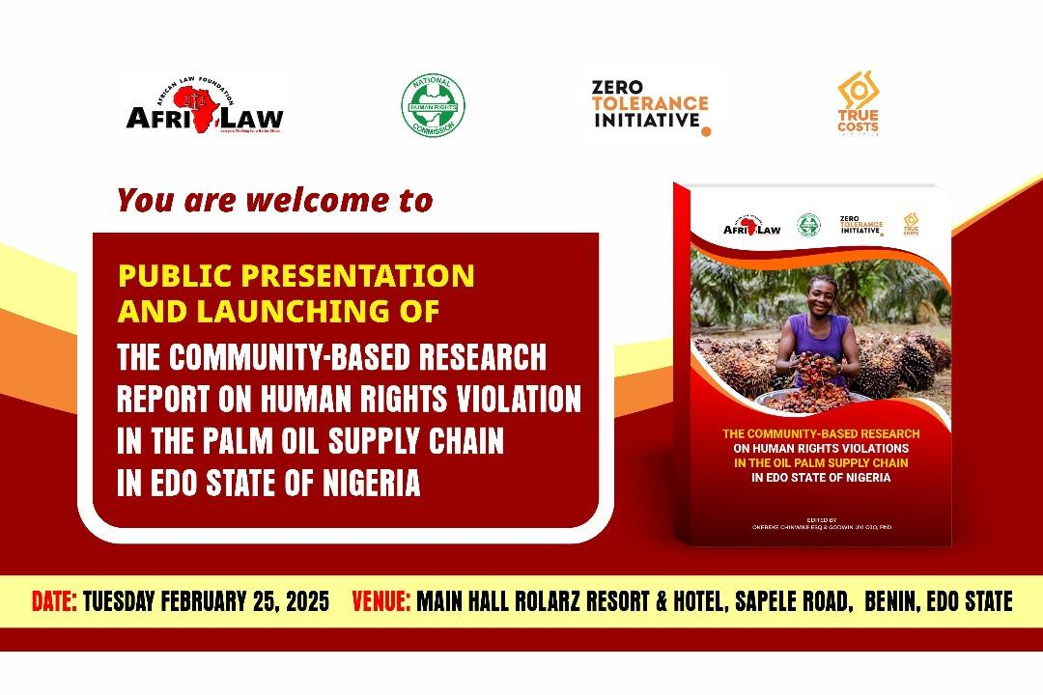About 1000 copies of the report was printed for dissemination during the workshop project activities.
- 1-DAY PUBLIC PRESENTATION AND LAUNCHING OF THE COMMUNITY-BASED RESEARCH ON HUMAN RIGHTS VIOLATIONS IN THE PALM OIL SUPPLY CHAIN IN EDO STATE REPORT:
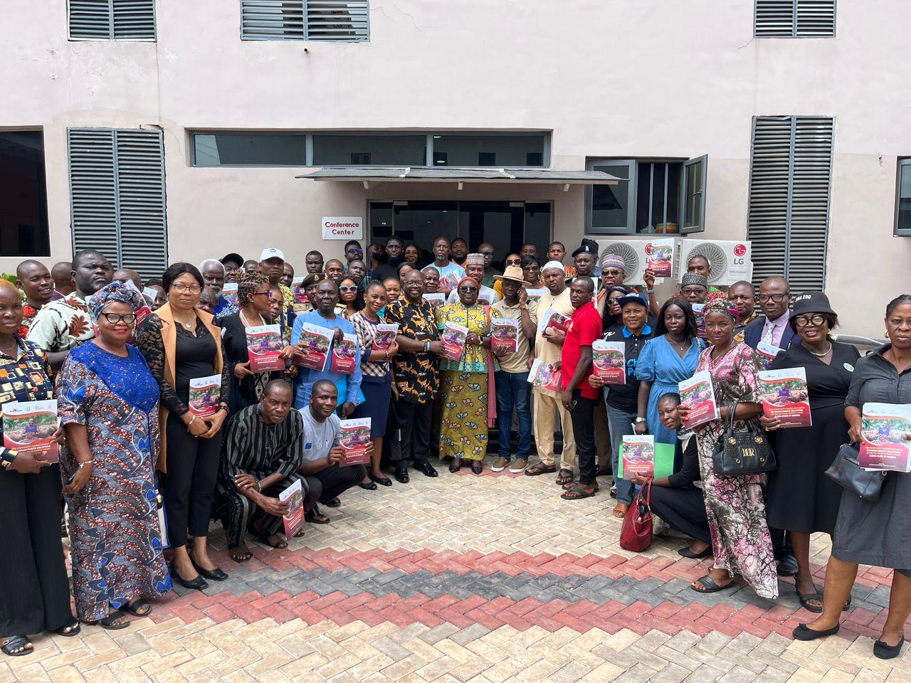
Group photograph of participants
The 1-Day Public Presentation and Launching of the Report was held on Tuesday February 25, 2025 at Rolarz Resort & Hotel, Benin City, Edo State with about Ninety-Two (92) participants in attendance. The participants comprised of Palm Oil Host Community members and leaders, Federal, State and Local Government Ministries, Departments and Agencies (MDAs), Palm Oil Companies and Industry Stakeholders, CSOs/NGOs/FBOs/CBOs and Media Organizations. The 1-Day Public Presentation and Launching of the Report was chaired by the Executive Secretary of the National Human Rights Commission who was represented by Mrs. Mary Okoh, Deputy Director, Legal/Focal Point-Business and Human Rights, NHRC, FCT-Abuja who was present with us in Benin City, Edo State. The members of the high table comprised of; the Executive Secretary of the National Human Rights Commission represented by Mrs. Mary Okoh, Deputy Director, Legal/Focal Point-Business and Human Rights, Mrs. Queensley Ojomo (Operations Assistant) representing the General Manager, Edo State Oil Programme Office, Mr. Ogemade Godfrey representing the Edo State Community and Social Development Agency (EDO-CSDA) and Mr. Olumide Dosumu, Edo State Coordinator, NHRC.

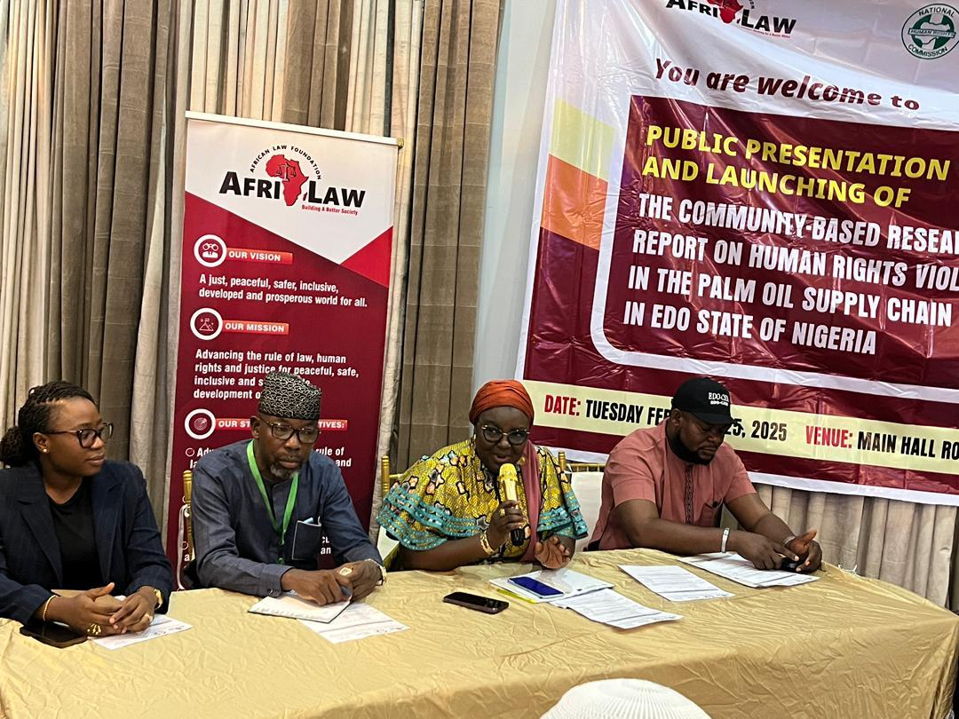
Members of the high-table
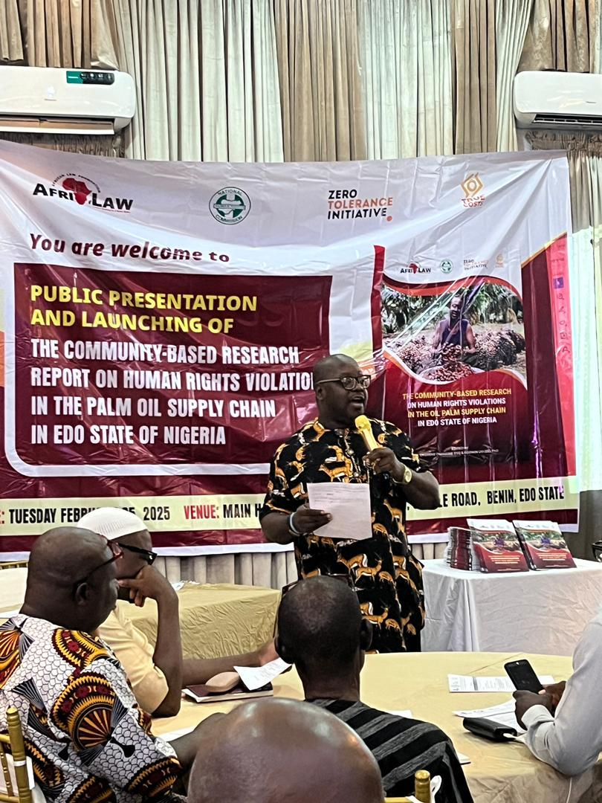
AFRILAW ED giving his welcome remarks

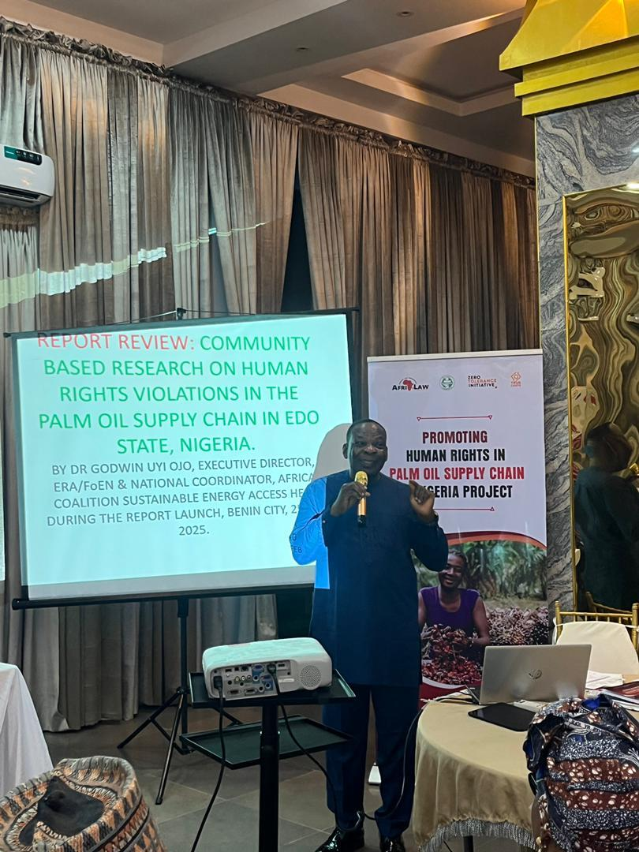
Dr. Godwin Uyi Ojo, Phd. Independent Research Consultant reviewing the research
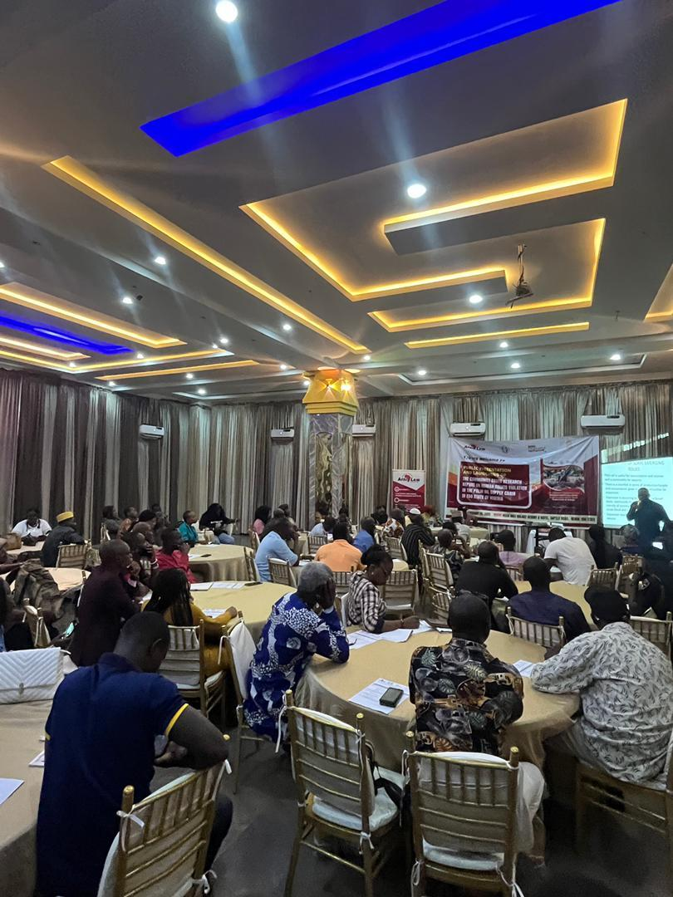
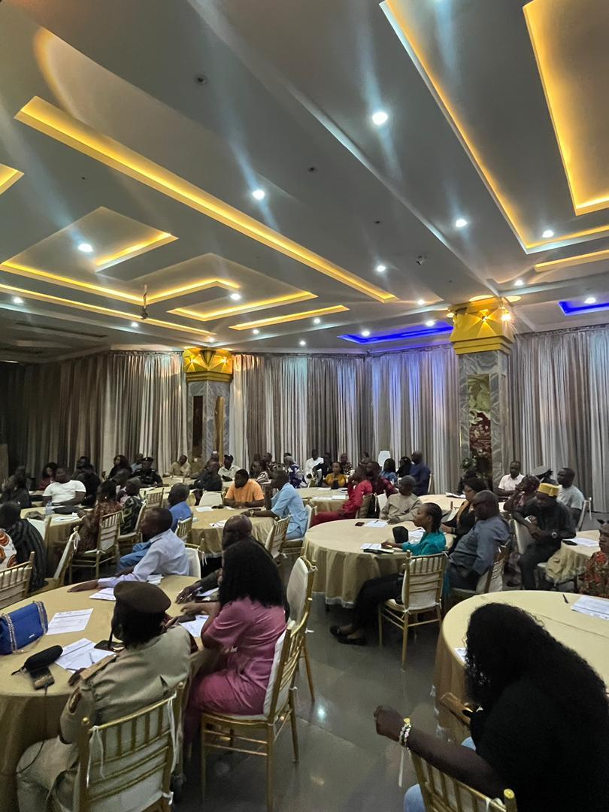
Cross-Session of participants
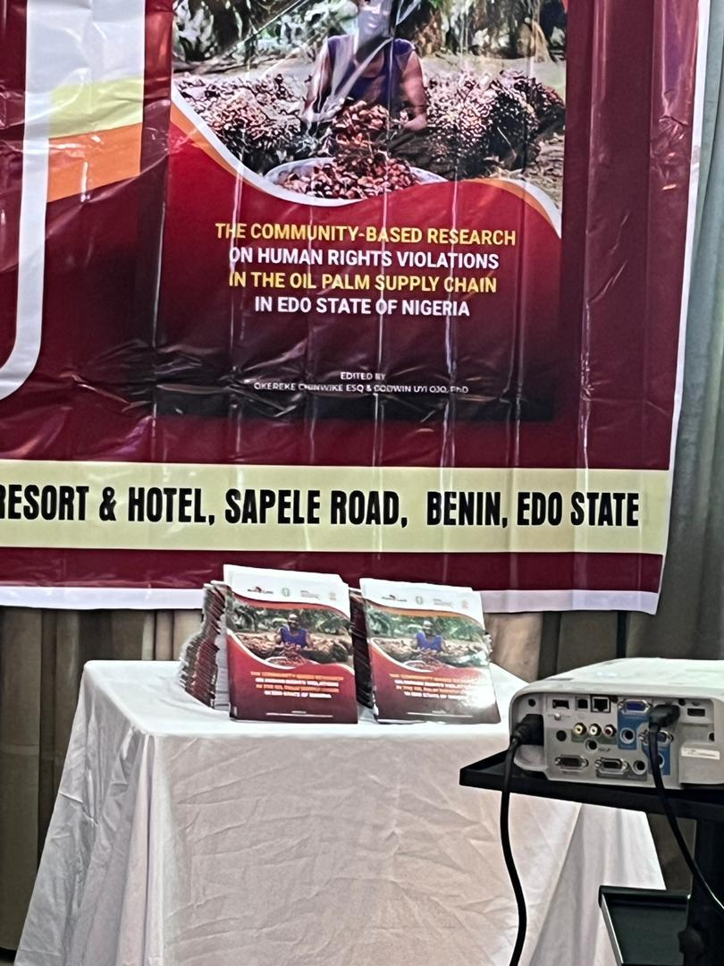
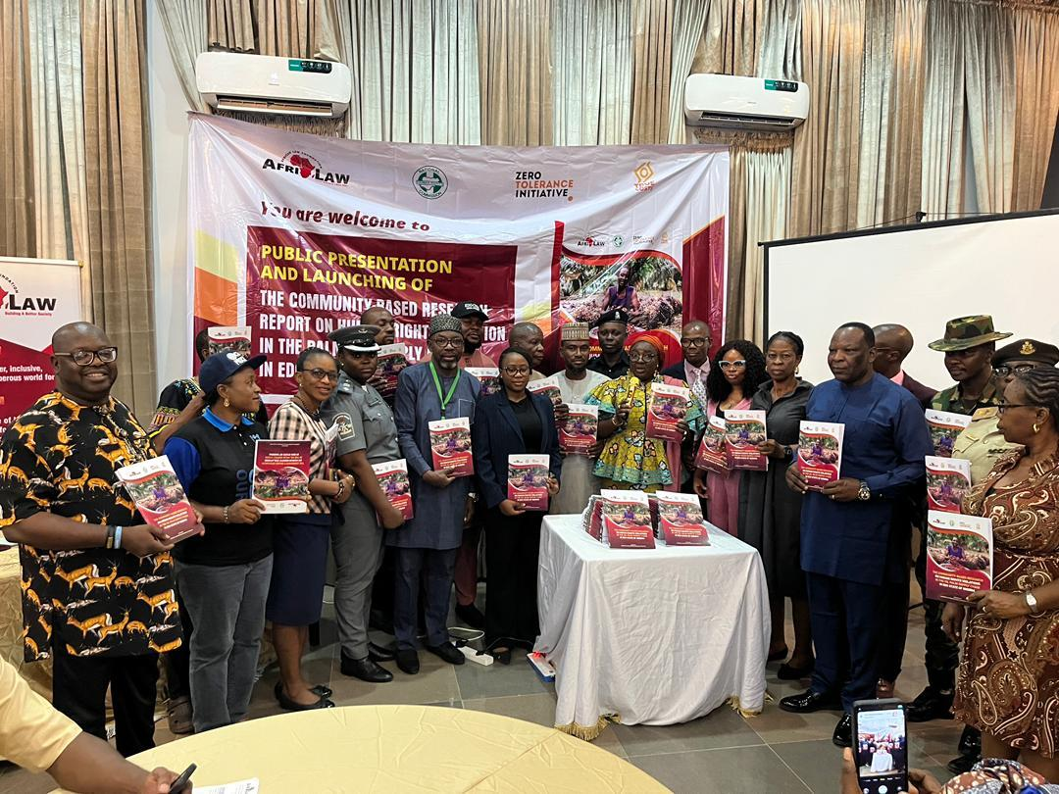
The Public presentation and lunching of the report
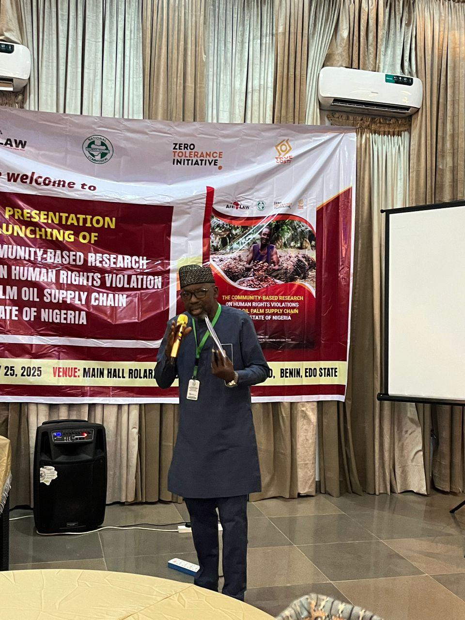
Mr Dosumu, the NHRC State Coordinator taking the General Discussion Session

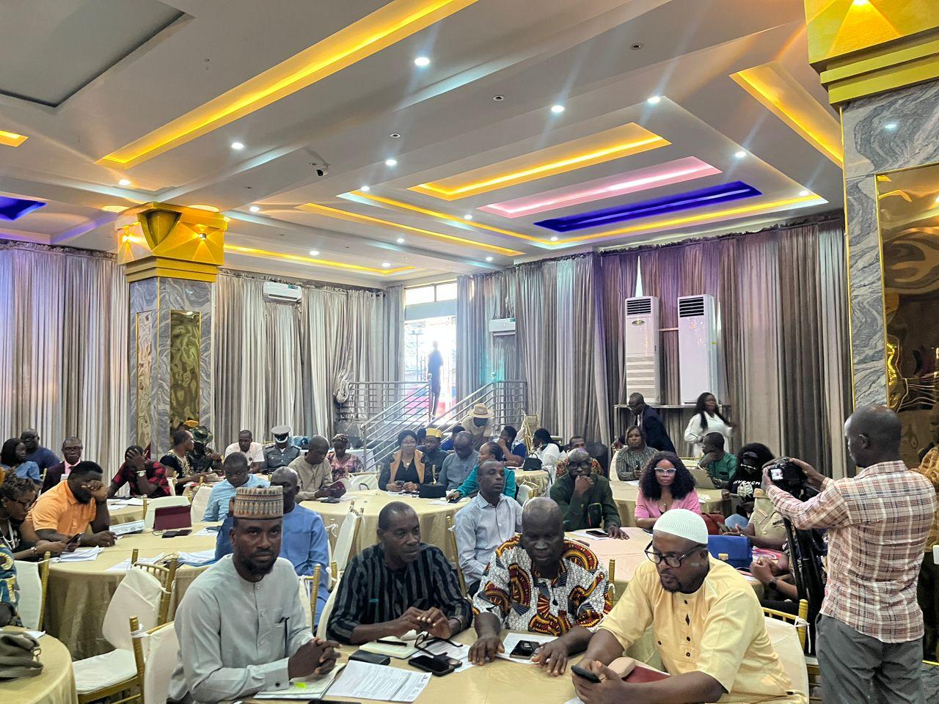
Cross-Session of participants
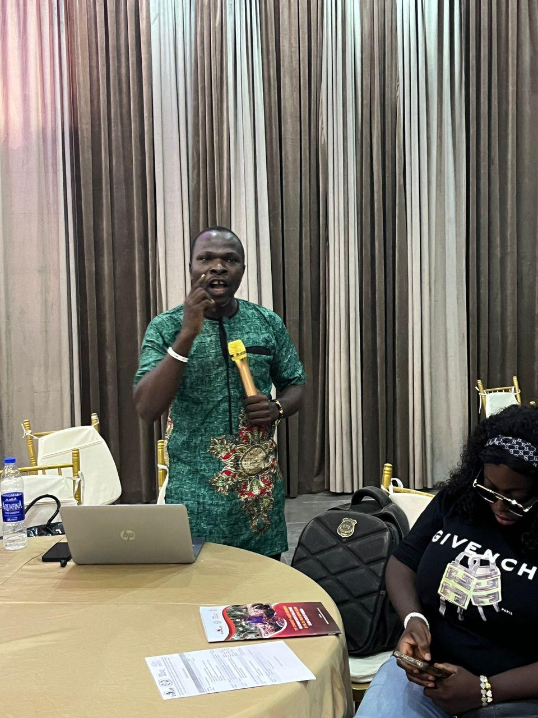
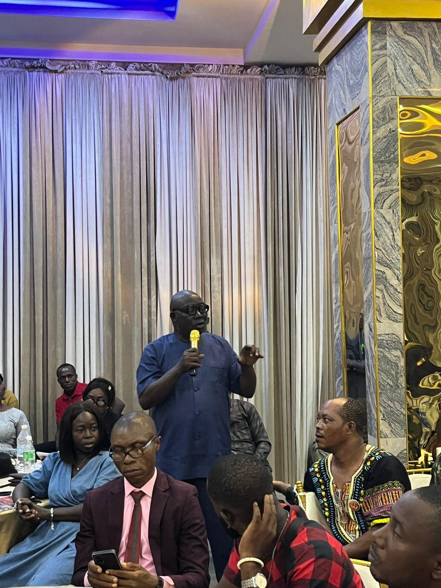
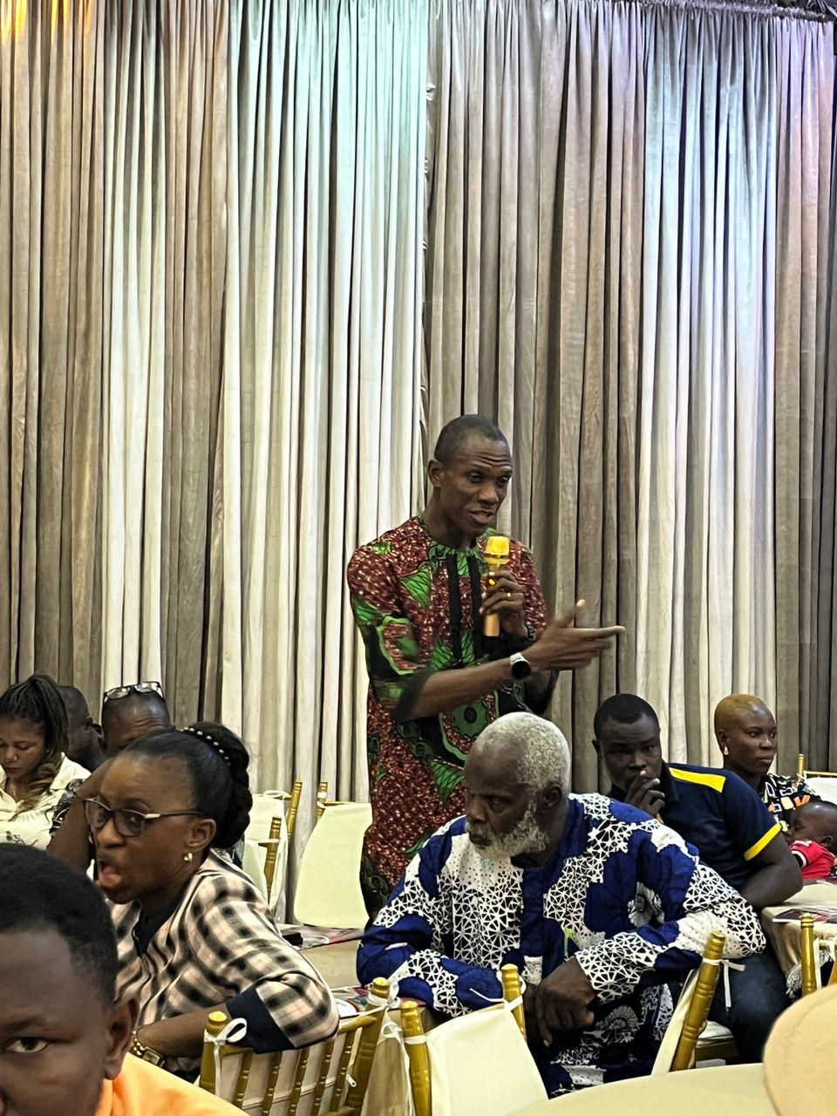
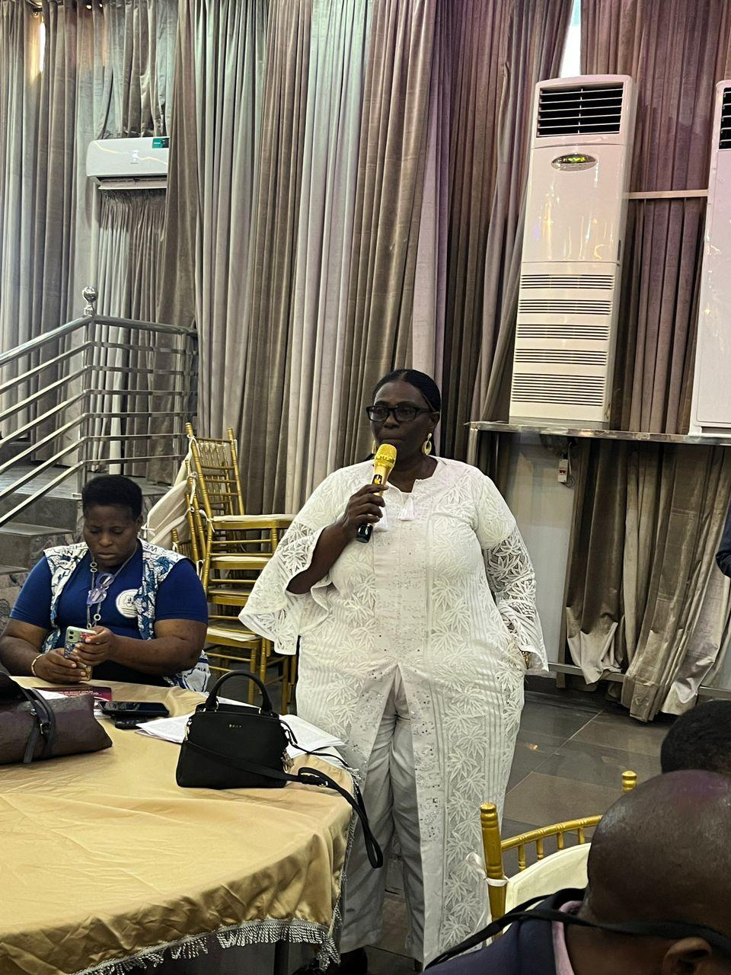
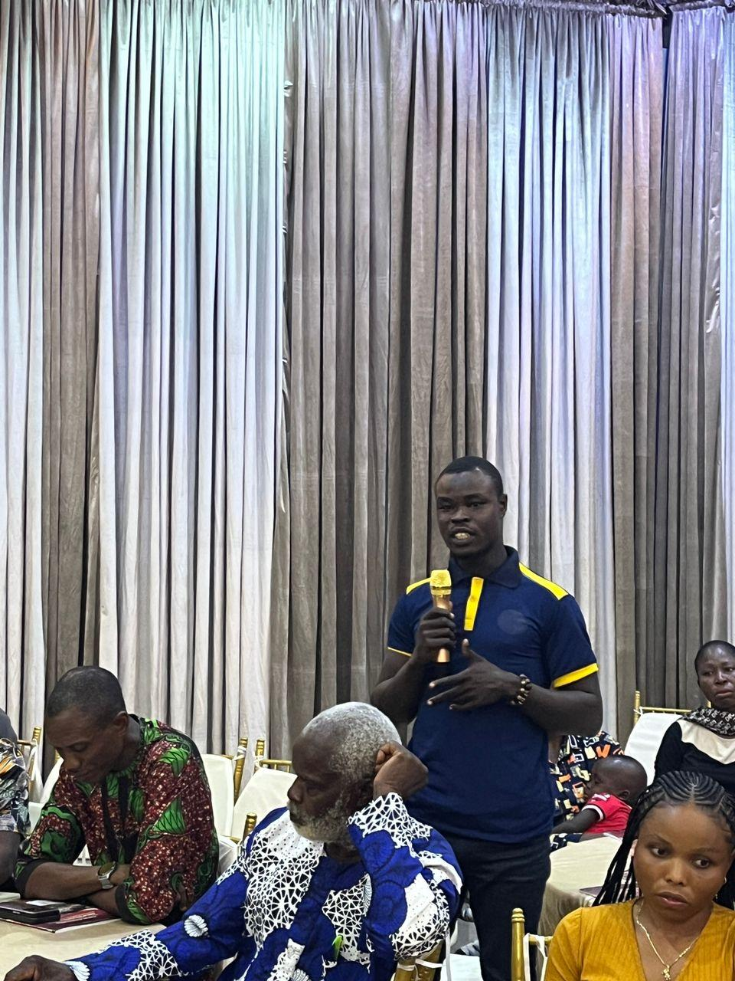
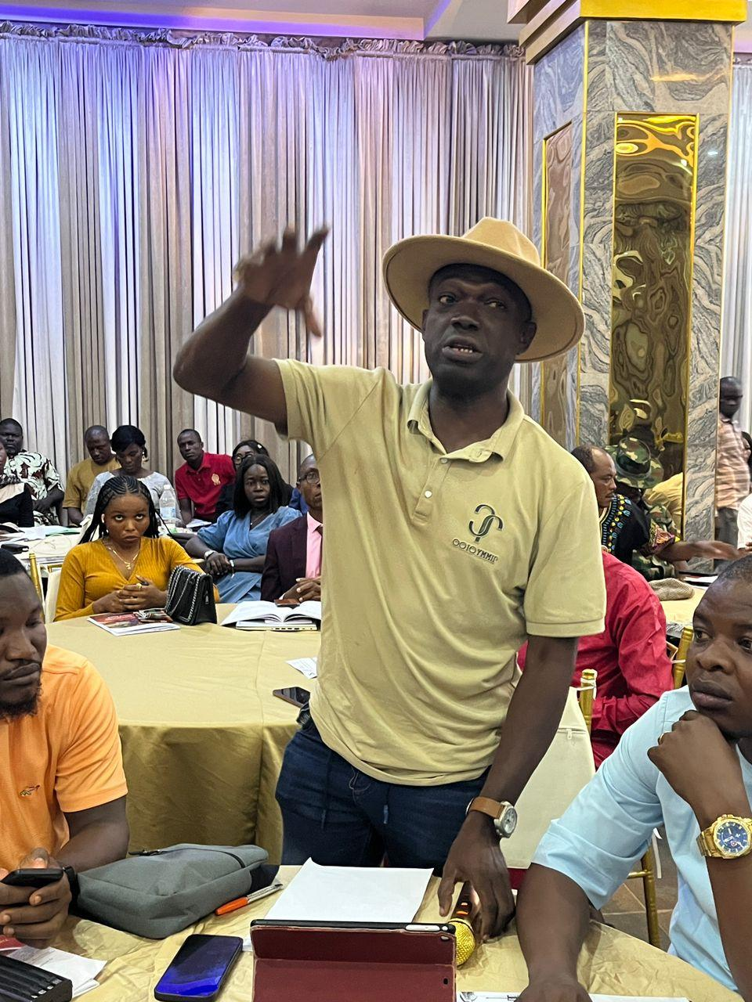
Participants asking questions and commenting on the research report
MEDIA LINKS:
- https://thesun.ng/nhrc-urges-multinationals-to-end-tokenism-in-host-communities/?amp
- https://infodailyng.com/protect-oil-palm-host-communities-address-spate-of-kidnapping-violence-govt-told/
- https://dailyflashng.com/2025/02/26/ngo-sets-agenda-for-palm-oil-supply-chain-in-edo/
- https://blueprint.ng/foundation-sets-agenda-for-palm-oil-supply-chain-in-edo/
- https://www.alertnews.ng/2025/02/nhrc-admonishes-multinational-firms-to.html?m=1
- https://www.sourcenews2day.com/2025/02/afrilaw-launches-community-base-human.html?m=1

- 1-DAY PALM OIL SUPPLY CHAIN HUMAN RIGHTS TRAINING WORKSHOP FOR OIL PALM COMPANIES AND BUSINESS ENTERPRISES IN EDO STATE:
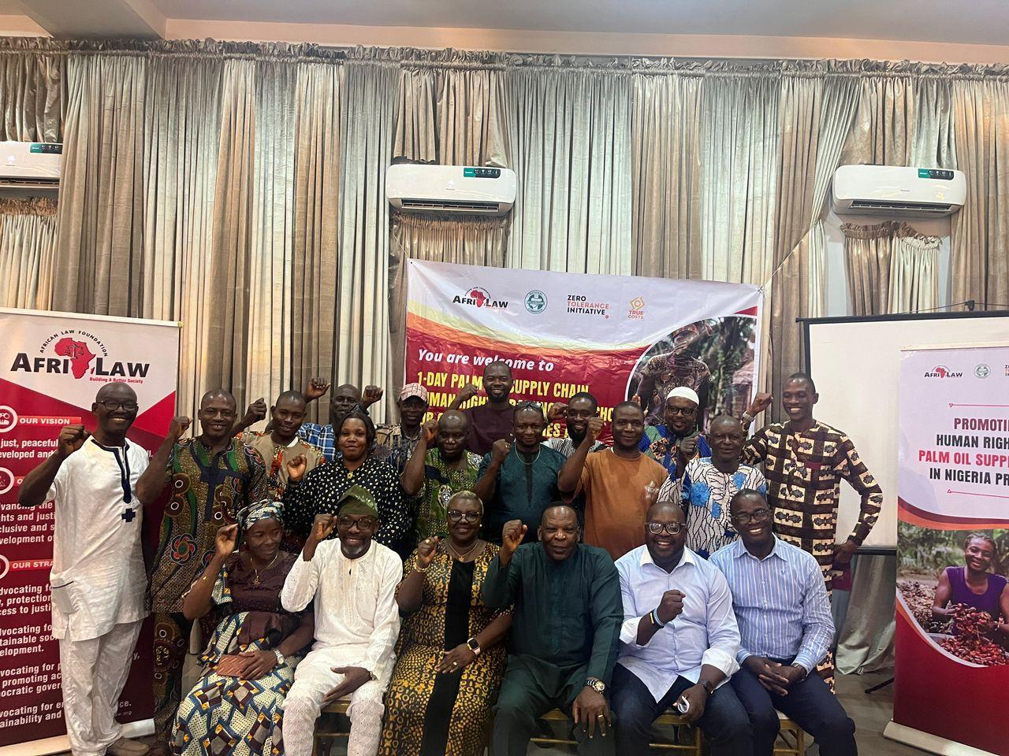
Group picture of participants
The 1-Day Palm Oil Supply Chain Human Rights Training Workshop for Oil Palm Companies and Business Enterprises in Edo State held on Wednesday February 26, 2025 at Rolarz Resort & Hotel, Benin City, Edo State with about Twenty-Nine (29) participants in attendance. The participants comprised of Palm Oil Companies and Industry Stakeholders.
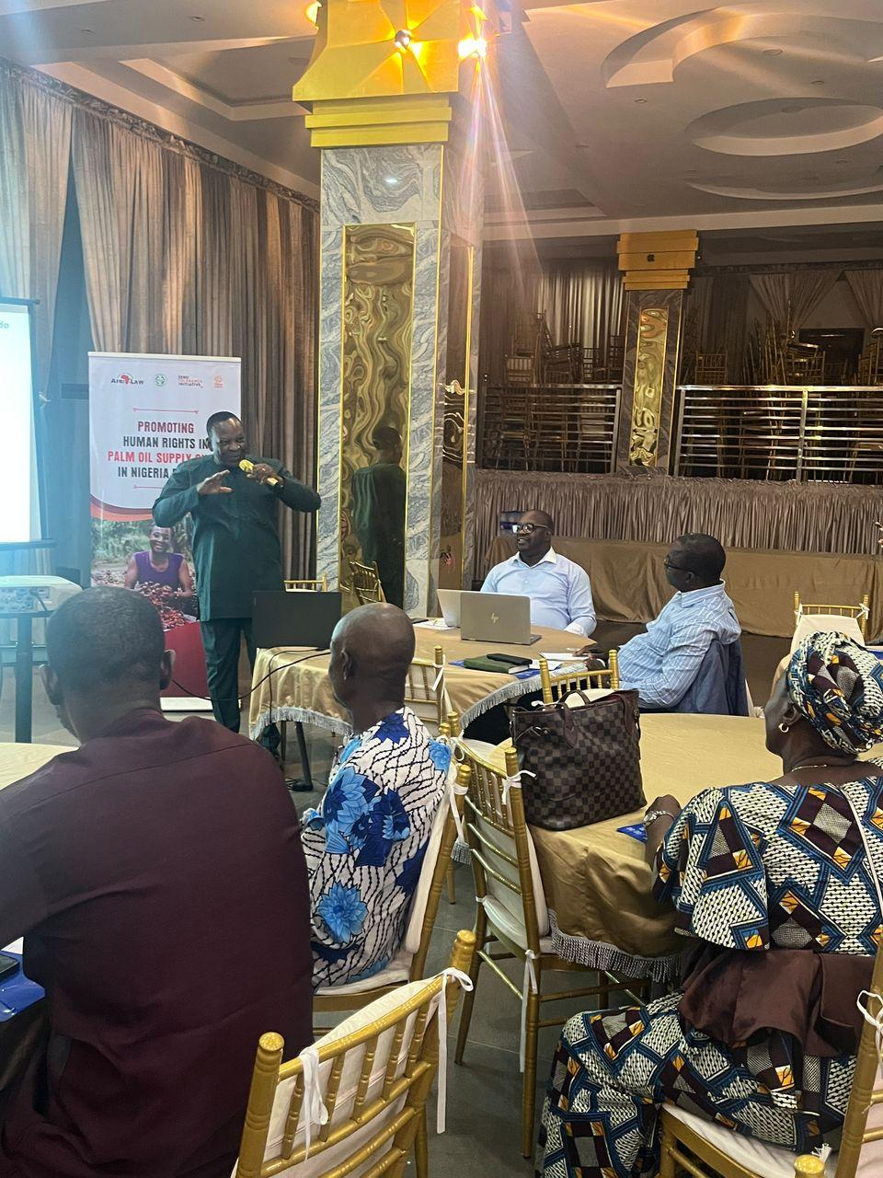
Dr. Godwin taking presentation 1
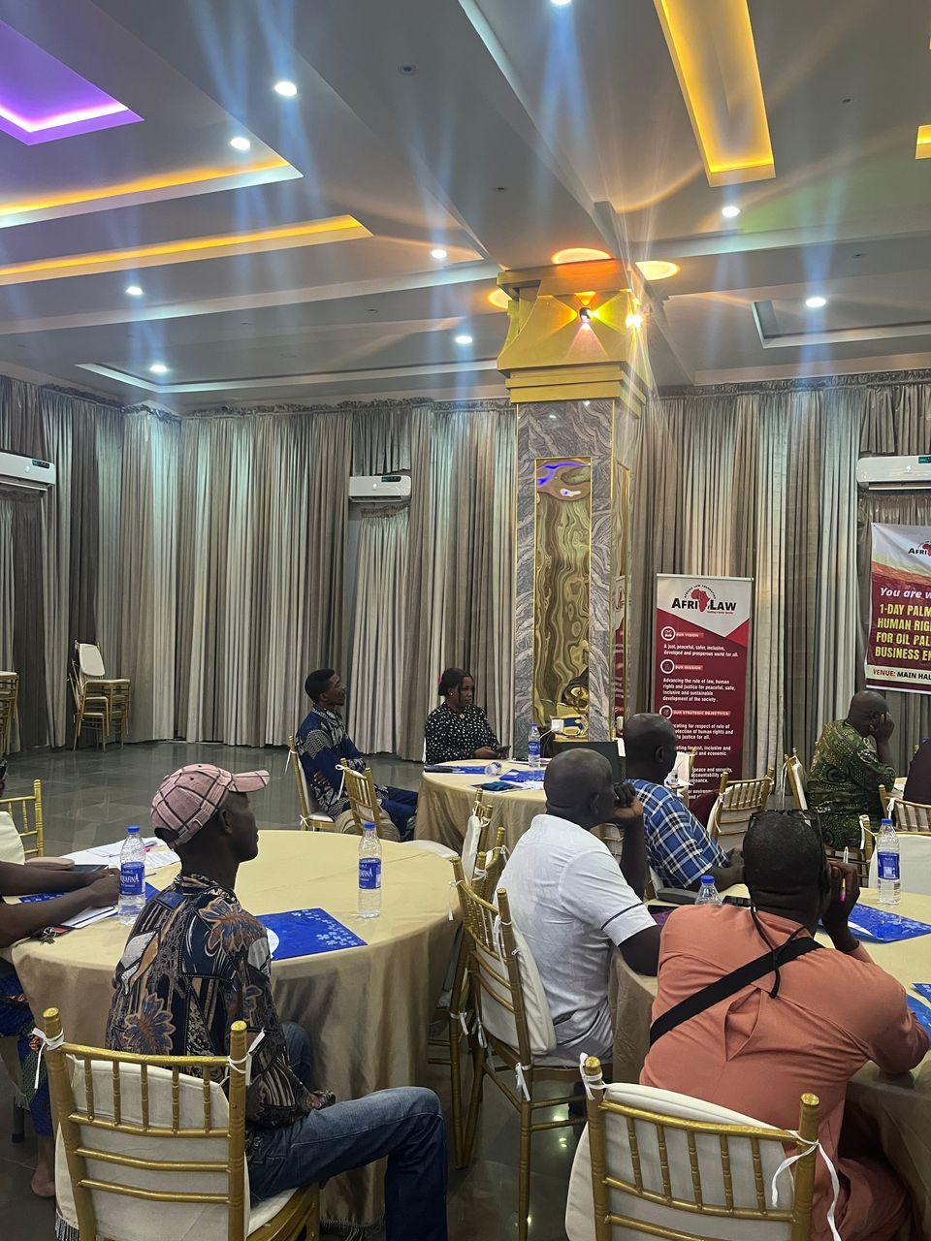
Cross-Session of participants
Participants were grouped into 5 groups
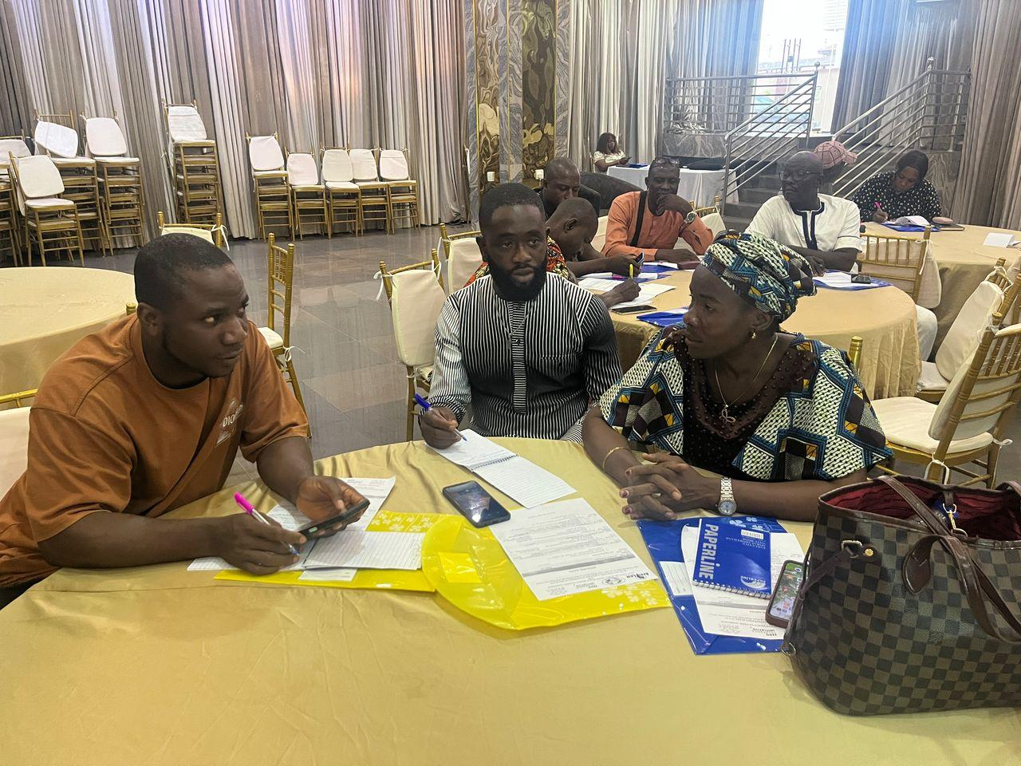
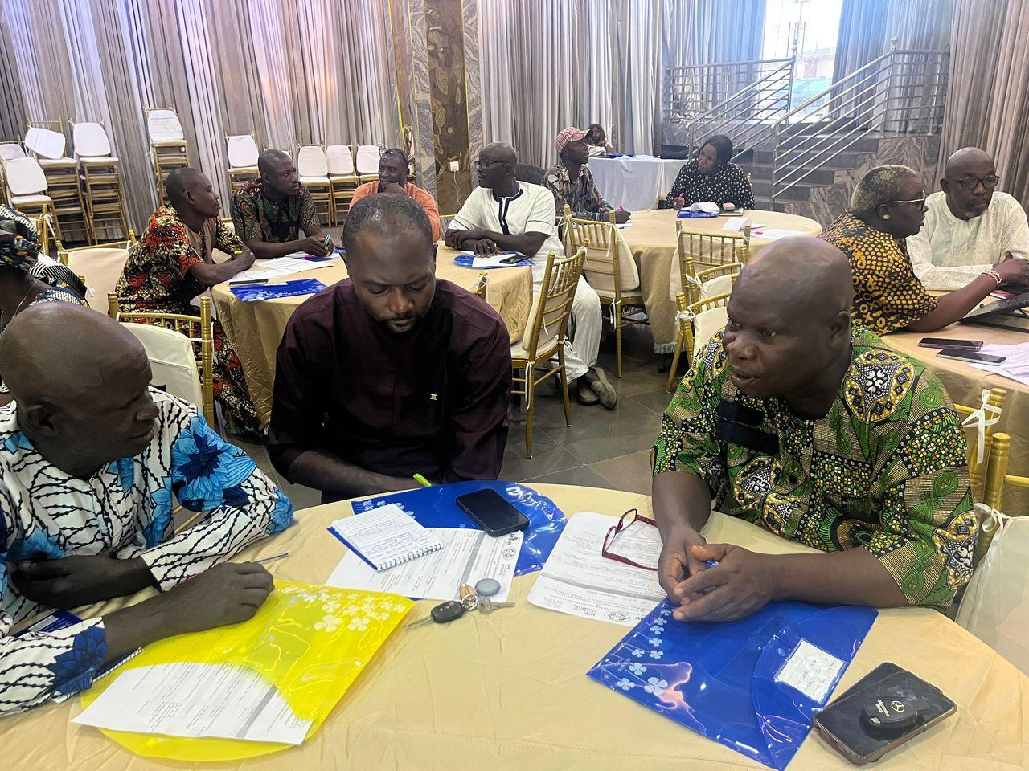
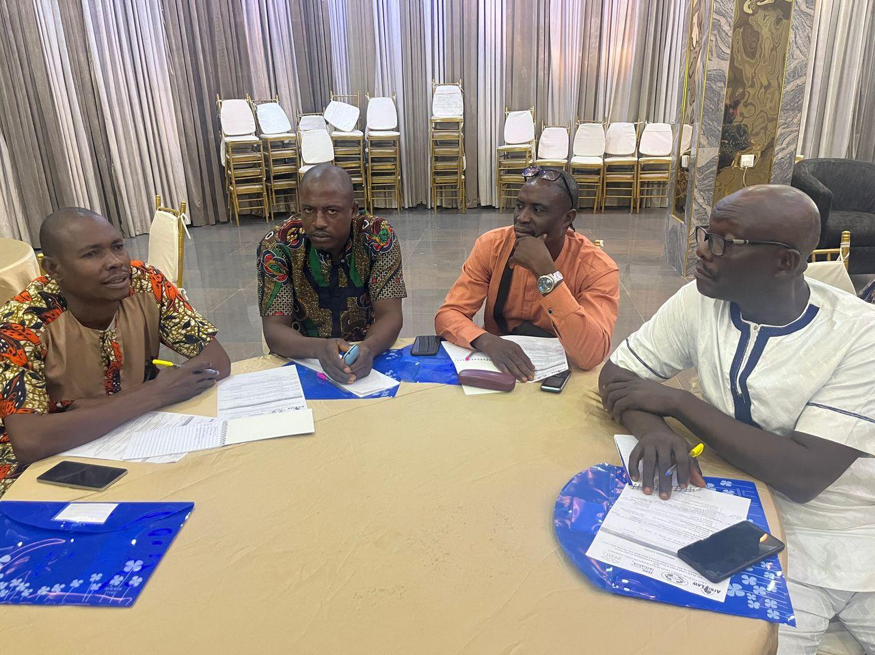
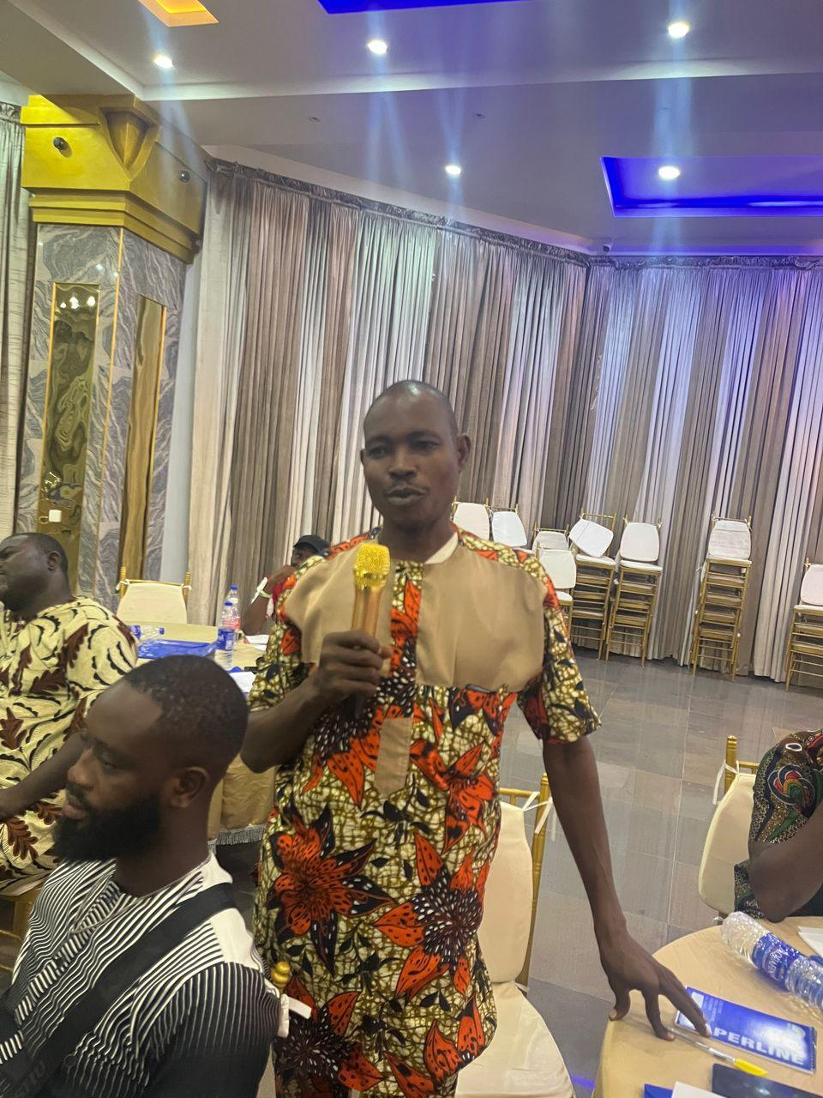
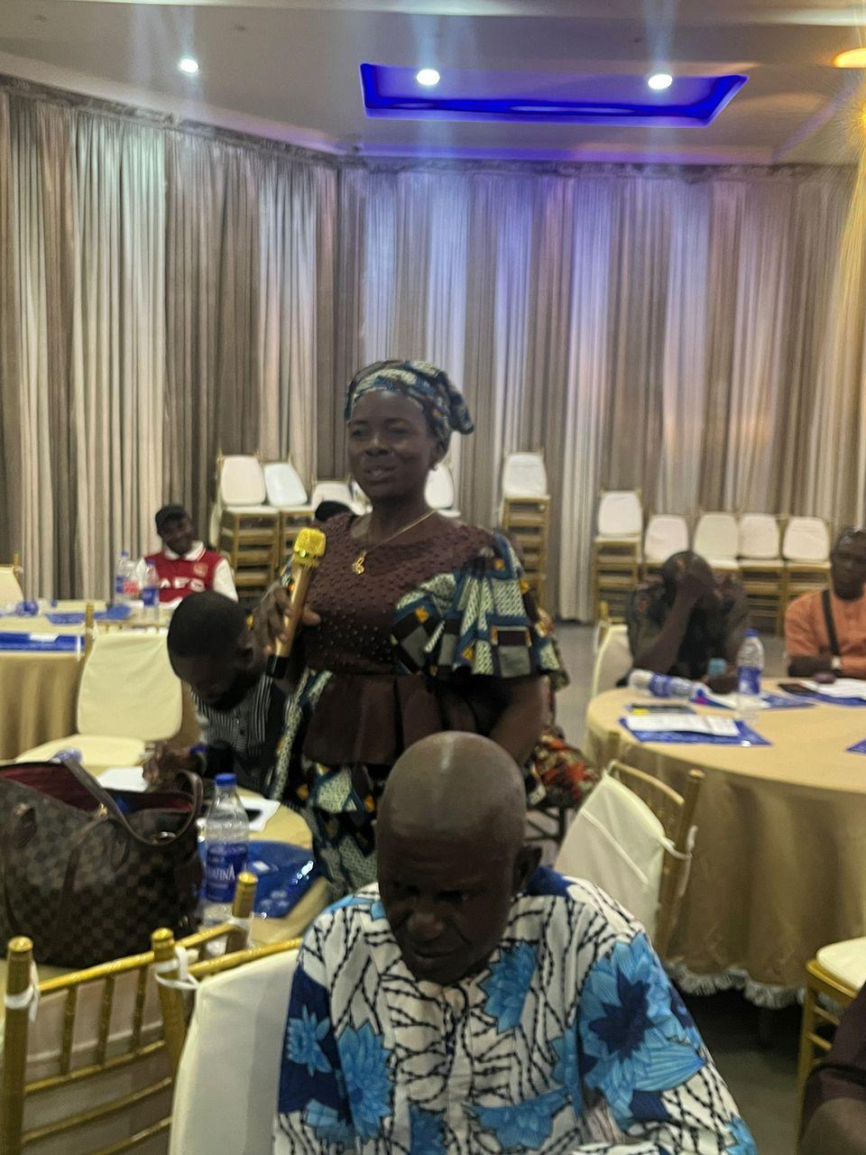
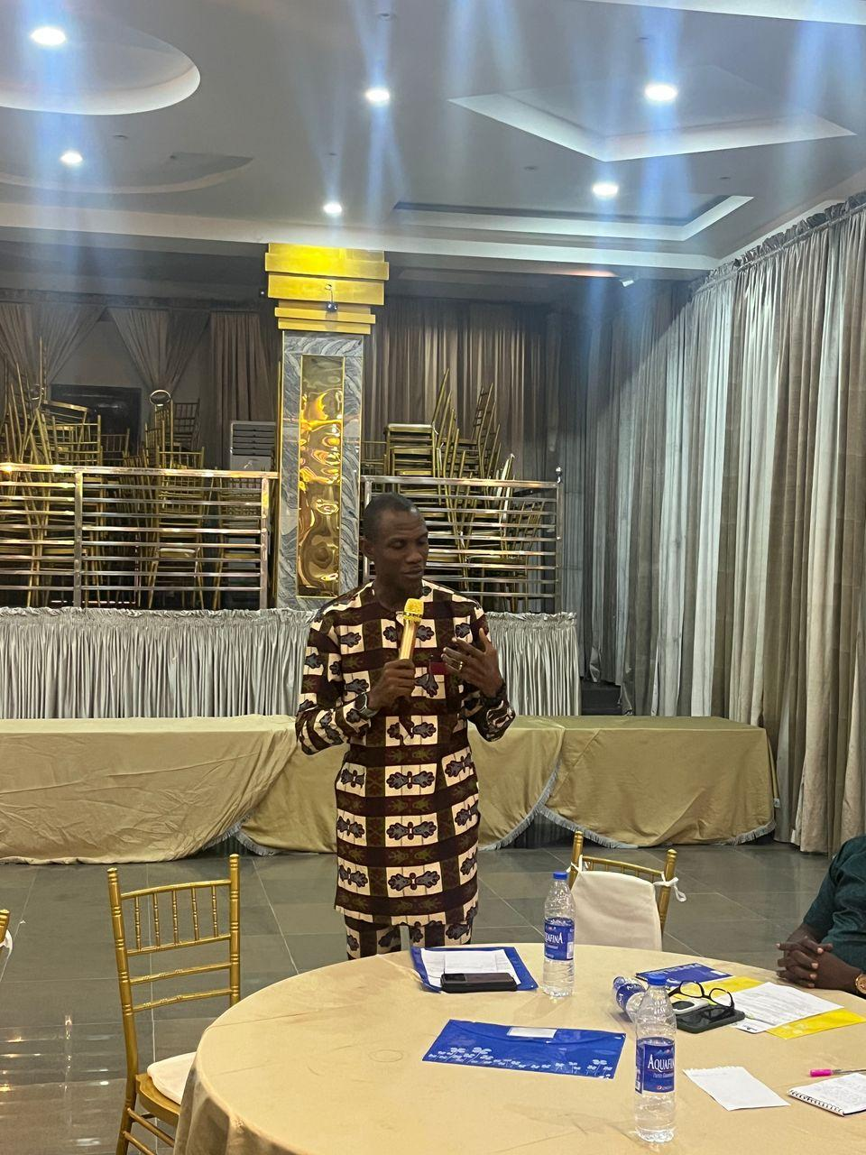
Participants asking questions and commenting

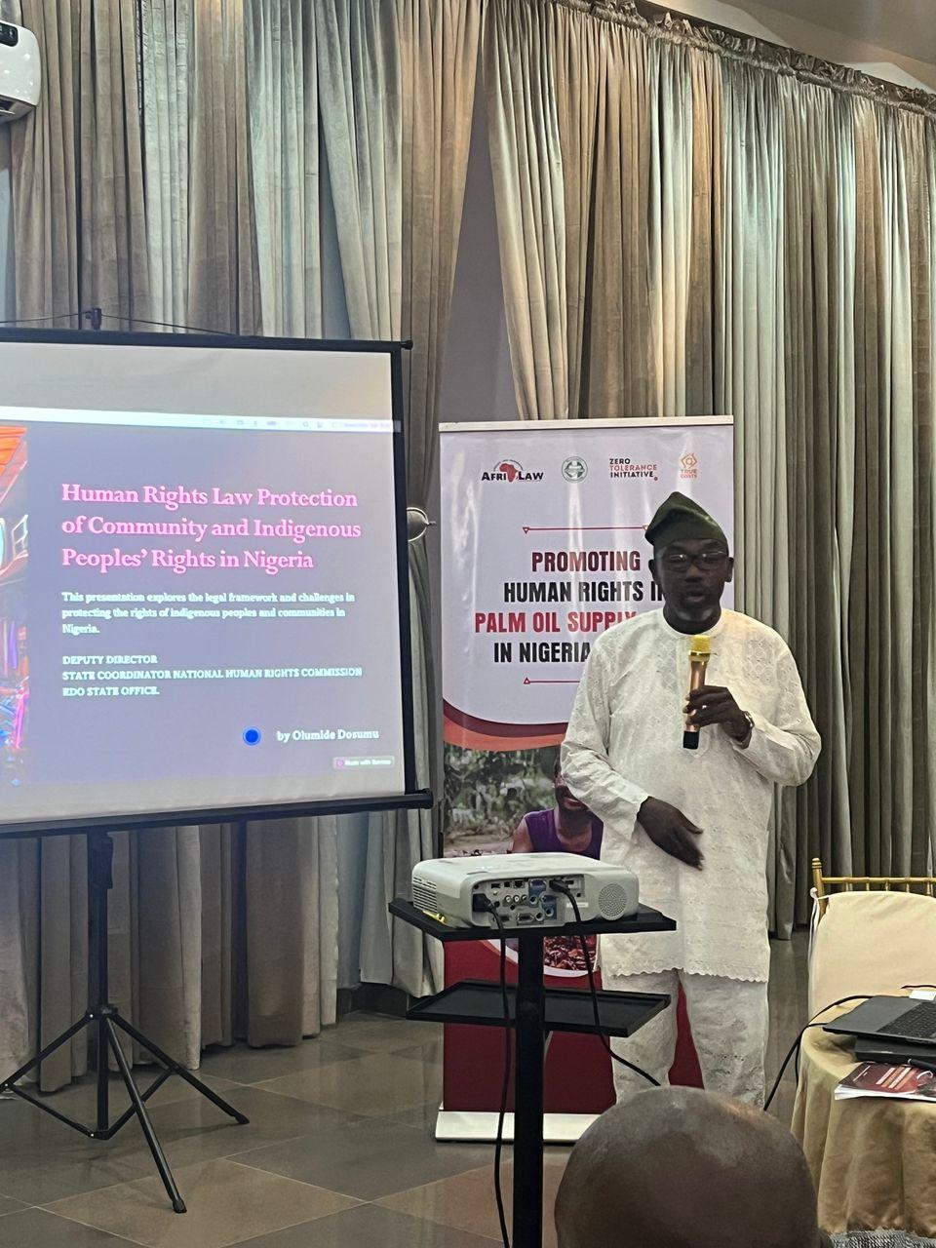
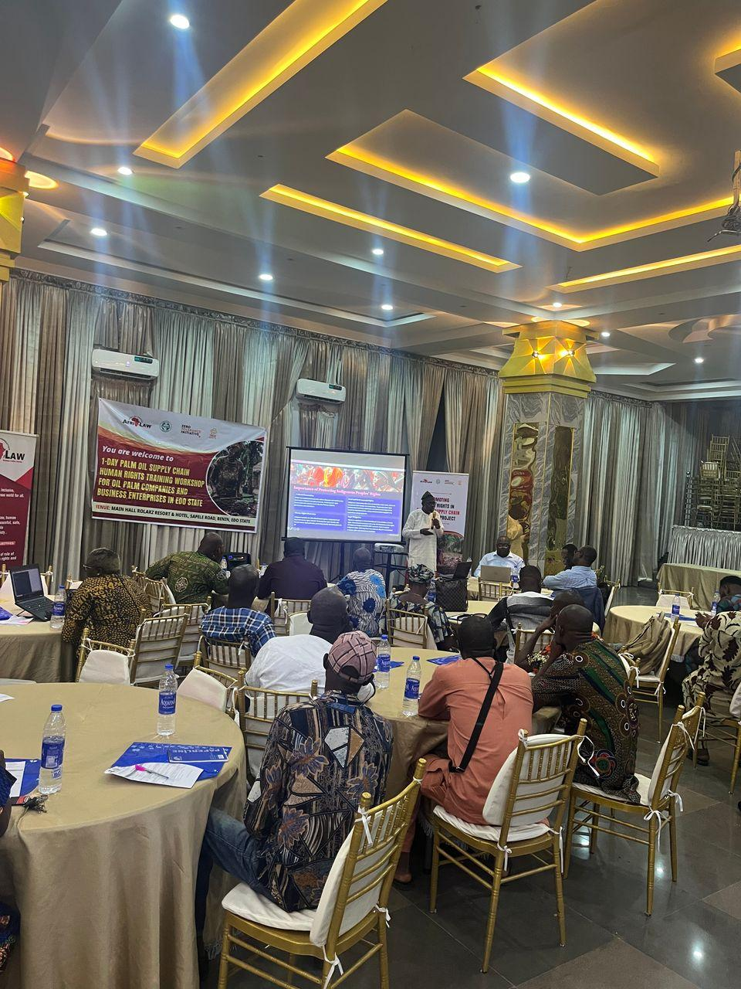
Mr Dosumu taking presentation 2

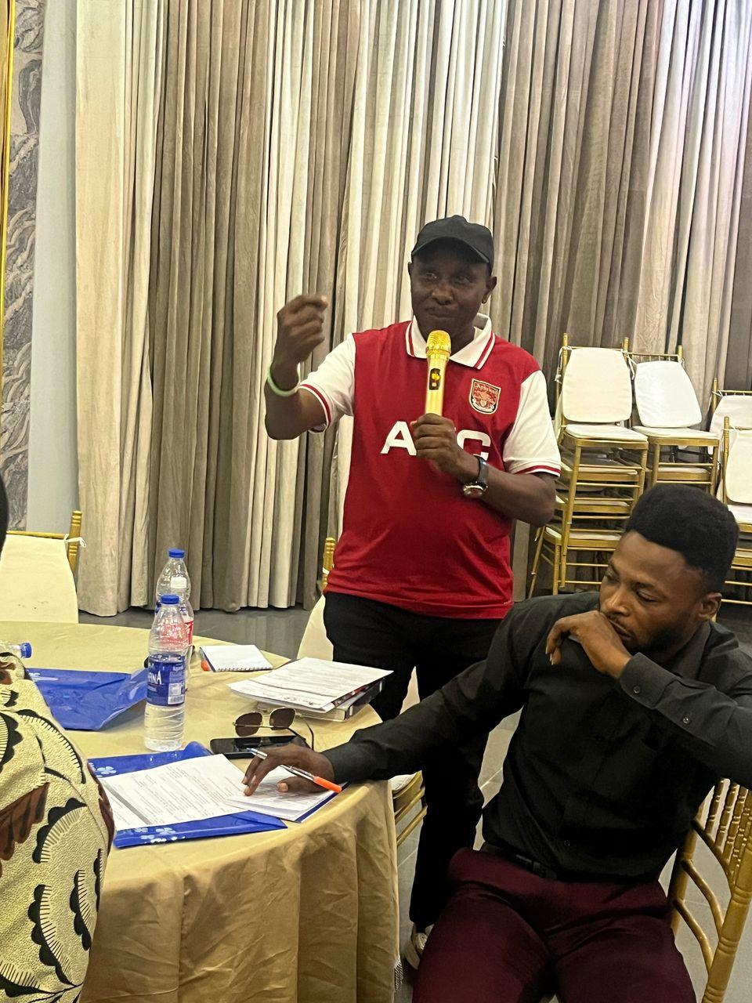
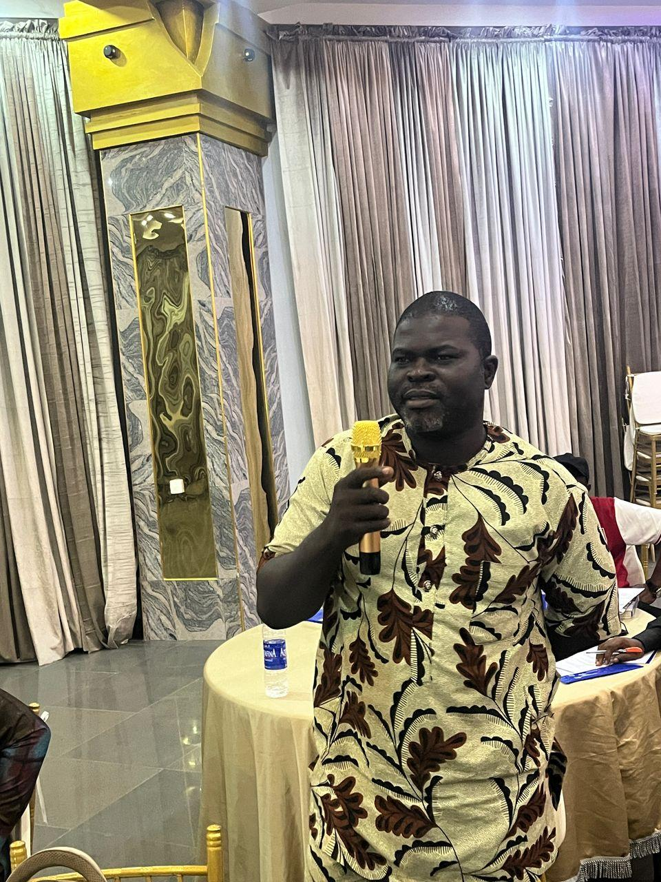
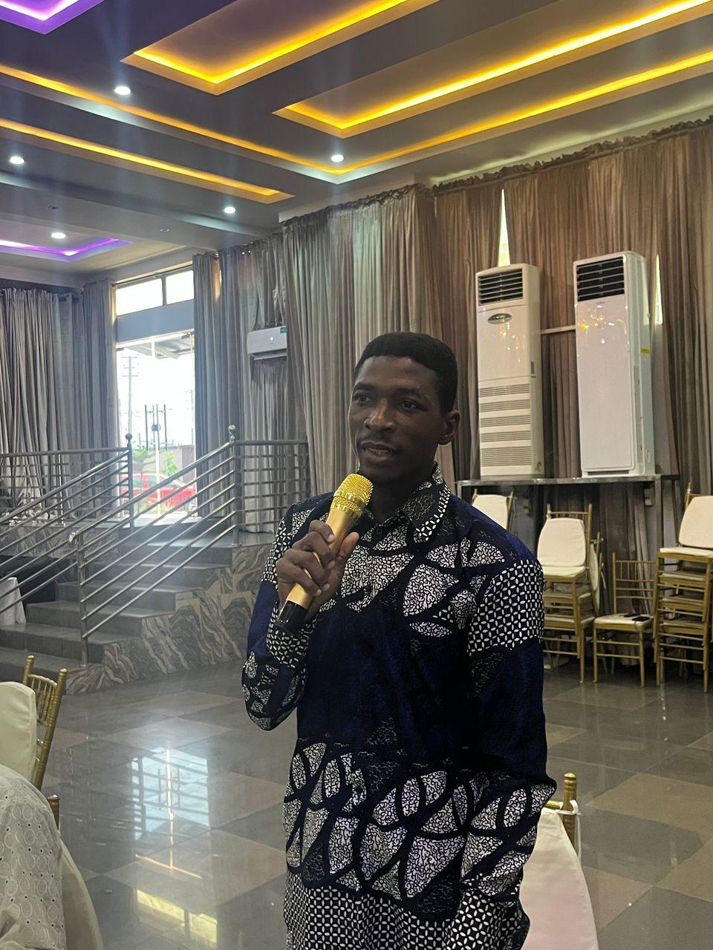
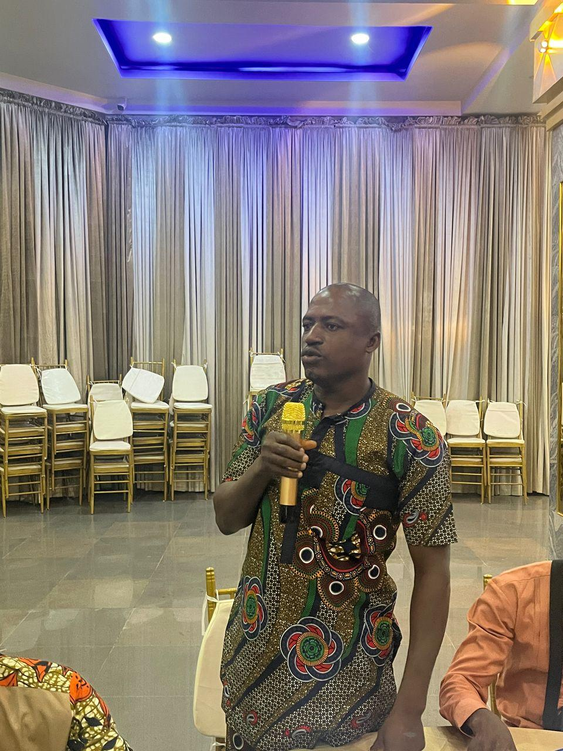
Participants asking questions after the presentation
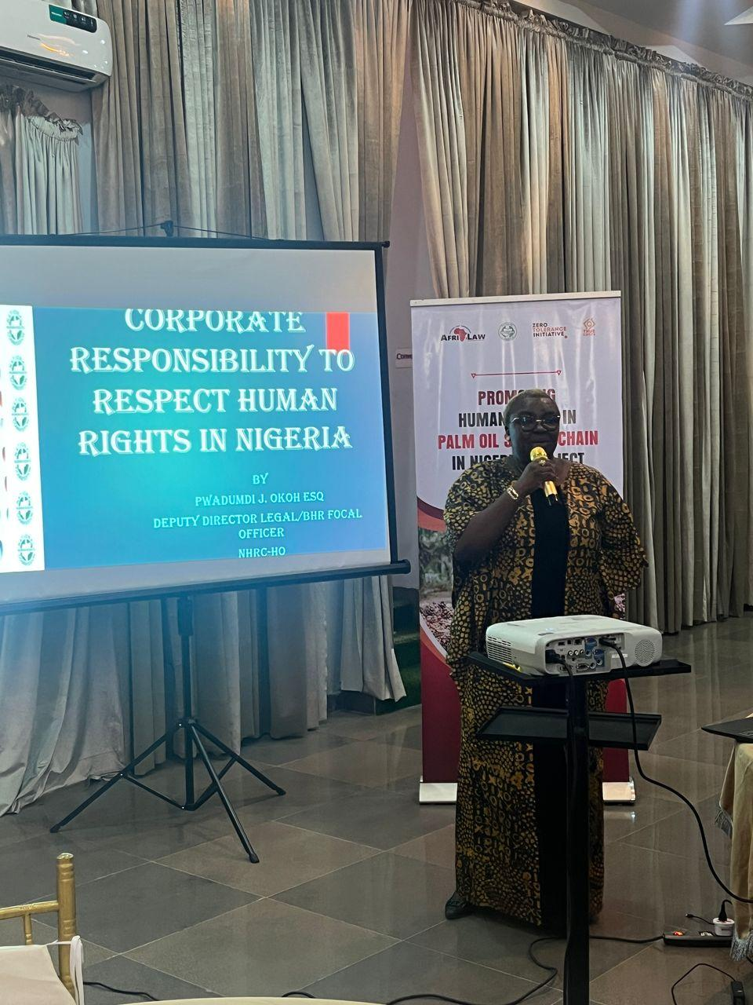
Mrs. Mary Okoh, Deputy Director, Legal/Focal Point-Business and Human Rights, NHRC, Abuja taking her presentation
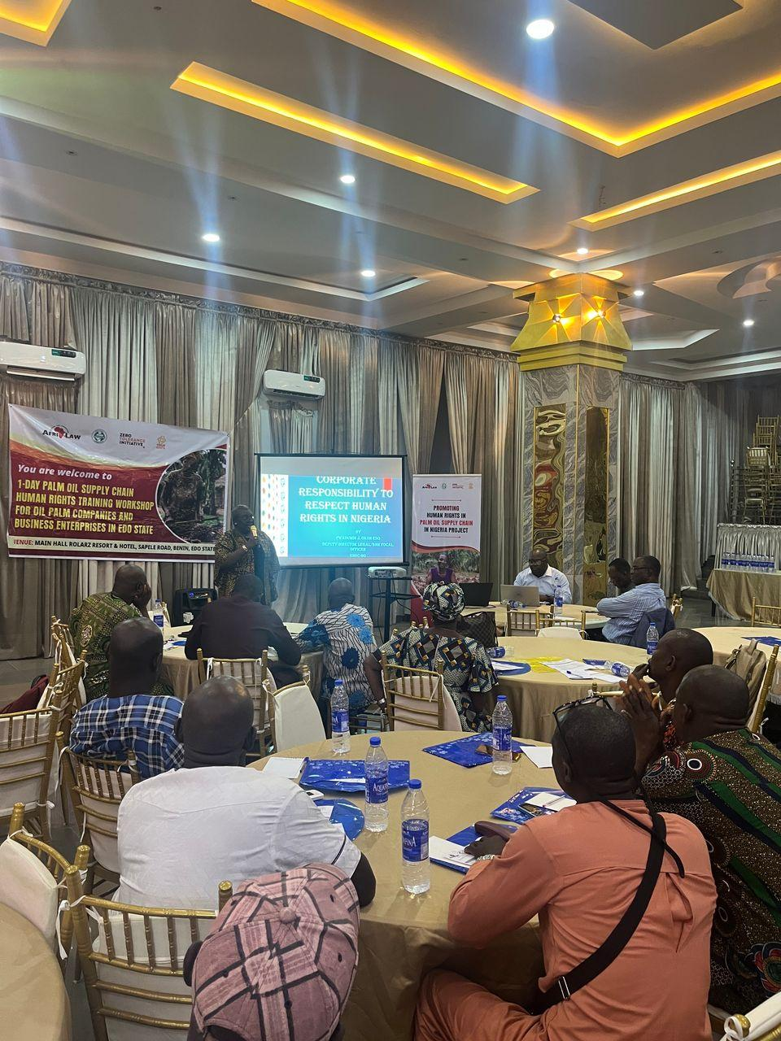
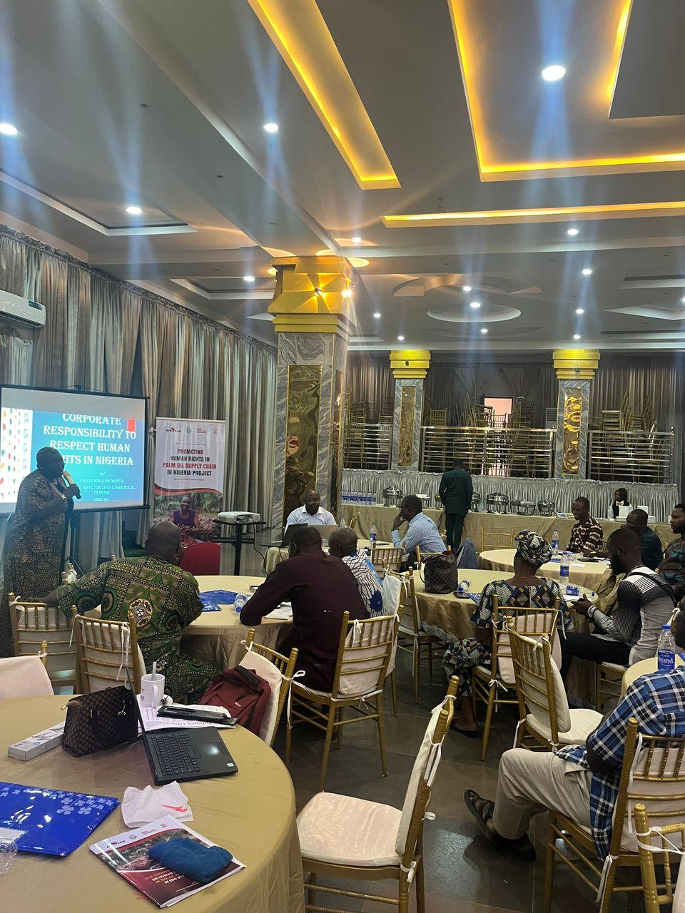
Cross-Session of participants
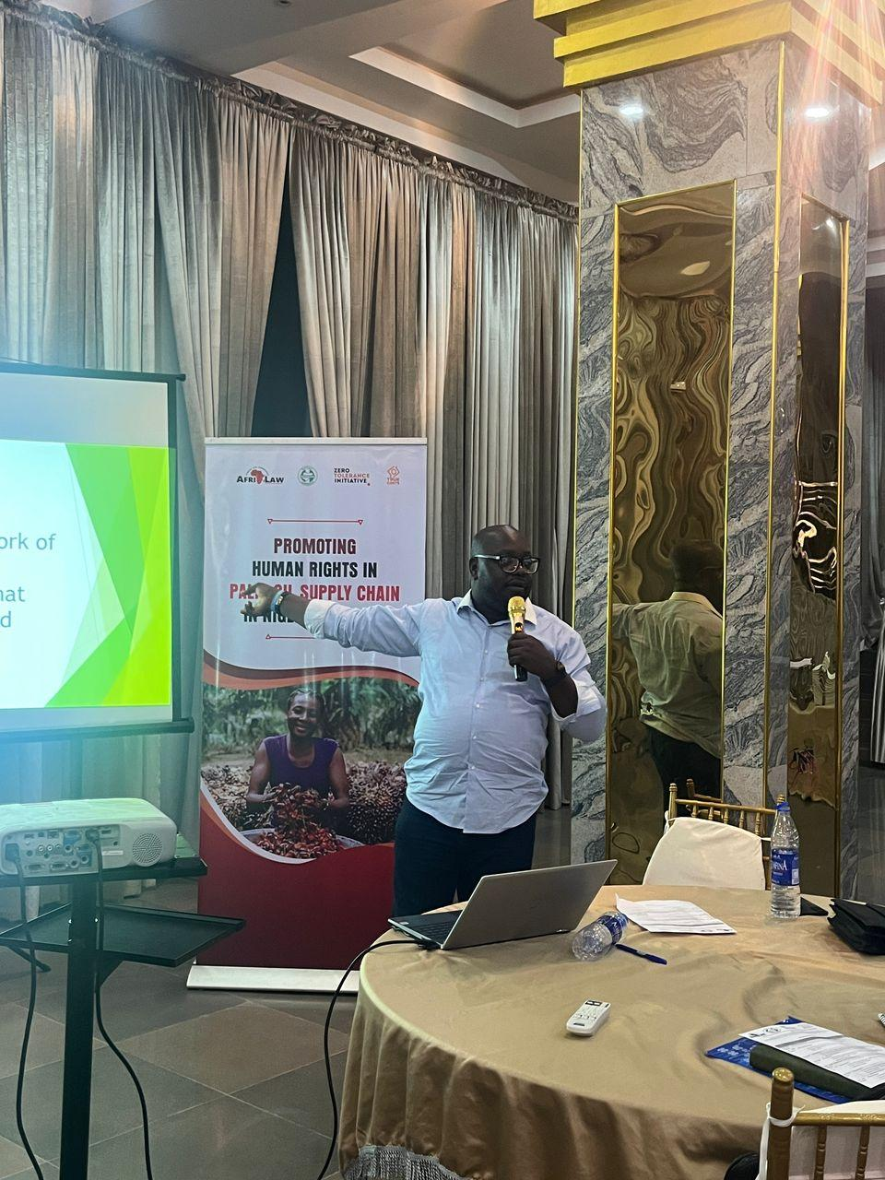
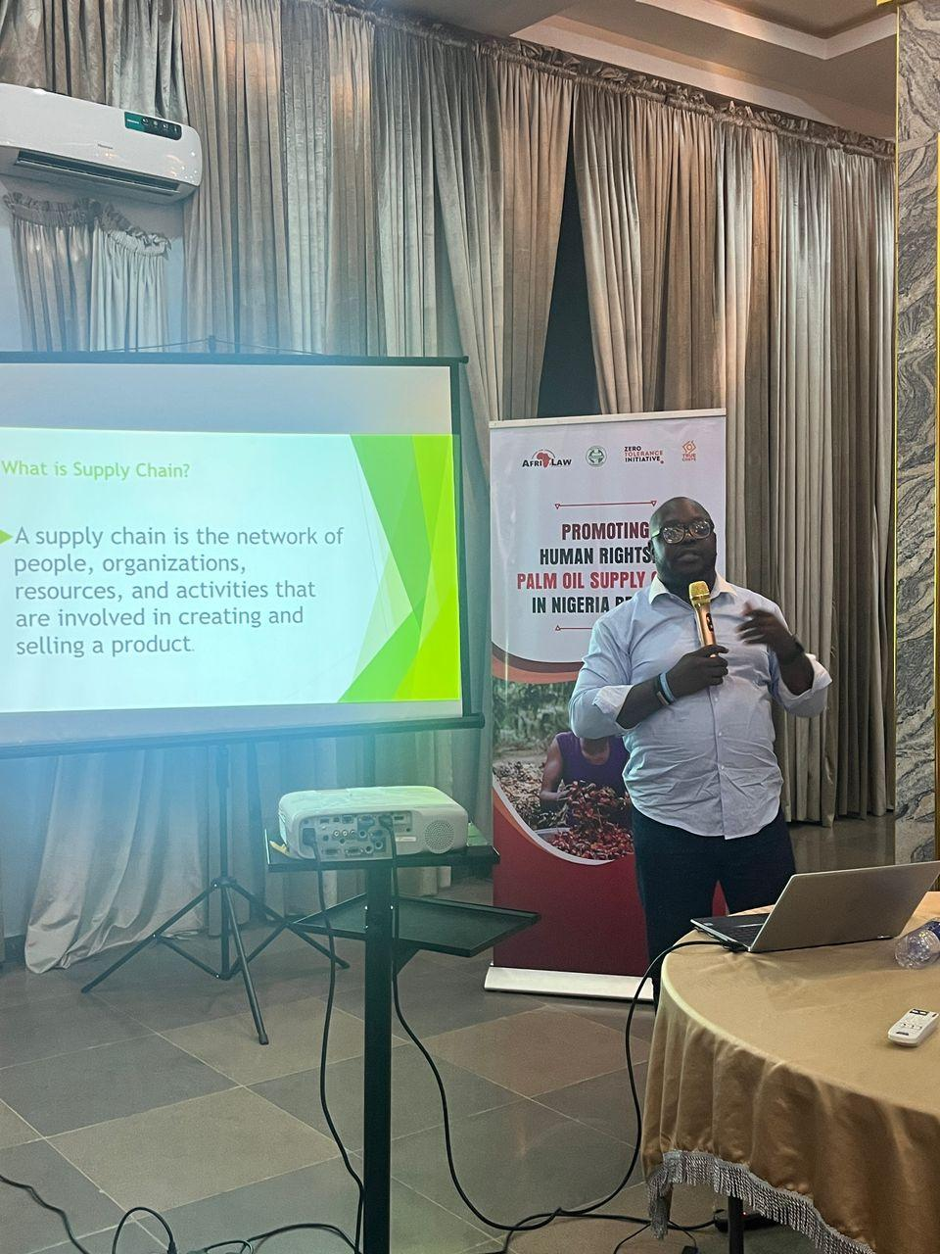
Barr. Chinwike taking his presentation

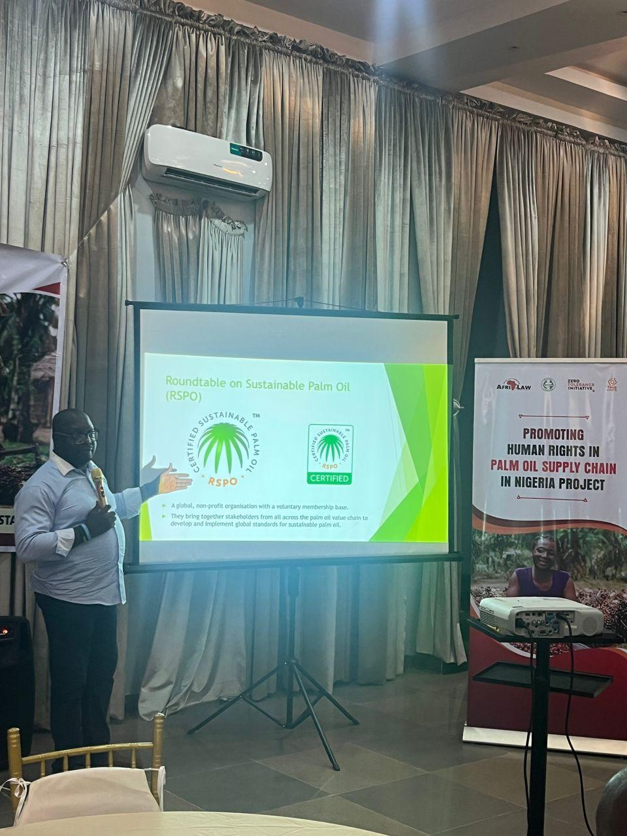
Cross-Session
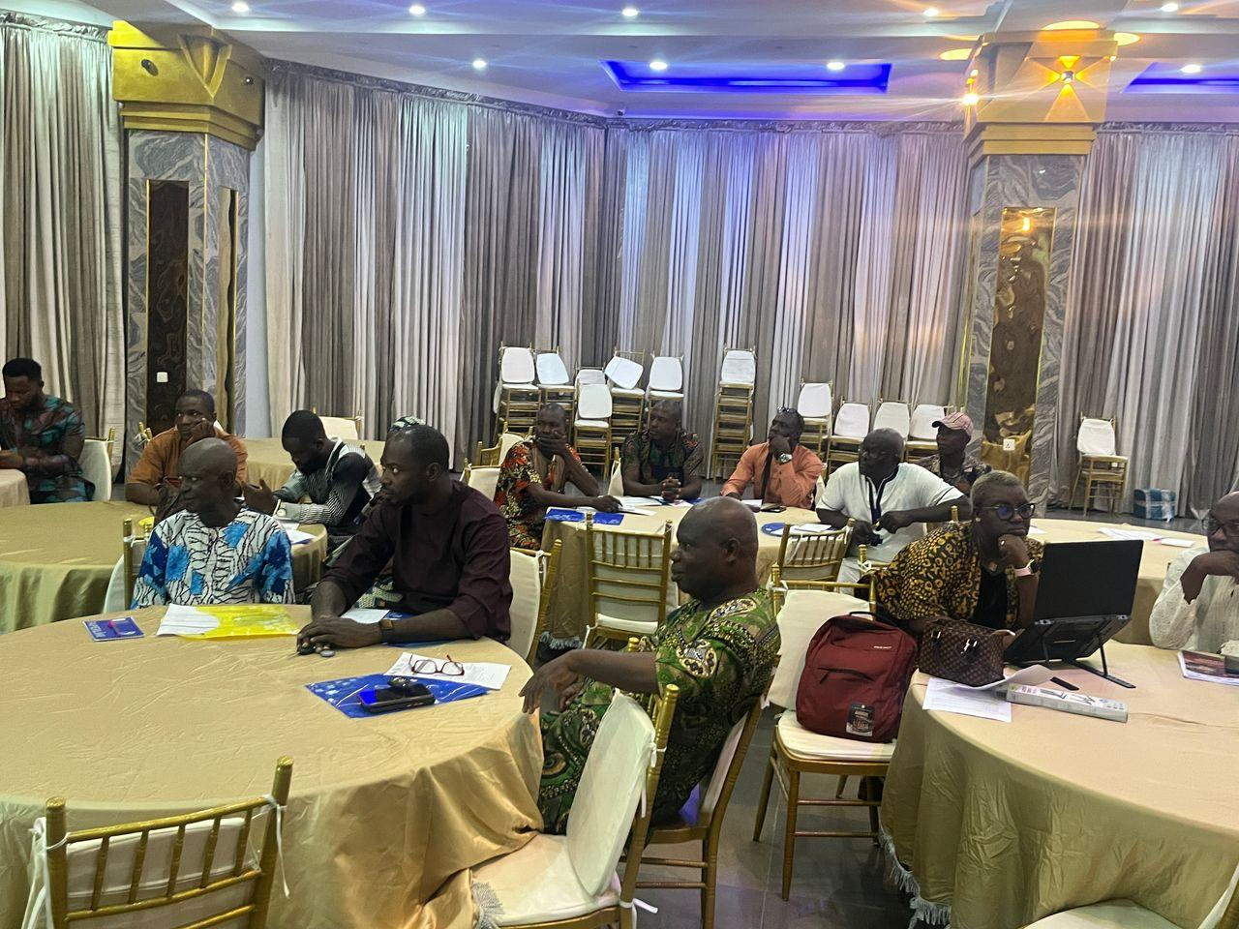
Cross-Session of participants

- 1-DAY PALM OIL SUPPLY CHAIN HUMAN RIGHTS TRAINING WORKSHOP FOR GOVERNMENT MINISTRIES, DEPARTMENTS AND AGENCIES (MDAs) IN EDO STATE:
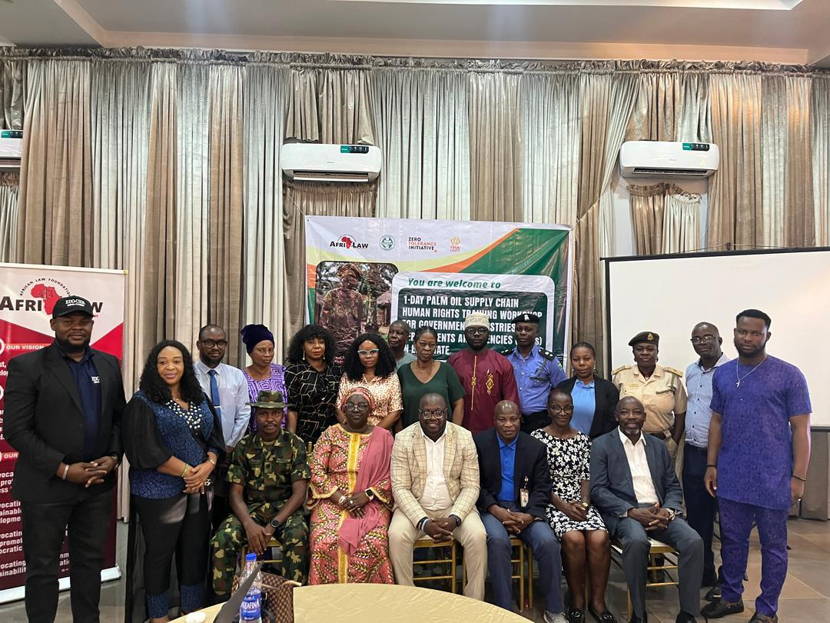
Group Photograph of participants
The 1-Day Palm Oil Supply Chain Human Rights Training Workshop for Government Ministries, Departments and Agencies (MDAs) in Edo State was held on Thursday February 27, 2025 at Rolarz Resort & Hotel, Benin City, Edo State with about Twenty-four (24) participants in attendance. The participants comprised of key and relevant Federal, State and Local Government Ministries, Departments and Agencies (MDAs).
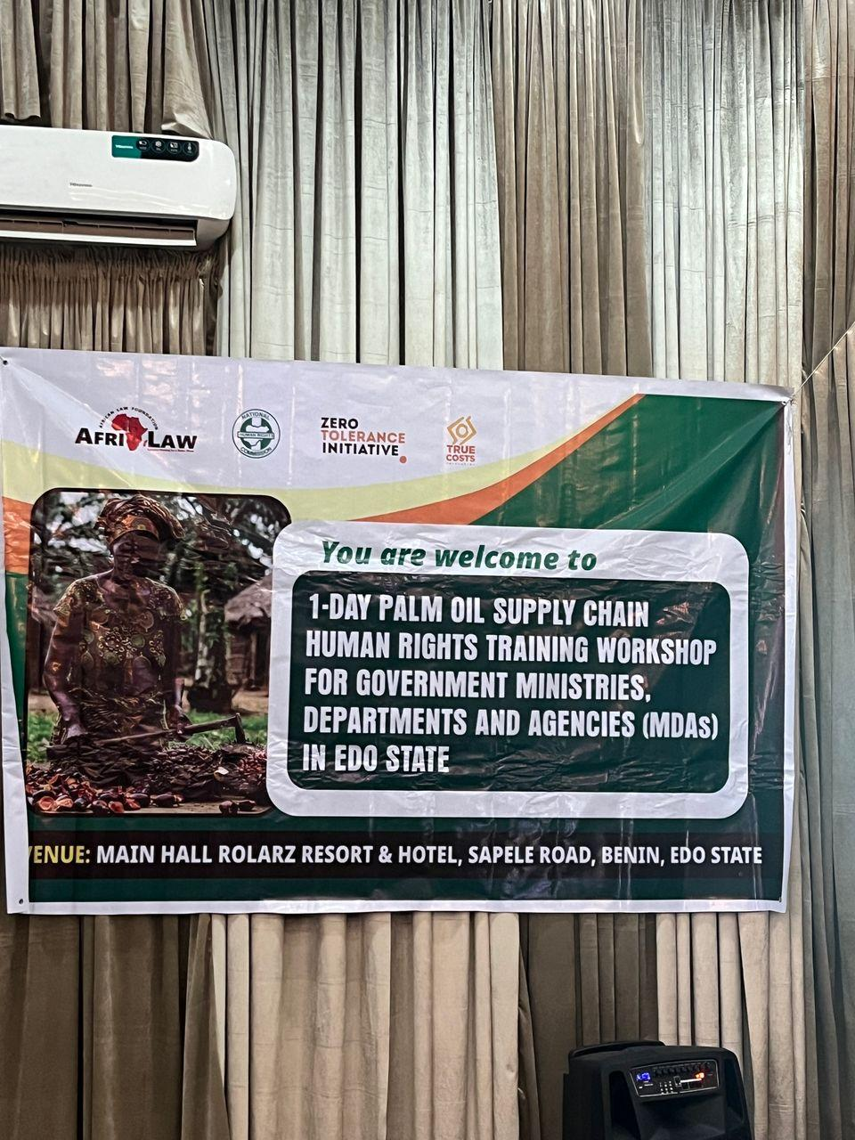
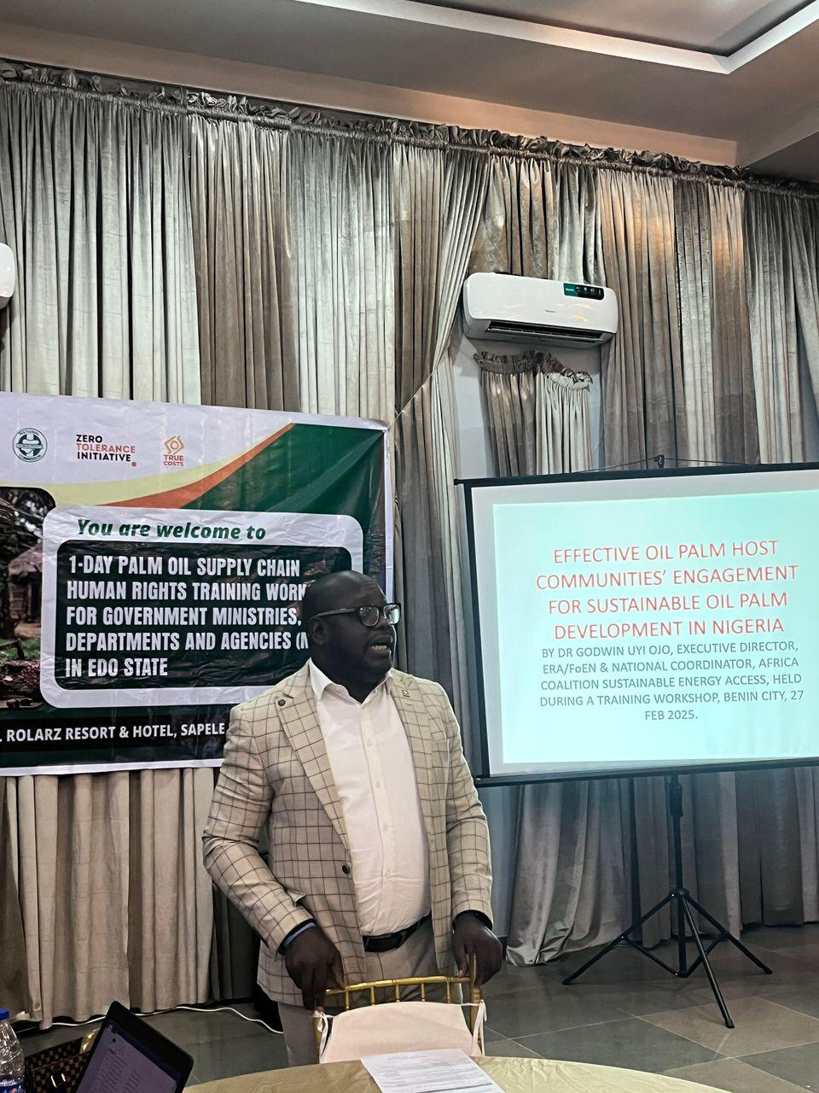
Barr. Chinwike giving his welcome remarks
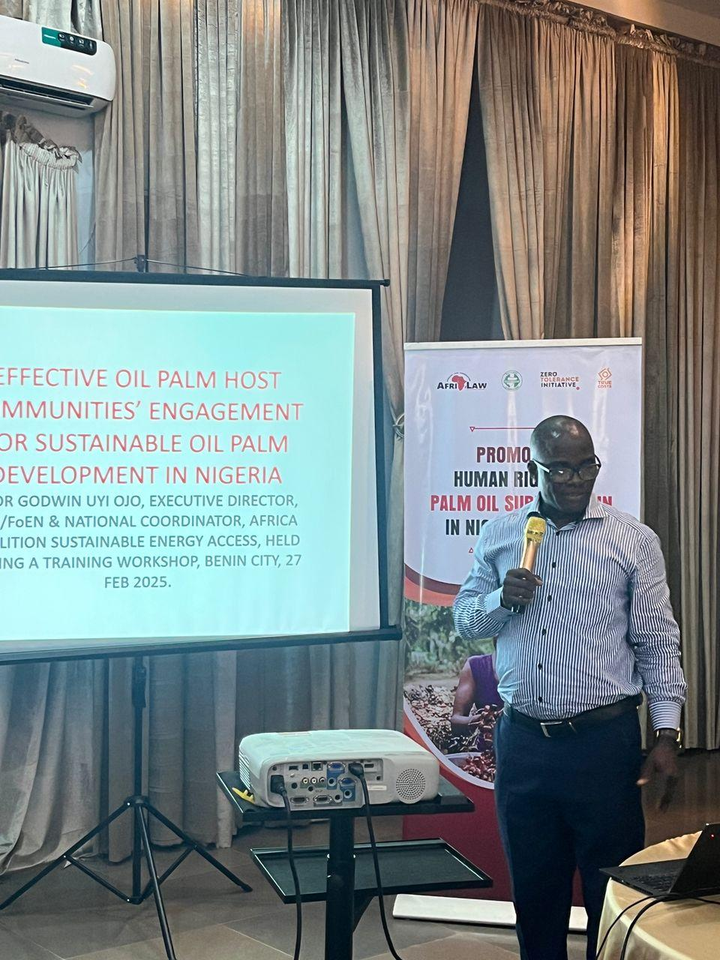
Prof. Iro Aghedo taking his presentation
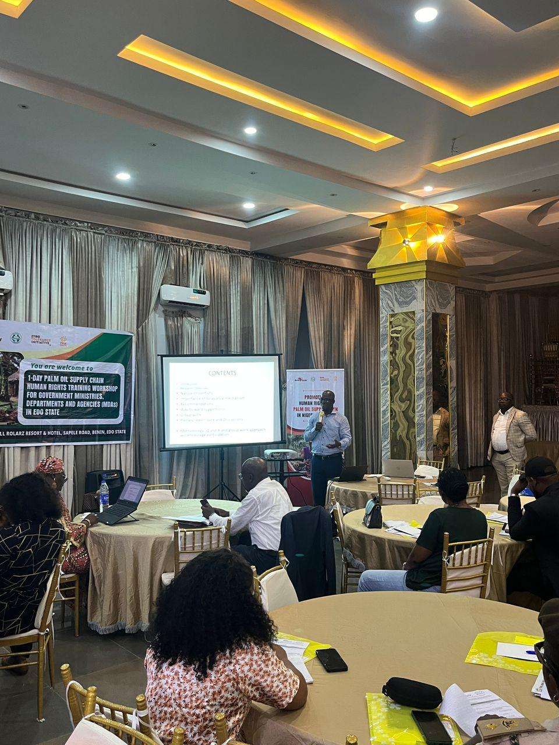
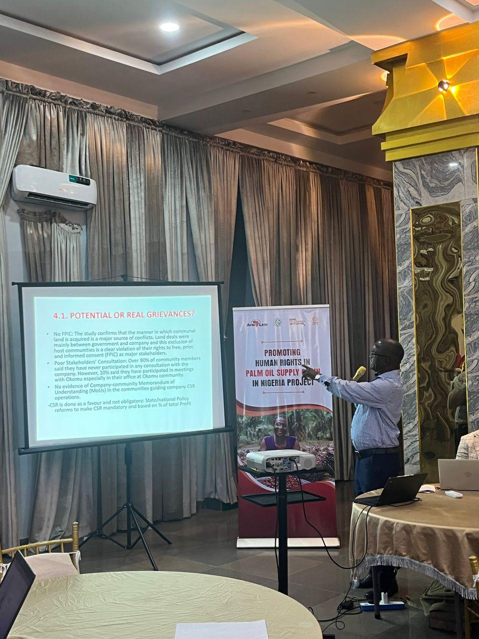
Cross-Session of participants
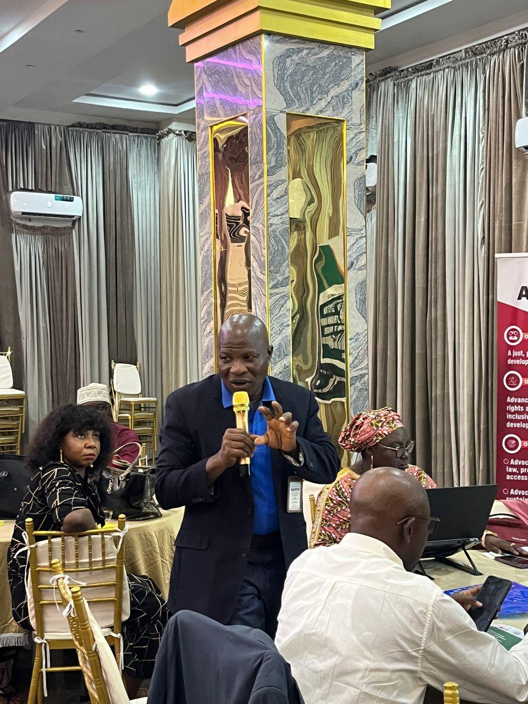
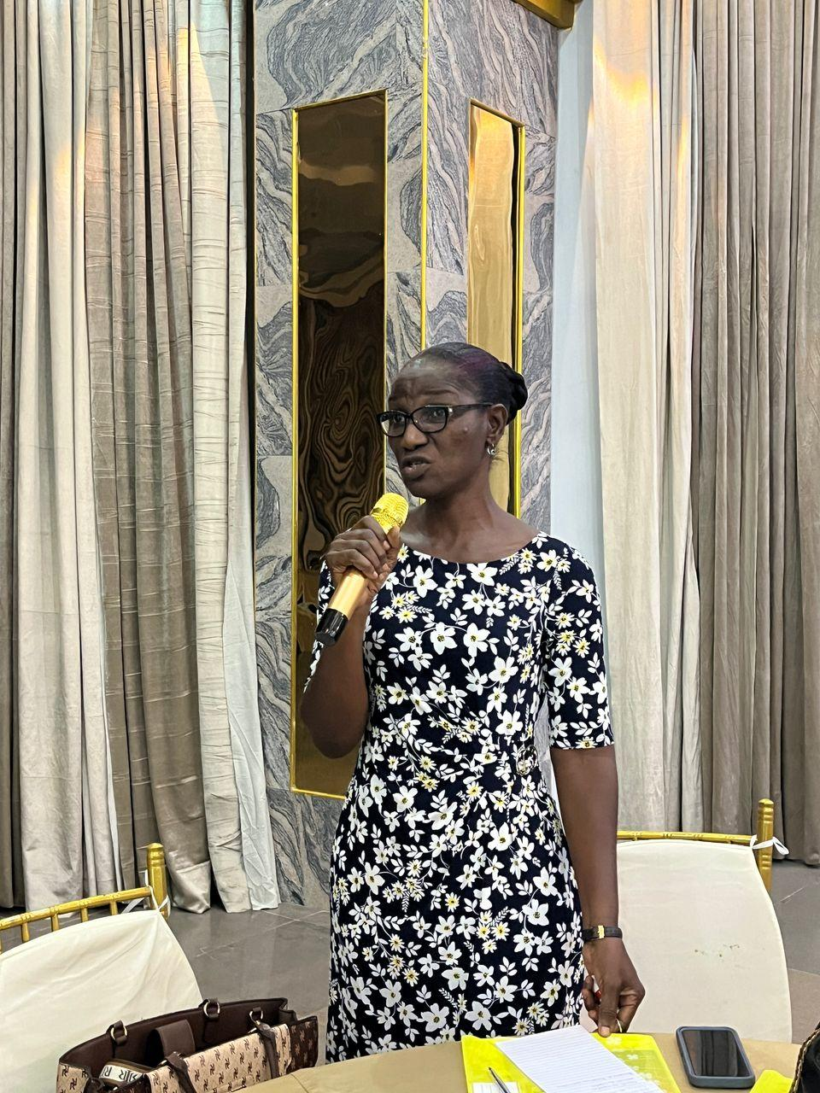
Participants asking questions and commenting after the presentation
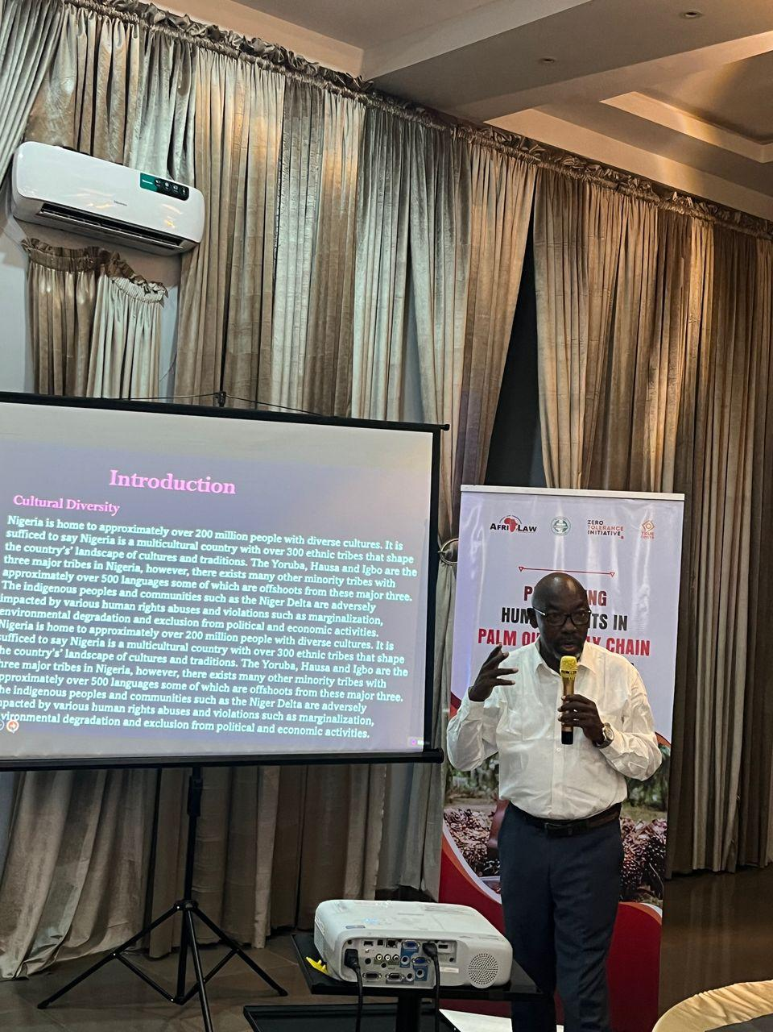
Mr. Dosumu taking his presentation
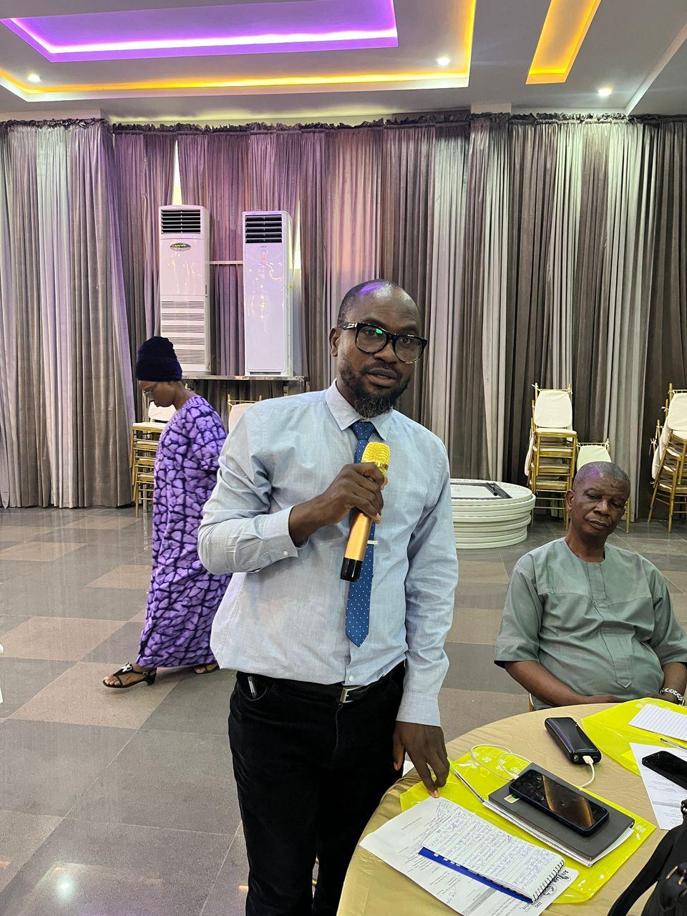
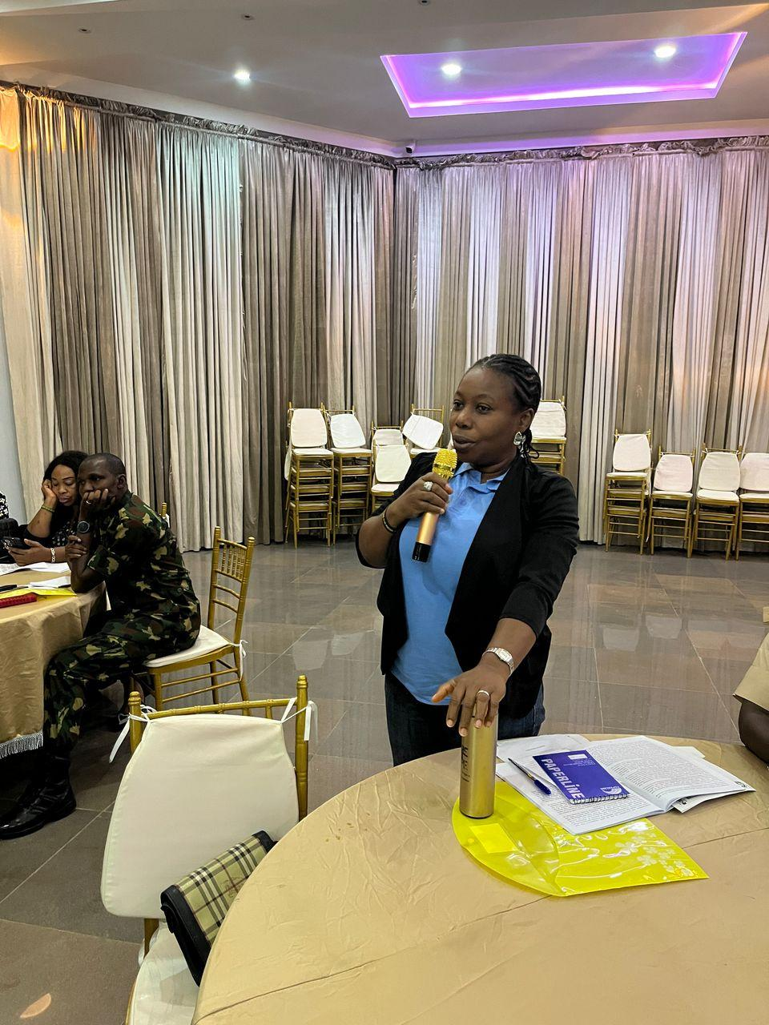
Participants asking questions and commenting after the presentation

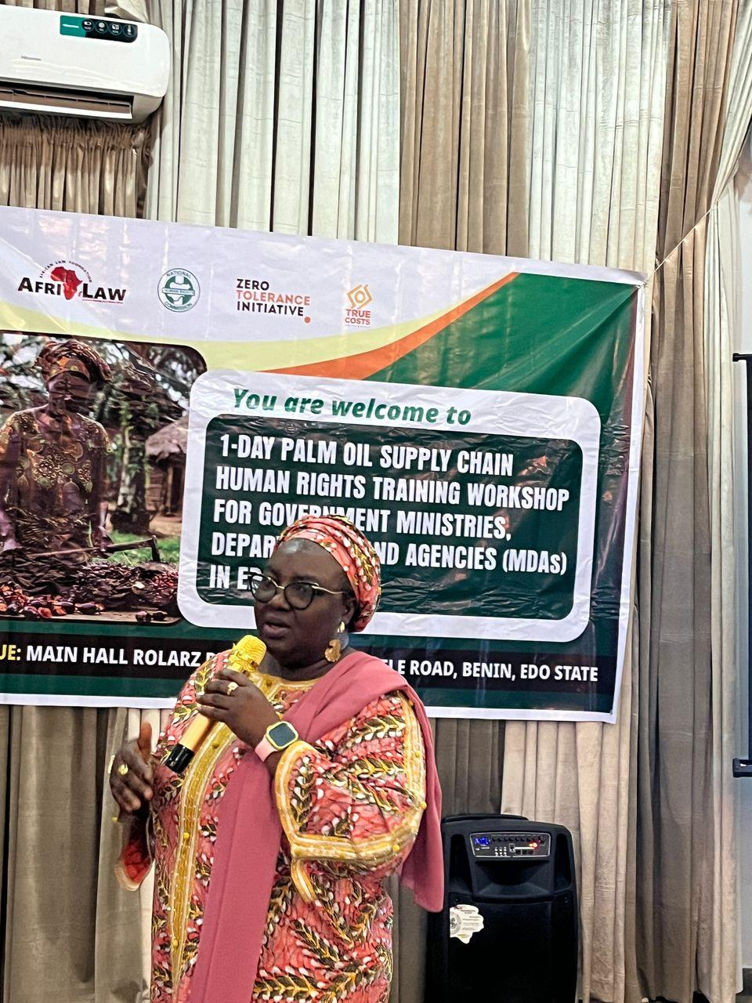
Mrs Mary taking her presentation
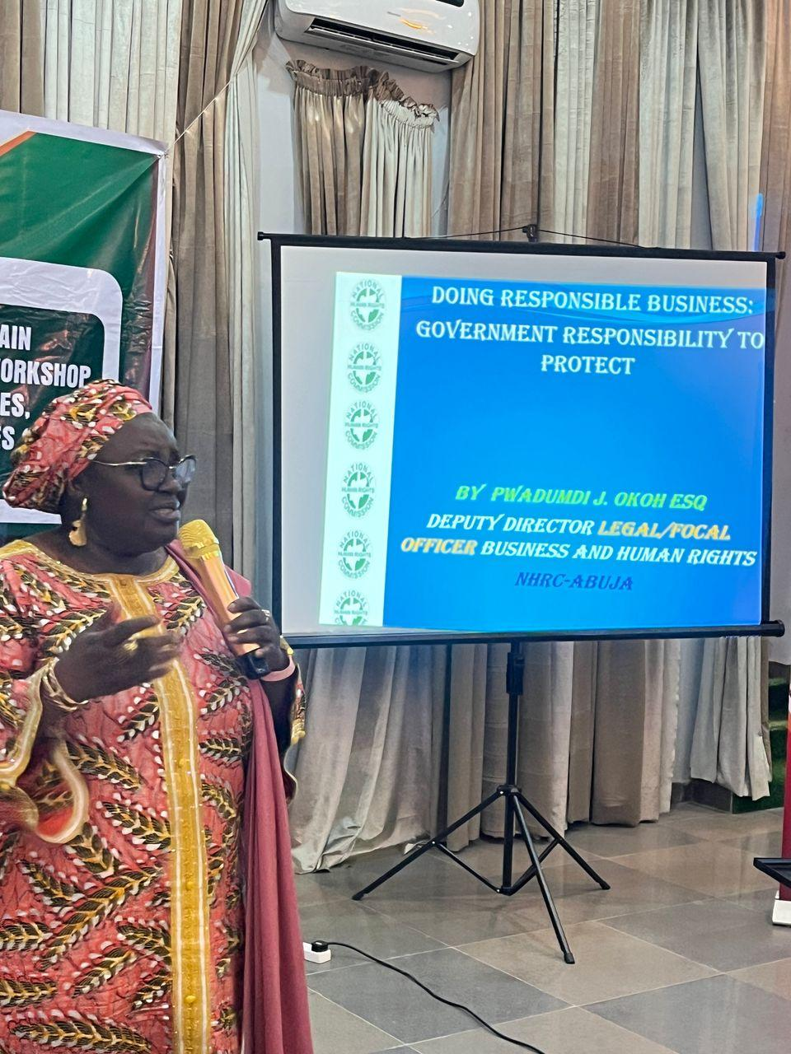
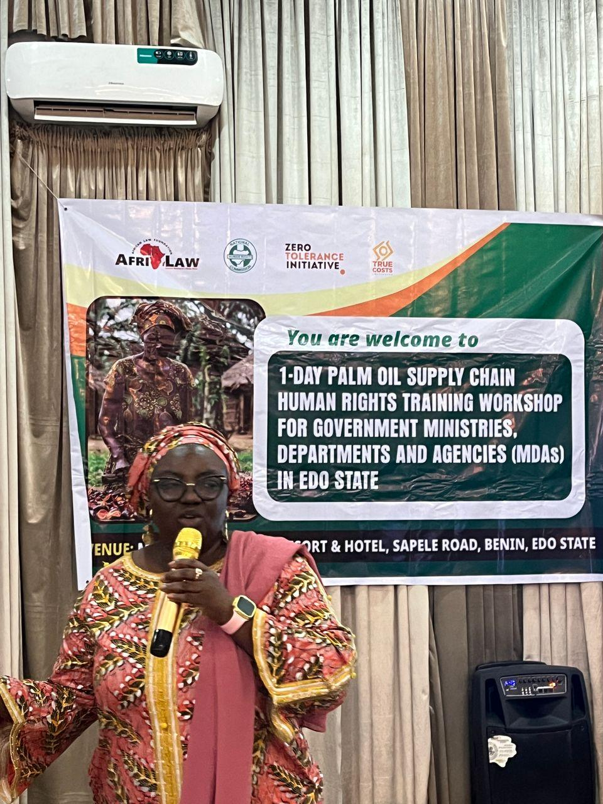
Cross-Session
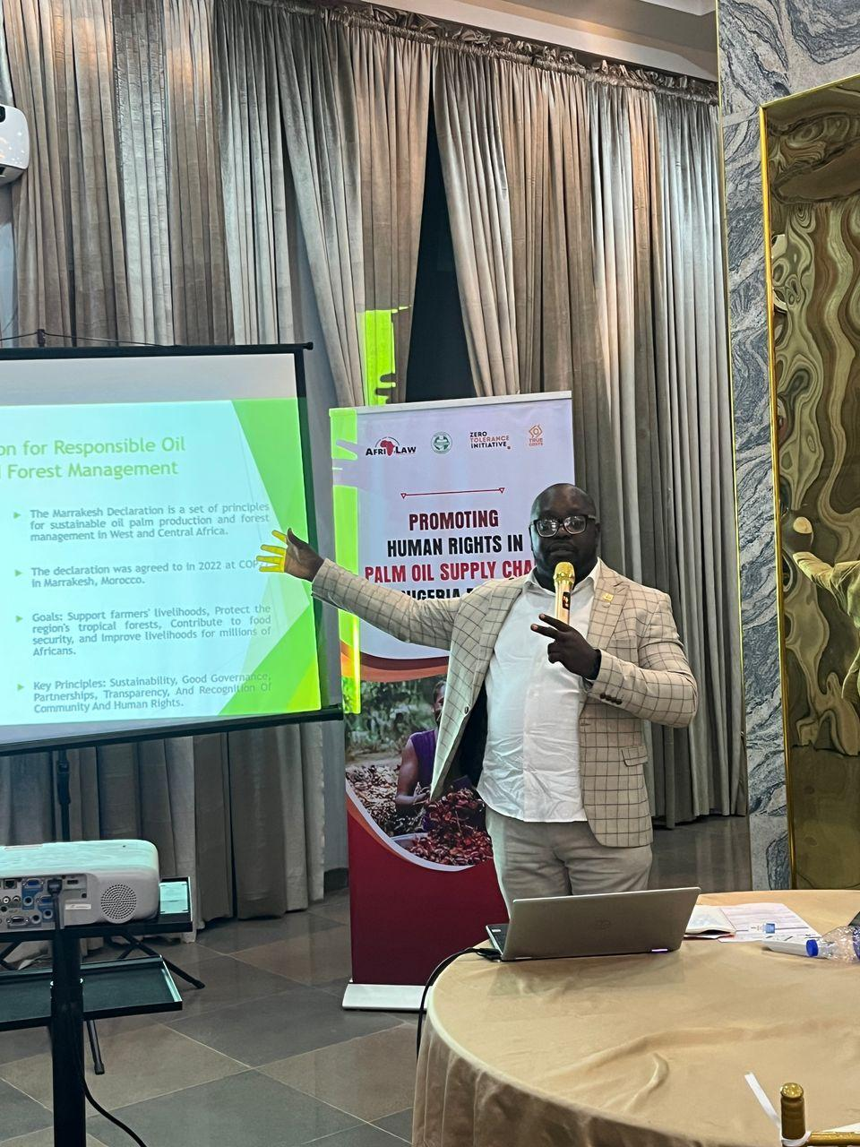
Barr. Chinwike taking his presentation
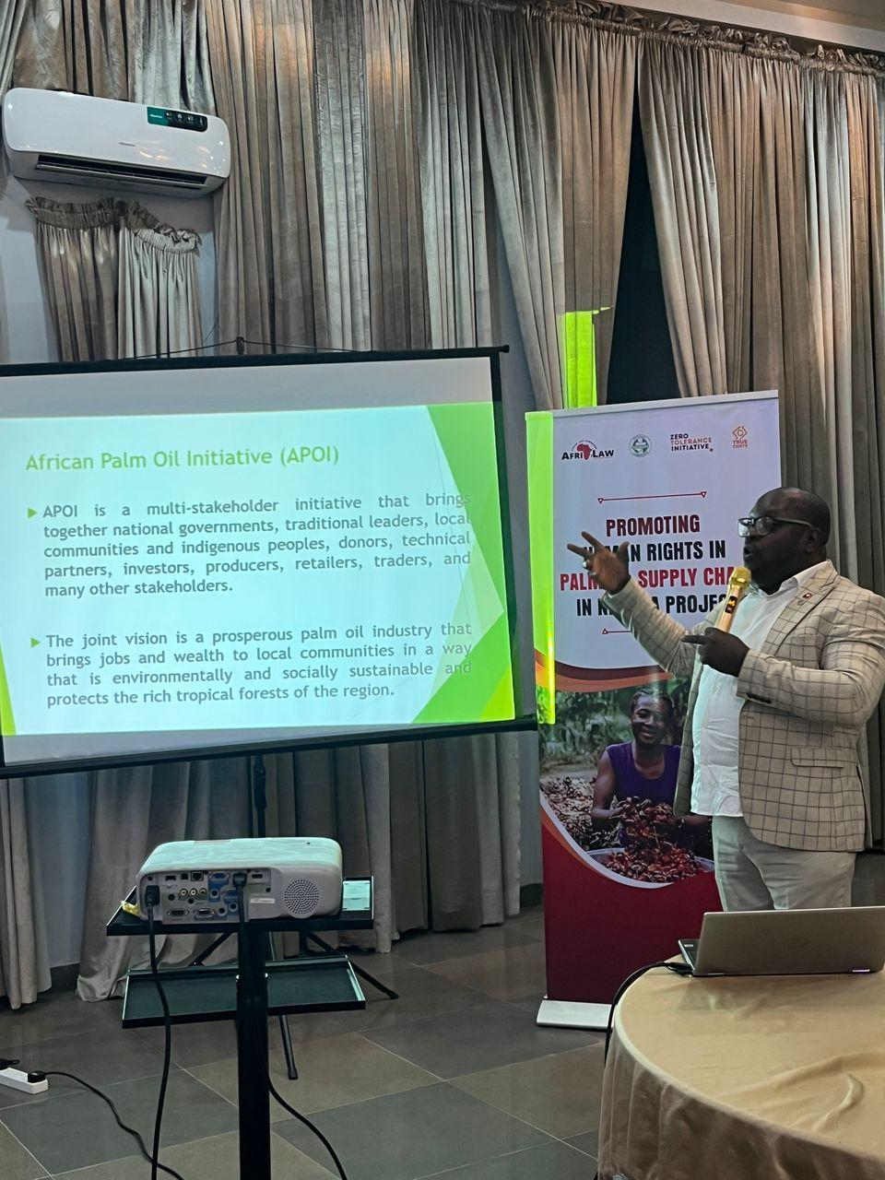
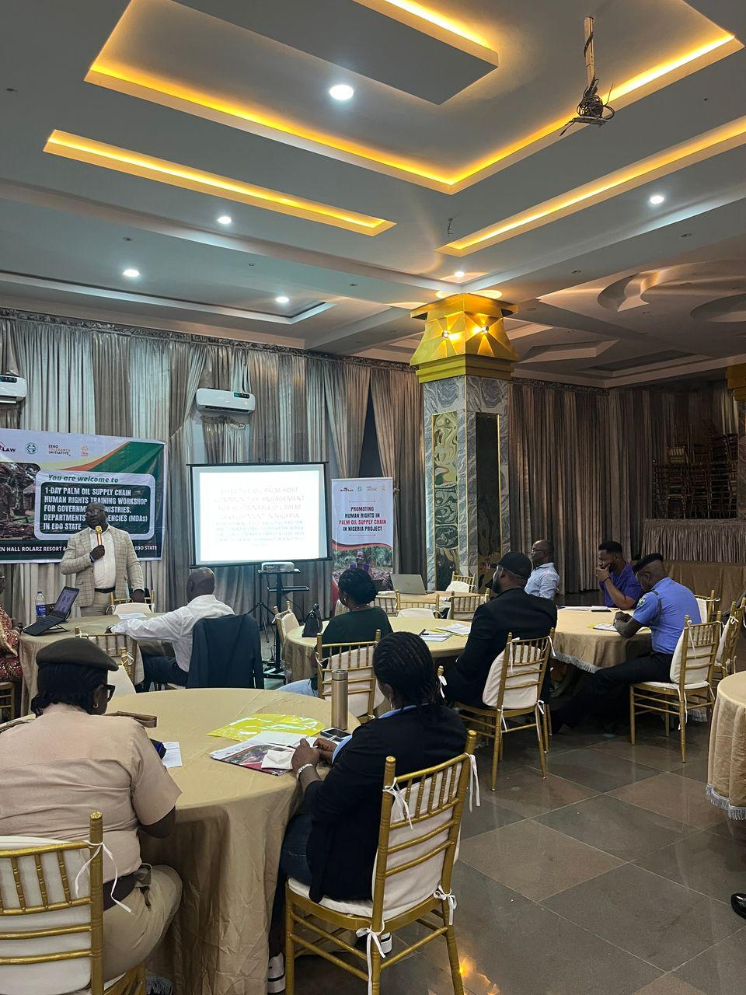
Cross-Session of participants
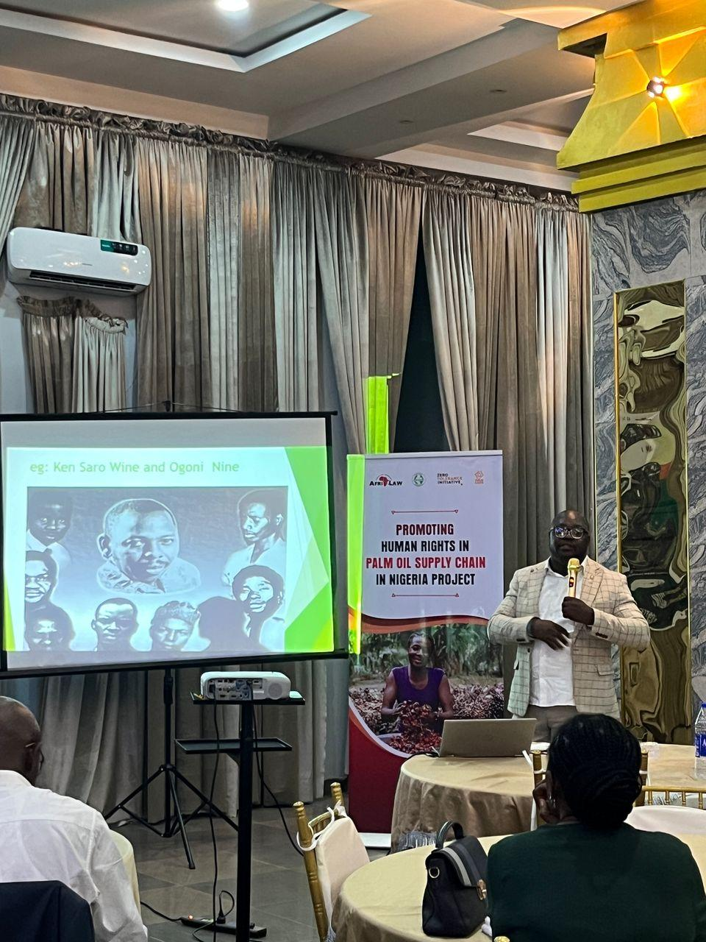
Cross-Session
- 1-DAY PALM OIL SUPPLY CHAIN HUMAN RIGHTS TRAINING WORKSHOP FOR CSOs AND MEDIA ORGANIZATIONS IN EDO STATE
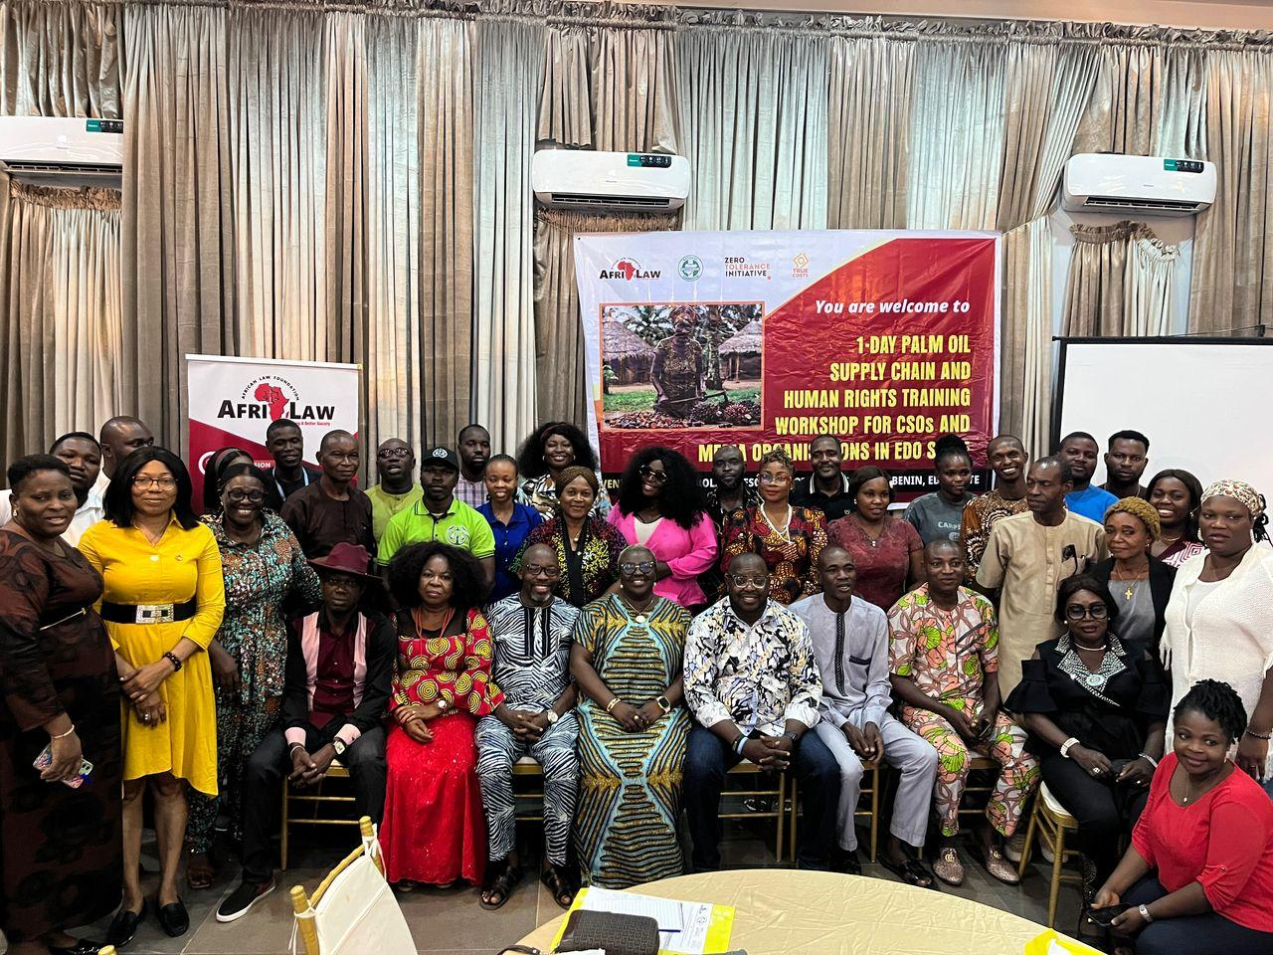
Group Photograph of participants
The 1-Day Palm Oil Supply Chain Human Rights Training Workshop for CSOs and Media Organizations in Edo State was held on Friday February 28, 2025 at Rolarz Resort & Hotel, Benin City, Edo State with about Forty-Five (45) participants in attendance. The participants comprised of CSOs from human rights and justice/community development/environment/forestry/conservation focused CSOs/NGOs/FBOs and Media Organizations.
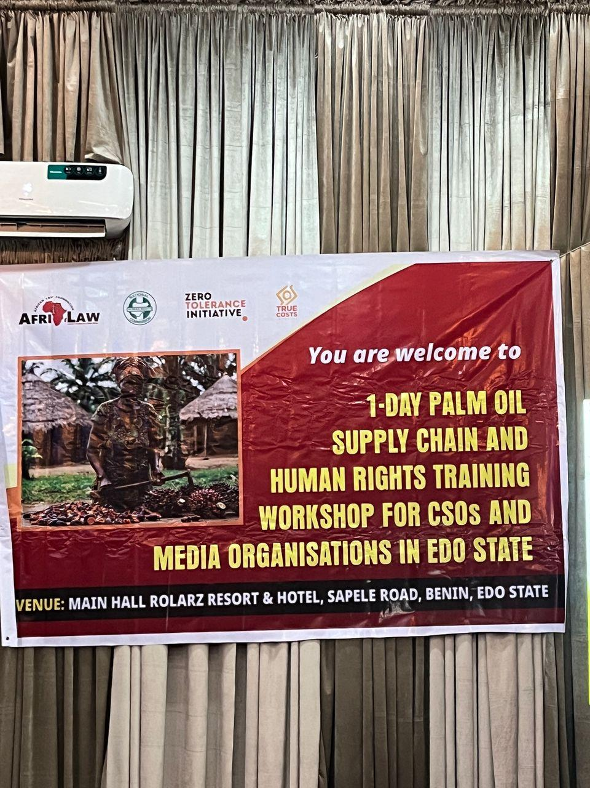
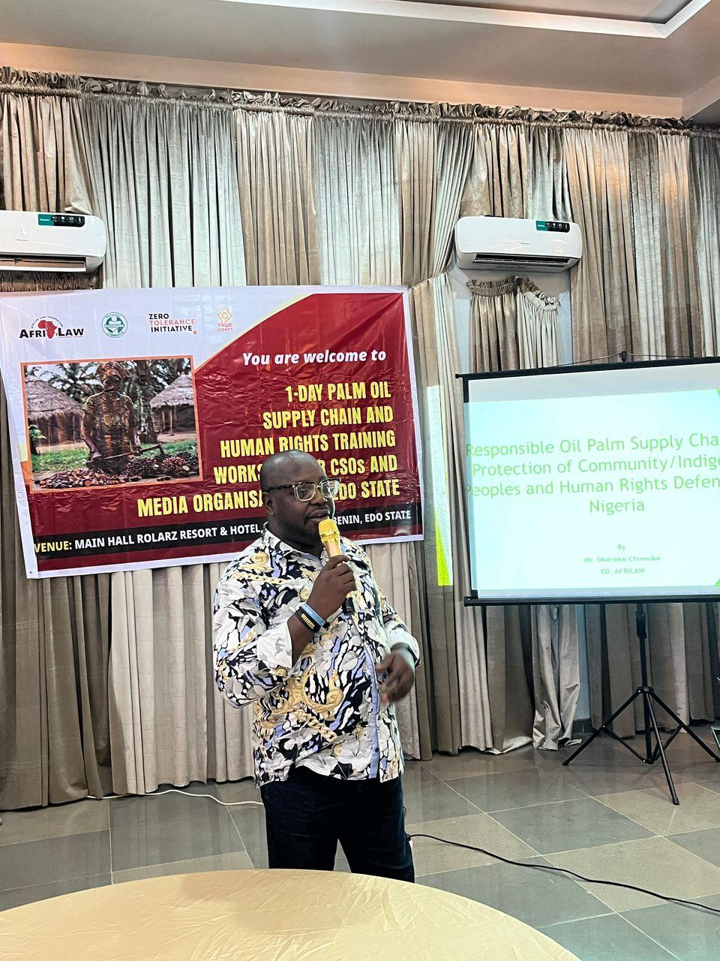
Barr. Chinwike taking his welcome remarks
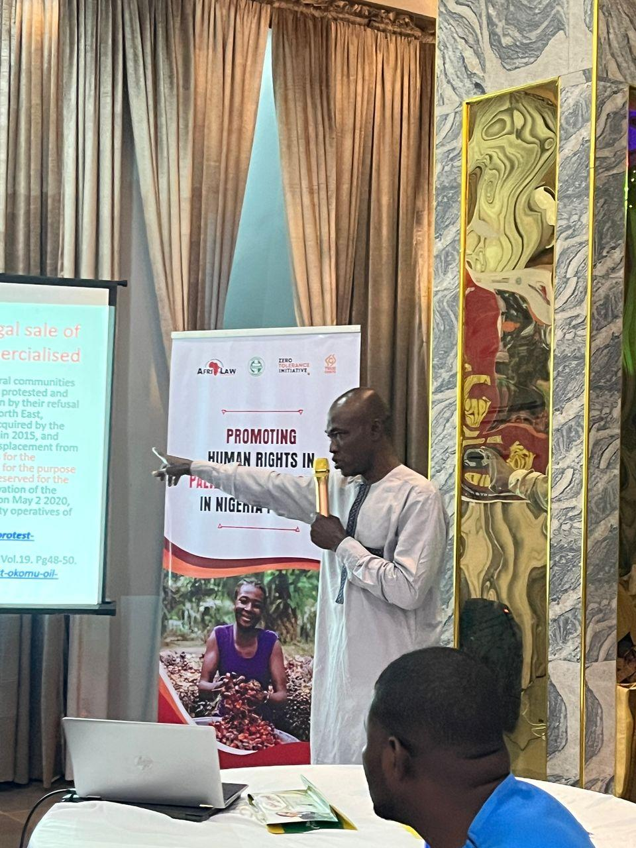
Prof Osumah taking his presentation
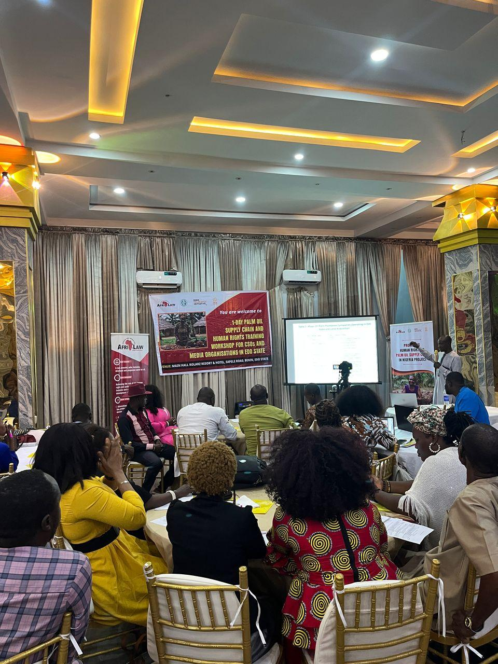
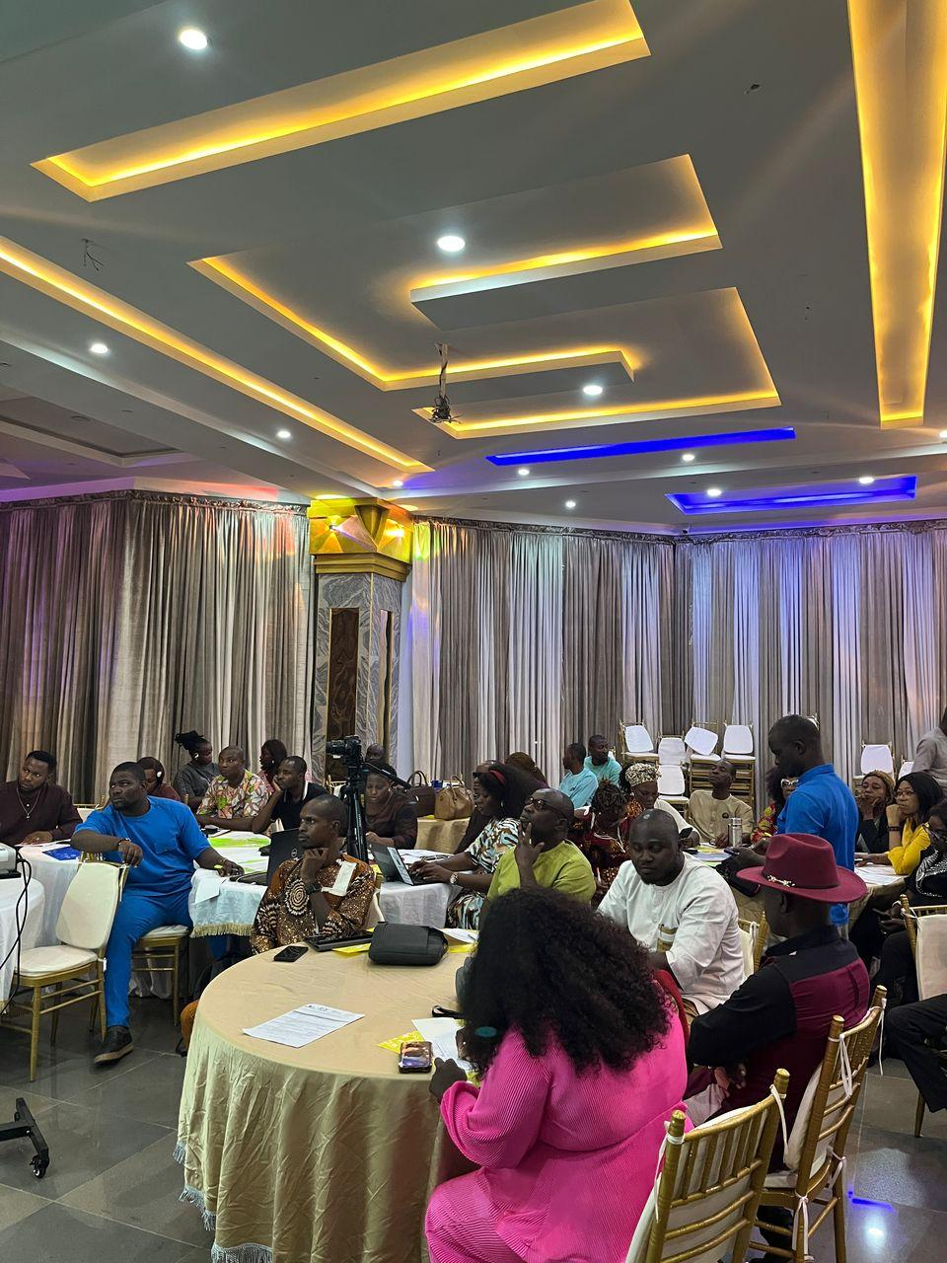
Cross-Session of participants
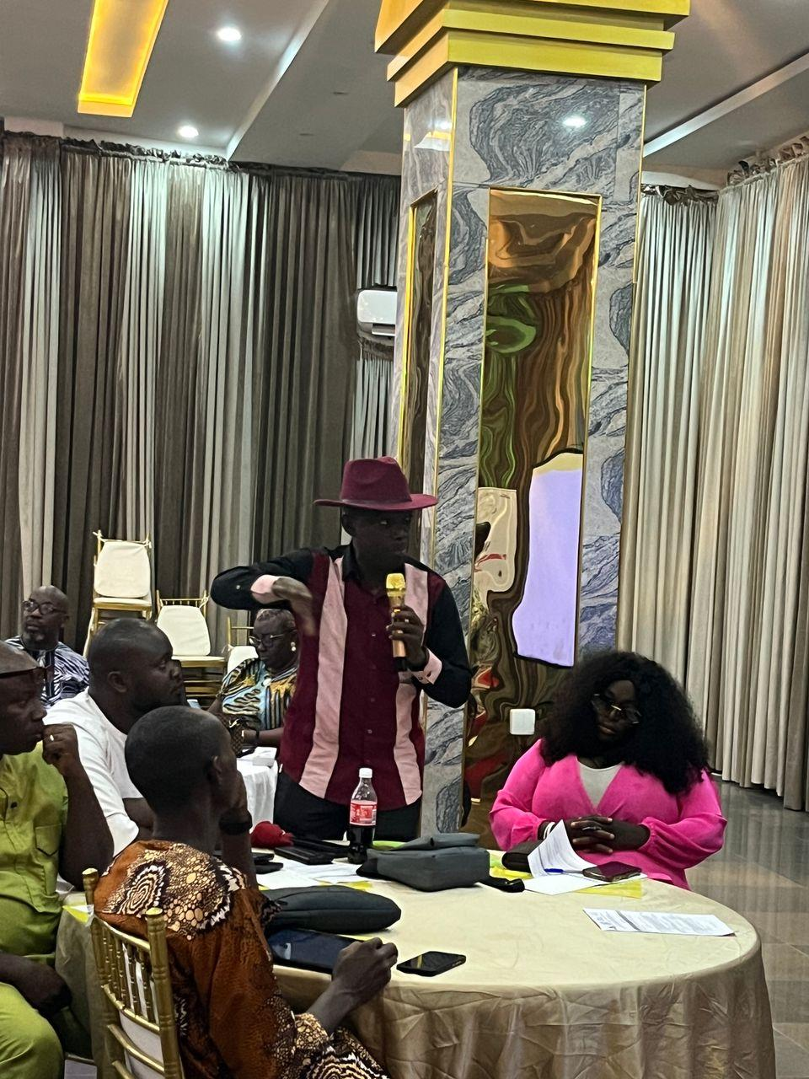
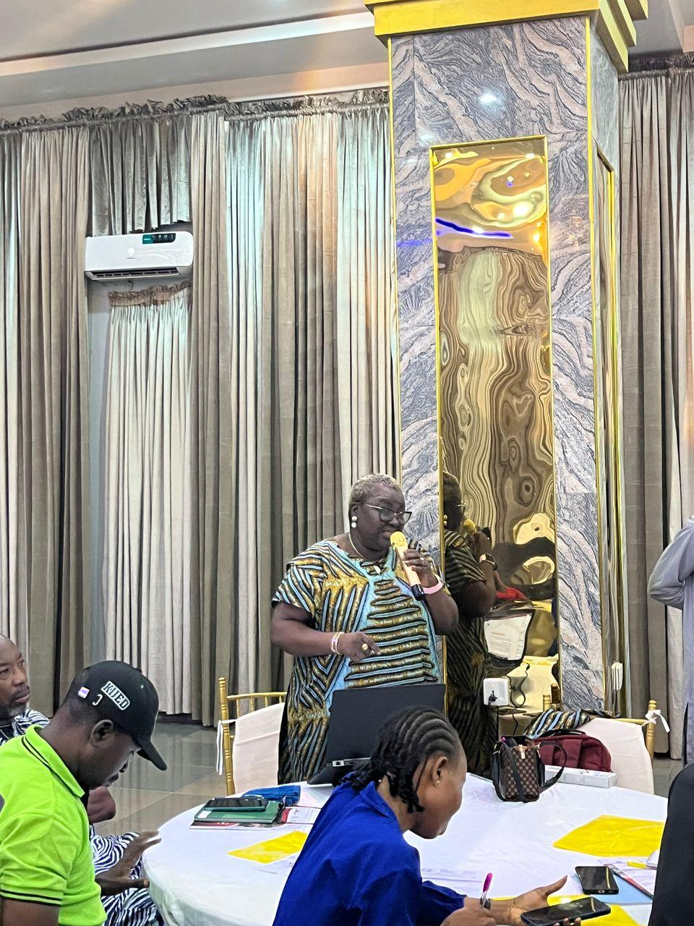
Participants asking questions and commenting after the presentation
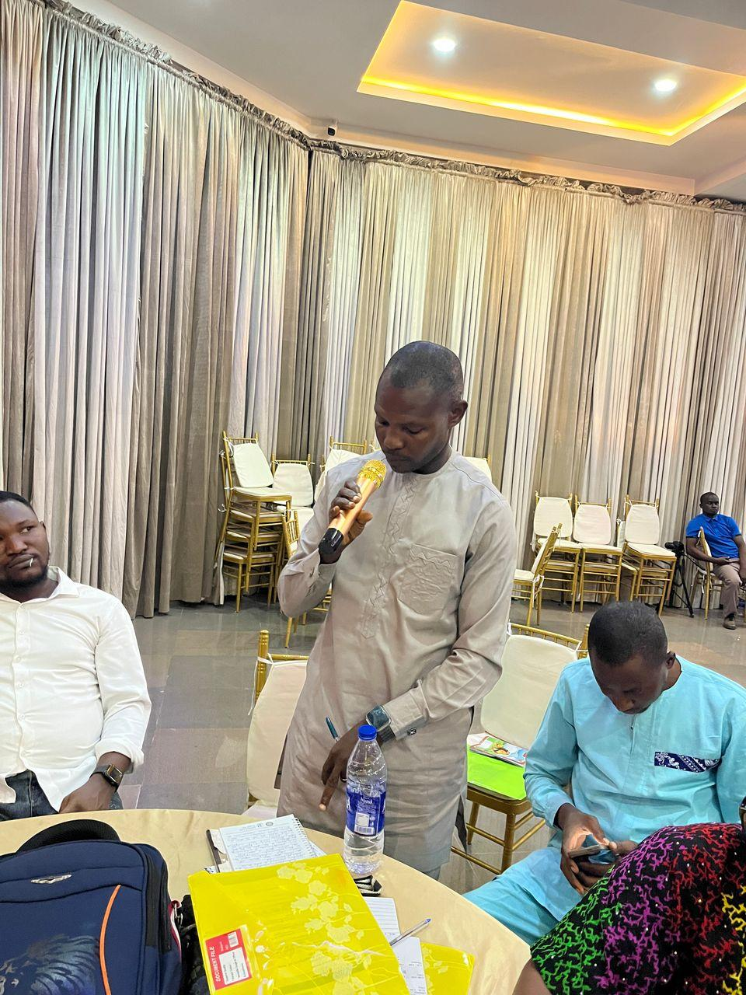
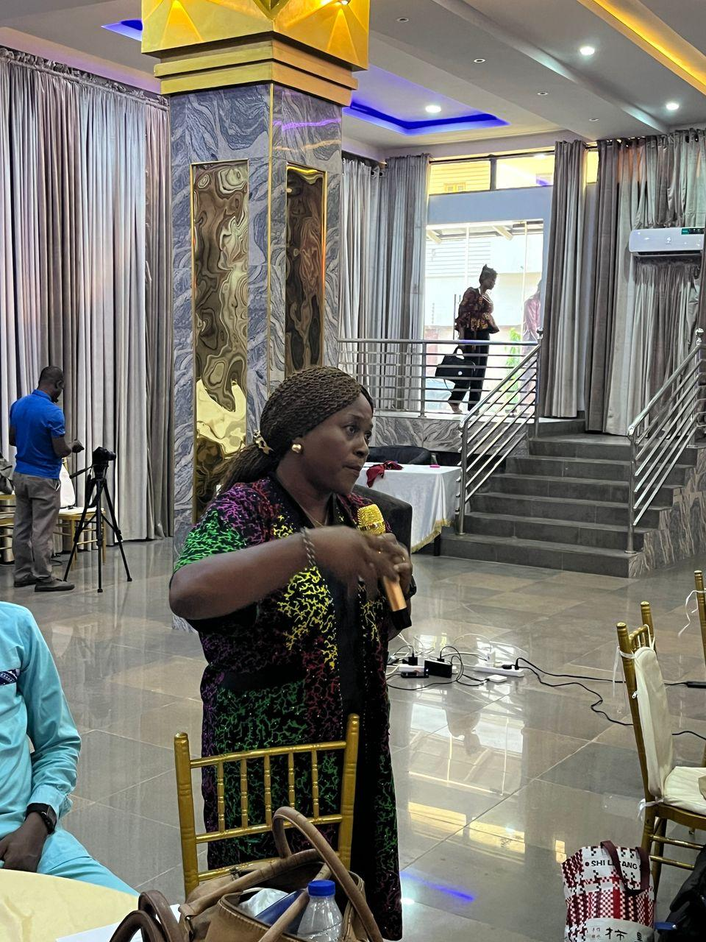

Participants asking questions and commenting after the presentation
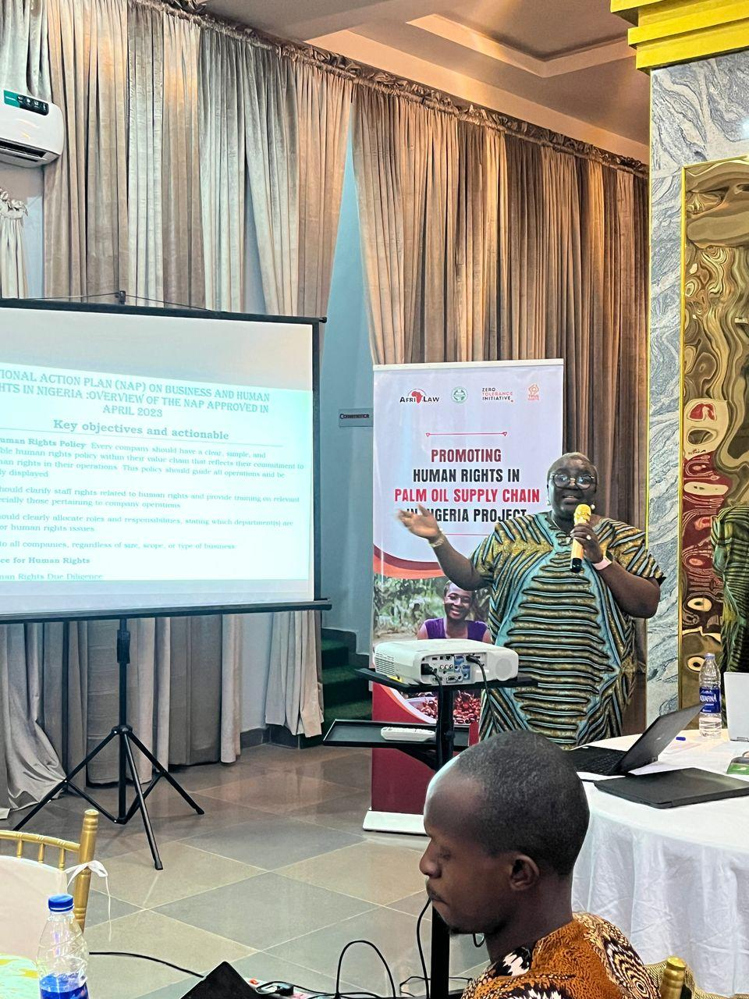
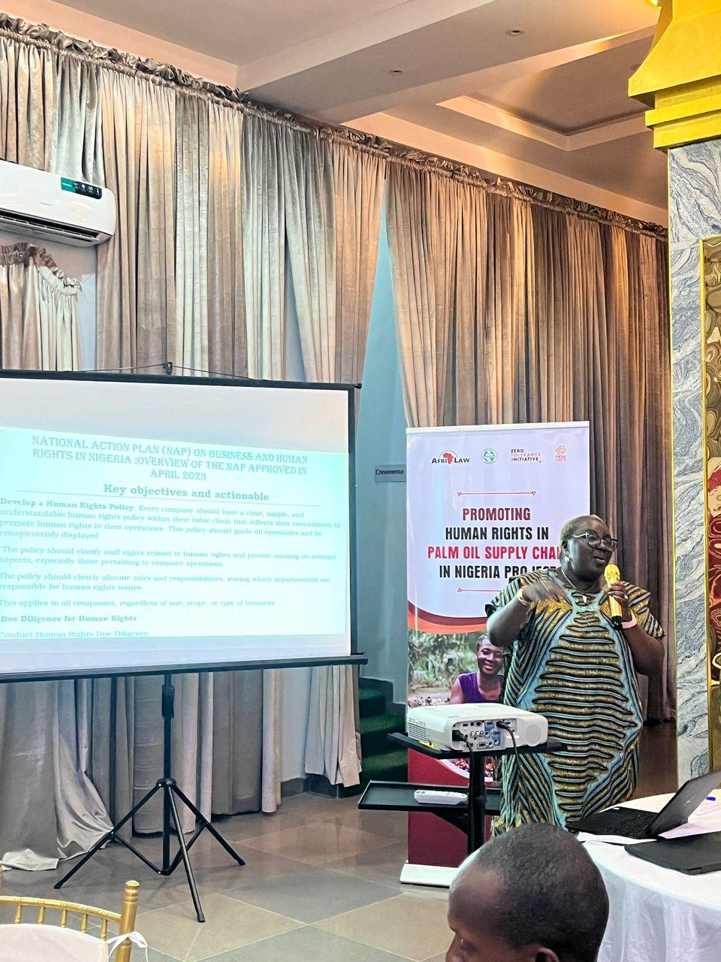
Mrs. Mary taking her presentation
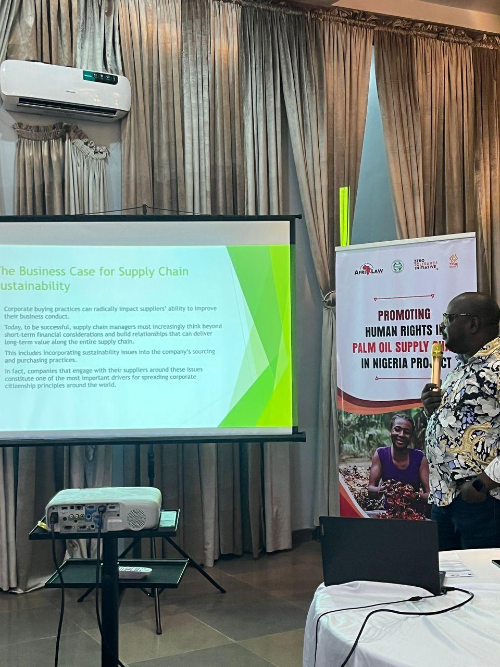
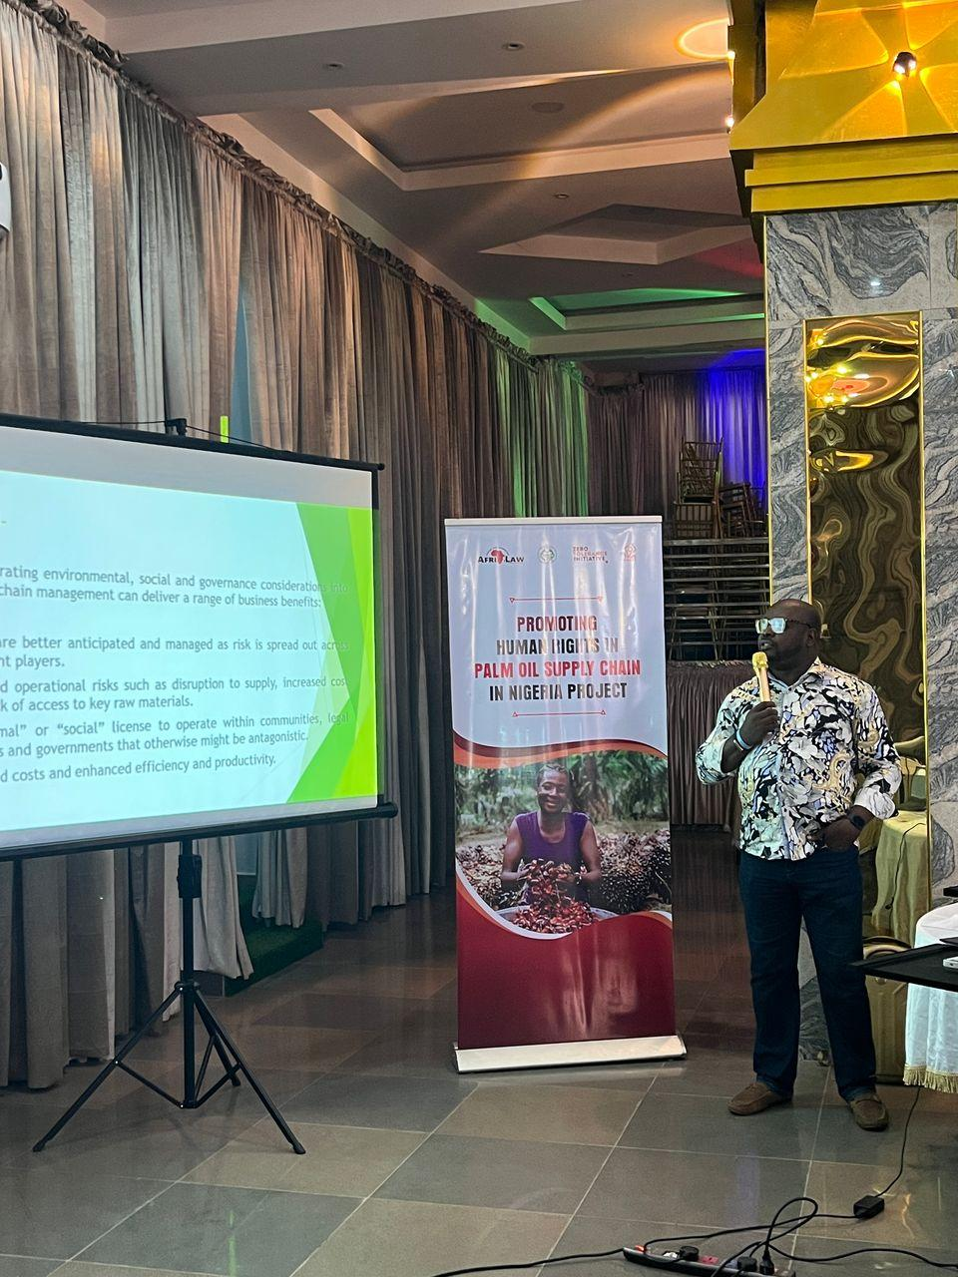
Barr. Chinwike taking his presentation

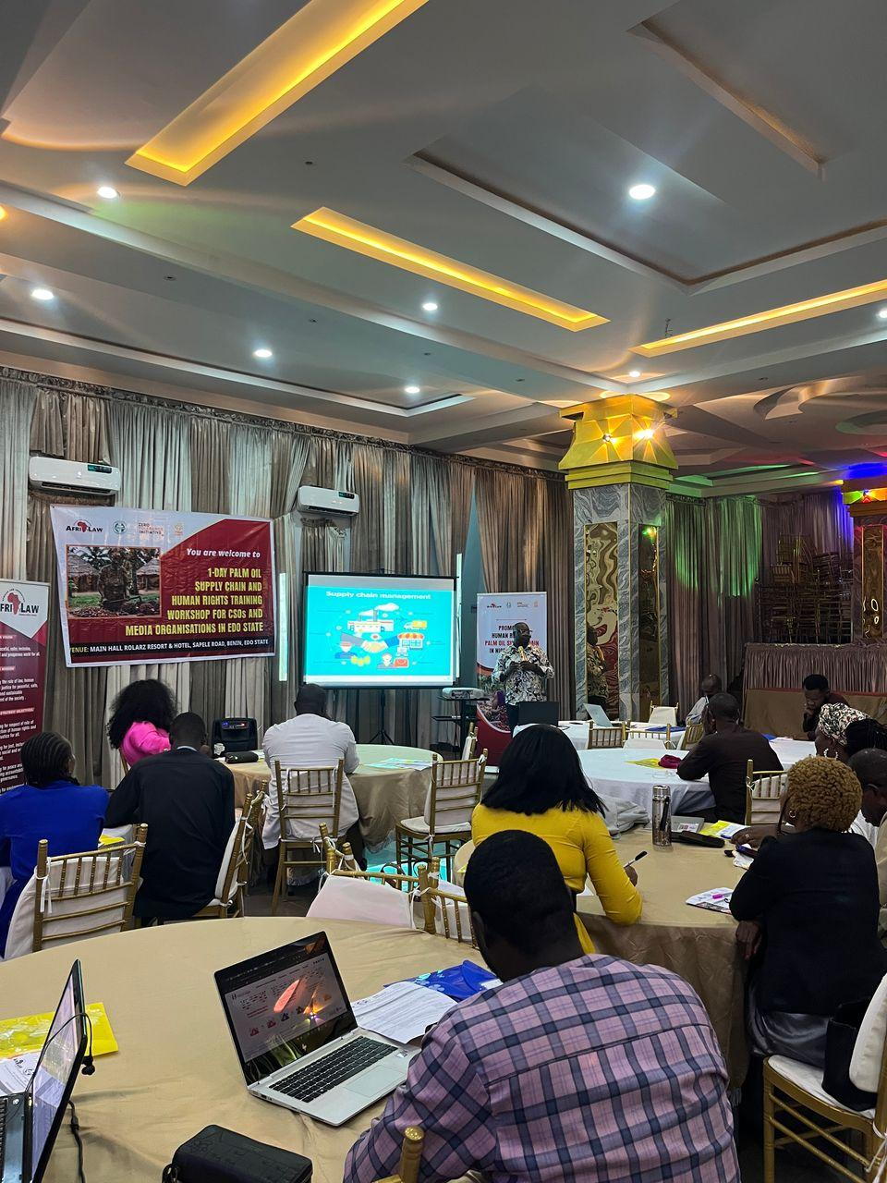
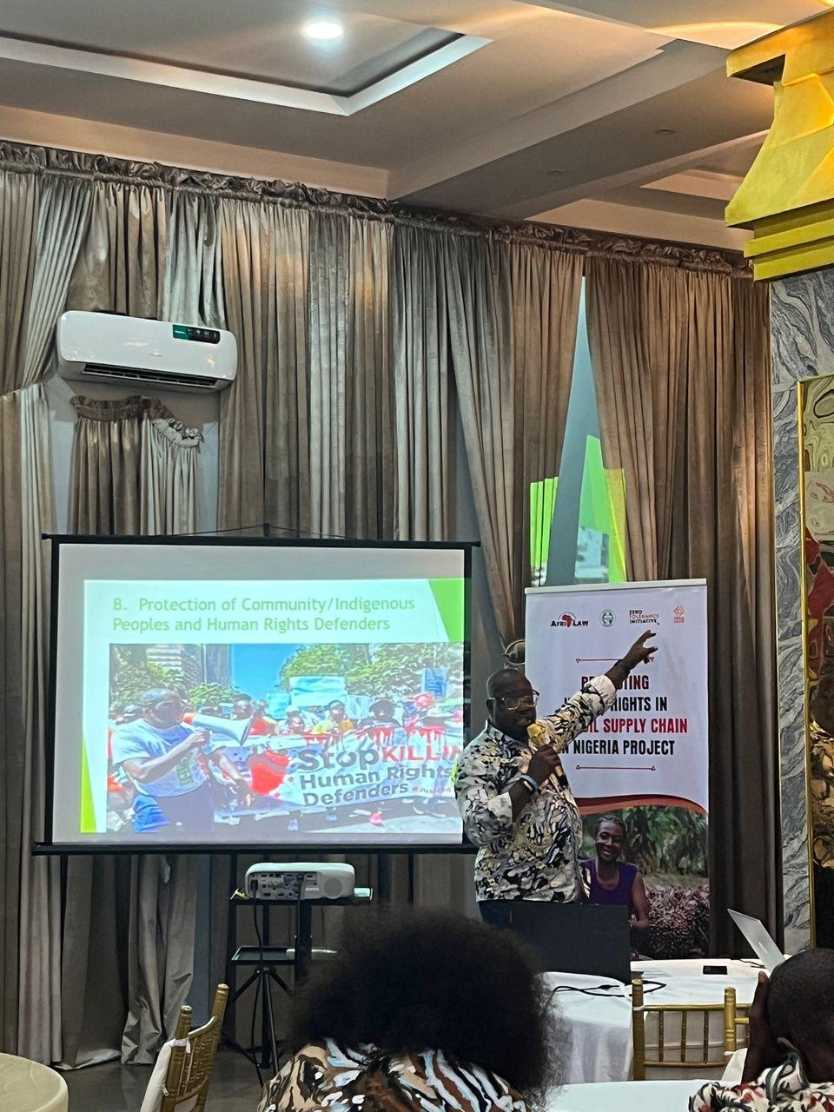
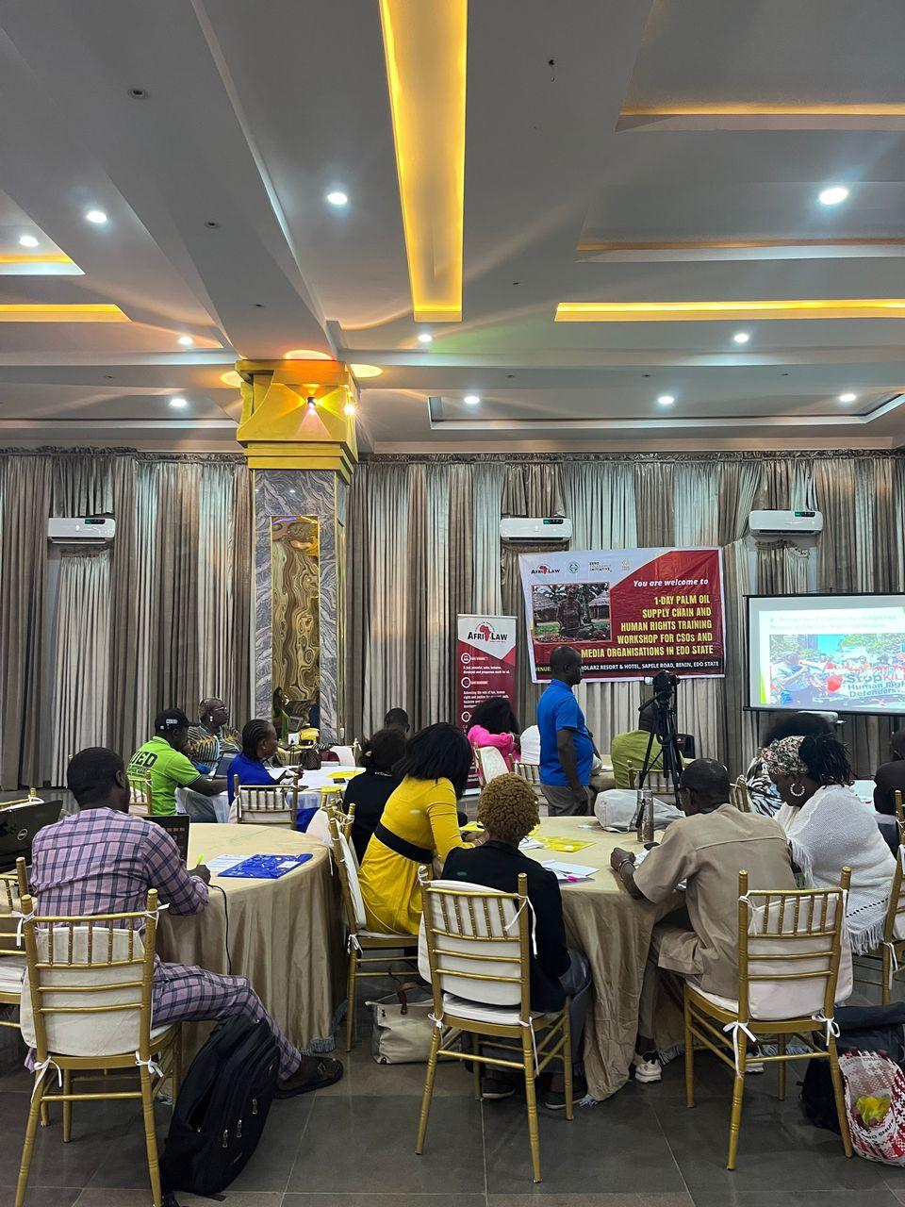
Cross-Session of participants
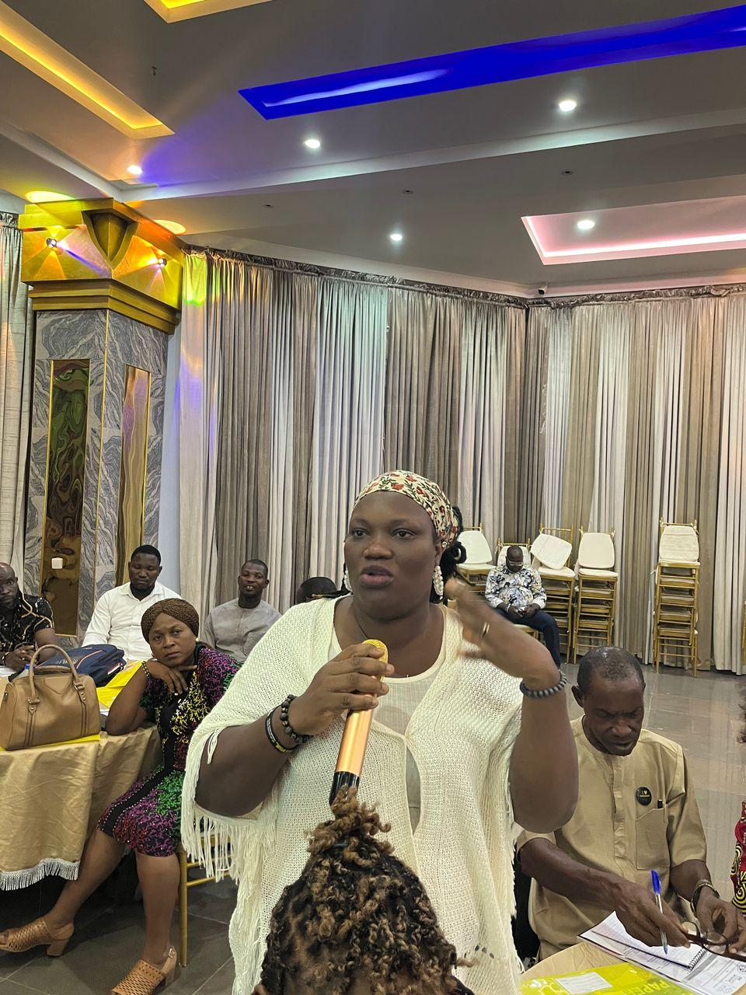
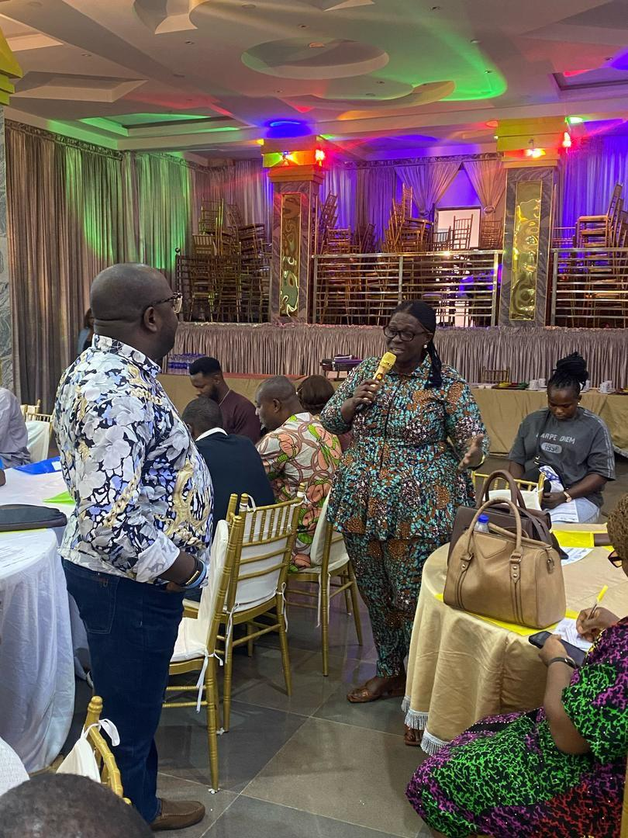
Participants asking questions and commenting after the presentation

