THE ENUGU STATE COMMUNITY WOMEN LAND RIGHTS FORUM 2020
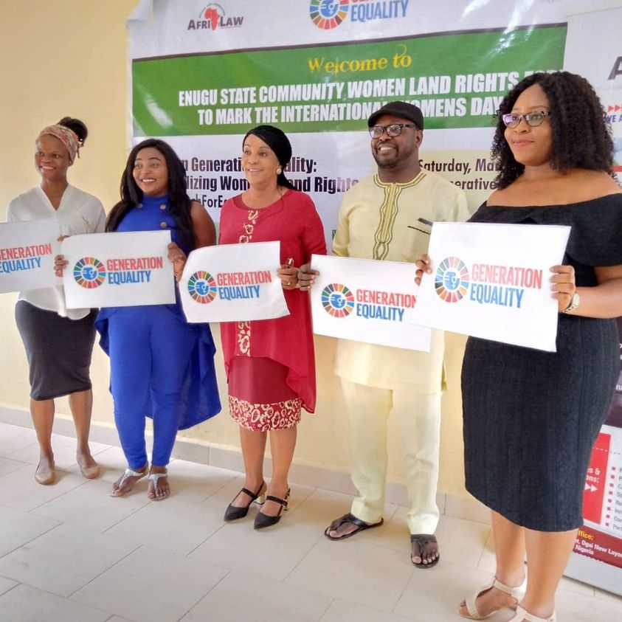

AFRILAW in partnership with the Network of Women in Agriculture (NWIA) organized the Enugu State Community Women Land Forum to commemorate the 2020 International Women’s Day. The project was done in collaboration with the Environmental Rights Action (ERA)/ Friends of the Earth Nigeria (FOEN) and International Land Coalition (ILC). The goal of the program was to strengthen women’s land rights and promote rural women’s access to use, control, own, inherit and dispose of their land and natural resources in Nigeria through gender awareness raising and community women mobilization.

- 1- Day Enugu State Community Women Land Forum:
The 1- Day Enugu State Community Women Land Forum for about 70 participants at the Cooperative College Hall, Enugu on Saturday March 7, 2020. The community women land forum saw the participation of women from Nigeria Women In Agriculture Network from different communities around Enugu, and also the Commissioner for lands and Rural Development of the Enugu State Government came around to and gave a goodwill remarks. The Training was facilitated by AFRILAW ED who gave presentations on Women Human Rights, Nigeria Land Law, Land Tenure Systems in Nigeria and Women’s Land Rights.

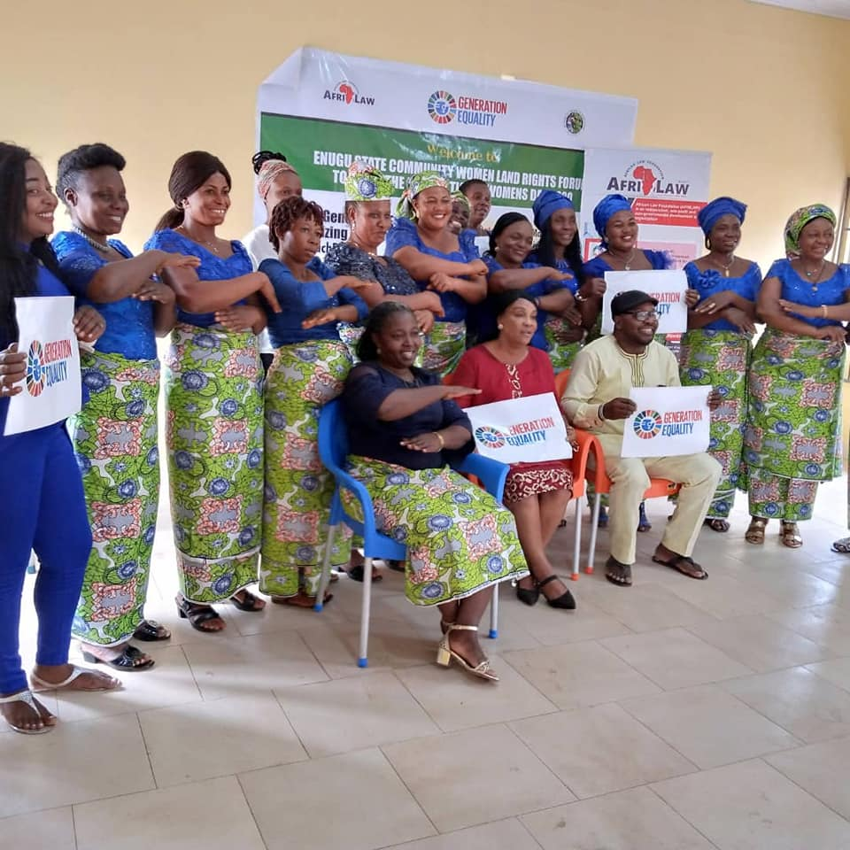
A group photograph of participants at the event

- Public Phone-In Radio Discussion on Women’s Land Rights in Nigeria
Also, as part of the programme to mark the 2020 International Women’s Day Celebration AFRILAW ED held a 60mins public phone-in radio discussion on women’s land rights in Nigeria at the Dream FM Radio Station, Enugu, Enugu State.

