STRENGTHENING PRIVATE SECURITY REGULATION AND
OVERSIGHT IN NIGERIA PROJECT
IMPLEMENTED BY AFRILAW
IN PARTNERSHIP WITH
GENEVA CENTRE FOR SECURITY SECTOR GOVERNANCE (DCAF) 2021

PROJECT OVERVIEW: AFRILAW in partnership with the Geneva Centre for Security Sector Governance (DCAF) in collaboration with the Private Security Governance Observatory and in partnership with the Nigeria Security and Civil Defense Corps (NSCDC) and the Association of Licensed Private Security Practitioners of Nigeria (ALPSPN) is implementing the “Strengthening Private Security Regulation and Oversight in Nigeria Project”. The Project commenced in August 2018, with a Baseline Study on Private Security Governance in Nigeria, which tried to get the true position of the private security situation in Nigeria. This study took place in August 2018 –June 2019. Springing from the finding of the study, in 2020 AFRILAW and its partners began to engage using a multi-stakeholder approach to strengthen the governance of private security industry.
IMPLEMENTED PROJECTS ACTIVITIES:
- CONFERENCE CALL AND TRAINING OF MEDIA REPRESENTATIVE
The Conference Call and Training for Media Representatives on the Relevance of International Best Practices in Nigeria: Media's Perspective organized by African Law Foundation (AFRILAW) and the DCAF was held on Wednesday June 23, 2021. The aim of the programme was to training (4) Media representatives selected to provide their own experiences and challenges into the draft tool to make sure that the tool also reflects the specific needs and challenges encountered by the media when dealing with private security actors and activities.
The Media Representatives selected for the training workshop include:
- Mr. Senator Iroegbu, Editor, The Global Sentinel (Online Media), Abuja/FCT (Representing North-Central Region)
- Mr. Samuel Luke, Editor, WikkiTimes and Correspondent, Daily Post (Online Media), Bauchi, Bauchi State (Representing North-East Region)
- Mr. Ignatius Okpara, Chief Correspondent- South East Region, Africa Examiner (US based Online Media), Enugu, Enugu State (Representing South-East Region)
- Mr. Kelechi Nwaucha, News Editor, Independent Monitor (Print Media), Port-Harcourt, Rivers State (Representing South- South Region)

BACKGROUND: In the framework of the project “Strengthening Private Security Regulation and Oversight in Nigeria”, a series of six Private Security Governance Forum, one in each regions of Nigeria, were organised by AFRILAW and DCAF, in collaboration with the Private Security Governance Observatory and in partnership with the Nigeria Security and Civil Defense Corps (NSCDC) and the Association of Licensed Private Security Practitioners of Nigeria (ALPSPN). During those Forums, six local experts were recruited, representing each of Nigeria’s six regions, to compile and crystallize the local discussion and to bring it at the national level. The testimonies of the local experts were presented in Abuja during a roundtable on the Montreux Document and the International Code of Conduct. The aim of the discussion was to encourage Nigerian government membership in the two initiatives, and the champions illustrated with their perspective the need for better monitoring of PSC and how the initiatives could help.
The compiled local discussions has been factored into the draft tool guide being produced by DCAF. However, there is need to incorporate Media perspective in the tool. For this reason (4) Media representatives was selected to provide their own experiences and challenges into the tool to make sure that the tool also reflects the specific needs and challenges encountered by the media when dealing with private security actors and activities. The meeting brings together the selected media representatives to enlighten them on their roles and responsibilities on the project with relation to the tool.
The programme was coordinated by Ms. Emmylou, and she stated by explaining the purpose of the programme and appreciating the Media Representative for their interest and accepting to participate in the project work. Also, there was a brief introduction of DCAF and summary of their global project activities in advancing and promoting good governance of the private security industry.
Thereafter, there was a general introduction of the Media representatives and the media organizations they work with.
Brief Summary of The Observatory and Its Activity in Nigeria: DCAF Project Officer, Ms. Emmylou, started the session by introducing the Private Security Observatory in Nigeria as a network of African Civil Society Organizations that seeks to share knowledge and reinforce their organizational capacity to promote good governance of the private security sector. She said that Civil Society Organizations play a large role towards the respect for human Rights in any Sector. However, the lack of information on the private security industry, the absence of adequate mechanisms to monitor their activities as well as weak national policy frameworks are factors that may limit the engagement of CSOs in the Private Sector in Nigeria. The Observatory however fosters the exchange of ideas, experiences, information and good practices. According to her, it provides tailor-made tools to support the role of CSOs in improving the oversight and accountability of the private security sector. She said the observatory was initiated in 2014 and has grown since then as a result of the interest and commitment of its members.
There was overview of DCAF project in Nigeria in partnership with AFRILAW which started in 2018 with the baseline study on private security in Nigeria. Their findings from the baseline study led to the private security forum in the six geo-political zones of Nigeria. The forums were organized to look at the challenges facing the private security industry in Nigeria and to x-ray the opportunities therein from a multi-stakeholder lens. The project he said insists on a stakeholder perspective to approaching the issues relating to private security regulation and oversight in Nigeria.
INTRODUCTION OF THE TOOL: PRESENTATION OF THE DRC ORIGINAL PROJECT & APPLICATION IN NIGERIA
There was a brief introduction of the development process and launch of a similar draft tool in in the Democratic Republic of Congo (DRC) and its application to Nigeria. There was highlights on results and impacts of the Private Security Toolkit They stated that in Congo, DCAF, ICoCA and observatoire d’Etudes et d’Appui a la Responsabilite Social et Environmentale, worked together over a period of 15 months to develop a similar toolkit as is proposed to be produced in Nigeria. The tool provides an overview of international norms and standards applying to private security and includes good practices and additional elements to consider when integrating a private security focus in larger human rights promotion and protection work. 13 CSOs based in 10 different provinces in the Democratic Republic of Congo supported the conceptualization of the tool by compiling information on their respective provinces and validating their findings during multi-stakeholder workshops.
CSOs and local regulatory authorities were introduced to the tool and they provided feedback. The tool was also tested by three monitoring expert organizations.
They said that this same application is what is sought in Nigeria however with a country specific approach. According to them, the Nigerian situation is similar to the DRC situation in that the highlighted challenges are cross-cutting. Some of the challenges highlighted were: dire working conditions, poor selecting and vetting, lack of information, poor training, lack of respect for international standards and national law etc.
They concluded by expressing hope that the success recorded in the Democratic Republic of Congo would also be recorded here.
Concrete Mandate: Overview of The Tool and Question: Ms. Emmylou Boddi then gave an overview and present the outline of the draft tool and the questionnaire with which to provide input to the tool. The questionnaire required needed input on the following areas: the use of force; to procurement of personnel; to welfare of employees; mechanisms of redress where an abuse has occurred; channels for reporting such abuses etc.
The tool provides guidance to civil society organisations (CSOs) and media on international best practices. It provides updated information on the various challenges linked with PSCS and PMSCS activities in Nigeria, with detailed overview for each of the six geographical regions of the country. To ensure that the publication will be updated, accurate and useful, they would like to benefit from the comments and inputs of the media representatives before its finalisation. She said that the mandate of the media with respect to the tool is to provide a perspective on the tool. She took them through the expectations and the draft tool questionnaire. She also said that the following deliverables are required from the media representatives:
- Fill in the Draft Tool Questionnaire, drawing on your experiences as media personnel within 1 to 2 weeks maximum starting from Monday June 25 to July 9th, 2021.
- Be available for additional clarification and revise the final version of the tool.
- Participate in Media Draft Tool Review Virtual Workshop to be held on Friday September 17th at 10.00 AM via the Zoom platform.
After the overview of the draft tool and questionnaires, Ms. Emmylou then opened the floor for questions and clarification. Emmylou responded to some questions from the media representatives as it relates to their research works and what they need to do. Three out of the four selected media representatives was present at the meeting, and Mr. Ignatius Okpala could not make it due to poor internet connection. AFRILAW ED was mandated to give a private training and update to Mr, Ignatius and this was done. The meeting ended at about 12:00pm.

- CIVIL SOCIETY ORGANIZATIONS DRAFT TOOL REVIEW VIRTUAL WORKSHOP
The Civil Society Draft Tool Review Virtual Workshop on Private Security Governance Challenges and The Relevance of International Best Practices: A Practical Guide for Civil Society and Media organised by AFRILAW and DCAF was held on Wednesday September 8, 2021. About 35 CSOs participated in the Virtual Workshop held through the Zoom Platform.
The aim of the Virtual Workshop was to bring together Nigerian civil society organisations to gather their feedback on the draft tool: “Private security governance challenges and the relevance of international best practices - A PRACTICAL GUIDE FOR CIVIL SOCIETY AND MEDIA”, to ensure that this new publication will be updated, accurate and useful. Moreover, the soft copy of the Draft Tool was earlier sent to the CSOs for review toward the event. The Meeting started at about 10:15am WAT after the host i.e. Geneva Centre for Security Sector Governance launched the zoom platform.
Summary of the Project “Strengthening Private Security Governance In Nigeria” Recap of How The Tool’s Content was Drafted: AFRILAW ED, Barr. Chinwike Okereke opened the program by welcoming everyone. He spoke briefly about the objectives of the program and encouraged everyone to contribute as much as possible. He then went ahead to speak of the project “strengthening private security regulation and oversight in Nigeria” in details, from 2018 till date. He said that in the course of the project a series of private security governance forums were held in the six regions of Nigeria. In each of the events a regional champion was appointed. The champion had the responsibility to interact with the community in his/her region and find out the challenges of engaging with PSCs and the relevance of the Montreux Document and the International Code of Conduct for Private security providers, to his region. The findings and testimonies of the champions have been factored into the draft tool. He said the meeting was pass the tool through the lenses of a wider CSO body to ensure that it is accurate, updated and useful in the Nigerian circumstance.
He went ahead to point out other landmarks and achievements on the project especially the recent agreement by the Nigeria Security and Civil Defence Corp agreeing to join the Montreux Document Forum (MDF) and the International Code of Conduct Association (ICoCA), and expressed great excitement on the work so far. He reiterated the fact that the event is a feedback session and would require great input from all participants. Once again he welcomed everyone warmly and then handed over the platform to the moderator, Emmylou Boddi.
PRESENTATIONS: After the summary of the work done so far, the next on the agenda was to discuss briefly: “Private Security, Civil society, Media and International Best practices: Why are they linked and relevant? What is the role of Civil Society? This session which was interactive was anchored by the Moderator, Ms. Emmylou Boddii, DCAF Project Officer. She spoke about the three organizations involved in hosting this workshop: DCAF, AFRILAW, and the Private Security Observatory in Nigeria. She then gave a recap on the research that led to the tool and the various questions asked that brought about the responses which were used to draft the tool. She reminded the group of the questions previously sent on the invitation to the program: why is private security important to place in the public sector and what is the most important characteristics of the sector, and she requested answers on the chat room. She also conducted a poll in relation to the above question. At the end of this poll, she handed over to the next speaker to introduce the tool.
Presentation On the Draft Tool: Ms. Gabrielle Priklopilova of DCAF, started off with a note of excitement for the participation so far on the conversation pointing out that this is the main reason for the review workshop. Having said that, she quickly introduced the tool, stating the need for the tool, the components of the tool and how the tool was drafted. She then handed over to the Moderator for the conversations to continue.
Feedback Session: The floor was opened for feedbacks on the tool challenge by challenge. The moderator asked the research questions which were leading questions that form the subject of the tool. She asked questions on issues ranging from the use of force; to procurement of personnel; to welfare of employees; mechanisms of redress where an abuse has occurred; channels for reporting such abuses. Participants upon raising their hands were given an opportunity to make comments and clarifications on each subject when raised. Participants who could not speak made their comments on the chat room. The session was very participatory. At the end of the session, the moderator appreciated everyone for their comments, observations and clarifications stating that those would be invaluable inputs for the final copy of the tool. She then handed over to Barr. Chinwike to conclude session.
Some Inputs on The Zoom Chat Room:
Question: why is private security important to place in the public sector and what is the most important characteristics of the sector?
Inputs:
- PSCs can facilitate intelligence gathering and sharing with other conventional security organizations- Mustapha Ishyaku
- There is also need for the PSCs to build relationships and networks with law enforcement agents to help with providing backup when there is security threat that cannot be handled on their own. This can also be an advocacy point for PSCs and the CSOs. There is need for close bond between the PSCs and Government security outfits. –Judith Agada
- The security of lives and property is the prerogative of the government. However, recently, the level of insecurity in the country is a case for concern, especially the security of lives. PSCs can help the government to safeguard property. – Kelechi Uzoma
- PSCs are important in the public sector because it serves as medium of normalizing emergency situations before the government intervention. Its brings immediate response especially in remote areas. –Shamsiyatu Isa
- PSCs are important in Nigeria especially since the country is experiencing a wave of security challenges presently.
Challenge: on protocols for the use of force.
Inputs:
- On the use of force, the PSCs have a limit to how far they can go. Usually the security outfits I had seen using force are vigilante groups, who are not trained and are not accountable to anyone. In fact, they carry guns as well invade privacies. –kelechi Uzoma
Challenge: on the issue of appropriate monitoring of the sector?
Inputs:
- The NSCDC is not strong enough to perform that oversight function. Another agency should be added to perform such functions. –Kelechi Uzoma.
- The must be an independent commission or agency to regulate the pscs for there to be value in the sector.
Challenge: on issues of personnel recruitment
Inputs:
- I think there is need for private security outfits to be properly trained in the area of personnel recruitment. Some of them do not have adequate and proper info about who they recruit nor does a proper background check before employing. In the event of problems they cannot provide complete info on their personnel. We have seen a lot of those situations. —Kate Duru
Challenge: welfare of personnel
Inputs:
- They treat the security personnel like domestic staff, with that servitude attitude. No professionalism, this is why they take in anyone because they don’t want to pay for better personnel. Inyinghi Irimagha
- Some of the PSC personnel are involved in alcoholism. It may be their way of suppressing their bad and terrible work conditions.-Kate Duru
Challenge: human right violation reporting mechanism
Inputs:
- There’s no clear reporting mechanism. The reporting line will be the police for the average person. In cases where the violated party knows the security outfit, they report to the management. -Inyinghi Irimagha
Conclusions: AFRILAW ED, Barr. Chinwike Okereke, expressed his appreciation to all participants for their active input in the review session. He also appreciated DCAF for their contributions also. He then requested that all CSOs who had not joined the WATSAPP group joined so they can continually be informed of the happenings on the project and consequently be able to bring their input where needed. The Virtual Workshop ended at about 12:45pm WAT.

- MEDIA DRAFT TOOL REVIEW VIRTUAL WORKSHOP
The Media Draft Tool Review Virtual Workshop on Private Security Governance Challenges and The Relevance of International Best Practices: A Practical Guide for Civil Society and Media organised by AFRILAW and DCAF on Wednesday September 17, 2021. About 21 media representatives were in attendance at the meeting. The aim of the workshop was to bring together Nigerian Media Representatives to gather their feedback on the draft tool: “Private security governance challenges and the relevance of international best practices - A PRACTICAL GUIDE FOR CIVIL SOCIETY AND MEDIA”, to ensure that this new publication will be updated, accurate and useful. About 21 media representatives were in attendance at the meeting.
BACKGROUD: AFRILAW and DCAF in collaboration with the Private Security Governance Observatory and in partnership with the Nigeria Security and Civil Defense Corps (NSCDC) and the Association of Licensed Private Security Practitioners of Nigeria (ALPSPN) organized a series of six Private Security Governance Forum one in each regions of Nigeria. During those Forums, six local experts were recruited, representing each of Nigeria’s six regions, to compile and crystallize the local discussion and to bring it at the national level. The testimonies of these local experts have been imputed into the tool drafted by DCAF.
Subsequently, four media experts were engaged to provide their own experiences and challenges into the tool to make sure that the tool also reflects the specific needs and challenges encountered by the media when dealing with private security actors and activities. This meeting brings together Nigerian Media Representatives to gather their feedback on the draft tool: Private Security Governance Challenges and the relevance of international Best Practices-A PRACTICAL GUIDE FOR CIVIL SOCIETY AND MEDIA”, to ensure that the new publication will be updated, accurate and useful.
The Meeting started at about 10:15am WAT after the host i.e. Geneva Centre for Security Sector Governance launched the zoom platform.
The Summary Of The Project “Strenghthening Private Security Governance In Nigeria” Recap Of How The Tool’s Content Was Drafted was done by AFRILAW ED.
Presentations: After the summary of the work done so far, the next on the agenda was to discuss briefly: “Private Security, Civil society, Media and International Best practices: Why are they linked and relevant? What is the role of the Media? This session which was interactive was anchored by the moderator, Emmylou Boddii, DCAF program coordinator. She spoke about the three organizations involved in hosting this workshop: DCAF, AFRILAW, and the Private Security Observatory in Nigeria. She then gave a recap on the research that led to the tool and the various questions asked that brought about the responses which were used to draft the tool. She reminded the group of the questions previously sent on the invitation to the program: why is private security important to place in the public sector and what is the most important characteristics of the sector, and she requested answers on the chat room. She also conducted a poll in relation to the above question. At the end of this poll, she handed over to the next speaker to introduce the tool.
Presentation On the Draft Tool: Ms. Gabrielle Priklopilova of DCAF, started off with a note of excitement for the participation so far on the conversation pointing out that this is the main reason for the review workshop. Having said that, she quickly introduced the tool, stating the need for the tool, the components of the tool and how the tool was drafted. She then handed over to the moderator for the conversations to continue.
Feedback Session: Next, the floor was opened for feedbacks on the tool challenge by challenge. The moderator asked the research questions which were leading questions that form the subject of the tool. She asked questions on issues ranging from the use of force; to procurement of personnel; to welfare of employees; mechanisms of redress where an abuse has occurred; channels for reporting such abuses. Participants upon raising their hands were given an opportunity to make comments and clarifications on each subject when raised. Participants who could not speak made their comments on the chat room. The session was very participatory. At the end of the session, the moderator appreciated everyone for their comments, observations and clarifications stating that those would be invaluable inputs for the final copy of the tool. She then handed over to Barr. Chinwike to conclude the session.
Conclusions: AFRILAW ED, Barr. Chinwike Okereke, expressed his appreciation to all participants for their active input in the review session. He also appreciated DCAF. The program ended at about 12:45pm WAT.

- MDAS CONSULTATIVE MEETING FOR NIGERIA TO JOIN THE MONTREUX DOCUMENT FORUM (MDF) AND THE INTERNATIONAL CODE OF CONDUCT ASSOCIATION (ICOCA)
The MDAs Consultative Meeting for Nigeria to join the Montreux Document Forum (MDF) and the International Code of Conduct Association (ICoCA) was held on October 14, 2021 at ToView Hotel Abuja organized by African Law Foundation (AFRILAW) in partnership with NSCDC with support from Geneva Center for Security Sector Governance (DCAF) Switzerland. The aim of the Consultative Meeting is to brief the key MDAs of the Federal Government on the importance of Nigeria becoming a member of the Montreux Document Forum (MDF) and the International Code of Conduct Association (ICoCA) initiatives and to get their support in this regard. There was about 15 representatives from the various MDAs who participated in the meeting.

Opening Session & Remarks: The Consultative Meeting officially commenced with an opening prayer said by Barr. Chinwike Okereke, ED. of AFRILAW at about 10:30am. Thereafter the national anthem was taken. The ED. of AFRILAW then introduced the Assistant Commandant General, Private Guards Companies, Nigeria Security and Civil Defence Corp (ACG-PGC, NSCDC) as the representative of the Commandant General NSCDC and the Chairman of the event. The participants’ thereafter introduced themselves. This session was coordinated by the ED. of AFRILAW.
Welcome Remarks/ Speech and Setting the Stage by AFRILAW ED –Barr. Chinwike Okereke: The ED AFRILAW gave the opening speech. He spoke about the security issues surrounding Nigeria and how in order to improve the situation DCAF partnering with AFRILAW started the “strengthening Private Security Governance in Nigeria” project. As part of the efforts to standardize this sector he said that there is need to join the two initiatives i.e. the International Code of Conduct for Private Security Operatives Association (ICoCA) and the Montreux Document Forum. In order to achieve that, this meeting is aimed at enlightening the Ministries, Departments, and Agencies in the Security Sector on what Nigeria stands to gain by joining these initiatives. He also said that a key component of this meeting is mobilizing support for the regulators i.e. the Nigeria Security and Civil Defence Corp (NSCDC) from other MDAs present in joining these initiatives. In order to achieve this goal, he said that a working group would be formed and their objective would be to work with NSCDC providing every needed support in its advocacy for Nigeria to join the MDF and ICoCA.
Opening Remark by the Commandant General NSCDC Represented By the Assistant Commandant General Private Guard Companies Department: He first welcomed everyone present and expressed his sincere appreciation to them for thinking it wise to be a part of this course. He then went further to say that it is important to note that the private security personnel are of utmost important in the security sector and to the society since they work in close contact with the community. He also encouraged everyone to be a part of the conversations as they discuss topics that would move the sector forward.
Goodwill Remarks by the National President Association of Licensed Private Security Practitioners of Nigeria (ALPSPN): The President of the ALPSPN was represented by Mr Dauda Ageni. Mr. Ageni apologized for the absence of the National President of the Association who he said had to attend to some urgent matters outside the state. In his welcome remarks, he thanked the regulatory ministry i.e. the ministry of interior, the regulatory agency, the NSCDC and all other actors present. He said that the association does not take for granted any effort towards improving the sector. He expressed his optimism that the industry is seeing light at the end of the tunnel owing to the effort to improve the sector by improving the law guiding the sector. He appreciated AFRILAW and DCAF for their support so far and said that without keying into international good practices relevant to an industry the industry may not move forward. He was therefore excited that all the critical parties were present at this meeting to provide the relevant insight needed to move the sector forward. He therefore said that the association is excited to be a part of this meeting.
PRESENTATIONS 1: Overview of AFRILAW/NSCDC/DCAF Project In Nigeria By Barr. Okereke Chinwike: He said that the project “Strengthening Private Security Regulation and Oversight in Nigeria Project” started in 2018 with the Baseline Study on Private Security Governance in Nigeria, research that was carried out to review the existing framework and regulations in the industry and to make recommendations for the improvement of the sector. Reactions to the level of ignorance on the activities within the industry exposed by the research work led to the private security governance forum (PSG Forum). The aim of the forum was to raise awareness and discuss challenges and opportunities in the industry using a multi-stakeholder platform. He showed graphic representations of the engagements at the forum in the different regions and the accompanying radio phone-in shows that provided a platform for members of the public to call in, express concerns and get clarification on issues relating to the sector.
Still on AFRLAW/DCAF engagement to strengthen the private security sector he spoke of the Joint Outreach for the Montreux document and the International Code of Conduct for Private Security providers Association. This he said is a platform for engaging stakeholders in the security sector on the need for Nigeria to sign up to the Montreux Document (MD) and the International Code of Conduct for Private Security providers. He spoke briefly about the two documents and how they apply to Nigeria. Also under the joint outreach he spoke of the creation of the CSO and media champions engaged to research into the importance of these initiatives to the sector in Nigeria. Still on the issue, he spoke of the CSO observatory in Nigeria. A program aimed at improving CSO engagement in the sector. He also spoke of AFRICA/DCAF engagement with the law reform team in Nigeria to standardize the legal framework in the private security sector in Nigeria. He said that AFRILAW and DCAF came in to provide both financial and technical support in the law review process. He then spoke of the Nigeria MDF/ICOCA membership advocacy engagement programme. This programme he said is aimed at making a case for Nigeria to join the two initiatives. Speaking of the way forward, he outlined all the various activities that are still to be engaged in this year to move the sector forward. Next he spoke of the MDF and ICoCA and what it comprises. He said that the program is saying that Nigeria joining the MDF would better enhance the sector. After the presentation the group took group photographs and had a working tea break.
PRESENTATION 2: IMPROVING PRIVATE SECURITY GOVERNANCE IN NIGERIA THROUGH MONTREUX DOCUMENT FORUM AND THE INTERNATIONAL CODE OF CONDUCT ASSOCIATION INITIATIVES –MR ANTOINE PERRET
He welcomed everyone on behalf of DCAF and AFRILAW. He said that at DCAF believe that improving security sector begins with governance. The ambition to improve security through governance he said involves taking all stakeholders into consideration. He said that in Nigeria especially, started in 2018 with the Baseline study on private security in Nigeria. He further said that they believe that private security companies can help the work of public security companies.
He went further to give an overview of the Montreux Document and the International Code of Conduct for Private Security Service Providers.
Presentation 3: The Benefits Of International Code Of Conduct Association To Private Security Industry In Nigeria And Procedure For Membership- Mr Chris Galvin ICoCA Representative: Talking about the code, he said that the goal is to provide responsible private security globally. The code is a living document produced as a multi – stakeholder initiative in 2010. The Association (International Code of Conduct for Private Security Providers Association ICoCA) is a multi-stakeholder initiative formed in 2013, three (3) years after the code itself was signed and serves as a governance oversight mechanism of the Code. Its members and affiliates are made up of governments, private security companies and civil society organizations. He said that about 10 private security companies operating in Nigeria are their members and several Nigeria based Civil Society Organizations are also part of the association. He spoke of the country members and said that the association is more than eager to welcome Nigeria on board its country membership.
He said that the mission of the Association- ICoCA is to raise private security standards that respect human rights and international humanitarian law and to engage key stakeholders reaching widespread audience through through the code. ICoCA’s mandate he said extends to private security companies operating on land and sea. Its core function includes monitoring of its members and affiliate companies, certification of companies, compliant function in which they insist that all companies must have grievance mechanism functions. They also provide guidance and training to its affiliates and members, and also works with the clients of private security clients to help them with the procurement of responsible private security companies that respects the code and is aligned to human right standards. He said that their monitoring includes in-country visits to ensure that the countries comply with the code. Monitoring in ICOCA is also done through in-country news, and through Civil Society Organisations working in the country.
He said that the network provides useful advantage to itself members. Some of the advantages include: a platform to share useful information and practices amongst themselves on the business, regulation and human rights in the industry.
He went on to say that by joining ICoCA, the Nigerian government would benefit from monitoring the association. He said that ICoCA seeks to provide support where needed and when appropriate. Also, Nigeria joining would send a strong signal to the private security companies and their users which would in turn drive the standards in the sector and encourage the uptake of responsible private security in the country. Nigeria will also benefit from networking with other countries who have decided to take a leading role. Finally, Nigeria would play a leading role by setting the example for other African countries to join the initiatives. He said the association would be eager to take useful insights from Nigeria on the issues of security. He concluded by appreciating the Nigerian government for considering these two initiatives and hopes to welcome Nigeria to the Association.
PRESENTATION 4: The Benefits Of The Montreux Document Forum To Private Security In Nigeria And Procedure For Membership- Ms Cristia Valdez MDF Representative:
She said that in 2000 a group of states developed the Montreux Document in response to the legal and humanitarian issues arising from private security companies in armed conflict. In response to this issue she said that the Montreux Document was created as a reminder to states that there well established rules of international law that apply to states in relation to these companies. The document she said includes good practices to enable countries take national measures to carry out obligations as well as provide guidance based on existing international law. She pointed out that the Montreux Document is not a legally binding treaty and therefore doesn’t provide new legally obligations but only reminds of already existing ones. She said that since the finalization of the process, the document has become a reference document not just in times of conflict but in peace times. Also she said in 2014, the participating states created the Montreux Document Forum as a platform to exchange good practices on the regulation of the industry and to implement such good practices at the national level. By this there is need for committees to exist especially considering the fact that the industry is continuously growing now than at the time of signing up to the forum.
Furthermore, she said that the role of the Montreux Document Forum is to ensure implementation of the Montreux Document at the National level as well as to strengthen dialogue on the plans, and practices and challenges of the regulation of the industry. It also aids governments in establishing appropriate regulatory and oversight mechanism at the local level. According to her, the Forum established two (2) Working Groups to foster experience sharing and lessons learnt on deeper and more thematic subjects. These working groups include: the working group on the International Code of Conduct Association (ICoCA) and the Working Group on the Use of Private Military and Security in Maritime security. The working group on the ICoCA provides advice to association on national and international policy and regulatory matters, while the Maritime working group serves as a forum to discuss the relevance of the Montreux Document in the maritime sphere.
With regard to providing support for government in establishing regulatory and oversight mechanisms, she said that the forum has identified several areas of challenges identified by states and from there the Forum provides advisory services for states to strengthen their regulatory and oversight mechanisms. These advisory services she said would be country specific to national context, tailor-made for national challenges and in consideration to national factors.
She then spoke concerning the procedure to join the Montreux Document Forum. She said that joining the Forum has no financial costs and states can follow the guidelines on the Montreux Document to join.
In conclusion, she shared a website that everyone can visit for more information.
Questions on the ICoCA and MDF presentations:
Q 1: The review of the ICoCA was done since 2008. Are the statistics still okay seeing it’s been a while since the review?
Response: The world has changed considerable since the past 10 years and the code however doesn’t speak of technology. However the code is undergoing review which is why the question is relevant.
Q2: Nigeria doesn’t have the private military service, does the MDF still have provisions for the non-military security provisions?
Q 3: How many companies in Nigeria are registered with ICoCA?
Response: More than 10 companies are operating in Nigeria who are members of ICOCA. Many of these companies operate in the maritime industry and about half are Nigerian owned. Participants were encouraged to visit the ICoCA website for this information.
Q 4: What are the benefits of Nigeria joining ICoCA?
There is networking advantage. It gives Nigeria a platform to share best practices. It would give Nigeria the opportunity to gather advice on how to improve the security situation from monitoring, to other forms of engagement. Nigeria joining would send a signal to the industry for practicing companies to join and by that come under the umbrella of ICOCA and MDF for monitoring to ensure that international best practices on human right principles are complied with.
Contributions: The representative from the National Human Right Commission (NHRC) suggested that there should be greater media engagement to enlighten the public on issues surrounding the industry. The Department of State Security opined that the military in Nigeria should be carried along for better engagement in MDF. The Assistant Commandant General of NSCDC said that the Nigerian situation is different from other countries and every initiative must accommodate the Nigerian situation.
General Discussions/Next Step/Setting Up of MDF/ICoCA Nigeria Working Group: The AFRILAW ED. Barr. Chinwike Okereke explained the need for the Working Group on Nigeria Joining MDF and ICOCA to be created and for them to meet after the event. The Working Group he said would be a platform for relevant MDAS to support the Nigeria Security and Civil Defense Corp (NSCDC) to ensure that Nigeria joins these two initiatives. In this view, the representative of the CG of NSCDC, ACG-PGC Raji Ibrahim inaugurated the Working Group.
Thereafter, the group took the time to talk of relevant issues surrounding the industry, from welfare of personnel, to awareness raising, to business constraints, the laws guiding the industry, the Police/NSCDC rivalry, and procedure to join the initiative. His session was also used to bring participants who needed clarification up to speed on the important issues in the industry. The Assistant Commandant General of NSCDC informed the group that NSCDC has a desk for complaints from guards on welfare, training and remuneration.
The Members of the Nigerian Working Group for Joining the Montreux Document Forum and the International Code of Conduct for Private Security Provider Association:
Some MDAs and their reps selected to be part of the Nigerian working group for joining the Montreux Document Forum and ICOCA include:
- National Human Rights Commission (NHRC)
- Ministry of Interior
- Ministry of Foreign Affairs
- Ministry of Justice
- NSCDC
- Department of State Security (DSS)
- AFRILAW
The mandate of the Working is to engage with the relevant stakeholders in Nigeria, support and work with NSCDC toward actualization of Nigeria membership of MDF and ICoCA. The Working Group will be headed by NSCDC. The Working Group meet briefly immediately after the program to discuss their patterns of engagement and the way forward. They also exchanged contacts and decided on a pattern of communication.
Closing Session: Barr. Chinwike Okereke on behalf of the organizers appreciated everyone for being a part of the meeting and participating fully in the deliberations. He however persuaded the working group to do all that they can to see that the goal for its establishment was achieved. He also appreciated the Commandant General Nigeria Security and Civil Defense Corp (NSCDC) represented by Assistant Commandant General Private Guards Company, for his support and work so far. The meeting ended at about 2:00pm with a closing prayer and the national anthem. Lunch and transport reimbursement followed afterwards.

- 1-DAY TRAINING WORKSHOP ON DEVELOPMENT OF PRIVATE SECURITY COMPANIES PROCUREMENT POLICY:
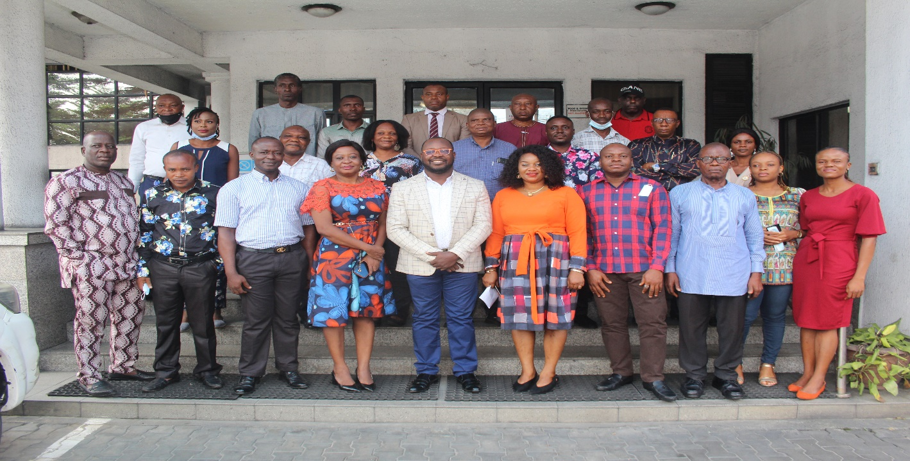
Participant’s group picture on procurement policy
INTRODUCTION: This is the narrative report of 1-Day Training Workshop on Development of Private Security Companies Procurement Policy organized by AFRILAW in collaboration with LITE-AFRICA in partnership with DCAF and ICOCA. There were about 30 participants representing diverse clients and users from companies, organizations and estates in Port-Harcourt, Rivers State.
The 1-Day Training Workshop is aimed at assisting selected companies especially those working in the extractive sector/region to review and developed an international standard Private Security Company Procurement Policy used in hiring of private security company services.
AFRILAW WELCOME REMARKS: AFRILAW ED, Barr. Chinwike Okereke welcomed everyone on behalf of AFRILAW, its partners –DCAF, ICOCA and LITE Africa. Then he introduced AFRILAW to the participants as a law, justice and development organization based in Enugu, Nigeria with its engagement around Nigeria. He spoke of AFRILAW’s engagement with DCAF on the strengthening private security governance project. He gave a brief rundown of the activities of the day. First he spoke of the reason for the meeting which is to bring to the notice of the group, good practices that are relevant for them when procuring the services of private security companies. He also spoke of the draft tool guide stating that the meeting today would need the feedback of everyone in order to fill in any gaps in the tool. He concluded his welcome remarks by welcoming everyone once more on behalf of the organizers.
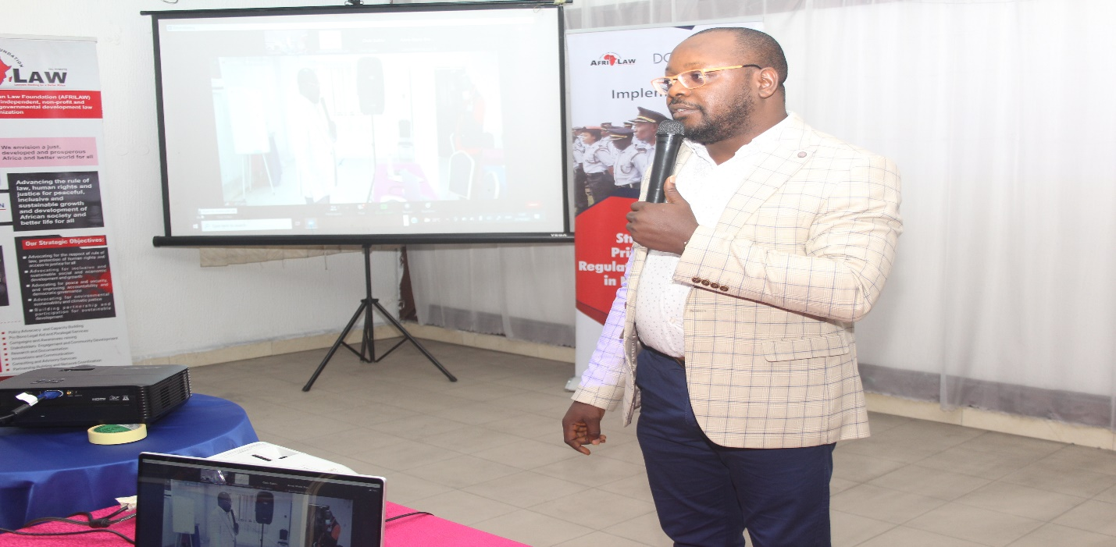
ED of AFERILAW during his welcome address
DCAF WELCOME REMARKS: Mr. Antoine Perret of DCAF welcomed everyone on behalf of DCAF and AFRILAW. He said that at DCAF they believe that improving security sector begins with governance. The ambition to improve security through governance he said involves taking all stakeholders into consideration. He said that in Nigeria especially, started in 2018 with the baseline study on private security in Nigeria. He further said that they believe that private security companies can help the work of public security companies. But that for this to happen, the private security companies must be properly regulated and monitored. This program he said is focused on bringing clients of private security companies to the table to discuss the issues surrounding their engagement with security companies and their interests as stakeholders in the goal to regulate private security in Nigeria. He expressed his optimism that the speakers would do a great job and wished everyone a great time at the program.
OVERVIEW OF AFRILAW/DCAF/NSCDC PROJECT IN NIGERIA by Barr. Chinwike Okereke: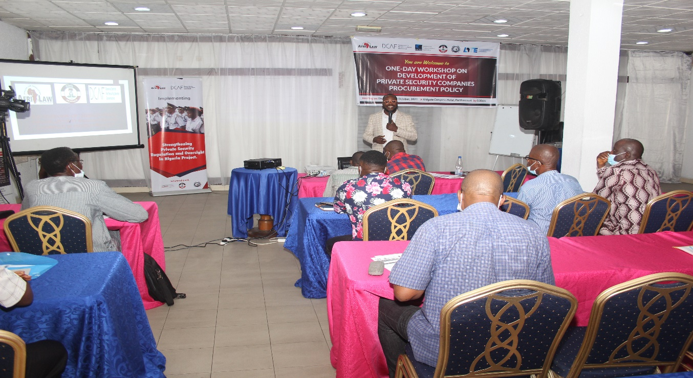
He stated that the project is “strengthening private security regulation and oversight project.” He started with reiterating the fact that the public security sector in Nigeria is overwhelmed to the point that it is almost inexistent. Globally and in a bid to solve the security situation, both private military and private security companies have been allowed in the security sector. However, in Nigeria, the public sector is overstretched and the private sector is neglected. This understanding he said is what has led to this project. In response to this he said that DCAF, a worldwide expert on issues of security sector governance and reform in 2018 collaborated with AFRILAW to do a diagnosis on the security issue in Nigeria especially the private security sector. This diagnosis was done through baseline research which reviewed the framework of private security sector in Nigeria, outlined the challenges and made recommendations for the improvement on the sector.
He said that from the findings of the research the project started with the private security governance forum in all the 6 geo-political zones of Nigeria, comprising the stakeholders from the civil society organizations, media, the industry itself through its association and the regulators. He also spoke briefly of the radio talk shows that accompanied the forum.
Next, he spoke of the joint outreach to join the Montreux Document Forum and the International Code of Conduct for Private Security Governance operatives and all the activities involved in pushing for the Nigeria to join these two initiatives. He explained the two documents and what they comprise. He also spoke of AFRILAW/DCAFs engagement with CSO and Media to ascertain the relevance of the two documents to Nigeria. He then spoke about the CSOs outreach and conference on private security governance.
He also spoke of AFRICA/DCAF engagement with Nigeria to standardize the legal framework in the private security sector in Nigeria. He said that AFRILAW and DCAF came in to give both financial and technical support in the law review process.
He then spoke of the Nigeria MDF/ICOCA membership advocacy engagement programme. This programme he said is aimed at making a case for Nigeria to join the two initiatives. He then enlightened the groups on what is yet to be done on the project this year.
Questions, Answers and Comments
- In the course of trying to provide a governing law for private security companies are their provisions for insurance, welfare and human right for the personnel of PSCS?
Response: the research work focused largely on the operatives. It covered largely many areas affecting the industry and made recommendations on what should be the case.
- What should be the model for CSOs to come into the system?
Response: there is a network of CSOs working in this area and everyone who is interested is welcome to join. There is also a WhatsApp group to ensure that anyone who is a part is made aware of all the happenings on the project.
Recommendations:
- There should be clarification of who a security professional is in Nigeria.
- There is lack of standard in the private security sector. Members of the private security industry need to come together to develop standards for the industry.
Response: AFRILAW/DCAF engagement to ensure that Nigeria joins the MDF/ICOCA is also a drive for standardization. Also, the draft bill insists that every operative is licensed individually. What this involves is that each operative goes through the rigors of training and certification to become a standardized security operative.

PRESENTATION 1: ADDRESSING THE CHALLENGES OF WORKING WITH PSCS IN COMPLEX ENVIRONMENT
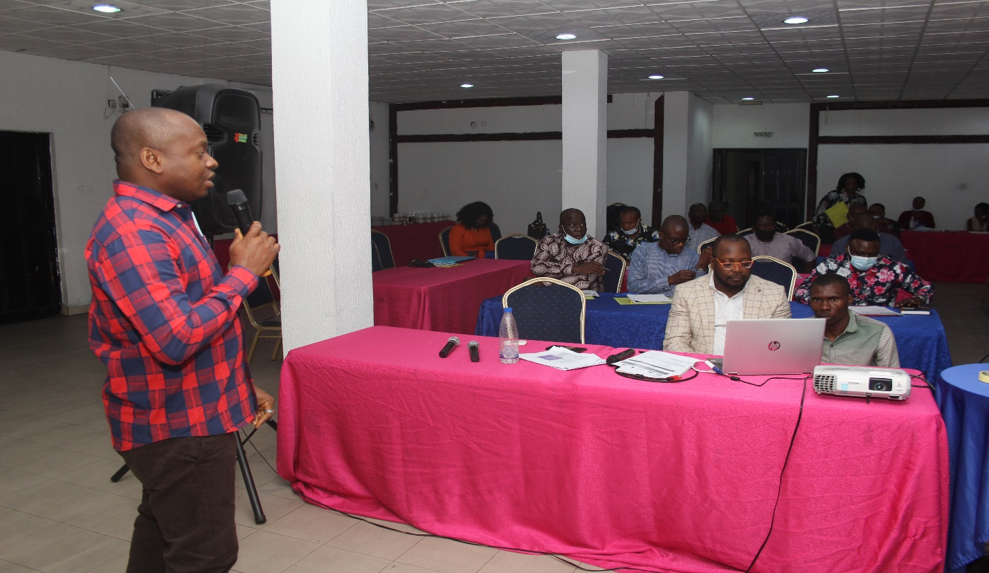
Mr. Arinze Ojukwu introduced his organization, LITE-Africa briefly as a co-chair of the Nigerian Working group on the Voluntary Principles Initiative (VPI).
Going on with his presentation, he said the Niger Delta is the focus in his presentation. He pointed out reasons why private security have become a necessity in Nigeria and the Niger Delta especially thus: the police to population ratio, Nigeria population, crime and poverty etc. He said that PSCS have become a direct response to the vacuum created by the public security sector.
Next he spoke of the various international documents that guide the operations of private security companies in Nigeria. Such documents include: the International Code of Conduct for Private Security Providers (ICoCA), the Voluntary Principles on Security and Human Rights Initiative (VPI) which focuses on guiding companies on their conduct of security operations with respect for human right. He said that the VP spells out how companies are to interact with private security, public security and how they are to go about carrying out their risk and impact assessment. Explaining risk assessment, he said that a proper risk assessment is critical to the security of personnel of the company doing business in a community, the private security operatives engaged and the company’s assets. He also said that a proper risk assessment is critical to the general success of the operations of a company and its promotion and protection of human rights. To engage a private security proper risk assessment is important. A company can get information for its risk assessment from the local and national government, the regulatory agency, other companies, multi-lateral organizations etc.
He said that an effective risk assessment must contain:
- Identification of security risks in the environment. This he said involves making an impact assessment and having a company’s security plan; checking out the regulations that set a boundary on the operations of PSCS and any defect therein; the history of the operations of that PSC in the country and especially in the community of your engagement, likelihood of violence in the environment etc
- Human right records: this involves considering past abuses and allegations to avoid recurrences as well as to promote accountability; identifying the capacity of the PSC to respond to cases of violence in a lawful manner; ascertaining the PSC’s capacity to develop appropriate mechanisms to combat future situations etc.
- Bids and Contracts: here he said that companies must ensure that PSCs observe their policies regarding the use of force, ethical conduct and human rights, local laws and standards, emerging best practices, observance of international humanitarian law, etc.
Practices under these polices must be done in a way that can be monitored. According to him monitoring for client companies should include:
- Follow up and monitoring of the status of investigations and press for their proper resolutions
- Proper investigation of all credible allegations
- Availability of disciplinary measures sufficient to prevent and deter
Etc.
- Companies must insist that the procurement contract they sign with private security companies provides that private security companies provide only defensive and not offensive services, that their work does not move into the basic work of the public military and police etc
- He also said that a proper risk assessment would take into cognizance national labour issues and labour issues specific to the PSC. He also said that during bidding process companies that patronize PSCs must ensure that PSC personnels are trained on human right and international humanitarian law and other relevant aspects; have an insurance cover, have a history of existence among other PSCs, ensure they have a human right policy document etc.
- He also said that companies should hold structured meetings with PSCs discuss security issues.
He then focused on understanding human right risk assessment. He pointed out specific approaches to be adopted by companies to ensure that PSCs comply with human rights. Finally, he presented a chart through which complaints can flow.
QUESTIONS AND ANSWER FOR THE FIRST PRESENTATION
- A participant commented that beyond building walls around the borders of our country, Nigeria the minds of individuals should be built also for security.
- Do Private Security Operatives have the right to self defense especially when there is a threat to their lives?
Response: PS personnel can defend themselves and this is why there is need for proper risk assessment before deploying security in an area.

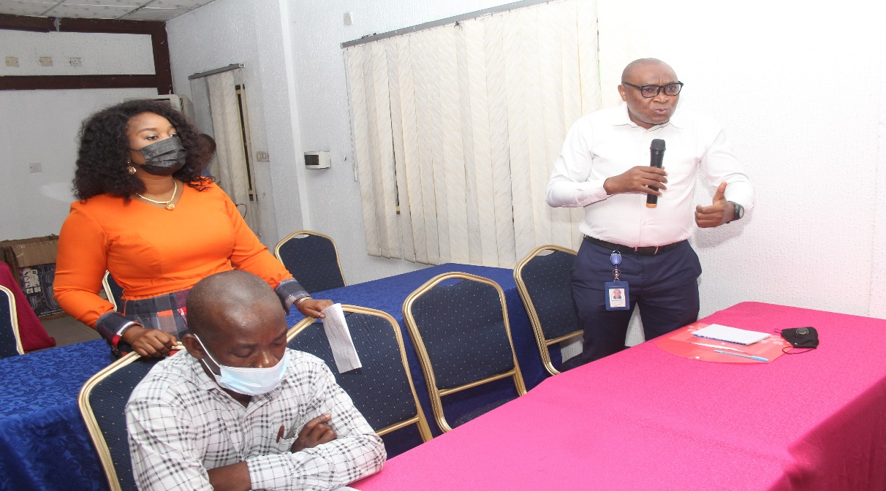
Participants asking questions.
- What are the inherent threats for companies and estates using unskilled PSCs?
Response: Unskilled PSCs is an issue. There is serious advocacy ongoing for PSCs to train their personnel. Also the draft bill for the regulation of PSCs is also big on training and certification of PSCs, for this reason each client must ensure that there is some level of basic training given to personnel of PSCs which they employ.
- What qualifies a PSC to carry arms and another not to and how do PSCs handle threats that are beyond them?
Response: Only vigilante groups can carry arms in Nigeria. No registered PSC in Nigeria is allowed to carry arms. Also it is important for companies to have contact lines to contact the police once there is a threat beyond the PSC.

- Do the trainings also involve psychological evaluation of security personnel to be deployed?
Response: This is very important and has been widely advocated for and actually is implemented to an extent. He also said that bad working conditions can result in psychological problems for security personnel.

- Is it possible to enshrine in the contract between PSCs and their Client a clause that lays the liability on PSCs to replace all stolen/missing items?
Response: Yes. This should be clearly written in the contract between the PSCs and the Client Company.
PRESENTATION 2: PRIVATE SECURITY PROCUREMENT: RISKS, CHALLENGES AND OPPORTUNITIES: Mr. Christopher Galvin of ICOCA said this session is targeted at getting the participants to work and hoped that they’d be taking notes. He said that his talk would be divided into three parts:
- Part 1: Introduction and overview of ICoCA
- Part 2: Introduce the guide for procurement of responsible PSCs and get feedback from participants.
- Part 3: Break out into groups to solve some questions he’d pose
Part 1: Overview of ICoCA: He gave an overview of the Code and how it came about. He spoke also on what the code is based on and that it is divided into chapters: chapter f: covers representing personnel and section g: that covers management and governance. At this point he pointed out that the code no longer acknowledges signatory status since it cannot verify that signatory companies operate in compliance to the code.
Section f which provides for PSP has essentially 10 guiding principles that look at the operation of the guards. Principles 1-3 talks about times when there is need for them in the discharge of their responsibility. The remaining principles he said talk about issues that should not happen and where they happen are clear violation of the human rights and the code. The final principle he said is that PSP should be clearly identifiable without which there would gaps in accountability.
Section g he said has 13 kinds of principles. He said that all these principles should be reflected in the policies of the PSC. Selection and vetting and also training are key and essential for any company that would be a part of the code.
On the association he said that the association was formed in 2013 as a governance group to ensure that the companies who opt to join the association commit to continuously be in compliance to the code.
The association he said is a multi-stakeholder initiative with the government, company, observer, and civil society pillar. He said that Clients are important to the code in that it is when they demand standards from companies and insist on membership of the code that the companies begin to seek membership with ICoCA. According to him Clients fall into the observer group.
He said there are three categories of members: ICOCA certified members: people who have gone through the rigor and have obtained certification, the transitional members who have a two year period to complete the rigors and processes of certification become members and affiliate members , who do not have the two year timeframe for certification and have no voting rights. He then went ahead to speak on what exactly ICoCA does. He said that ICoCA engages in capacity building, monitoring, certification, and handling complaints.
The capacity building function of ICoCA is basically providing guidance on the provisions of the code. He said they provide guidance on the principles enshrined in the code. This capacity building also entails training for members as required on the various principles in the code. Finally capacity building provides a feedback system. This feedback system also moves into the monitoring component.
In monitoring ICoCA goes visiting countries and clients who are members. They track news on companies who are members of ICoCA. Also, and importantly Civil Society Organizations are the eyes and ears of the association in the various countries of engagement. The certification of ICoCA is done by some recognized certified companies who have been certified themselves. These organizations take private security companies through the process of certification and there are stringent rules for getting the ICoCA certification.
In its complaints function ICoCA receives complaints from stakeholders and individuals who use Private Security Companies. All companies who are members of ICoCA must have a grievance complaint mechanism where persons aggrieved can lay their complaints. All of the functions are integral. He concluded his discussion on the code by saying that focusing on good security feeds into the wider sustainable goals like goal 5,8 and 16.
Part 2: RESPONSIBLE PROCUREMENT: He started this session by restating that ICoCA is developing a tool to guide companies on responsible procurement of private security. He said the guide is for anyone involved in procurement of private security. The tool according to him can be used by personnel to make the case to their management for responsible private security procurement. His discussion was going to take the form of a focus group discussion into the tool where participants provide feedback on the tool: pointing out what works and what doesn’t work. He said that the first part of the tool provides guidance on why it is important to procure private security responsibly while the second part speaks on the step-by-step guide to responsible procurement. He said participants would be shared into three groups to discuss the question:
- What are the risks in contracting private security providers?
- How does your private security provider procurement process work?
- How human rights due diligence work in your organization does, is it relevant?
He pointed out that these questions should be kept in mind as the presentation goes on. He also asked for participants to reflect on the presentation, asking themselves what is different in their experiences from what they are hearing, what is missing, what needs to be added and what needs to be removed.
Speaking on the first part of the tool he said that the UN guiding principles on business and human rights is the foundation document for companies to build their human rights due diligence on. In implementing the UNGP companies must put in place policies that respect human rights. In addition, he said that human right due diligence involves proper risk assessment and continuous risk management accompanied with remedy for grievances.
Next, he spoke on the human right risks that may arise from contracting Private Security Companies. He pointed out real news headlines on abuse of human rights by private security providers and reaffirmed what had earlier being said that the reputation at stake is usually that of the employer of private security i.e. the client.
He then spoke of some the mistakes that businesses make in procuring private security:
- Monitoring and verification:
- No ownership
- No Certification
- No capacity building
He said that the absence of all or any of the above potentially leads to human right abuses.
Speaking on the issue of “Price”, he said that though price is a key issue influencing procurement, it shouldn’t be the only issue. He said that procurement only on the basis of price carries unforeseen costs. He said that responsible companies need to live up to their statements on sustainability, ethics and governance. A least cost approach he said leads to a system of increased hours and decreased wages to win business. This trend leads to a cycle of security risks with guards inadequately trained, not properly vetted, are incapable of carrying out their responsibility, pushed to exhaustion and ultimately to poverty. He said that responsibility really starts with a procurement system that takes these price issues into account.
In countries where there are no ICoCA authorized certification companies, ICoCA recommends that clients work with those companies to ensure a respect for human rights and they play a key role in supporting the private security providers to improve the operations and reduce the potential for abuse. The procurement process makes this possible by providing a requirement/clause that contracted private security providers would work with your company to attain the ICoCA affiliate, member or/ and ultimately the certification status. This improvement process clause has many advantages in that it sends a strong message of the client and his security provider’s commitment to protecting human rights, it can help other regional companies to improve processes. It shows also that the company is trying to do good by helping regional companies do better.
Questions and Answers:
- Most regulations from the western world are truncated by a lot of factors: such as enforcement, implementation and price when brought down to the local context in Nigeria.
Response: discussions like this are important for us because it allows us to cross-check our impressions with the in-country situation and it would be impossible to generalize since circumstances may differ from country to country and even in a country from region to region.
- How do we regulate issues of ethics and lack of standards; trainings etc?
- Can client companies train security personnel by themselves and not wait for the private security company to do this?
- Private Security operatives have yet to be integrated/ adapted into the security system in Nigeria. This is largely because of the perception of public security and of the general public towards them.
How do we handle the issues of perception to ensure that private security is integrated into the system?
Response: ICoCA focuses mainly on private security. However there are times when public and private security can and should or shouldn’t work together. One of these instances is in instances where the government regulates the sector. In that instance they are not a separate entity.
Response: private and public security operatives can work together and collaborate. The important thing is that each group’s role must be spelt out. Private security has a key role to play if they collaborate so it would be great to find a way to handle the public and private security distrust.
Group Work: Cross Section of the Participants Engaged in a Group Work:
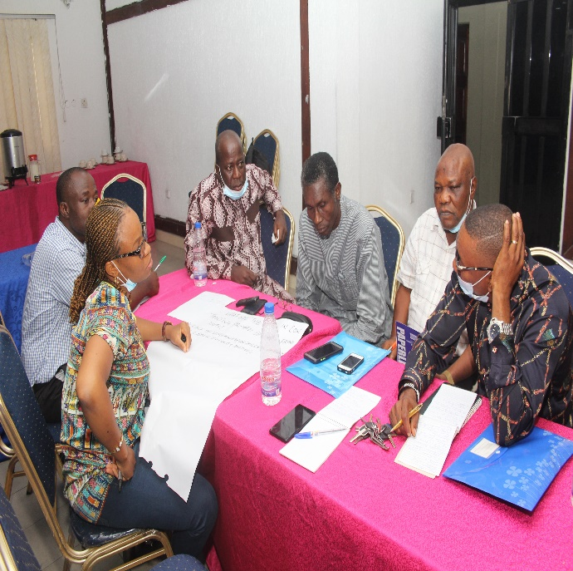
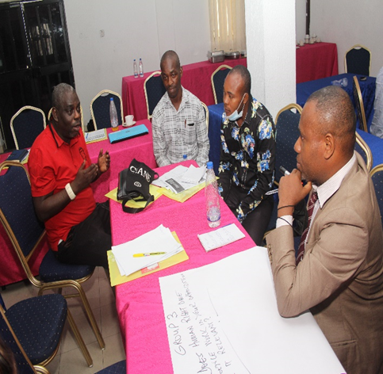
After this question-and-answer session participants split into 3 groups to deliberate and ask the following questions:
- What are the risks in contracting private security providers?
- How does your private security provider procurement process work?
- How human rights due diligence work in your organization does, is it relevant?
At the end of the deliberations group members made presentations on their result. Groups 1-3, answered numbers 1-3 respectively and made presentations.
Group Presentations
Group 2- how does your private security provider procurement process work? What is missing? What needs to be added? What needs to be removed?
Client companies usually do not do a background check before engaging private security providers.
What is missing?
- Lack of ethics
- No capacity building
- Poor remuneration
- Inadequate funding
- Poor/lack of monitoring and enforcement terms of contract
What needs to be added?
- Certification
- Periodic evaluation
- Insisting on getting information on the company through their website or directly from them.
What needs to be removed?
- Unethical practices
Group 1 - What are the risks in contracting private security providers?
- Untrained/unskilled personnel
- Negligence of duty due to lack of motivation and good welfare
- Lack of training on basic human right leading to abuse and violence
- Abuse of trust/stealing
- Lack of conducive working environment (such as a conducive working space)
- Lack of proper accoutrements (uniforms, whistles, rain capes, rain boots etc)
- Lack of social health scheme
- Insensitivity of government on private security
Group 3- How does human rights due diligence work in your organization, is it relevant?
Human right due diligence here involves how companies manage actual adverse human right impact with which they are involved.
Also human right due diligence involves identifying and assessing actual and potential human right impacts.
Integrate findings into the process of the organization.
The issue of human right due diligence is relevant.
What is missing?
Implementation is missing.
Concerned stakeholders should be involved to discuss issues relating to security in the environment. This would help to find out whether the particular guard has what it takes to provide security in the area.
Mr. Christopher Gavin appreciated everyone for working so hard and giving feedback. He concluded by presenting two procurement options that client companies would have access to using this tool.
Option 1: procuring ICoCA member or affiliate companies. This assures every company that the human right due diligence is taken seriously and that risks are minimize. Taking this option the client company must insert clearly in their tender that persons who would want to take up the bid must be ICoCA certified, affiliate or member private security companies. Also the company seeking to procure private security companies should as a necessity check the ICoCA website to ensure that the private security company is actually an ICoCA certificated, transition member or Affiliate Company.
Option 2: companies personally do the human rights due diligence on their private security providers themselves. To enable them to do this the tool is setting out 10-point selection checklist that companies can follow to assure themselves that those companies are operating in compliance with human rights and essentially in compliance with the code.
He then asked the participants which of the options they prefer, what are the pros and cons of each.
Feedback on the first option:
- The importance of a third eye in security issues is important. This makes the first option very important. However, the enforcement of the audit reports is a question. The international regulatory system is important to provide an international spice.
- Is ICoCA in Nigeria? Where there is no ICoCA member or Affiliate Company the second option seems to be the only option.
Christopher Gavin said that where there is no affiliate or member companies in the place of engagement, companies can engage with ICOCA to ensure that the private security provider goes through the process to get certified by ICoCA.
Feedback on the second option:
- This option is a hands-on program and companies can monitor the progress.
- Companies can explore the two options at the same time.
- Taking this option may create room for cutting corners.
At the end of this feedback, Mr. Christopher Gavin appreciated everyone for the feedback. He encouraged all participants to visit the ICoCA website for all the information they require and also his email to get any clarifications that they may need. He encouraged all participants to keep on insisting on standards bearing in mind what he said previously about clients being major drivers of standards and in turn certification.
On behalf of DCAF, Ms. Gabrielle Prinkilova thanked everyone for participating; she also thanked ICoCA and Barr. Chinwike for organizing the event.
Presentation 3: Incorporating Human Rights and Gender Perspective in Contracting PSCS Services- Barr. Chinwike Okereke
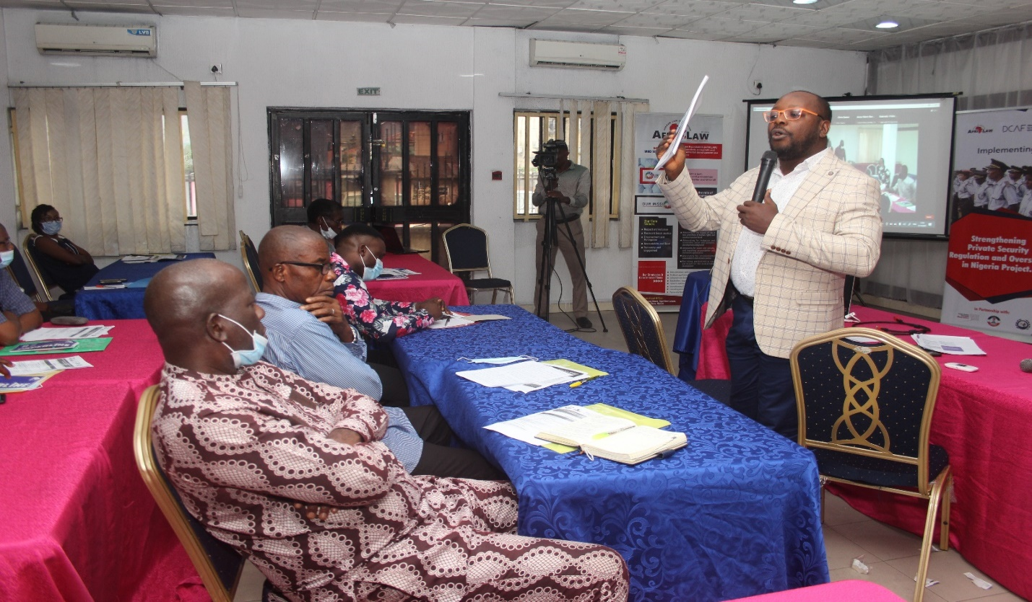
Presentation by ED of AFRILAW
Barr. Chinwike Okereke started his presentation by giving an overview of the UN Guiding Principles on Business and Human Rights and stated that the UNGP has several references to gender and women which is grouped into 3 “Gender Windows Gender Framework such as:
Window 1: This is framed by the general principle of non-discrimination: the Guiding Principles should be implemented in a non-discriminatory manner with due regard to the different risks that may be faced by women and men.
Window 2: This is shaped by provisions explicitly highlighting the need to integrate a gender perspective at certain places. The commentary to Guiding Principle 3 provides that States should provide appropriate guidance to businesses on how to consider effectively issues of, among other things, gender, recognizing the specific challenges that may be faced by women.
Guiding Principle 7 underlines that States should provide adequate assistance to business enterprises operating in conflict-affected areas to assess and address the heightened risks of abuses, paying special attention to both gender-based and sexual violence.
The UNGP Gender Framework 1 covered Gender Responsive Assessment; Framework 2 is for Gender Transformative Remedies; and Framework 3 provided for Gender Transformative Measures.

He made presentations on understanding “a gender perspective” on PSCs Services; Some Gender-based Challenges and the PSCs; Integrating a gender perspective is good for the private security industry; National, regional and international legal frameworks for gender equality apply to State regulation of PSCs; PS Industry Good Practice Demands A Gender Perspective; ICOC Requirements; ICOCA Guidelines for Private Security Providers on Preventing and Addressing Sexual Exploitation and Abuse; and How can States integrate a gender perspective in the regulation of PMSCs; and Integrating Gender Perspective In Procurement and Contracting of PSCs’ Services;

Finally, he listed and explained information participants need to have or request when procuring/contracting of PSCs’ services; and what to Integrate or Require When drafting the PSC contract.

Questions and Contributions from the Participants:
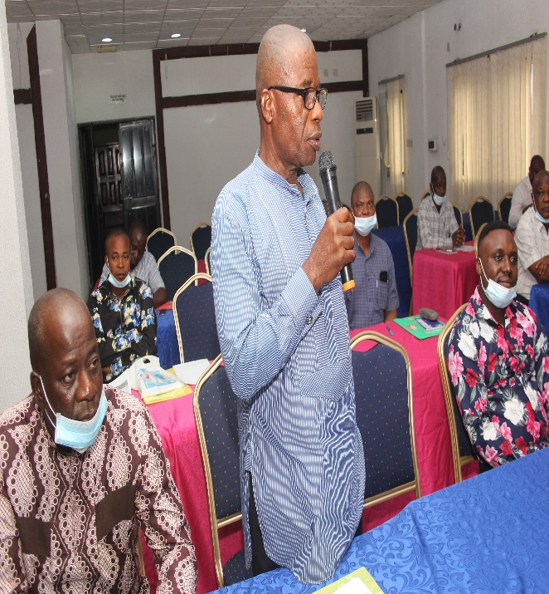
Participant asking question
- You said something about it being a breach of human rights to post a woman on night duty. I realize that some companies post women to the booths and not outside the office for night duty and nurses are also pasted on night duty? Is there a law that supports your claim or is it a matter of discretion.
Response: it is discretionary and the general practice is not wrong but the circumstances may make it so.
On behalf of the organizers, the ED of AFRILAW appreciated everyone for being a part of the program and encouraged them to keep engaging and playing their part in ensuring that standards are set and maintained in the industry.
Also Gabrielle Prinlilopilovia appreciated everyone for coming and which them safe journey as they went home.
Meeting ended with the Closing prayers at about 4:00pm.
Recommendation/Next Step:The workshop was very impactful and was well accepted and actively participated by selected PSCs Clients and Users.
There is a strong recommendation that this workshop should be replicated in the remaining 5 geo-political zones of Nigeria for PSCs Clients and Users.

- 1-DAY TRAINING WORKSHOP ON REVIEW AND DEVELOPMENT OF INTERNAL DOCUMENTS OF PRIVATE SECURITY COMPANIES

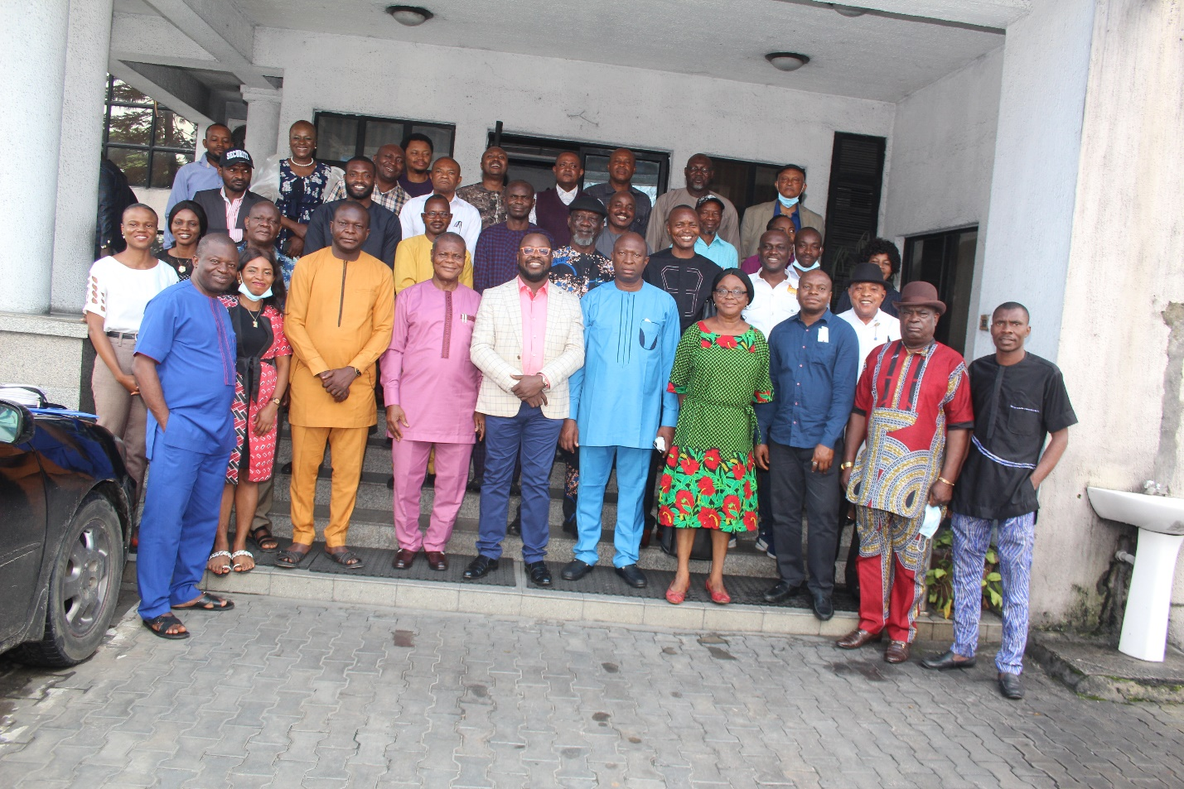
Participant group picture on review and development of internal document
INTRODUCTION: : The 1-Day Training Workshop on Review and Development Of Internal Documents of Private Security Companies was held on Friday October 22, 2021 at Aldgate Congress Hotels, Port Harcourt, Rivers State, There was about 55 participants including about 45 private security companies. The free 1-Day Training Workshop aimed at assisting selected Private Security Companies to improve and strengthen their internal management and operational system for organizational development, effectiveness and responsible service delivery in Nigeria.
OPENING SESSION AND REMARKS: The program commenced at about 10:30 am with an opening prayer by the National Vice President, Association of Licensed Private Security Practitioners of Nigeria (ALPSPN), Rev Mark Abere. After that, the National Anthem was said and participants briefly introduced themselves.
Welcome Remarks by AFRILAW ED & Founder: He warmly welcomed everyone to the program and introduced AFRILAW as a law and development NGO based in Enugu working across the country. He said that part of what AFRILAW does is to promote security sector governance and human rights. In 2018 in partnership with DCAF, AFRILAW developed a baseline study on private security governance in Nigeria x-raying the status of private security governance in Nigeria. In 2020 he said the program strengthening private security governance regulation and oversight began as a bid to implement the findings and recommendations of the baseline study. He welcomed everyone and said that he is pleased to see them despite the day’s weather condition. Speaking on the objectives of the program he said that the goal is to work with the private security companies present to improve their systems. He also said that the partners DCAF, and ICoCA were already present at the meeting and everything is ready. He therefore encouraged everyone to sit back and enjoy the conversation, make their contributions and be set for the improvements that are about to be brought to their notice. On behalf of the organizers, he welcomed every participant.
Welcome Remarks by DCAF-
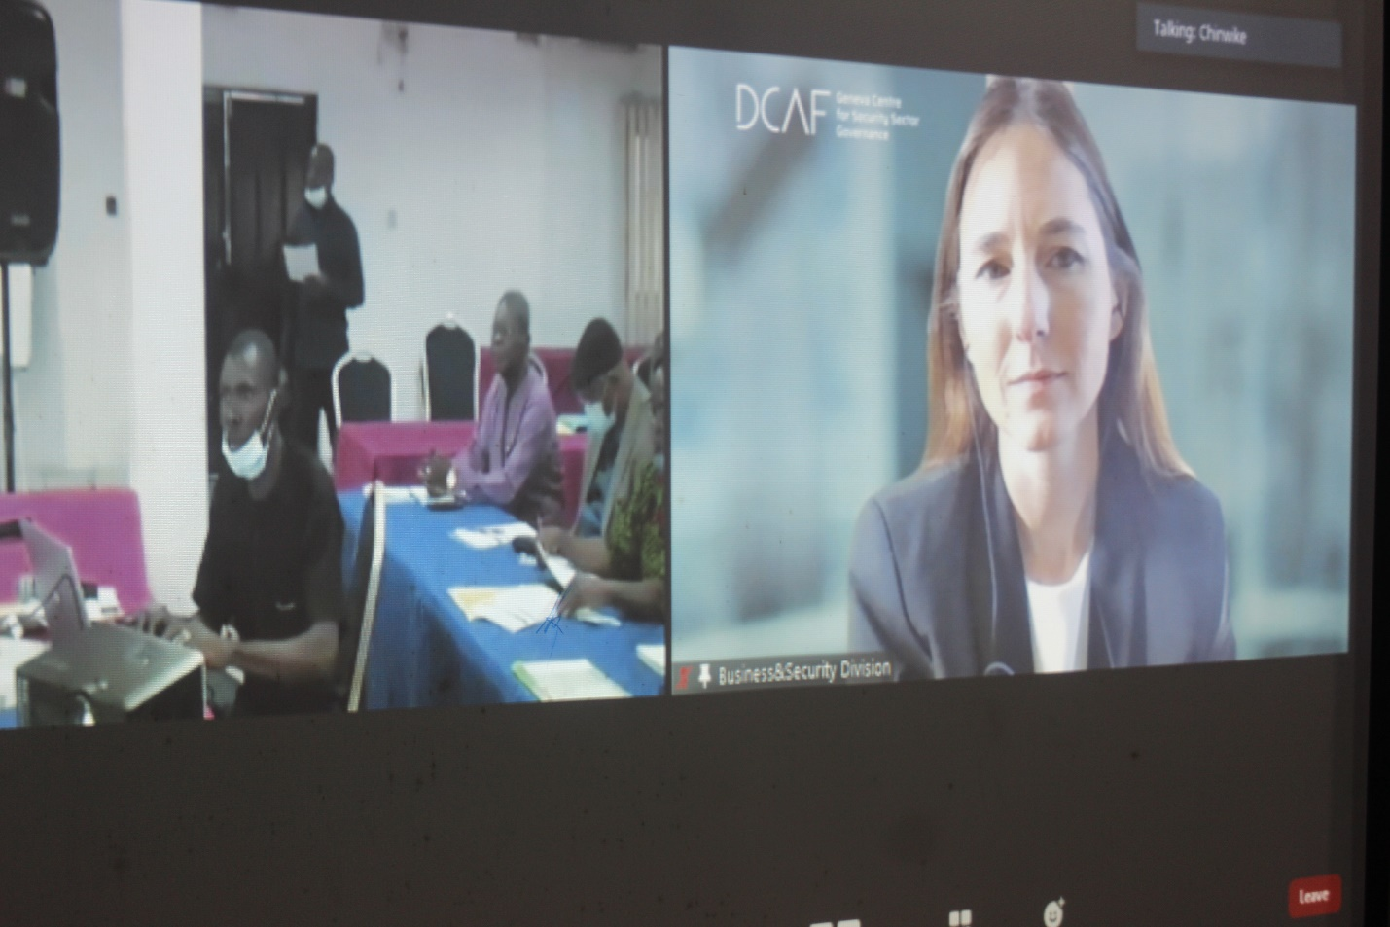
The DCAF representative introduced herself as Gabriella Prinkipilovia of the Geneva Centre for Security Sector Governance (DCAF). She expressed great delight at the possibility of the program saying that they would have loved to be there except that the conditions are not favourable. She said her duty would be only to take a step back to talk about what they’ve done so far with AFRILAW and what has been achieved thus: they have
- Supported discussions on PSC legal reform
- Strengthened CSOs in supporting good governance of PSCs
- Facilitated multi-stakeholder exchanges in PSC governance.
All these things they’ve done because they believe that the improvement of PSC governance requires a long-term vision. Here she said they salute the Nigeria Security and Civil Defense Corp for leadership which is necessary to bring the change required.
This work she said started in 2018 with a baseline study authored by the Executive Director of AFRILAW which gave a full picture of the work left to be done. She said they believe the Private Security Companies if given the tools can strengthen human rights, security and prosperity of a country. So what they see is that in many contexts the private security companies would be a force multiplier of Public security. This she said is only possible where private security companies are supported and accompanied and that is the main aim for organizing this meeting. The objective therefore of the meeting is basically to improve and strengthen the policies of these companies so that the standards are upgraded and they can operate with international best practices especially in complex environments such as the Niger delta. She concluded by appreciating AFRILAW and the German Corporation for their support and for making the meeting possible.
Welcome By Rev. Mark Abere, National Vice President of ALPSPN: He began by saying that as an association they are indebted to the activities of AFRILAW, and also now DCAF and ICOCA who are behind the scenes working to support the work of AFRILAW. He recalled the private security forum held also in Rivers State which he said was an eye-opener for them the private security practitioners, the government and other stakeholders. He said that ever since then the industry has taken a new turn. On today’s program he said that he is sure that at the end of the program they’d appreciate the gaps in their security practice and the way forward will definitely be presented to them. He once again appreciated AFRILAW on behalf of the organization.
Welcome Remarks by the State Chairperson ALPSPN, Rivers State: He appreciated AFRILAW for its immerse contribution to the Association and their drive to strengthen the operations of private security operatives in the Nigeria. He said that as the chairman of the association in rivers state he has started the process to see that individual companies can be part of ICoCA. He said that personally he has started the process and that the concept is laudable and is important. He appreciated the organizers again on behalf of the ALPSPN.

OVERVIEW OF AFRILAW/DCAF/NSCDC PROJECT IN NIGERIA by Barr. Chinwike Okereke
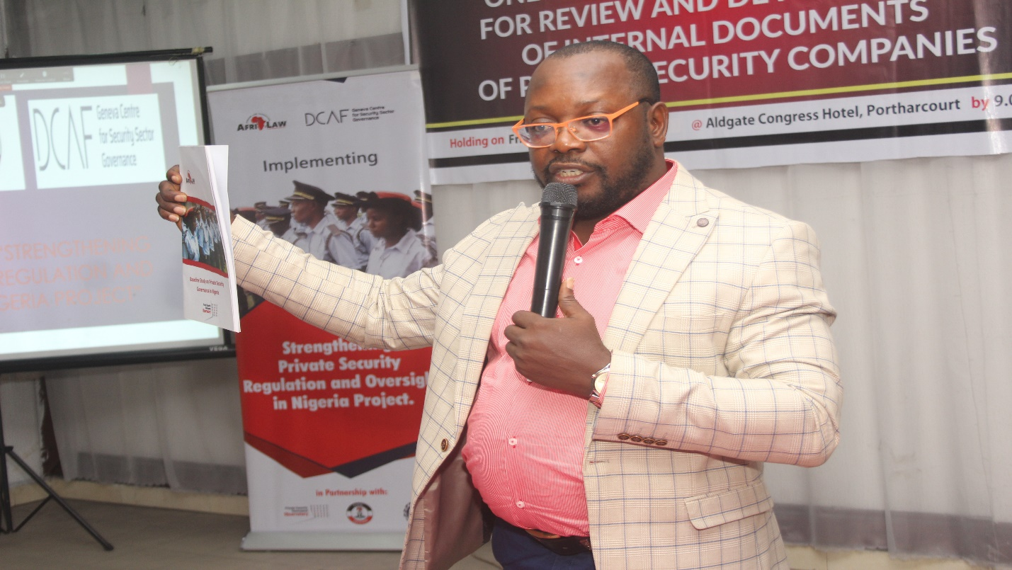
He stated that the project is “strengthening private security regulation and oversight project.” He started with reiterating the fact that the public security sector in Nigeria is overwhelmed to the point that it is almost inexistent. Globally and in a bid to solve the security situation, both private military and private security companies have been allowed in the security sector. However, in Nigeria, the public sector is overstretched and the private sector is neglected. This understanding he said is what has led to this project. In response to this he said that DCAF, a worldwide expert on issues of security sector governance and reform in 2018 collaborated with AFRILAW to do a diagnosis on the security issue in Nigeria especially the private security sector. This diagnosis was done through baseline research which reviewed the framework of private security sector in Nigeria, outlined the challenges and made recommendations for the improvement on the sector.
He said that from the findings of the research the project started with the private security governance forum in all the 6 geo-political zones of Nigeria, comprising the stakeholders from the civil society organizations, media, the industry itself through its association and the regulators. He also spoke briefly of the radio talk shows that accompanied the forum.
Next he spoke of the joint outreach to join the Montreux Document Forum and the International Code of Conduct for Private Security Governance operatives and all the activities involved in pushing for the Nigeria to join these two initiatives. He explained the two documents and what they comprise. He also spoke of AFRILAW/DCAFs engagement with CSO and Media to ascertain the relevance of the two documents to Nigeria. He then spoke about the CSOs outreach and conference on private security governance.
He also spoke of AFRICA/DCAF engagement with Nigeria to standardize the legal framework in the private security sector in Nigeria. He said that AFRILAW and DCAF came in to give both financial and technical support in the law review process. He then spoke of the Nigeria MDF/ICOCA membership advocacy engagement programme. This programme he said is aimed at making a case for Nigeria to join the two initiatives. He then enlightened the groups on what is yet to be done on the project this year.
PRESENTATIONS:
PSCS & CHALLENGES OF OPERATING IN A COMPLEX ENVIRONMENT
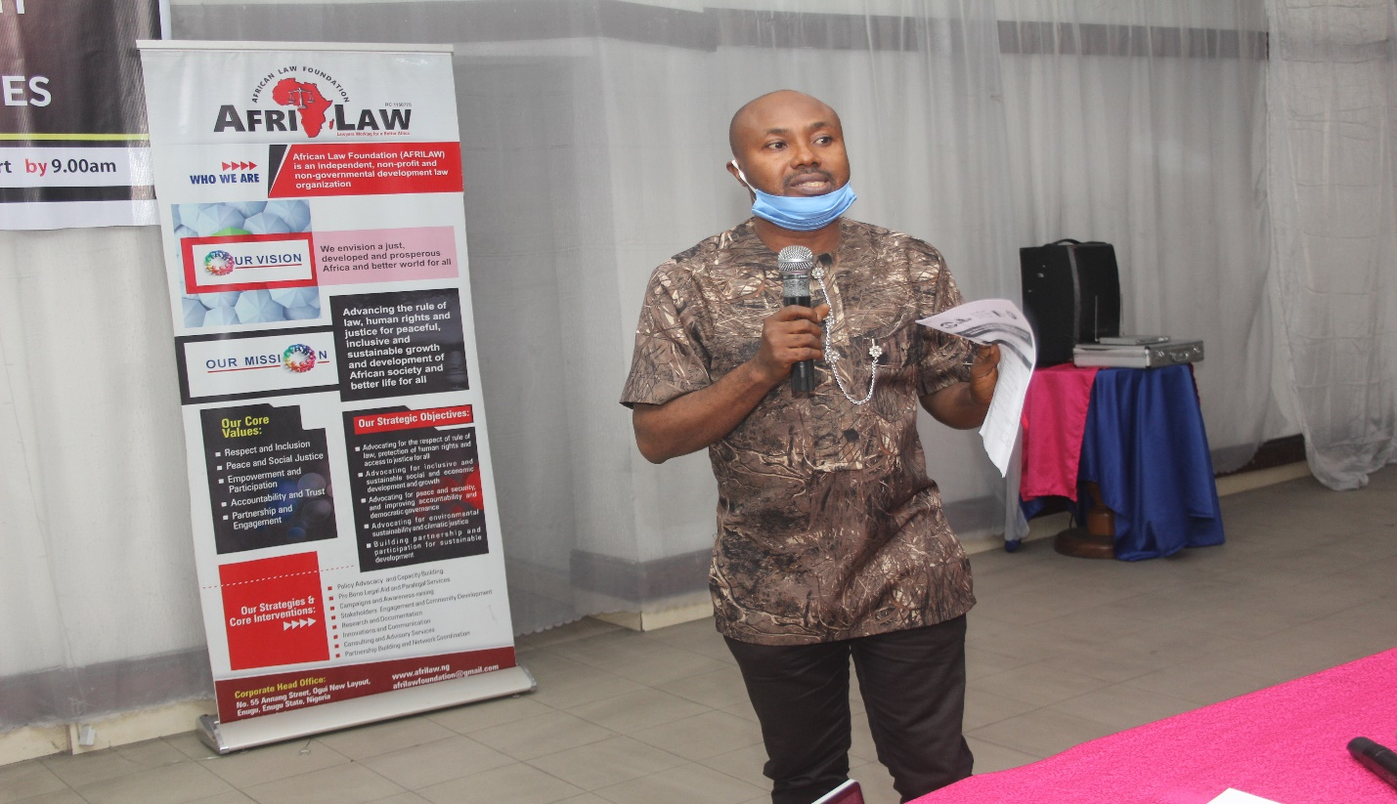
Dr. Vareba of CEHRD, Port-Harcourt started by saying that no business or endeavor thrives in a place of high risks. This therefore means that success and prosperity of a place and endeavour is tied to a secure environment. He however opined that Nigeria has been a country with a high risk of insecurity and this has affected businesses and endeavours.
He traced the evolution of private security in Nigeria saying that security has moved from the old retired police or army officer sitting at a gate to provide security, to well kitted men providing security even; to technology of all forms being used to provide security. Presently and because of the call for professional security experts, academic programs now offer certification after going through its rigors. He said nowadays it is not unusual to see a professional security expert. He however said that this is not the case in Nigeria.
Exploring the challenging environment in Nigeria he said that the symptoms and not the cause of insecurity have over the years been addressed in Nigeria. He went further to say that the police to citizen ratio in Nigeria which is 1 police man to 540 citizens is far below the United Nations Standard of 1-450. The public security is therefore overstretched beyond capacity and other security agencies like the army in one way or the other have had to stand in to bridge the gap as they also go about their statutory duties. He said that all the above challenges make private security companies very important. According to him, the current cases of terrorism and insurgency in Nigeria have farther widened the gap and heightened the need for and the opportunities within the private security industry. This industry however will only actualize its potentials if harnessed properly since by every indication the Nigerian situation (i.e. the cases of terrorism and insurgency) is a complex environment. These opportunities are already being tapped by the foreign private security companies’ domicile in Nigeria.
He said that though there is a need for and an opportunity for the industry, there are also some challenges bedeviling the private security industry in Nigeria. Some of these challenges are: a) the role of private security industry having being usurped by the traditional police. b) the cumbersome cost of regulation and licensing of private security companies and the dearth of professional code of conduct c) no comprehensive database of ex-convicts existing making it possible for ex-convicts to become security staffs of organizations d) the inability of PSCs to bear arms even in high risk environments e) the presence of unconventional groups like vigilante groups, OSPAC, OPC groups. These groups confuse the private security space as people are unable to clearly differentiate them from traditional private security practitioners registered and licensed. According to him, these groups now vie for and are granted security contracts especially in complex environments. F) According to him there are about 6 associations for private security practitioners in Nigeria. He said all these associations must come together, network and enforce standards especially in the area of wages, doing background check on prospective private security operatives, setting maximum working hours, provision for training etc.
He then made a case for a “Private Security Industry Authority of Nigeria”. According to him the Nigeria Security and Civil Defense Corp (NSCDC) is over burdened with its primary responsibility to appropriately carry out its oversight functions for the private Security Industry. He therefore proposed a full-fledged, self-funding and autonomous civil authority to be known as the “Private Security Industry Authority of Nigeria (PSIAN)”. He however posited that the NSCDC can retain its oversight functions over the PSIAN. He said that this arrangement would be an advantage rather than a disadvantage to the government since the PSIAN will not depend on government funding to operate.
In conclusion he proffered a way forward. He said that in March 6, 2012 over 55 private security companies met in Geneva to sign the International Code of Conduct for private security providers (ICoC) which promotes self-regulation of the security industry. He said the Private Security Industry in Nigeria will do well to have a self-regulatory, self-funding model. This conforms to global best practices and will invariably enhance professionalism, standards, effective monitoring, and instill discipline. He said PSCs must be encouraged to play an active role in the current haze of insecurity. The government must also as a matter of urgency, streamline the cost and bureaucracy associated with registration, licensing and running a PSC in Nigeria otherwise many will be forced to operate under the radar.
Questions and Contributions:
- The private security industry has made a great contribution to the economy of the country and springing from that the government should make provision for access to loans and funds. This should be another area of advocacy for CSOs on behalf of the industry i.e. for a bank of industry to carter to the needs of security.
- Another area bedeviling the private security industry is the area of renewal of licensing. There are no days of grace for genuinely operating private security companies to renew their licenses before sealing their office.
- How tenable are the reports submitted by private investigation companies in the court in improving a case?

Response: Private security companies exist and the admissibility of the facts gathered by them is dependent on whether or not there is enough evidence to prove their claims and cannot be thrown off just because they are obtained from private investigation companies.
- Are the private investigation companies also regulated by the NSCDC considering that it is easier to regulate a man guarding company than it is to regulate intellectually driven companies? How does their regulation work?
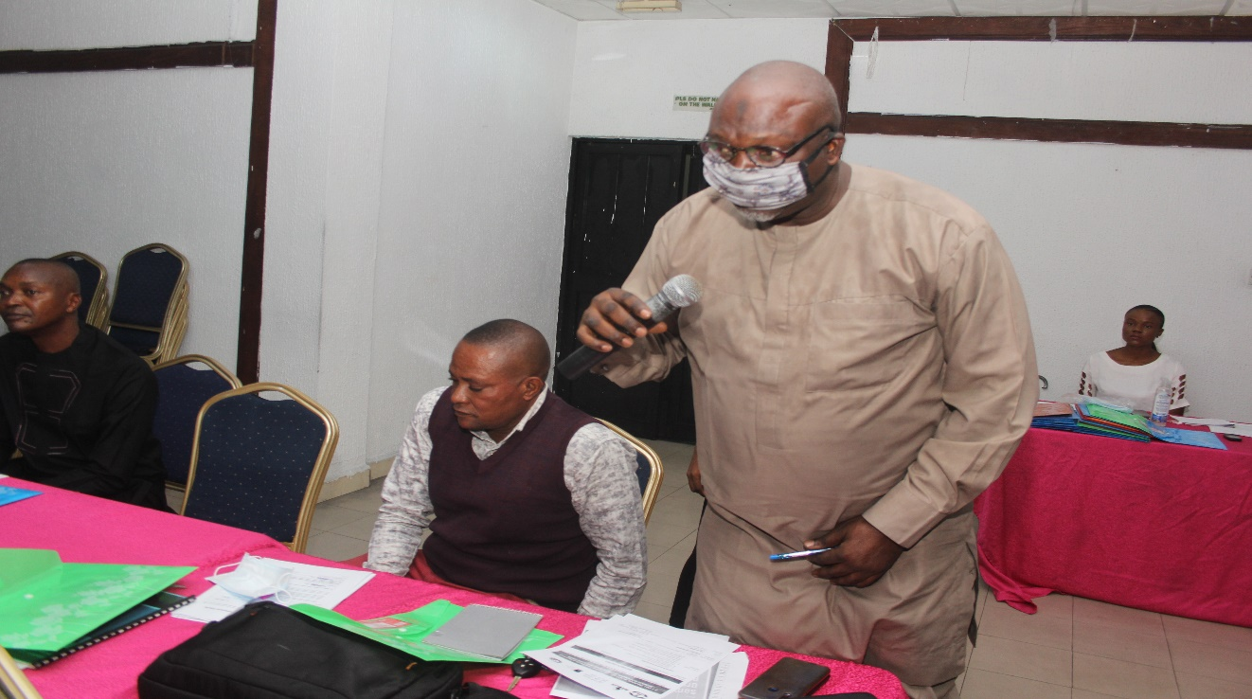

- Can we get examples of these foreign private security companies and do they also do man-guarding.
Response: Robinson Security Company is a foreign security company in Nigeria dealing in cyber security.
- You mentioned the various private security associations. Some of which are focused on offering certifications which are not recognized by any employing agencies in the country can they be collapsed.
Response: The reason for mentioning all these associations is to emphasize the need for synergy and professionalism and the general benefit of all.
- Why should I join ICoCA if it doesn’t help my business?
Response: there are immense benefits in joining ICoCA, some which have already been mentioned. Some other advantages are: a) the in-country working group is working so hard to ensure that Nigeria joins the association as a government pillar. When this happens, it would become compulsory for companies to join. b) the act of voluntarily signing up to a code of conduct increases the CV of a company. C) it increases professionalism d) updates and upgrades a company’s personnel to international standards of behavior and ethics d) consequently it improves the output of a company. f) networking and business benefits are still attainable since companies who want to work in your region and need your services may require recommendations from ICoCA and where you are compliant you stand a greater chance of having all those business advantages.
- I do not totally agree with the thought on an independent regulatory body for two reasons: 1) The NSCDC will not agree to an independent association because of the gains attached to regulating the industry. 2) The attitude of corruption in Nigeria will affect the success of such organization.
Response: we understand that there could be resistance from the present regulators for obvious reasons but it is pessimistic to say that a Nigerian –manned organization would not work. There could be checks and balances set in place to ensure compliance to rules
A lot of advocacies has been done on this area but there is no political will to bring this to fruition.
- There should be a difference between private security companies and private guards’ companies.
Response: the new law is providing for a term called private security operatives as the term to refer to private security professionals.
The position of the draft bill is that every form of private security provision whether vigilante or other groups are now under the regulation of the NSCDC and must be registered. Individual private security practitioners obtain certification and then approach companies to get employed.
- The signing of the ICoC that was done by some private security companies was Nigeria represented? If yes, by who? If no, why?
Response: Nigeria wasn’t there at that time. However, many Nigerian civil society organizations have become members of the association and have been engaging with the government to make sure they join and be a part of the association. A lot of work is already going on in this aspect and we are hopeful that Nigeria would join soon.
- The reason why these unconventional groups are flourishing especially in this complex environment is because the private security companies do not carry arms. This is because in the pipeline regions the people coming to vandalize the pipelines are usually armed while the unarmed private security companies cannot stand them and so they employ the people who can carry arms i.e. the unconventional groups so that they can be effective.
Response: this practice would definitely lead to illegalities. My suggestion would be that compliant companies go ahead to employ private security companies and if and where they are not able to protect the pipelines because they are not armed it would then a good point to make a case for allowing Private security companies to carry arms especially in conflict areas like the pipeline regions. It would however be ineffective to try to use an illegality to achieve legality.
After these questions and discussions the group stepped out for a group photograph and tea break. The tea was a working tea.

INTERNATIONAL GOOD PRACTICES ON EFFECTIVE MANAGEMENT AND GOVERNANCE OF PSCs by Mr. Chirstopher Galvin, Head, Communication and Outreach, ICoCA:
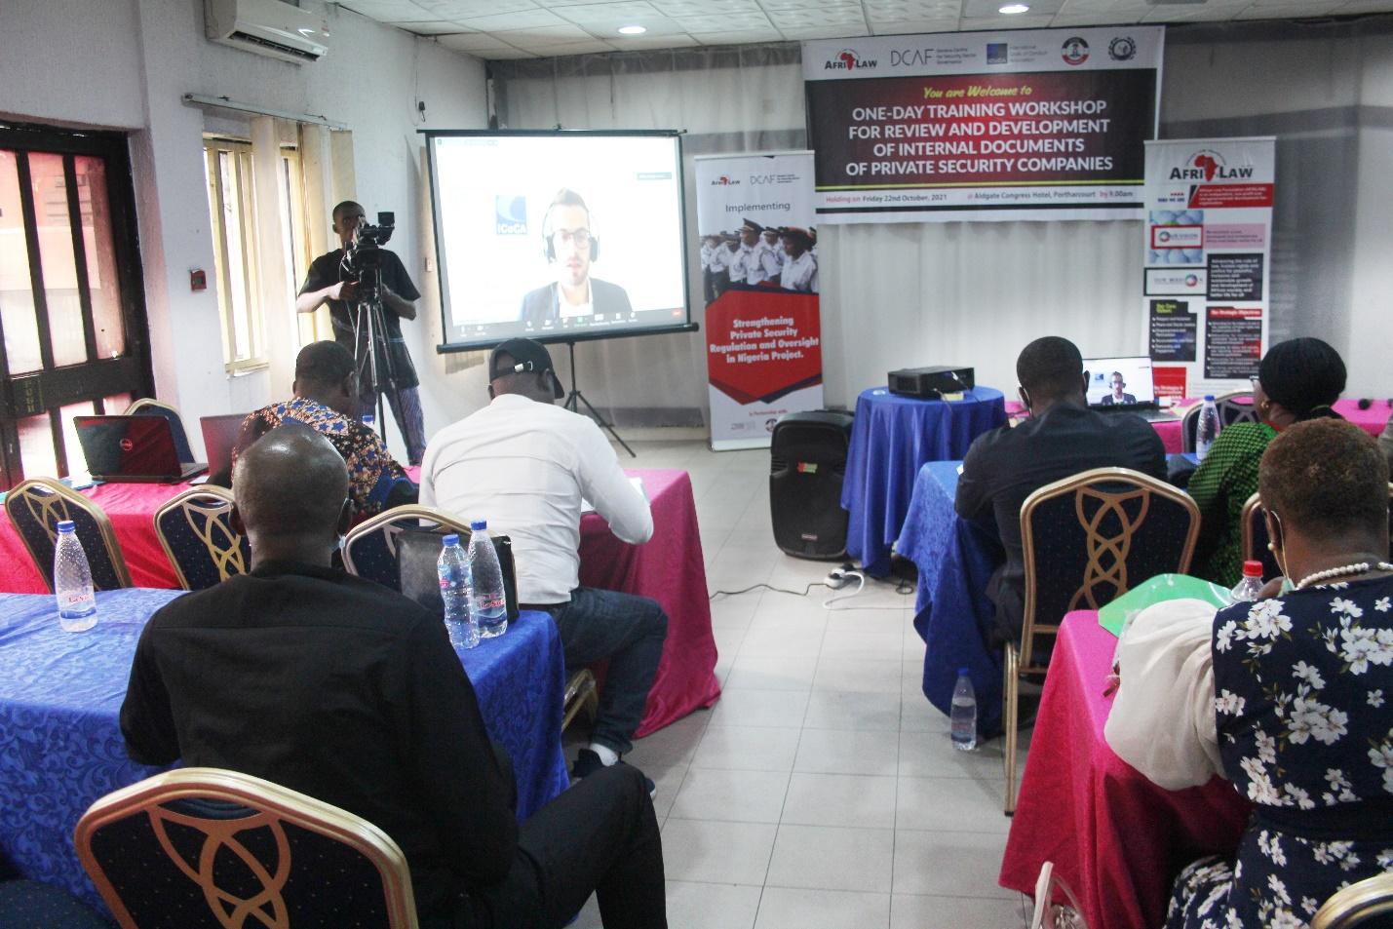
Mr. Galvin started by reiterating the benefits of joining the ICoCA. He said that the companies who become part of the code give them feedback that their operations improve as a result and their reputation improves with clients and prospective clients. Tenders go out preferring or insisting on companies with ICoCA membership from Clients. For companies this is an investment.
Going on to the topic, he said that the ICoC itself articulates the responsibilities of companies under human rights and humanitarian law to ensure responsible provision of private security. He said that section F of the code addresses the personnel of private security i.e. the guards while section G deals with the management and governance of PSCs. His presentation is centred on the latter. The monitoring function of ICoCA involves checking out how the members comply with the code i. e. section F and G and to do that ICoCA looks out for procedures in place and implementation on ground/in practice.
Section G which deals with governance has 13 commitments of companies in the area of management and governance. He focused on three of these commitments to give the participants and idea of what ICoCA looks out for in a company’s governance framework.
- ICoCA require that the guidelines in the code are incorporated in the policies of a company
- Also ICoCA wants to be sure that companies have a detailed outline of its vetting and selection of personnel, performance review of personnel, terms of employment of personnel written in the language the personnel understands. At the point of hiring companies have to ensure that individuals are not under the age of 18, have verifiable references, have sufficient physical and mental fitness to handle the job, have not dishonourably being discharged of any military duties etc.
They also want to see that companies hire without discrimination as to race, ethnicity, belief, colour, disability, sex or sexual orientation etc. That records of employment are kept until at least 7 years after dismissal of a personnel. That companies would consistently and periodically evaluate the mental capacity of personnel. That personnel must bring to their notice any reason(s) why they will not be able to provide their services.
He said that some challenges are present and can stand in the way of compliance to these requirements and they recognize them. ICoCA however is continuously learning ways to support companies to ensure that there is compliance to the processes on paper.
- On training, ICoCA looks out to see that companies have detailed documentation of their schedule for initial and recurrent training. Who is trained and on what? On implementation ICoCA wants to see a commitment by companies to provide initial and recurrent trainings. These trainings have to be done in the language the trainees understand. The trainings must contain risk assessment; explanations on the code, for people who use arms that they are trained on the type of arms they are permitted to carry. There should be proof of training records and the type of trainings delivered. These manuals of trainings also should be reviewed periodically.
He also enumerated some challenges that companies may encounter complying to these requirements and the challenges they encounter verifying it. He also said that ICoCA has developed a training manual on prevention of sexual exploitation and abuse, online cases are made available to affiliate and member companies and training guidelines have been provided on issues found in section F of the code.
- Finally, he spoke of grievance mechanism. Companies are required to establish “Grievance Complaint Mechanisms. He stated that these mechanisms may seem complex and for that reason ICOCA has come up with guidelines on how to operate a fair and accessible grievance mechanism. As far as grievance mechanisms are concerned the mechanism should speak to personnel and third parties; describe the role of each party in grievance procedure; define a process for accepting or rejecting complaints; the circumstances upon which complaints can be escalated; process for the complainant to bring in an advisor; process for handling anonymous complaints; confidentiality of all reports made etc
He also pointed the challenges on both ends for the grievance mechanism. He also said that where there are no complaints, ICoCA asks the question to find out if this is as a result of the fact that the company is running a perfect operation, or that the grievance mechanism is not assessable, or that the personnel and third parties do not trust the system.
Questions and Answers:
- What is ICoCA going to do for a complaint member company who is framed by its clients since there may be no tangible means of verifying these claims?
Response: with any type of complaint that comes in ICoCA analysizes and investigates these complaints to find out whether the complaint is relevant to ICoCA provisions i.e. whether there is substantial non-compliance to the code. Where such complaints are not relevant to the code though valid they would not be addressed by the association. The ICoCA would however come in where the complaints are relevant to the code.
Also, it is important to distinguish between complaints that are made in good faith but ultimately false and those that are made maliciously with the intent to defraud the company. When a complaint is made in good faith but is not substantiated, companies should see them as opportunities for improvement. Where the reverse is the case, companies can institute actions against such personnel.
- Criminal data base should be made robust and assessable to Private Security Companies so that its recruitment process is not stalled.
Response: This depends on whether the national body in custody of this information is willing to share it at the public domain or upon request. However, where there is no access to these information companies can leverage on other means of doing their due diligence by identifying alternatives to ascertain whether the individuals are fit for the job.
- What should a company get ready for registration at ICoCA?
- Would ICoCA provide a platform for interaction and networking amongst these companies for business advantages?
Response: this is one of the benefits of joining the association. The ICoCA works to ensure best practices and sharing among companies and is currently piloting a mentoring scheme for small and medium size companies. The idea of the scheme is to pair small and medium companies with larger companies who would hold their hands and assist them in their journey to standardization.
Functional Planning Support and Delivery of Security Operations Management System by PSCs – Africa Director, MSS Global Limited
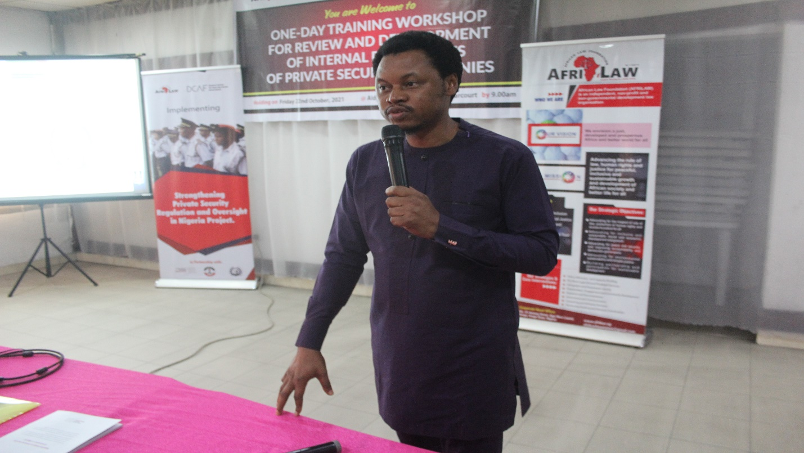

Mr. Jonah Eromon started his presentation by saying that the way a person decides to operate in an industry is what distinguishes him from other players in that field. He said that the Private Security Industry in Nigeria is experiencing set back because it has not decided to upgrade its standards and operations in the industry. This he said has pushed them to the back burner as foreign PSCs take up the business space in Nigeria. He went ahead to explain to the participants that while they scramble for the smaller jobs in Nigeria, companies who want to engage in Nigeria and have the big contracts usually first go to the ICoCA website to look at the companies that are certified in the regions they want to engage to offer them these security services.
Going further he also explained that to be ICoCA certified a person needs to go through MSS global certificate to obtain the ISO 190 2015. And to get that MSS global certification there are things that MSS global looks out for. Those things are the things he would discuss with them.
He said that MSS Global looks out for whether a company has a management system. He said that a management system is not the organogram of the company or a set of documents but that it is the interaction between all the departments and elements of that organization.
It would also be looking out for the strategic planning of that company and the step-in deed to bring those plans to fruition. These plans would answer the question
- What has to be done? This deals with the plan itself.
- Who will do it? Deals with specification of job roles.
- How will it be done? Deals with the standard operating procedures of the company.
- When will it be done? Which speaks of the time frame within which to achieve those goals.
MSS global will also look at the supplier’s competence of the company. This he said involves selection, vetting and engaging supply chain partners with a signed contract.
He then pointed out Clause 4 of the ICoC which affirms the responsibility of companies to all that are affected by their operations suppliers/vendors included.
Going forward he spoke about other things to look out for like risk assessment, support that a company has and needs, whether legal, technical or human resources requirements. Speaking on risk assessment he emphasized the need for companies to have and implement insurance policies for their clients.
He finally spoke on internal and external communications. Internally he said that companies are required to communicate policies, standards and vision to their staff and management. Externally, companies are expected to engage effectively with stakeholders. This is important for their operations.
Questions and Responses:
- Speaking about engaging with stakeholders, some communities are hostile to any form of external intrusions and may not want to engage with the companies. What is the way out?
Response: Communities would most likely push back in a situation where you bring in guards without first engaging with the community. The better approach is to have a liaison officer to interface between you and the community. Companies may also decide to employ their guards from the community and supervise externally. However those guards must be trained by the company on its standard operating systems.
- Insurance is an issue in Nigeria because the insurance companies do not comply with the provisions of the insurance and the insurance is very costly. What then would be the way out?
Response: it would be better to work with private insurance firms and engage the services of a lawyer to interpret those insurance documents to you and insure that your interest is protected therein. Also to take action where there is a breach.
Also and importantly, the association should insist on building themselves up to a point that they have a voice. This would increase their influence and make it easy for them to bring people to the table especially agencies like the Federal Inland Revenue Scheme and others whose functions directly affect the PSC operations to discuss issues relating to the industry and search solutions and also set standards within the industry.
This is important because though compliance is important it should not suffocate the complier.
- One of the challenges we encounter is that after a thorough assess of a job including the risk assessment and presenting these findings to a company, some of the companies jettison those recommendations and look for companies that are willing to do less and charge less.
- Considering the Nigerian peculiar situations are these provisions viable and can the standards be reduced to accommodate this situation?
Response: The standards are globally set and cannot be reduced; people can only rise up to them.
- How can ICoCA help the arm carrying campaign since this is the major thing that would give PSC greater jobs bigger than just gate keeping?
Response: Arm carrying is a regulatory issue and is within the scope of the NSCDC. NSCDC feels that the industry is not mature enough for it yet and insist that where there is need to carry arms; companies should collaborate with the NSCDC arms department. This is the reason why AFRILAW and its partners are preaching improvement and believe that where standards are improved these issues would become incidental.
HUMAN RIGHT IMPACT ASSESSMENT BY PRIVATE SECURITY COMPANIES BY MR. GIUSEPPE SCIROCCO, MONITORING OFFICER, ICOCA:
Mr. Giuseppe Scirocco started by saying that some years back the United Nations came up with the United Nations Guiding principle on business and human rights. He said that this was a milestone because it sets out the obligations of companies to make sure that they do not carry out actions that negatively impact human rights of persons in the places they operate and that where they do that they do something to address it. In other to show a level of responsibility in their activities companies are to identify and access areas they could have human rights impact, integrate what they have found in their work, take action on their findings, track the effectiveness of their actions and communicate how they have been addressing this human right impact assessment.
Defining human right impact assessment, he said that it is essentially a process through which companies identify and assess how their operations would negatively impact on the human rights of people. He said that human rights impact assessment is fundamentally a type of risk assessment but is different from other risks assessment in that where other risk assessments look at the risk on the company, human rights risk assessment looks at the impact of the engagement of the Private Security Company on people. It looks at the entire spectrum of human rights no matter how salient or not that right is.
He went ahead to say that ICoCA has published a guidance on human rights impact assessment. The guide was developed by a multi-stakeholder initiative, relies on already existing standards and is tailored towards the peculiarity of private security industries around the world.
Going further he took the group through the six (6) steps/ questions to ask when doing human right impact assessment. The steps include:
Step1: timing. Here he said that the question to ask is when to start the assessment. This could be done before operations begin to assess the potential impacts and when operations are already ongoing to assess both potential and current risks. This assessment is also reviewed periodically.
Step2: plan and scope. Here the parameters of assessment are established and questions like what is the operation, what is the context and who are the relevant stakeholders are asked. He said that stakeholders have different categories in this part but most important are the right holders, the duty bearers and other stakeholders that can provide relevant input such as CSOs. According to him, the stakeholder assessment is perhaps the most important part of impact assessment because it is directed to the people.
Step3: Data Collection and Baseline development. Once the stakeholders have being identified data should be collected to identify potential impact on these stakeholders. The data collected should not only represent the views of the company but the stakeholders especially the right holders should make an input in the assessment.
Step 4: Analyze impact. Here companies are to
- Identify adverse human right impacts that stem from their operations
- Assess the scale, scope and remendability of the impact
- Assess the impact severity
He said that the scope refers to number of people and/or groups of people that may be affected by their operations, scale refers to the extent of the impact while remendability refers to how much, or to what extent can the impact be remedied. The above 3 criteria would determine the impact severity.
Step 5: Mitigate and manage impact. Here he said that the 3 criteria above would determine what risks to prioritize. Once a company determines the severity and impact of the operations it should develop an impact management plan and develop a budget to that effect.
Step 6: Evaluate and Report: here the company ascertains how effective the assessment was in differing the impact. It ascertains whether the action identified has been implemented correctly and were they effective or not. And then reports externally on how it has addressed impacts and how the company intends to address future impacts. In areas of armed conflict companies are also to assess how its operations may escalate the conflict also companies are to consider not just human rights but international humanitarian laws in this context.
He concluded by saying that this assessment may seem technical and some companies especially smaller ones may need help in implementing it. This support he said can come from the government, CSOs and other organizations like ICoCA. According to him what ICOCA has done is that it has developed guidance on the area as said before, developed indicators to measure compliance by companies and developed questionnaires to assess those indicators. He said ICoCA stands ready to assist anyone who may need such assistance in this area.
Questions: There were no questions on this presentation
Group Works: Participant split into three groups for a brain storming session and at the end of those sessions each group presented its findings.
Group 1:
Group 1 answered the question “who are the relevant stakeholders”
They started by saying that a stakeholder is anyone who is connected, interested or/and impacted by a project.
Stakeholders in this context are:
- The community
- Management and Staff
- Government Security Agencies
- Vendors
- Management and Staff of Facility Security Operator
Group 2:
Group 2 identified possible human right issues that may arise as a result of the delivery of private security services.
To answer this question they divided their services into 3 parts thus:
- Access control
- Avoiding access. Where people are barred from accessing a particular place it may lead to a violation of the person’s right to associate and his right to personal liberty.
- Avoiding harassment/assault. In the course of doing its duty a company, in a bid to bar access stands the risk of harassing people.
- Static security/gate keeping
- The company may intimidate people and many be rude
- They may also encroach into the facility they were asked to provide security and breach the rights to privacy of the property owners.
- Electronic security particularly CCTV
- The company is at risk of breaching the right to privacy of its clients
- And also client’s confidentiality.
Group 3: The third group identified actions to prevent/mitigate adverse impact on human right thus:
- Ensure that adequate plans are made for emergency arms response
- Ensure that the operatives are provided with adequate PPE.
- Adequate number of personnel must be engaged to ensure that labour working hours are not exceeded
- There should be a standby medical outpost in case of health emergencies.
- Put in place adequate grievance response procedures.
- Engage liaison officer/personnel to interface with the host community.
- Ensure adequate shelter and convenience for operatives.
- Provide adequate incentives to motivate the operatives.
CLOSING SESSION: After this the ED of AFRILAW appreciated everyone for being a part and engaging in those timely conversations. He expressed hope that greater things and bigger achievements are possible as this drive keeps going.
On behalf DCAF, Gabrielle Prinkilopilovia expressed her appreciation and wished everyone a safe journey back. Closing prayers was taken by one of the participants. Group lunch followed at about 4:15pm.
Recommendation/Next Step: The workshop was very impactful and was well accepted and actively participated by the PSCs. There is a strong recommendation that this workshop should be replicated in the remaining 5 geo-political zones of Nigeria for ALPSPN members.

- THE PRIVATE SECURITY GOVERNANCE CHALLENGES AND THE RELEVANCE OF INTERNATIONAL NORMS AND BEST PRACTICES: CAPACITY BUILDING WORKSHOP FOR CSOS AND MEDIA.
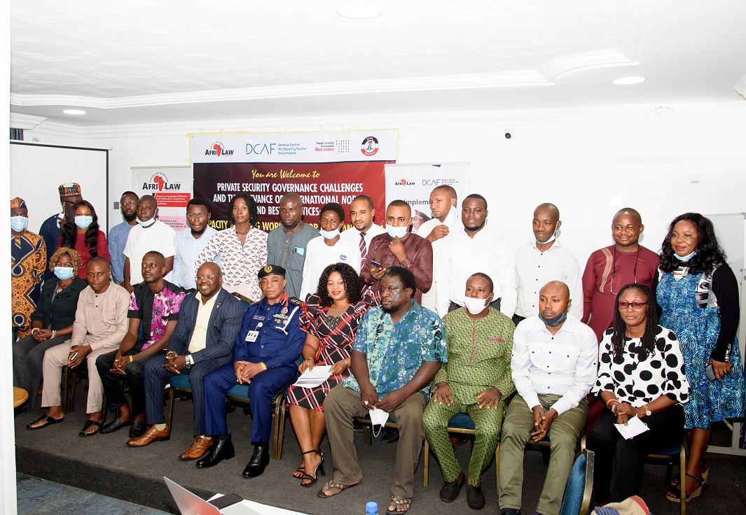
Participant group picture on capacity building workshop
INTRODUCTION: The Private Security Governance Challenges and The Relevance of International Norms and Best Practices: Capacity Building Workshop for CSOs and Media was held on Tuesday November 16, 2021 at Madam Janet Hall, TopView Hotel, Abuja. About 50 CSOs and Media representatives who participated in the workshop including ACG-PGC and his entourage who visited as a Special Guest. The Toolkit was developed to empower a strong and informed civil society and media: with the aims of providing updated information on the various challenges linked with private security companies’ activities in Nigeria, with detailed overview for each of the six geographical regions of the country; and providing guidance to CSOs and media on international norms and best practices. The guide draws on the three main source of international norms and good practices for the good governance of PSCs namely the International Code of Conduct for Private Security Service Providers (the Code), the Montreux Document on Private Military and Security Companies and the Voluntary Principles on Security and Human Rights (VPs).
OPENING SESSION: The event started with an opening prayer said by Ms. Inyingi Irimagha of GADA, Port-Harcourt, Rivers State at about 10: 00pm. Thereafter, there was a general introduction was done by participants present.
WELCOMING REMARKS AND SETTING THE AGENDA BY AFRILAW ED, BARR. OKEREKE CHINWIKE: The meeting started at 10 am with an apology from the convener in person of Barr. Chinwike for starting the meeting late, he welcomed everyone present from far and near for making out time for attending this wonderful occasion. He said that the meeting is joined with the conference for private security, he on behalf of the partners sincerely welcomed everyone and said the program is centered on improving security in the country and improving areas that will avoid the fall of the sector. He said that in ensuring that the challenges are properly handled, there are various factors that are going to be looked into to handle the challenges.
GENERAL REMARKS BY DCAF: The representative of DCAF in person of Ms. Emmylou Boddi, welcomed everyone seated, she thanked everyone present and the NSCDC for their contribution towards making this gathering a success and the state of private security in Nigeria. She went further to state that today is an opportunity to discuss how the key role researched on will support the process. DCAF has being in support of the process for the process and look forward to being physically present in the next meeting. Finally she appreciated AFRILAW for the incredible work so far.
OVERVIEW OF AFRILAWS/NSCDC/DCAF PROJECT IN NIGERIA: Barr. Okereke Chinwike appreciated the effort of DCAF for making it possible for us to be here, he said that there is one workshop left to round up the activities for this year. The project of AFRILAW/NSCDC projects so far by the organization has witnessed progress at most levels so far, In the Beginning: The Baseline Study on Private Security Governance in Nigeria Project (2018-2019) To review the existing legal and regulatory frameworks governing the operations of PSCs, Assess their standards of operations and challenges, To issue recommendations for legal and policy reforms and general improvement of the operations of PSCs in Nigeria, moving forward, he gave the activities for the year 2020- 2021 starting with aims which includes:
- To raise awareness and to discuss challenges and opportunities presented by the private security sector as well as ways to strengthen its governance in a multi-stakeholder approach in Nigeria.
- About 350 policymakers and stakeholders were engaged and sensitized.
He further stated to say that research was conducted in some parts of the country including some zones across the country and the included: Kano State, Enugu State, FCT/Abuja, Lagos State, AkwaIbom State and Bauchi State getting the stakeholders together to discuss the approach of private security in Nigeria. The executive director stated that the various programs hosted by the organization was well attended and wonderful recommendations on human rights, justice and security were bought together, a radio program was organized and about 2milion people were sensitized through the media platform (media and news broadcast/publications) people contributed their quota and recommendations were made.
He went further to emphasize more on the second outreach which has to do with Joint outreach on the Montreux Document and the International Code of Conduct in Nigeria (ICOC/MD Outreach Programme) and it entails ICoC/MD Sensitization during the PSG Forum which aim is to assist Nigeria in becoming a member of the Montreux Document Forum (MDF) and the International Code of Conduct Association (ICoCA) initiatives, CSOs/Media capacity-building tool development and capacity building, Government outreach event .
He stated that in order to advocate for this initiative, there was a round table, were the research idea was shared, Conduct research to identify the main private security governance gaps and challenges in their region that could be addressed by Montreux Document and Code implementation. The Report includes the main findings on regional private security challenges and an outline of how international good practices contained in the MD and the Code can address such challenges and state that those who are not part of the organization should ensure the do that at the end of the meeting because NSCDC has taking a bold step by joining this organization.
He further stated that during the process of developing this Guide, we selected and engaged 6 security and human rights experts from the 6 geo-political zones and also 4 media representatives who conducted a research to identify the applicability and relevance of the key principles and provisions from the 3 initiatives across their various regions in Nigeria.
The goal of the Nigeria CSOs Conference is to initiate first gathering of Nigerian civil society organisations to share experiences on CSO’s role in the good governance of private security in Nigeria, identify challenges and define the need for support and as well as The first gathering of Nigerian civil society organisations to share experiences on CSO’s role in the good governance of private security in Nigeria, identify challenges and define the need for support. There was some question from the participants based on the presentation which was attended to by AFRILAW ED.
Special Guest Visit by NSCDC Assistant Commandant General Private Guards Companies (ACG-PGC) represented by ACG-PGC Mr. Raji Ibrahim: The NSCDC ACG-PGC came as a Special Guest to the Workshop to felicitate with AFRILAW and the workshop participants. He expressed his delight for the invitation, and on behalf of the CG appreciated AFRILAW and DCAF for their work in mobilizing and engaging the CSOs and Media toward promoting the development of the private security industry in Nigeria. Also, he thanked and appreciated the participants and expressed the NSCDC willingness to partner and work with CSOs and Media to promote private security sector in Nigeria. He finally wished a participants a successful workshop event. The ACG-PGC took a group picture with the participants before he left.
PANEL REFLEXIONS ON THE PRIVATE SECURITY GOVERNANCE CHALLENGES AND THE RELEVANCE OF INTERNATIONAL NORMS AND BEST PRACTICES: A GUIDE FOR CIVIL SOCIETY AND MEDIA, NIGERIA: This session started with presentation of the Guide by AFRILAW ED and he gave an overview of the contents of the Book. He also explained the process and the contributions of various stakeholders especially some CSOs and Media representatives some of who are part of the discussion. He emphasized the importance of the toolkit and roles of the CSOs and media therein. Other members of the Panellists who reflected on the challenges of private security governance and what does the Guide offer and including the next steps.
The Panellists is made up of selected CSOs and Media Representatives who were engaged as researchers for the development of the toolkit. The selected CSOs and Media Representatives include:
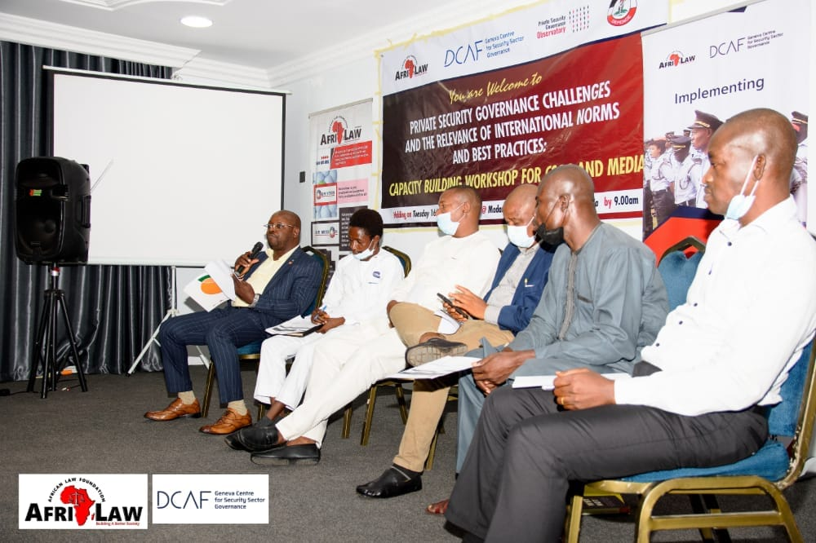

The Panellists Include:
- Mr. Kelechi Nwaucha (Media Representatives)
- Mr. Ignatius Okpara (Media Representatives)
- Mr. Abba Bello Ahmed (CSOs Representatives)
- Mr. Saviour Akpan (CSOs Representatives)
- Mr. Mbami Llia Sabka (CSOs Representatives)

Each CSOs and Media Representatives where given an opportunity to share his experience during the research for the toolkit, and expressed their various opinions on the challenges of private security governance and what the Guide offer and including the next steps. Some of the reflections include:

Mr. Abba Bello Ahmed said the research and workshop came at the right time due to the issue of insecurity in the country, issues around human rights, use of weapon, the research looked into issues and identifying the challenges, when we talk about security, we need to engage people in that area. He recommended for more capacity for CSOs to enable them to effectively engage with the private security stakeholders and play their role in the area of ensuring private security governance, monitoring and reporting of human rights abuses by PSCs in Nigeria.

Mr. Kelechi Nwaucha stated that before the research work that he was no exposed or informed about the private security issues and the works of PSCs in Nigeria. That the work have helped him a lot to learn and be sensitized in this regard. He suggested for more engagement and training for media personnel and most of them are not familiar with the private security sector.
Mr. Illiya from PIDI Bauchi State said that some of the challenges identified were discussed in part of the research by AFRILAW, there is a difference between private security and the modus of operandi and the toolkit is gender sensitive because some of the respondents are females. He said a lot of issues were identified and discussed during the research. He called for training and engagement with relevant private security stakeholders on mainstreaming gender and promoting gender perspectives in private security sector in Nigeria.
Mr. Ignatius said from the media perspective, when the private security commits an offense, there is proper procedure of operations. He stated that there is limited information and the media find it difficult to access and report offense against human rights perpetuated by the PSCs and their personnel. He recommend for engagement with media across through training and sensitization.
Mr. Savior Akpan from COMPPART Foundation Uyo commends AFRILAW for the effort so far, he states that he prays the bill is passed to be able to tackle the issues regarding security and also check-mating the excesses in the private security company. He stated that there should be core values that will guide and regulate the activities of the private security. He stated the need for improved and continuous CSOs and Media participation in improving and promoting the private security governance and holding the PSCs and NSCDC accountable and ensuring the private security industry operates within the principles of human rights and respect of rule of law.
PRESENTATION ON CHALLENGES IN FOCUS: MONITORING & REPORTING OF PSCS HUMAN RIGHTS ABUSES BY DR. AUSTEN BISINA (PROGRAMMER MANAGER LITE- AFRICA): The presenter started by appreciating everyone present. He started by introducing the participants to the context of human rights monitoring, and reporting on private security companies. Human rights wrongs are a big problem for the Nigerian government. Torture, domestic abuse, arbitrary arrest and incarceration, sexual assault, and extrajudicial killings are only a few examples of these violations. CSOs and human rights activists are working across the country to prevent and prosecute these breaches, but they are up against many obstacles. As a result, more grassroots human rights monitors must be educated to watch, document, and report abuses of human rights.
He went further to talk more on understanding monitoring and reporting which has to do with the process of collecting, analyzing, and disseminating information about human rights abuses in a systematic and active manner for immediate use by concerned and interested parties. The Working Group has defined a private military and security company as “a corporate entity which provides, on a compensatory basis, military and/or security services by physical persons and/or legal entities.” They may operate in both conflict and peacetime situations and are significant providers of military and security products and services in the cybersphere. Emphasizing more on monitoring and reporting, he states the A global study undertaken by the Working Group on national legislation for PMSCs covered over 50 countries and showed that national regulation in this industry is inconsistent and that robust safeguards against potential human rights violations by PMSC personnel are lacking.

While some of the challenges encountered so far are includes:
- Data and information are in short supply
- The private security sector operates on both a global and national scale.
- Seeming mix of public and private security
- Weak national legal frameworks to control and manage the private security sector, to prevent and addressing human rights abuses by companies and their staff.
He said that human rights are a big problems for the Nigerian government which include torture domestic abuse, arbitrary arrest and extra judicial killings and only a few of these validations. CSOs are human right activists are working across the country to prevent and prosecute these breaches, but they are up against many obstacles.
Some of the questions from the Participants:
- How do we check with the entertainment industry on how to get stakeholders to come on this platform to give the media a gateway?
- At what stage can we say that the human right is violated?
- How long can information be on a data base before it is erased from a database?
Dr. Austen stated that information on a data base can remain there for some years and one of the participants said that information can remain on a database for 3-5years.
GROUP WORK ON MONITORING OF PSC HUMAN ABUSES.
Civil Society and Media: How Can Their Role Be Strengthened: Various groups where assigned to discuss extensively on the issues and after much deliberation, from the groups.

PRESENTATION ON CHALLENGES IN FOCUS: GENDER AND PSCS BY BARR. OKEREKE CHINWIKE: Barr. Okereke started his presentation with interactive method through the “Gender Game”, where he asked some gender related and they answered.
He started his main presentation explaining Gender perspectives under the UN Guiding Principles on Business and Human Rights. He stated that the Guiding Principles contain several references to gender and women. The references can be grouped into 3 “Gender Windows”.
- Window 1: This is framed by the general principle of non-discrimination: the Guiding Principles should be implemented in a non-discriminatory manner with due regard to the different risks that may be faced by women and men.
- Window 2: This is shaped by provisions explicitly highlighting the need to integrate a gender perspective at certain places. The commentary to guiding Principle 3 provides that States should provide appropriate guidance to businesses on how to consider effectively issues of, among other things, gender, recognizing the specific challenges that may be faced by women.
- Widow 3: The foundation of the third gender window is the commentary to Guiding Principle 12, which provides that, depending on circumstances, business enterprises may need to consider additional standards.
He emphasised the importance of integrating a gender perspective in PSC services, and integrating a gender perspective was defined as seeing or analysing the impact of gender roles, gender stereotypes and gendered power structures in society and in institutions. Integrating a gender perspective enables one to make women’s as well as men’s concerns and experiences an integral dimension of the design, implementation, monitoring and evaluation of policies and programmes, so that women and men benefit equally, and inequality is not perpetuated.
In addition, it is a strategy by which to achieve gender equality, which can be understood as “the absence of discrimination on the basis of a person’s sex in opportunities, the allocation of resources or benefits, or in access to services.” A gender perspective also recognized how a person’s gender affects their opportunities is shaped by factors such as their ethnicity, religion, age, social class, sexual orientation, gender identity and expression, marital status, race, ethnicity and disability.
Integrating a gender perspective in the regulation of PSCs means both analysing the potential and actual impact of PSCs’ operations on different groups of men, women, boys and girls, and also making women’s as well as men’s concerns and experiences an integral dimension of the design, implementation, monitoring and evaluation of private security regulation.
Some Gender-based Challenges and the PSCs: He further state that activities of PSCs and their personnel affect various parts of communities differently. Women and girls, in particular, face discrimination and barriers to seeking effective remedies such as stipulated:
- Sexual violence, and other forms of gender-based violence (GBV), disproportionally affect women and girls.
- Abuse by security guards in the extractive industry was identified by the UN in multi-stakeholder consultations as a significant challenge
- The risk of firearms being used in domestic violence murders is increased where private security personnel are authorised to carry small arms and light weapons
- Women and men face inequality in opportunities to work within PSCs.
- Evidence suggests that women routinely experience discrimination, are overwhelmingly employed in marginal roles, are overlooked or disregarded in company policies, and have limited access to managerial roles.
National, regional and international legal frameworks for gender equality apply to State regulation of PSCs:
- International: International Covenant of Civil and Political Rights (ICCPR), International Covenant on Economic, Social and Cultural Rights (ICESCR), Convention on the Elimination of All Forms of Discrimination against Women (CEDAW) and Its Optional Protocol.
- Regional: African Charter on Human and People’s Rights, Protocol to the African Charter on the Rights of Women in Africa, and the Declaration on Gender Equality in Africa
- National: 1999 Constitution, Violence Against Person (Prohibition) Act, African Charter on Human and People’s Right (Enforcement and Ratification) Act, Labour Act.
ICOC Requirements: The ICoC requires private security companies to:
- Prevent the engagement of their personnel in SEA (including prostitution) or GBV (including rape, sexual harassment, or any other form of sexual abuse or violence);
- Ensure that they or their personnel do not benefit from SEA, including prostitution, or GBV;
- Remain vigilant for all instances of SEA or GBV; and
- Report instances of SEA or GBV to competent authorities.
How can States integrate a gender perspective in the regulation of PMSCs?
- Regulate PSCs in a consultative manner
- Establish a national PSC regulatory authority with gender expertise
- Integrate a gender perspective in the licensing requirements for PSCs:
- Company procedures on effective vetting of personnel,
- Required training for PMSC personnel,
- Required training for PMSC personnel,
What to Integrate or Require When drafting the PSC contract:
- Requirements to respect all rights and obligations related to SEA, GBV, international human rights law and international humanitarian law, as well as applicable national laws.
- Clearly delineated roles, duties and responsibilities for the PSC.
- Clear statement of the context in which the PSC operates.
- Clear definition of the limits of the PSC’s duties.
- The activities contracted to private security personnel should not negatively impact the community – considered with reference to the particular vulnerabilities of women, girls, men and boys.
GENERAL DISCUSSIONS AND NEXT STEPS:
There was general discussion on the next steps and development of a strategy that will help to strengthen CSOs and Media’s role in the good governance of private security in Nigeria. The participants at the workshop made some suggestions and highlighted some next steps which include the following:
- There is need for more mapping and identification of stakeholders and their effective engagement across the country
- Proper documentation and monitoring in terms of human rights abuses etc.
- Create client forums to sensitize them before engaging PSC
- Make private security governance trend via various social media platforms
- Organize forums where both regulators and private security companies meet to exchange ideas
- Consider creating frameworks on how to implement all that has been discussed in terms of legal framework, media and gender issues
- Develop APP technology in terms of tracking and monitoring PSC and their employees
- Using google alert in case of low funding.
CLOSING REMARKS: The ED of AFRILAW gave the closing remarks and thanked all participants present for their patience and contributions. He also stressed the need for stakeholders to take steps towards implementing all that has been discussed about in this forum. On his part, he also promised to keep the light burning and take vigorous steps towards ensuring the implementation of all that has been discussed today and also take all necessary follow up actions seriously. The workshop ended at about 5:00pm.
Recommendation/Next Step: The workshop was very impactful and was well accepted and actively participated by selected CSOs and Media representatives. There is a strong recommendation for more capacity building workshops for CSOs and Media across the 6 geo-political zones of Nigeria for PSCs Clients and Users. Also, there is need for gender specific programmes for the private security sector in Nigeria.

- PUBLIC PRESENTATION/LAUNCHING EVENT OF THE TOOLKIT: “PRIVATE SECURITY GOVERNANCE CHALLENGES AND THE RELEVANCE OF INTERNATIONAL NORMS AND BEST PRACTICES: A GUIDE FOR CIVIL SOCIETY AND MEDIA”

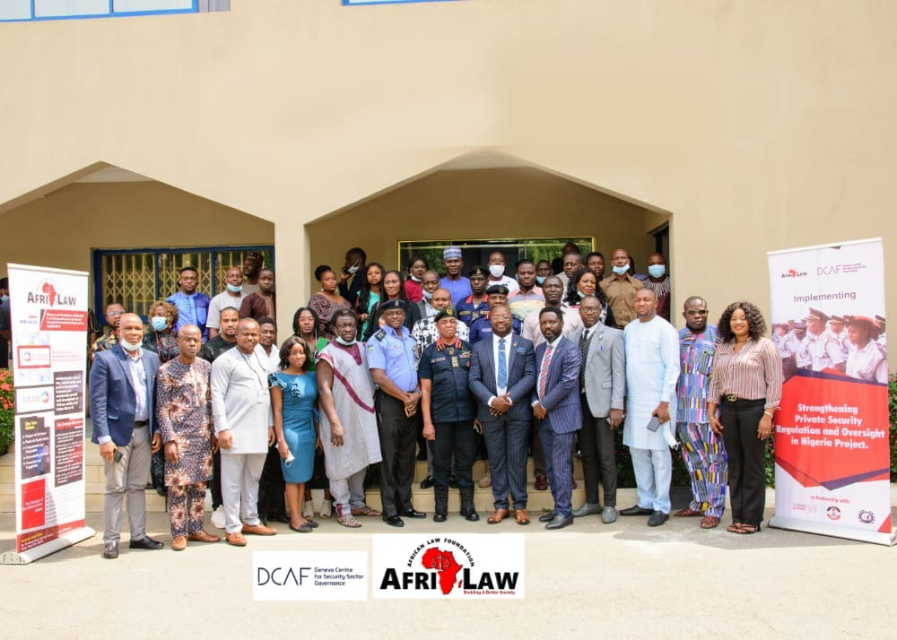Participant’s group picture
INTRODUCTION: The Public Presentation/Launching Event of the Toolkit: “Private Security Governance Challenges and the Relevance of International Norms and Best Practices: A Guide for Civil Society and Media” was held on Wednesday 17th of November, 2021 at Madam Janet Hall, TopView Hotel, Wuse Zone 5, Abuja. There were about 70 participants covering representatives from federal government security, justice and human rights agencies, CSOs/NGOs/INGOs and Media, ALPSPN and PS industry and Swiss Embassy. The Public Presentation/Launching Event was chaired by the Commandant General of the NSCDC ably represented by Assistant Commandant General Private Guard Company (ACG-PGC), Mr. Raji Ibrahim. The Toolkit was developed to empower a strong and informed civil society and media: with the aims of providing updated information on the various challenges linked with private security companies’ activities in Nigeria, with detailed overview for each of the six geographical regions of the country; and providing guidance to CSOs and media on international norms and best practices. The guide draws on the three main source of international norms and good practices for the good governance of PSCs namely the International Code of Conduct for Private Security Service Providers (the Code), the Montreux Document on Private Military and Security Companies and the Voluntary Principles on Security and Human Rights (VPs).

WELCOME REMARK AND SETTING THE AGENDA BY THE EXECUTIVE DIRECTOR OF AFRILAW:
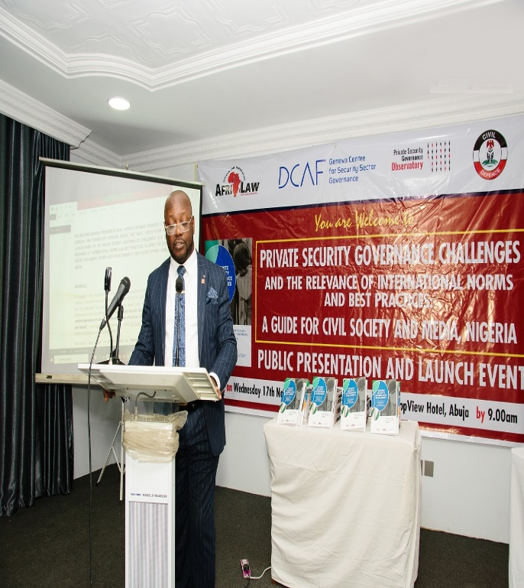AFRILAW ED during his presentation
He welcomes everyone on behalf of the organizers of this event, African Law Foundation (AFRILAW) and Geneva center for security sector for security governance (DCAF) in partnership with NSCDC, he said he is very pleased and delighted to welcome everyone to the public presentation and launching of the toolkit “Private Security Governance Challenges and The of International Norms and Practices: A Guide For Civil Society and Media”. He specially welcomed everyone.
He went further to state that this launching is a part of the activities under strengthening private security regulation and oversight in Nigeria project being implemented by African law foundation (AFRILAW) and Gevena Center for Security Sector Governance (DCAF) in partnership with Private Security Governance Observatory and Nigeria Security and Civil Defense Corps (NSCDC), and with partnership and support of Association of Licensed Private Security Practitioners of Nigeria (ALPSN). Crime, violence and insecurity rise in Nigeria, demand for the private security services has strongly increased in the last decade. While the number of registered private security companies grew exponentially, private security companies have grown in importance in the government’s fight against the rising crime, violence and insecurity rise across the nation.
In regards to civil society which plays a fundamental role in promoting a better understanding of private security that violations are reported and that of applicable national laws and policies address all relevant issues. CSOs and media who are conscious of their role covering topics that affects the private security sector, he said that the guide was developed to empower a strong and informed civil society and media. The guide draws on a three main source of international norms and best practices for good governance of PSCs, namely the international code of conduct for private security service providers, the Monteux document on private military and security companies and the voluntary principles on security and human rights.
Rounding up he appreciated the Commandant General of NSCDC, assistant commandant general private guard company and the national president and the executives of association of licensed private security practitioners association of Nigeria (ALPSN), CSOs and the media for their support and partnership with AFRILAW in implementing various projects and activities towards strengthening private security governance and advancing responsible private security service in Nigeria.
WELCOME REMARKS BY DCAF: Ms. Emmylou Boddi on behalf of DCAF welcomed all stakeholders present for making out time for this meeting. She spoke on good governance and private security. She said it’s a really wonderful to be a part of the launching the Guide for civil society and media and the relevance of international norm and best practices and from the feedback received is truly inspiring. The code of conduct and research has helped to point out the challenges being faced by the private security sector in Nigeria. She thanked everyone for the support, open-mindedness, and the privilege to be present today for the launching which will lead to the next step towards the progress of private security sector in Nigeria.
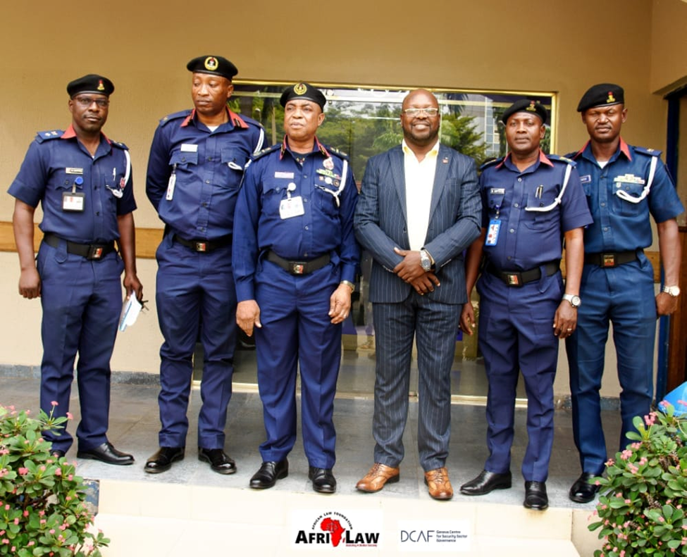
ED of AFRILAW with NSCDS Members

GOODWILL MESSAGE FROM THE INSPECTOR GENERAL OF THE NIGERIAN POLICE FORCE, ABLY REPRESENTED BY CSP OLUMUYIWA ADEJOBI:
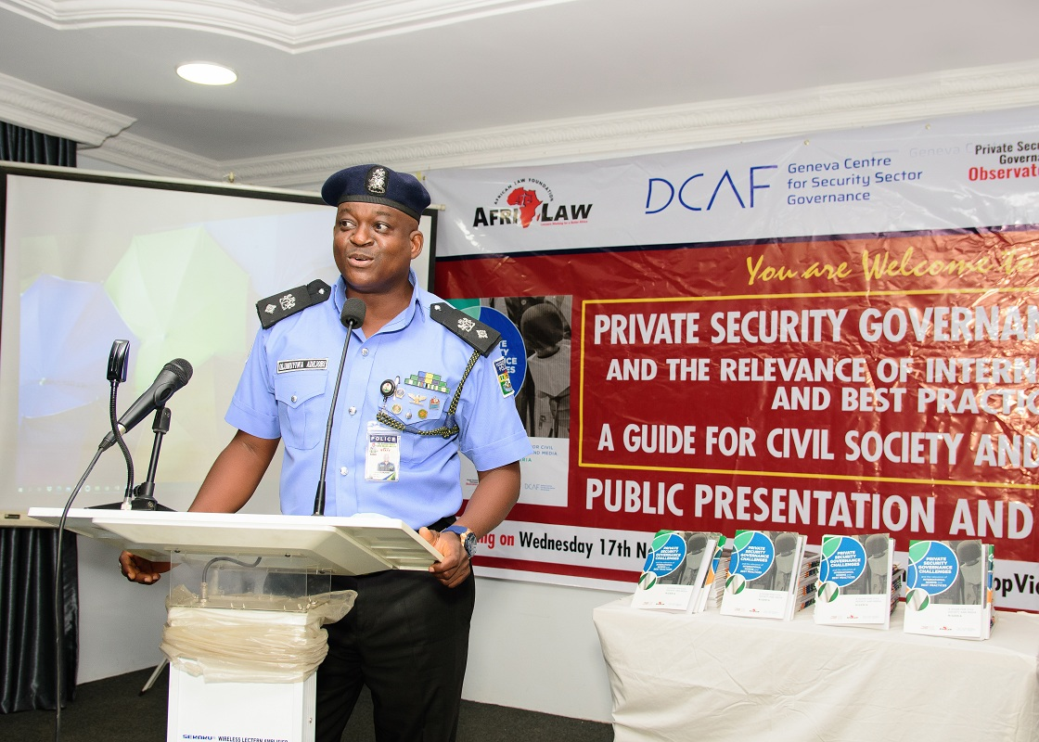Welcome address
He welcomed everyone present at the meeting and said the Nigerian police force are very happy to be present here in this gathering. He said one of the major responsibilities of the NSCDC is mentoring and vetting the activities of the private security sector, AFRILAW has put together the code of conduct and the federal government should try in improving better security. He said every individual has a role to play in ensuring good governance and better security in the country.
He appealed to African law foundation to do more of such programs to help in proper update of information among the security agencies in the country. Everything in life is dynamic and dimensional and so the Nigerian police are ready to work with all the security agencies to improve security in Nigeria.
GOODWILL MESSAGE BY SULYMAN DAWODU, SECRETARY OF ADMINISTRATION OF CRIMINAL JUSTICE MONITORING COMMITTEE (ACJMC), FEDERAL MINISTRY OF JUSTICE: He started by thanking the executive director for the opportunity to be part of the occasion, saying that the toolkit came in every timely due to the nature of security currently in the country. The effort by AFRILAW towards strengthening private security is very important, he also used the opportunity to invite members of the public, the fourth realm and private investigators to put hands together to promote and strengthen our security apparatus and also be vigilant. The Administration of Criminal Justice Monitoring Committee is also doing their best to ensure decongestion in correctional centers through speedily dispensation of justice. We are in a new era of promoting security.
GOODWILL MESSAGE BY MR. MEBRIM KENNETH, REPRESENTING THE EXECUTIVE SECRETARY OF NATIONAL HUMAN RIGHT COMMISSION (NHRC): He started his speech by appreciating AFRILAW and partners for their effort so far in ensuring good security and launch of the toolkits. It is a fact that the role played by private Security Company and the media are appreciated. The role played by private security companies, civil society and the media is very essential. He gave kudos to the management of African law foundation for not looking out for their selves alone but including media and other CSOs making them co-partners in the journey towards good governance and nation building. Nigerians are expected to join the band wagon in various activities that will help in this course. It is therefore interesting to note that government alone cannot address all the problems in the society. He ended by urging every CSOs, private security companies and the media should work relentlessly for the betterment of all and working towards the good of humanity.
WELCOME/OPENING REMARK BY THE ASSISTANT COMMANDANT GENERAL, PRIVATE GUARD COMPANY (PGC) RAJI IBRAHIM REPRESENTING THE COMMANDANT GENERAL OF NSCDC:
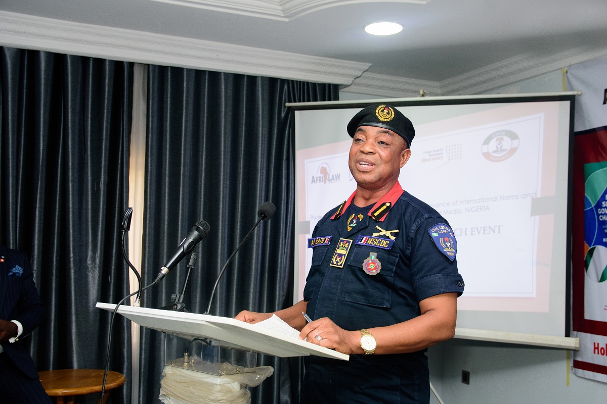Welcome address
ACG Raji Ibrahim welcomed everyone and states that the issue of security issues today is not a man show, but everyone’s business. If there is synergies and collaboration among the security agencies, things will be better when information is properly shared. He stated that the private guard companies in line with global standards have grown into advance information sharing because they are closer to the grassroots. NSCDC being a civil society are closer to the grass-root and community and the information sharing is efficient. He said the role of private security companies all over Nigeria cannot be over- emphasized and NSCDC is ready to support the program at time, any day to ensure security.
The book launching today will broaden and strengthen the role of private security companies and he went further to appreciate AFRILAW and Geneva Center for Security Sector for Security government (DCAF) for all their effort, support and partnership with NSCDC. He stated further that the NSCDC is ready and willing to join ICoC and MDF. He thereafter declared the Event opened.
OVERVIEW OF AFRILAW/NSCDC/DCAF PROJECT IN NIGERIA BY BARR.OKEREKE CHINWIKE: Barr. Okereke Chinwike started by appreciating partners like DCAF for their overwhelming support and contribution in promoting human rights and private security since the organization was founded in 2013, the organization has being in charge of good governance and private security business . The research conducted gave the basic foundation which has helped a lot.
The research conducted has helped to bring out the challenges and ways in rectifying issues faced by the private security sector. The research has yielded positive results on the way forward. Through the forum, radio programs were organized in some state like Kano, Bauchi, Lagos, Enugu and Port Harcourt it helped to sensitize the private security governance forum. Joint outreach was carried out as part of activities for the year. There was an overwhelming support and the network from the MDF observatory committee helped to mobilize other sectors to help.
BOOK REVIEW BY DR. NDUBUISI NWOKOLO (MANAGING PARTNER AND CHIEF EXECUTIVE, NEXTIER SPD: Dr. Ndubuisi thanked AFRILAW and DCAF including everyone who has contributed to putting the book together. He said it is very important to say that the growth of private security company is failing, how we can regulate the activities of the sector. He said firstly we are doing the private security for business, to create jobs and contribute to national security structure and going through the manual, the sector is contributing to the economy. Necessary structure that will improve this sector should be put in place and civilian oversight needs to be brought forward. He concluded by saying that this guide provides an in-depth knowledge of the industry to CSOs and the Media. It will be good if every stakeholder in the industry understands the industry to raise the bar of accountability.
He made a presentation and critically reviewed the Toolkit chapter by chapter review covering the topics such as: What is Private Security; What is the Role of Civil Society and the Media in Good Private Security Governance; the International Frameworks including the United Nations Guiding Principles on Business and Human Rights (UNGPs); Montreux Document on Private Military and Security Companies (MD); The International Code of Conduct for Private Security Service Providers (The Code); and Voluntary Principles on Security and Human Rights (VPs); and Private security governance challenges and the relevance of international norms and practices in Nigeria.
PRESENTATION ON THE RELEVANCE OF MONTREUX DOCUMENT AND INTERNATIONAL CODE OF CONDUCT ASSOCIATION TO NIGERIA: WHY NIGERIA SHOULD JOIN THE INITIATIVES BY MR. NWAKONYE OBINNA (DEPUTY DIRECTOR, HUMAN RIGHTS INSTITUTE, NATIONAL HUMAN COMMISSION (NHRC) & NIGERIA WORKING GROUP ON MD/ ICOCA MEMBER): Mr. Nwakonye started his presentation by appreciating everyone seated for this great occasion. He said the complexities surrounding the use of private security companies have become increasingly visible, due to incidents of gross human rights violations involving private security operations. This led to the perception that PSCs somehow operate with impunity and outside the realm of international law. In order to dispel the idea of a legal vacuum and to promote compliance of PSCs with international humanitarian and human rights laws, the International Committee of the Red Cross and the Swiss government initiated an intergovernmental process leading to the development of the Montreux Document.
His presentation covered situational analysis of security and PS sector in Nigeria; Conceptual Exposition on the Montreux Document (MD), the International Code of Conduct (ICoC) and ICoC and its Association (ICoCA); Understanding the relationship between the Montreux Document and the International Code of Conduct in the regulation of global private security industry; Relevance of MD/ ICoCA to Nigeria; Why Nigeria should join the Initiatives; and How Nigeria can join MDF and ICoCA.
He stated that following the adoption of the Monteux Document (MD), leading PSCs; several governments; and selected civil society actors initiated a parallel multi-stakeholder initiative to develop the International Code of Conduct for Private Security Service Providers (ICoC, the Code, or the Code of Conduct). The ICoC requires companies to comply with these principles, to include them in personnel and subcontractor contracts, and not to enter into contracts where performance would directly or materially conflict with them.
With the emergence of new security challenges in Nigeria, there was sharp increase in private security services contracted by individuals, organisations, businesses and State agencies. Currently, Nigeria is undertaking efforts to update its legal and regulatory framework to address the evolution of the private security sector and the new emerging security threats facing the country. As the Federal agency in charge of overseeing Private Security Companies (PSC) and their activities, the Nigeria Security and Civil Defense Corps (NSCDC) leading the efforts towards a more accountable and responsible private security operations in Nigeria.
Concluding his presentation, Nwakonye said that The Montreux Document and ICoC are two independent but complementary initiatives to regulate the private security industry globally and the relevance of the MD and ICoC lie in the relationship, interaction and cooperation with other Nations and learning standard practices, administration, monitoring and regulations of private security industry. He said that there is a need for Nigeria to join ICoC so that innovations can be exploited to their full potential in supporting oversight of private security industry in Nigeria and as a member to the Montreux Document Forum, Nigeria would access the MDF’s platform for exchange on national and international good practices in private security regulation.
PUBLIC PRESENTATION OF THE PRIVATE SECURITY GOVERANCE CHALLENGES AND THE RELEVANCE OF INTERNATIONAL NORMS AND BEST PRACTICES “A GUIDE FOR CIVIL SOCIETY AND MEDIA”, NIGERIA BY THE ASSISTANT COMMANDANT GENERAL, PRIVATE GUARD COMPANY (PGC) RAJI IBRAHIM REPRESENTING THE COMMANDANT GENERAL OF NSCDC:
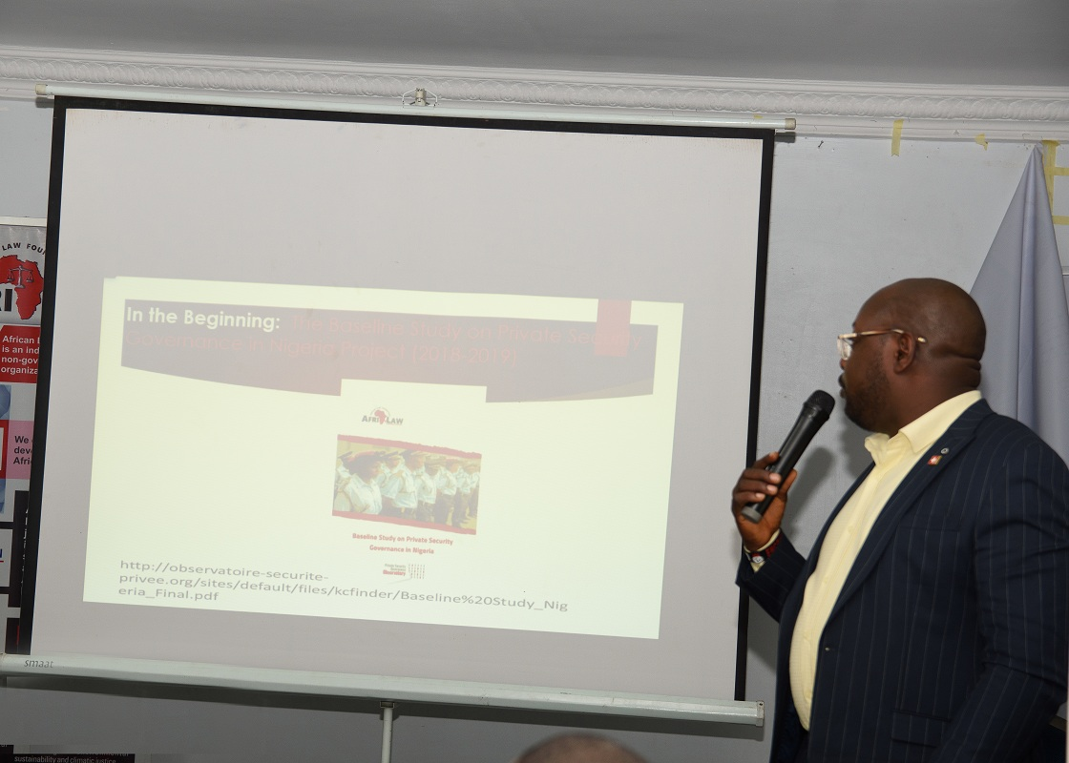
AFRILAW ED, Barr. Okereke Chinwike started by appreciating the efforts and contributions of DCAF and other CSOs and Media representatives in developing the Toolkit. He attributed the success to collective efforts of all and appreciated all of them. He specially appreciated the support and partnership of NSCDC to AFRILAW since 2018 and throughout the implementation of 2021 project activities. Thereafter he invited the representative of the CG of NSCDC, ACG-PGC Mr. Raji Ibrahim to do the public presentation of the Toolkit.
The ACG-PGC Mr. Raji Ibrahim made a public presentation of the Toolkit and in his remark he appreciated the efforts and contribution of AFRILAW and DCAF in developing the Toolkit and stated that the 3 initiatives covered is very relevant in ensuring private security governance and responsible services in Nigeria, and the toolkit will help the stakeholders to under this and promote the same.
He emphasised the importance and contributions of CSOs and Media support and engagement toward improving private security governance and private security services in Nigeria. He stated that the Toolkit will help to improve the engagement and contribution of CSOs and Media in advancing the private security industry in Nigeria. The ACG-PGC was later joined by representatives of the Swiss Embassy, Nigeria Police Force, National Human Rights Commission, the Book Reviewer, AFRILAW and the event Moderator to do the public presentation.
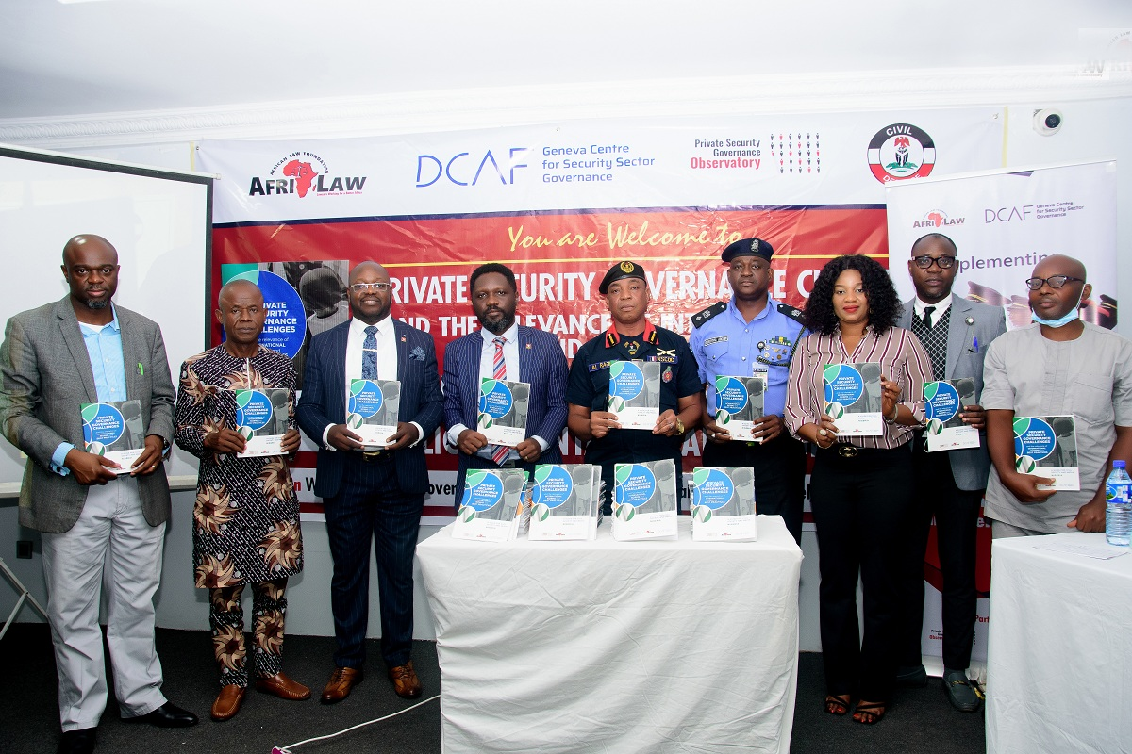
ED of AFRILAW and some stakeholders during public presentation and launching.
Closing Session: In closing, AFRILAW ED and representatives of Swiss Embassy emphasised the need for active CSOs and Media engagements in promoting private security governance and responsible private security services using the Toolkits. They urged them to use the information in the toolkit to engage the PSCs and NSCDC in their various states of residence. In his closing remarks, AFRILAW ED greatly thanked participants for honouring the invitation and their active participation. He specially thanked DCAF, NSCDC and Swiss Embassy for their wonderful support and partnership with AFRILAW.
DISSEMINATION OF THE TOOLKITS: The printed copies of the Toolkit were shared among the participants and some copies were donated to NSCDC, Nigeria Police Force, National Human Rights Commission and ALPSPN. The meeting ended at about 3.30pm with a closing prayer and the national anthem. Lunch and transport reimbursement followed afterwards.
NIGERIA WORKING GROUP ON MD/ ICOCA MEMBERS MEETING: During the MDAs Consultative Meeting for Nigeria to join the Montreux Document Forum (MDF) and the International Code of Conduct Association (ICoCA) held on October 14, 2021 at TopView Hotel Abuja, the Nigeria Working Group on MDF/ ICOCA was set up and inaugurated by the ACG-PGC of NSCDC with the mandated of engaging with relevant MDA and stakeholders and work toward actualization of Nigeria joining the MDF and ICOCA.
After the end of the Public Presentation and Launching Event, the member of the Nigeria Working Group on MDF/ ICOCA had their first members meeting, and was presided by the representative of ACG-PGC.
The members present at the inaugural meeting are:
- National Human Rights Commission (NHRC)
- Ministry of Justice rep by ACJMC
- NSCDC
- Department of State Security (DSS)
- AFRILAW
Apologies:
- Ministry of Interior
- Ministry of Foreign Affairs
Agenda:
- Update on getting Nigeria to join MDF and ICOCA and getting approval from the Minister of Interior to initiate the process of Nigeria joining the 2 initiatives:
The AFRILAW ED started the meeting by first thanking the members for attending the public presentation and launching of the Toolkit event and appreciated them of their support and contributions in making the event a success. He explained the ongoing efforts by him in engaging with the NSCDC and Ministry of Interior and ALPSN in other to ensure and maintain the momentum toward getting Nigeria to join the 2 initiatives.
AFRILAW ED also briefed the Working Group on the recent visit of Swiss Ambassador to the Minister of Interior where the issue of Nigeria joining the initiatives were discussed and the Honourable Minister designated his Technical Adviser on NSCDC as a contact and follow up person in this regard.
The NSCDC representatives also gave an update on their own efforts in getting the necessary authorisation from the Ministry of Interior to initiate the joining process. He reconfirms the interest and commitment willingness of NSCDC to lead the efforts and follow through the process when the time comes. The members responded positively to the both reports and expressed hope that the interest and commitment of the NSCDC and Ministry of Interior will help to ensure support of other MDAs and key stakeholders in getting Nigeria to join the 2 initiatives.
- Discussion on the Next Step of Action:
After some deliberations on what the Working Group need to do to ensure the fulfilment of their mandate in getting Nigeria to join the MDF and ICOCA, the following 4 points were agreed upon:
- NSCDC and AFRILAW should intensify efforts in getting the required authorisation from the Honourable Minister of Interior
- There should be a meeting between the Working Group with the CG and TA to Minister of Interior on NSCDC if the authorization is not given by end of January 2022.
- The membership of the Working Group should be expanded to include some other key stakeholders namely: 2 Representatives of the ALPSPN, 2 members of Private Security Governance Observatory and Media, and a representative of the Nigeria Police Force and Nigeria Army.
- There should be a monthly meeting of the Working Group members starting in January 2022.
- All efforts should be intensified to ensure actualization of Nigeria joining the 2 initiatives by end of first quarter of 2022.

The meeting ended with a closing remark by AFRILAW ED by urging members to remain committed and keep supporting the ongoing efforts by NSCDC and AFRILAW and actualization of the mandate of the Working Group in a record time. He thanked NSCDC for their interest and willingness to lead the ongoing efforts in getting Nigeria to join the MDF and ICOCA. Also, NSCDC rep appreciated AFRILAW and other members for their support and commitment in this regard. The meeting ended at about 4:00pm, and meeting allowance was paid to them.

- ADVOCACY VISITS AND MEETINGS
This is the narrative reports of various advocacy visits and meetings by the AFRILAW ED with various private security industry policymakers, regulator and key stakeholders within the period of April to September 2021. The advocacy visits and meetings are as follows:
- ADVOCACY VISIT AND MEETING WITH SWISS DEPUTY AMBASSADOR ON APRIL 20, 2021:
As part of the efforts to get Nigeria government’s interest in joining Montreux Document Forum and International Code of Conduct Association (ICOCA), AFRILAW ED submitted a request for advocacy visit and meeting with a proposal for Nigeria to Join MDF and ICOCA on December 2020 and March 2021 respectively to the Honourable Minister of Interior, as Ministry of Interior is the supervising ministry of NSCDC, and to the Commandant General of NSCDC, as NSCDC is the private security regulatory authority in Nigeria. Based on our request the Minister of Interior invited AFRILAW ED and Swiss Federation Ambassador in Nigeria for a meeting on May 6, 2021.
In preparation for the meeting with the Honourable Minister of Interior by the Swiss Ambassador, Swiss Deputy Ambassador invited AFRILAW ED for briefing on what AFRILAW is doing in this regard and discussion for better understanding of the proposed visit and meeting with Honourable Minister of Interior.
The meeting between AFRILAW and Swiss Deputy Ambassador took place on Tuesday April 20, 2021 at the Swiss Embassy, Abuja. Mr. Tunde Ajala, the Senior Economic and Political Adviser of Swiss Embassy was also present at the meeting.
AFRILAW ED used the opportunity to introduce himself, AFRILAW and its activities to the Swiss Deputy Ambassador particular the DCAF project with AFRILAW in Nigeria on private security governance. He explained in detail the various aspects of the project including the results and impacts recorded. He further explained about the programme and agenda of getting Nigeria government joining Montreux Document Forum and International Code of Conduct Association (ICOCA) and AFRILAW efforts so far and the need for Swiss Embassy support in this regard.
There was a lot discussion on the subject matter with various questions and disagreement on why Swiss Embassy should be support the effort from the Swiss Deputy Ambassador. Key
Challenges: The Swiss Deputy Ambassador seems not to appreciate and support the idea of participating in any advocacy visit and meeting with any Nigeria government official and agency on the subject matter.
Key Results/Opportunity: It was a great opportunity for AFRILAW to get introduced to Swiss Deputy Ambassador and brief him on the various project activities been implemented on private security governance in partnership with DCAF.
- ADVOCACY VISIT AND MEETING WITH SWISS DEPUTY AMBASSADOR TO CG OF NSCDC ON MAY 06, 2021
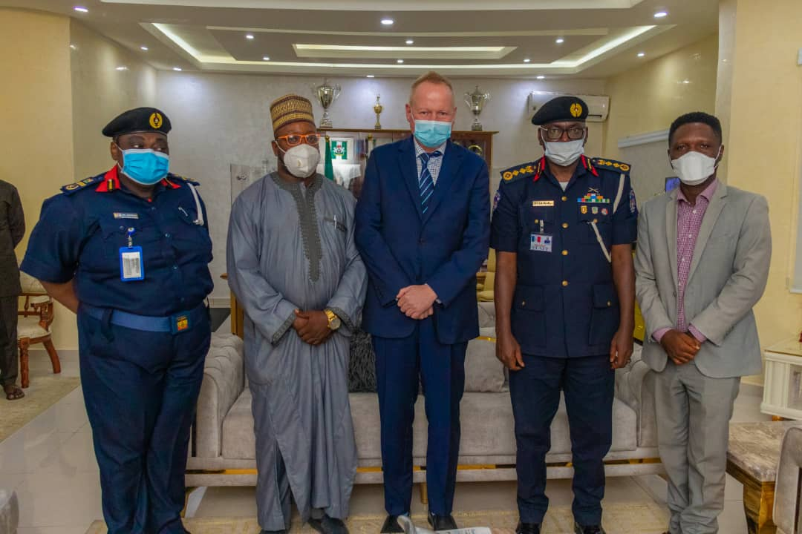
Following some pressures from the DCAF HQ and Swiss Foreign Affairs, the Swiss Deputy Ambassador accepted to join AFRILAW ED for an advocacy visit and meeting with the new Commandant General of NSCDC on Thursday May 6, 2021.
Moreover, the advocacy and meeting with the Honourable Minister of Interior by the Swiss Ambassador was cancelled because of non-availability of the Swiss Ambassador within the time. AFRILAW ED, the Swiss Deputy Ambassador and Mr. Tunde Ajala visited the CG of NSCDC as scheduled. Our team was warmly welcomed by CG with the company of ACG-PGC, Mrs Helen Amakiri. The CG is his welcome remark appreciated the visit and the efforts of the Swiss government via the Embassy in promoting peace and security in Nigeria. He also appreciated the AFRILAW for partnership with the NSCDC and the works they are doing with the PGC department in advancing private security governance in Nigeria.
In his speech, the Swiss Deputy Ambassador congratulated the CG on his recent appointment as the CG of the NSCDC and assured him of the Swiss Embassy support and partnership with the NSCDC in fulfilling their mandate. He explained the reason for the visit and solicited for the support of the CG toward ensuring that Nigeria government joined the MDF, ICOCA and the VPs initiatives. He later presented a gift to the CG of NSCDC.
AFRILAW ED also spoke about the key benefits of Nigeria joining the 3 initiatives and AFRILAW efforts in this regard, and called on the CG to take the lead in this process and ensure that Nigeria joined the initiatives. He thereafter presented copies of the MDF and ICOC to the CG.
In his response, the CG appreciated the efforts of the AFRILAW and Swiss Embassy in promoting that Nigeria should join the 3 initiatives. He acknowledges the benefits of Nigeria membership of the initiatives and promised to consider the request of supporting and promoting the cause.
Challenge: Inability of the CG to make public commitment to support the Nigeria joining the 3 initiatives. The change of former CG of NSCDC was a huge a setback to AFRILAW’s efforts in getting Nigeria to join the MDF and ICOCA as we have to start afresh in educating the new CG about the initiatives and why Nigeria should join them in other to get his support and buy in. The former gave his support to the then ACG-PGC, Mrs. Helen Amakiri toward ensuring the Nigeria join the MDF and ICOCA.
Key Results/Opportunity: This was a great opportunity to get introduced and acquitted with the new CG and lay foundation for future partnership in AFRILAW work with the NSCDC.
- ADVOCACY VISIT AND MEETING WITH NSCDC ACG-PGC AND DLS ON JULY 27, 2021
Following the redeployment of former ACG-PGC, Mrs Helen Amakiri, and appointment of the new ACG-PGC Mr, Raji Ibrahim, it became imperative for AFRILAW ED to introduced AFRILAW to him and brief him on our various project activities. The advocacy visits and meeting was held on July 27 at the NSCDC HQ, Abuja. AFRILAW ED used the opportunity to explain all the project activities with the former ACG-PGC and highlighted the various achievements and results recorded to the new ACG-PGC. He solicited for his support and partnership with AFRILAW going forward.
In his response, the new ACG-PGC expressed his delight in the existing partnership between AFRILAW and NSCDC particularly the PGC Department. He appreciated AFRILAW for the various projected implemented in partnership with NSCDC since 2019. He greatly thanked DCAF for their support in this regard. He pledged his support to AFRILAW and DCAF and expressed his willing to continue the partnership between AFRILAW and PGC Department in advancing the development of the private security industry in Nigeria.
Also, AFRILAW ED has a meeting with the Director of Legal Services of NSCDC, Mr. Umar Mohammed where they discussed the efforts in getting Nigeria join the MDF and ICOCA and seeking the DLS support in this regard. The DLS after appreciating the efforts of AFRILAW and their works in partnership with NSCDC, and he pledged to support AFRILAW in all their programmes and activities with the NSCDC.
Challenges: Redeployment of former ACG-PGC, Mrs Helen Amakiri was a huge setback to AFRILAW’s efforts in getting Nigeria to join the MDF and ICOCA as we have to start afresh in educating the new ACG about the initiatives and why Nigeria should join them in other to get his support and buy in. Mrs Helen has already started pushing forward and working toward getting Nigeria to join the initiatives before she was redeployed.
Key Results/Opportunity: The willingness of the new ACG-PGC to support and continue partnering with AFRILAW in its works with DCAF in advancing private security governance in Nigeria. The support of the DLS is paramount in ensuring AFRILAW success in its works with NSCDC.
- ADVOCACY VISIT AND MEETING WITH NSCDC CG AND ACG-PGC ON AUGUST 17, 2021
Based on a successful advocacy visits and meetings between AFRILAW ED, Swiss Deputy Ambassador and new CG, and between AFRILAW ED and the new ACG-PGC, and as way of following up some key agreement during the visits, AFRILAW ED resubmitted the proposal for Nigeria to join the MDF and ICOCA and NSCDC to lead the efforts in this regard to the new CG of the Nigeria. The submission of the proposal brought about the call for a visit for a meeting with the new CG for further discussion and clarification on the subject matter.
AFRILAW ED and ACG-PGC had a meeting with the CG of NSCDC on the proposal for Nigeria to join MDF and ICOCA and the need for NSCDC to lead in advancing the process.
AFRILAW ED used the opportunity to explain in details in key benefits of membership of 2 initiatives to Nigeria and to NSCDC in particular. The CG expressed a doubt about the need for NSCDC to lead the process and represent Nigeria in the 2 initiatives. In particular, he was of the view that NSCDC does not need to be part of ICOCA with the same companies they are regulating. However, AFRILAW ED presented a good clarification on the CG’s concern by explaining the 3 Pillars of ICOCA, their functions and benefits to Pillar members.
After the clarification, the CG showed an understanding of the concept of the ICOCA 3 Pillars, and thereafter accept the proposal and expressed his support and interest for NSCDC to work toward ensuring Nigeria membership of the 2 initiatives. However, He maintained that they can only work on the proposal after obtaining the authorisation and approval from the Federal Ministry of Interior, their supervising ministry. He later instructed us to meet with his PA who should draft a Memo to the Honourable Minister of Interior seeking for his authorisation and approval for NSCDC to initiate the process of joining the membership of the 2 initiatives.
Thereafter, AFRILAW ED and ACG-PCG had a meeting with the CG’s PA on drafting of a Memo to Honourable Minister of Interior seeking for his authorisation and approval for NSCDC to initiate the process of joining MDF and ICOCA. AFRILAW ED used the opportunity to explain in details the proposal and the need for Nigeria to join the 2 initiatives and expectations from the NSCDC. The PA to the CG expressed his delight about the proposal and pledged his support to it and promised to work on the Memo together with the ACG-PGC.
Challenge: Expression and lack of understanding by the CG on the reason why NSCDC should be in the same association with PSCs they are regulating.
Key Results/Opportunity: Provision of good clarification to the CG on the 3 Pillars of ICOCA by AFRILAW ED, and subsequent expression of support and interest by the CG of NSCDC to lead in the efforts for Nigeria to join MDF and ICOCA, and initiation of the process of obtaining the required authorization and approval from the Honourable Minister of Interior in this regard.
- ADVOCACY VISIT AND MEETING WITH CENTRAL EXECUTIVE MEMBERS OF THE ALPSPN ON SEPTEMBER 2, 2021
Following a yearlong advocacy engagement with the national leadership of the ALPSPN, AFRILAW ED was invited to meet with the members of the Central Executive of the Association during their meeting at their National Secretariat, Abuja on September 2, 2021. The Central Executive of the ALPSPN is made up of all the National Executives and all the State Chairmen of State Chapters of the Association.
The aim of the visit and meeting with the Central Executive is to formally introduce AFRILAW and its activities to the Association and explore opportunity for partnership between AFRILAW and ALPSPN in advancing development of private security industry in Nigeria and implementing AFRILAW project activities in advancing private security governance and responsible private security services in Nigeria.
During the meeting AFRILAW ED, was introduced to the Central Executive members by the National President of the Association, and he was later given opportunity to address the central executive members. AFRILAW ED started by appreciating them and the great efforts of the leadership of the association in promoting the development of the industry. He gave them an overview of AFRILAW and its project activities in Nigeria in partnership with DCAF and NSCDC. He also introduced ICOCA to them and implored them to register and become a member of the Association. The advocacy for Nigeria to join the membership of MDF and ICOCA was also put forward by the ED. He used the opportunity on seek for opportunity for formal partnership between AFRILAW and ALPSPN. After the presentation from the AFRILAW ED, there was a Q and A Session where the members seek for more understanding on the work of DCAF and ICOCA and the opportunity to their members. How AFRILAW project activities in Nigeria can directly benefit the Association and members. AFRILAW ED answered the questions and gave clarification to their concerns.
Signing of Memorandum of Understanding (MOU) between AFRILAW and ALPSPN:
On the 2nd Day of the Central Executive members meeting, that is on September 3, 2021, the AFRILAW ED and ALPSPN National President signed a Memorandum of Understanding (MOU) between AFRILAW and ALPSPN for partnership and collaboration for technical support and services in Nigeria for an initial period of 2 years subject to renewal.
The purpose of this MOU is to establish the terms and conditions for strategic partnership and collaboration for provision of technical support and services to the ALPSPN and its members by AFRILAW and its partners toward an improved and effective private security services and development of private security industry in Nigeria.
Under the MOU, AFRILAW has the responsibilities of facilitating and providing technical support, professional development and capacity-building services for improved and effective management and operational standards, and compliance with the code of conducts, ethics and human rights and professional standards for ALPSPN and its members in Nigeria. The responsibilities of ALPSPN under the MOU include facilitating, mobilizing and ensuring active participation, support and cooperation of ALPSPN and its members and provision of necessary resources as may be required for a successful provision of technical support, professional development and capacity-building services by AFRILAW and its technical partners.
Signing of Framework Agreement between ALPSPN, DCAF and AFRILAW:
Also, on September 3, 2021 the National President of the APSPN signed the Framework Agreement between ALPSPN, DCAF and AFRILAW for Training on International Good Practices for Private Security Companies in Nigeria Programme. In signing this Framework Agreement, the Parties agreed to work together in a spirit of mutual learning and cooperation in order to jointly develop and promote international norms good practices regarding private security governance in Nigeria. The Framework Agreement sets forth the general terms and conditions under which the Parties agree to cooperate. Agreement of individual activities, including allocation of specific roles and responsibilities, budgets and timelines will be done on a case-by-case basis.
The scope of cooperation under the Framework Agreement includes the following areas of activity:
- Review and update the code of conduct of ALSPN
- Develop a curriculum for an executive training for ALSPN members
- Organization of a pilot training
- Promotion and application of the value of the Montreux Document and International Code of Conduct.
Challenges: AFRILAW ED meeting with Central Executive members where delayed for long due to vested interest and misunderstanding of the intention and purpose of proposed AFRILAW quest for partnership with the ALPSPN.
Key Results/Opportunity: The successful signing of an MOU between AFRILAW and ALPSPN for partnership and collaboration for technical support and services in Nigeria; and National President of APSPN signing of the Framework Agreement between ALPSPN, DCAF and AFRILAW for Training on International Good Practices for Private Security Companies in Nigeria Programme.

