THE NARRAATIVE REPORT
OF THE
THE NIGERIA RESPONSIBLE PRIVATE SECURITY COMPANY TRAINING PROGRAMME
IMPLEMENTED BY
AFRICAN LAW FOUNDATION (AFRILAW), ABUJA-NIGERIA
IN PARTNERSHIP WITH INTERNATIONAL CODE OF CONDUCT ASSOCIATION (ICOCA) SWITZERLAND, GENEVA CENTER FOR SECURITY SECTOR GOVERNANCE (DCAF) SWITZERLAND, MSS GLOBAL UK AND NIGERIA SECURITY AND CIVIL DEFENSE CORPS (NSCDC) WITH FUNDING SUPPORT BY UK FCDO AND MSS GLOBAL UK

INTRODUCTION: This is the Narrative Report of Nigeria Responsible Private Security Company Training Programme Pilot activities implemented by African Law Foundation (AFRILAW) in partnership with the International Code of Conduct Association (ICoCA) Switzerland, Geneva Center for Security Sector Governance (DCAF) Switzerland, MSS Global UK and Nigeria Security and Civil Defense Corps (NSCDC) with funding support by UK FCDO and MSS Global UK.
The goal of this project is to provide capacity building and training to Nigeria Private security companies on existing obligation and best practices for improved standards of operations, excellent service delivery and professional conducts and effective private security governance and management system. The key objectives of the training programme are; increasing awareness and knowledge on existing obligation and best practices, gain specific expertise on inter sectional thematic areas of use of force, gender equality and preventing sexual exploitation and abuse. Get support for long-term development of a culture that respects and seeks to protect human rights within their company and how to address human rights challenges in complex environments, integrate effective private security governance and management system, learn the benefits and how to become ICoCA member and get ICoCA certification. The pilot Nigeria Responsible Private Security Company Training Programme was implemented across 5 states of Nigeria from October 2022 to March 2023.

PROJECT ACTIVITIES:
- THE FLAG-OFF TRAINING WORKSHOP FOR NORTH- CENTRAL REGION (ABUJA):
The Flag-off workshop on the Nigeria Responsible Private Security Company Training Programme was held on October 26th, 2022 at Top View Hotel, Abuja. There were about forty-five (45) participants including thirty (30) PSC representatives, seven (7) Nigeria Security and Civil Defense Corps (NSCDC) officers which included the Assistant Commandant General ACG-PGC, one (1) MSS Global representative, four (4) media personnel’s and three (3) AFRILAW staff.
OPENING SESSION AND REMARKS: The Workshop began by 9:30am with one of the participants leading the opening prayer and afterwards the National anthem was taken. The Executive Direct or of AFRILAW (Barr. Chinwike) welcomed all the participants in attendance and set out the agenda of the day. The Assistant-Commandant General (ACG)- Priavet Guards Companies (PGC) representing the Commandant General of NSCDC was invited to give his opening remarks and flag-off the programme. He took the stage and started by thanking AFRILAW and its partners for initiating the wonderful programme in Nigeriaa and proceeded to commend the PSCs present for responding to the call to attend and also pointed out that the said workshop would further improve their skills and the certificates received upon conclusion of the event would form part of the criteria for future assessment of the security companies.
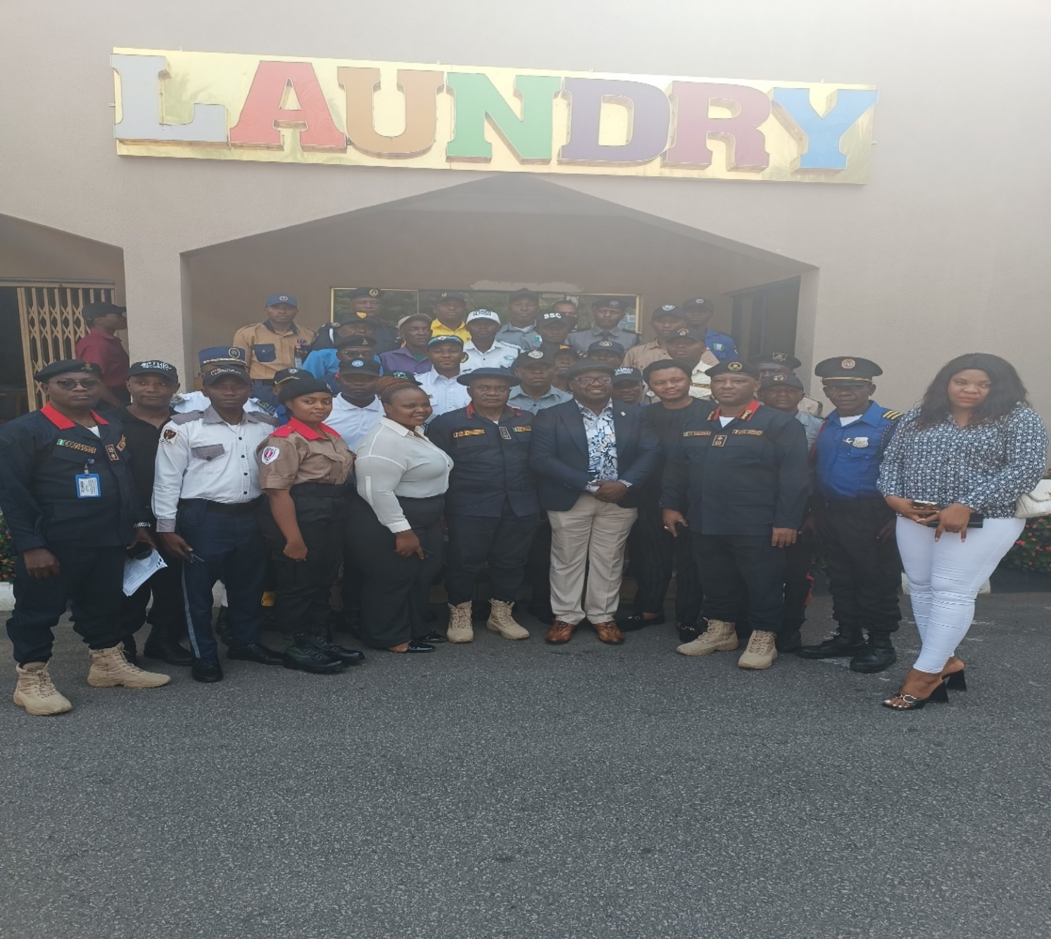
Group Picture of the Training Workshop
The ACG- PGC further encouraged the PSCs to adhere to all that would be taught in the program and declared the program open. While the technical team dealt with the internet connection issues faced at the event, the attendees proceeded to take group photographs with the Assistant-Commandant General PGC of the NSCDC and the AFRILAW Team.
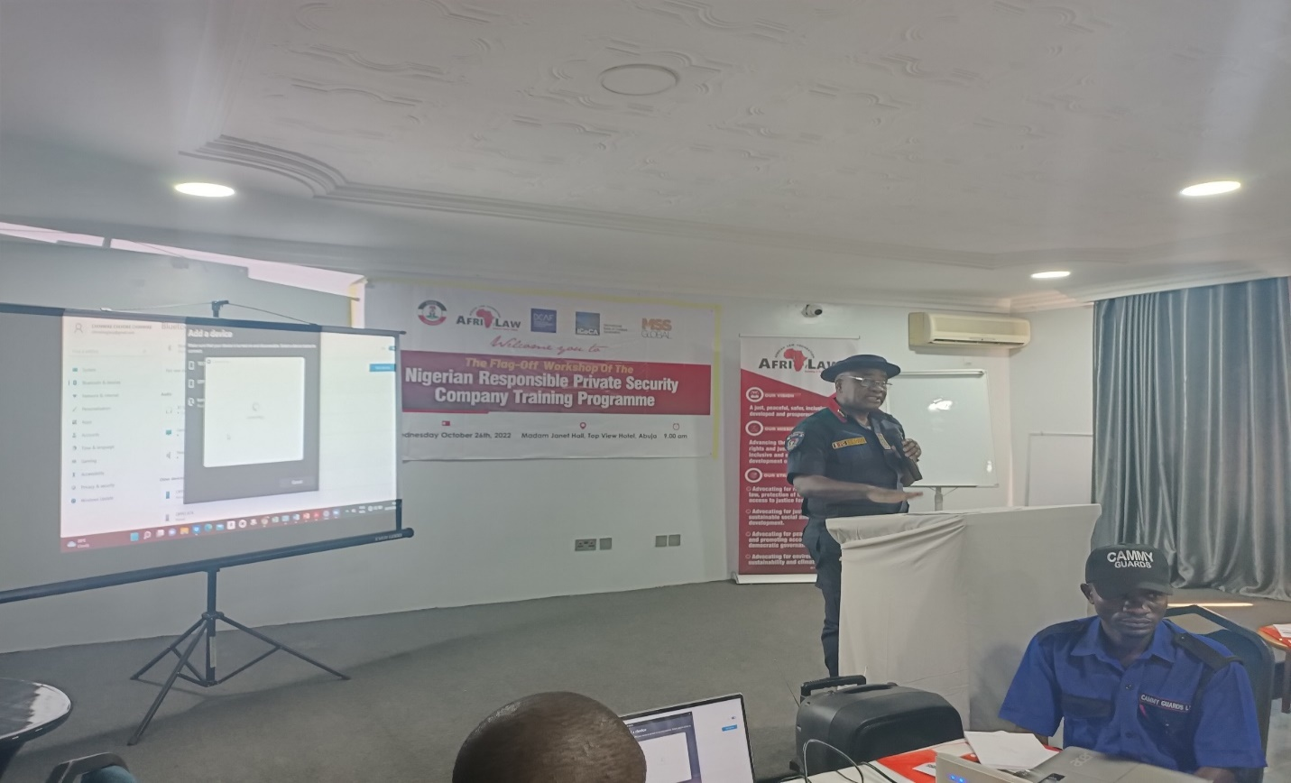
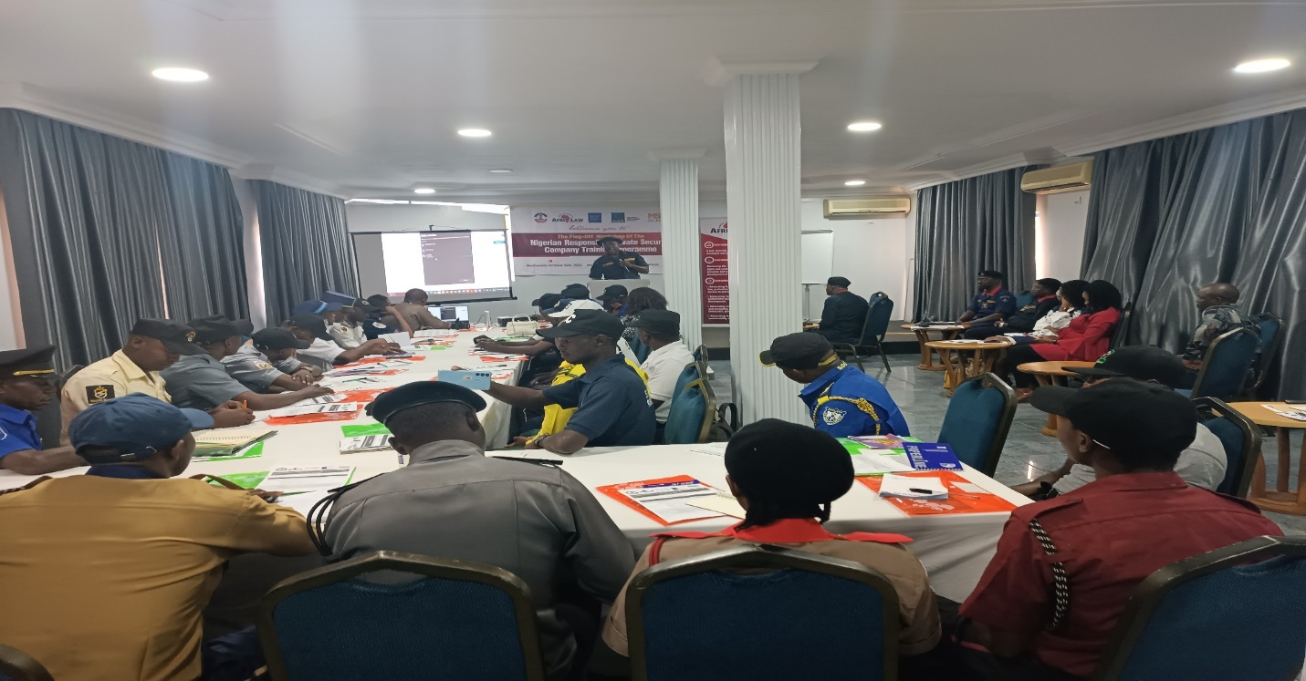
The ACG-PGC giving his Opening/Welcome Remarks and declaring the Programme opened.
PRESENTATION 1: Introduction to ICoCA & Code of Conduct for PSCs, Respecting Human Rights by PSCs and Conducting Human Rights Impact Assessment by PSCs
Mr. Giuseppe Scirocco and Mr Christopher Galvin representatives of the ICoCA team took the presentation via zoom. ICoCA and the Code was introduced to the participants. They were also taught the principles regarding the conduct of private security personnel’s, covering issues such as: the use of force, preventing sexual exploitation and abuse, detention, apprehension, torture, human trafficking, child labor, discrimination and modern slavery. They were further taught the right principles on management and governance for PSCs which includes; selection and vetting of personnel, selection and vetting of subcontractors, training, management of weapons and ammunitions, incident reporting, health and safety, harassment, grievance procedures and meeting liabilities. A brief history on ICoCA was given as a governance and oversight mechanism to ensure the implementation of the code and once a private security company becomes a member, they agree to be monitored by the Association to ensure compliance with the code. They were briefed on current members of the Association both state members and private security companies who are members as well as observers of the Association. The purpose of the Association was highlighted which is to promote responsible private security, by strengthening human rights due diligence on private security providers.The Association promotes capacity building by providing guidance which includes; human right impact assessment for PSCs, guidelines for PSCs on preventing and addressing sexual exploitation and abuse, developing and operating fair and accessible company grievance mechanism that offer effective remedies and trainings. They also carry out monitoring of PSC by visiting, tracking, reporting and creating a civil security network. The need for PSCs to be ICoCA certified was also discussed as PSCs who are certified represents gold standards who have submitted themselves to be monitored and verified by ICoCA mechanisms.
The reason why private security users care about human rights due diligence was also taught in the presentation. This is because of the many and rising abuses by PSCs contractors especially in the mining sites which will in turn be a reputational and financial damage for such company. Also the treatment of the private security personnel themselves was stated to be the biggest human right risk in the industry and the need for these PSCs to meet the mandatory human rights due diligence requirements was emphasized. The voluntary principles on business and human rights was also introduced to the private security guards. The need for these PSCs to conduct human right impact assessment was explained as it helps companies understand how certain activity affects human rights. They were advised to start the assessment as early as when the company starts to plan operations. The phases of the assessment was also highlighted to include: planning and scoping, data collection, impact analysis, impact mitigation and management and evaluation and reporting.
The session was very enlightening for the PSC guards as they proceeded to ask questions on areas they needed clarifications on and how their companies could be part of ICoCA which all questions were answered satisfactorily by the resource persons and further stated that all resource materials used for the lecture would be made available for more clarifications as well as the organizations website was provided for all who needed it. The next thing on the program agenda after the first presentation was the tea break where all the guards were served with a light breakfast.
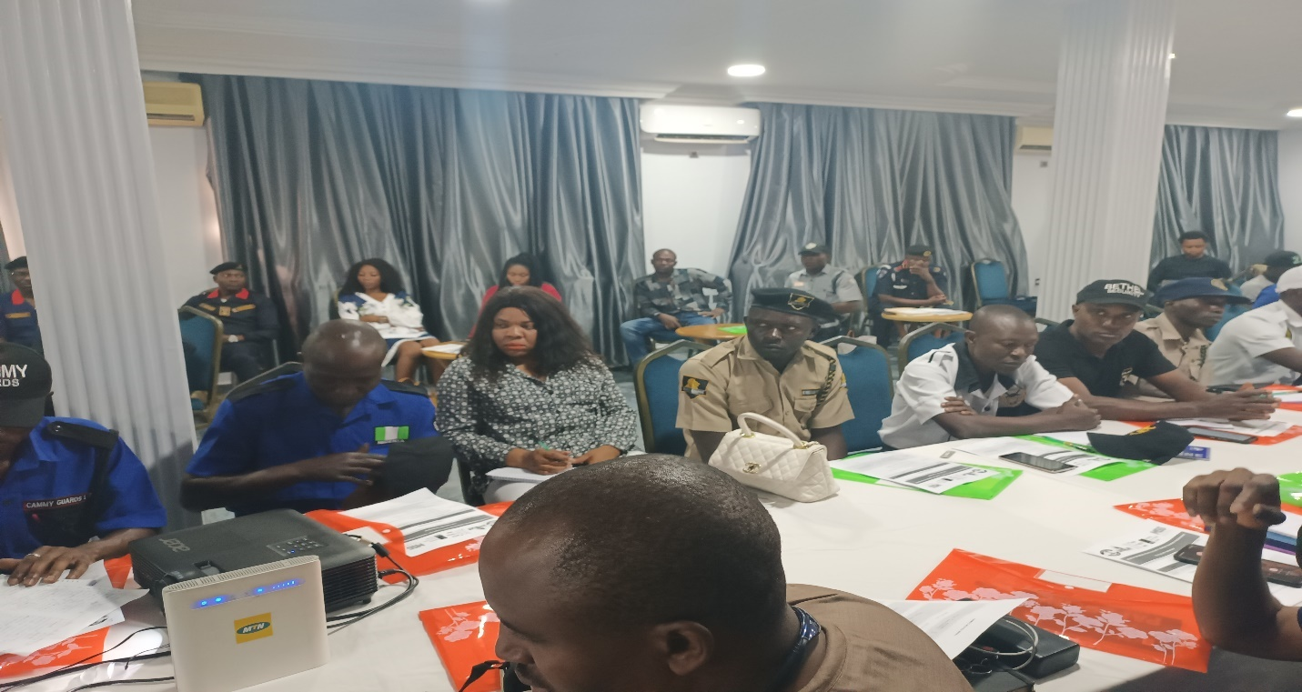
The Cross Section of the participants

PRESENTATION 2: Introduction to Montreux Document and its benefits to PSCs in Nigeria and Basic Principles of the use of force by PSCs:
Immediately after the tea break, Ms. Valdes Cristina form DCAF began her presentation also via zoom, she started by introducing the Montreux Document as on which reaffirms the existing obligations of states under international law. The document is said to have two parts, Part I: recalls the relevant legal obligations of states towards PMSCs and Part II: contains a description of good practices that aim to provide guidance and assistance to states in the regulation of PMSCs. The benefits for PSCs was stated to be legislative guide as this guide will help address the main challenges of implementation, offers recommendation and finally illustrates practical cases. The challenges were out left out which includes; staff training and capacity building, normative policies on the use of force and effective complaint and grievance mechanisms.
The use of force by PSCs was also discussed, it was pointed out that due to a lack of specific rules both PSCs and the regulators tend to apply force applicable to law enforcement and this leads to human right violations. It was stated that the force to be used by PSCs is very different form that used by law enforcement agencies and the force allowed for PSCs must be guided by personal self-defense like any other citizen. It was stated that these PSC guards do not have a general mandate to ensure public security beyond the objectives set out in the contract. They are not to use lethal force to protect property and they are not substitutes for public forces. They further states that states are to impose limitations on the type of services PSCs can provide and weapons they can possess as well as the operational criteria they must meet. This was also a very interesting presentation as it spurred the attendees to ask question bothering on the protection of the rights of the guards. All questions were given satisfactory answers by the resources person who also stated that further questions could be sent across to her via email and also made available the resource materials used for the lecture for the attendees to access.
PRESENTATION 3: Functional Planning Support and Delivery of Security Operations Management System by PSCs, ICoCA Certification and 18788 for Nigeria PSCs by Mr Jonah Eromon, Africa Director of MSS Global UK.
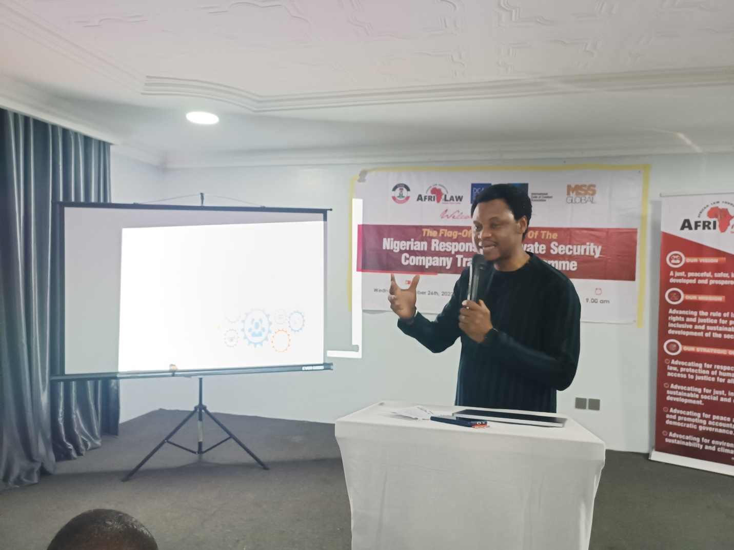
Mr. Jonas of MSS Global making a presentation

Mr Jonah, who was present physically took this presentation. He began by with a brief introduction of MSS Global afterwards he went to the crux of the presentation. He discussed the need for PSCs to plan and implement its objectives through a management system, security operations planning which sets out a timeframe for achieving the set goals. He pointed out that these can be done through the standard operating procedure of the PSCs, stating that operations cannot be devoid of risk and the need to manage this risk to the clients, organization and stakeholders. Also, he summarized by stating that all responsible PSC must first cascade its strategic objectives into operational task, do a supplier due diligence before signing a contract, identify and understand resources needed and finally plan the internal and external communication.
He afterwards went into the second part of the presentation on how PSCs can achieve ICoCA certification in three simple steps. First by internal preparations, then an initial certification and finally contact the ICoCA secretariat and audit report review. He stated that becoming ICoCA certified comes with real commercial and operational benefits and urged the guards to inform their company on the need to get certified. The guards really enjoyed the presentation and some indicated interest in the certifications as well as asked question on areas they needed clarifications on which was satisfactorily answered. Afterwards the attendees proceeded for lunch break.
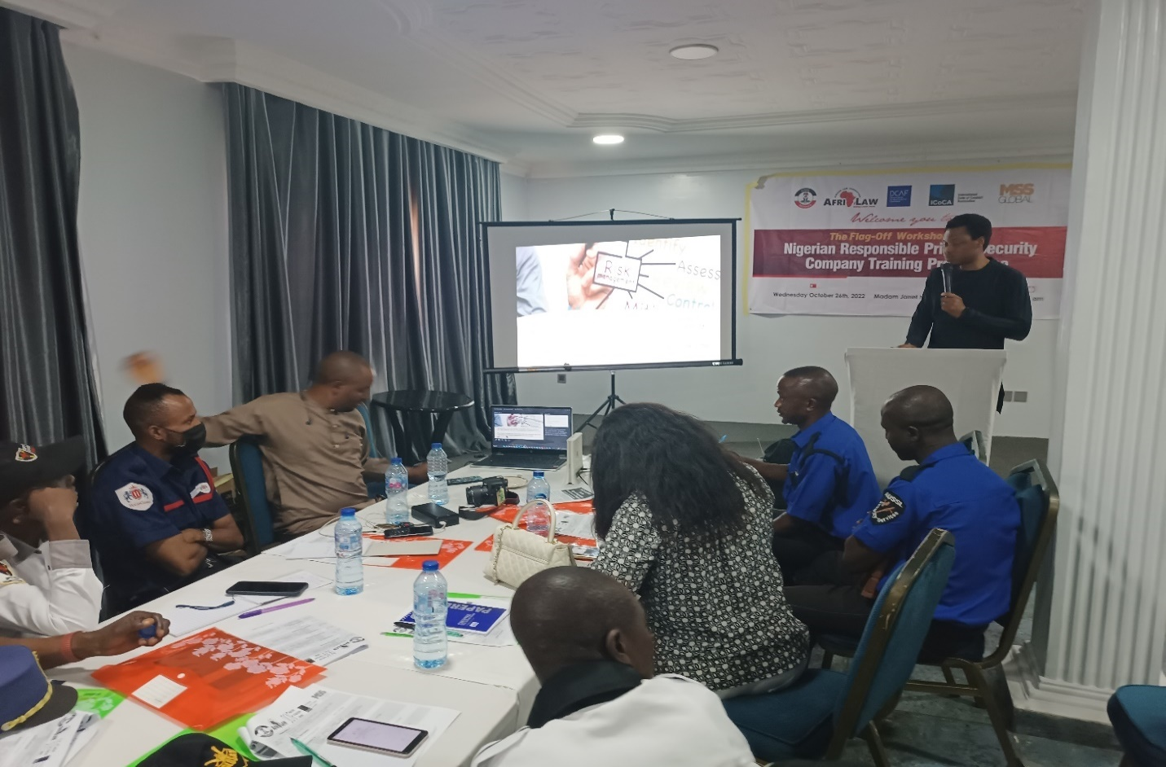
Cross Secession of the participants
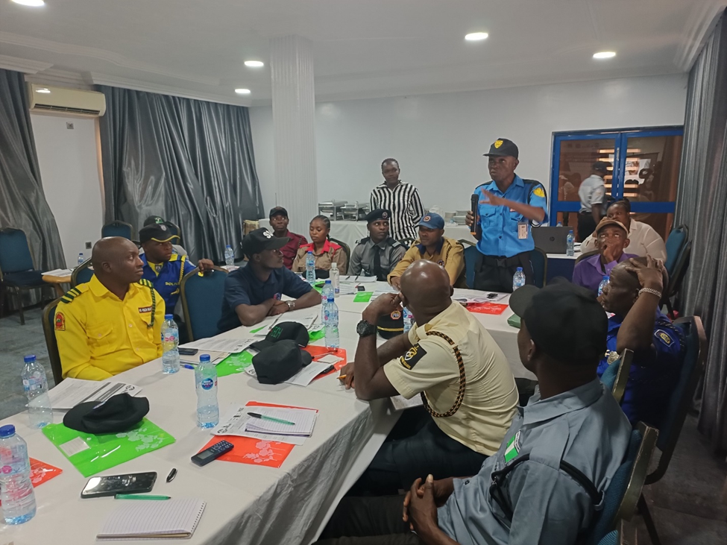
A participant asking a question during one of the sessions

PRESENTATION 4: Gender Sensitization for PSCs and Preventing and Addressing Sexual Exploitation and Abuse (PSEA) by PSCs in Nigeria by AFRILAW ED.
ARFILAW ED (Barr. Chinwike) took the presentation after the lunch break, he started by engaging the guards with a gender game which they all participated and had fun doing. He proceeded with a gender sensitization for the guards and began the presentation on preventing and addressing sexual exploitation and abuse by PSCs in Nigeria. He first discussed the UN guiding principles on business and human rights by pointing out UNGP 6 and 13 as important basis for effective procurement and contracting policies. He also defined gender concepts as well as equity and equality. He pointed out that gender equality is the absence of discrimination on the basis of a person’s sex in opportunities and the equal allocation of resources, benefits and in access to services. He stated that sexual and gender-based violence (SGBV) refers to all violence that are committed against a person based on their perceived or actual sex and or gender. It is a gross violation of human rights, and is both a cause and a consequence of gender inequality. The definition included physical, verbal or sexual violence against women and girls (VAWG), the victimization of people because of their masculine or feminine traits or sexual orientation, and any form of violence that stems from unequal power relations. He further listed the actions that comprise SGBV to include sexual threats, exploitation, humiliation, assault, molestation and rape, domestic violence and incest, involuntary prostitution, torture and or insertion of objects into genital openings, female genital cutting and attempted rape giving a detailed explanation of all of them. Afterwards he began the second part of the presentation on preventing and addressing sexual exploitation and abuse by PSCs and started by defining sexual exploitation, sexual abuse and its impact on PSCs which could be serious reputational, operational, financial or legal detrimental consequences. He further discussed the need of integrating a gender perspective in PSCs services stating the necessary guidelines. It was an engaging topic for the guards as they shared their inputs on the topic.
PRESENTATION 5: Introduction to VP on Security and Human Rights for PSCs by AFRILAW ED.
Afterwards AFRILAW ED (Barr. Chinwike) proceeded with the final presentation on introduction of Voluntary Principles (VP)s for PSCs pointing out responsibilities placed on the security companies and the Association as a whole. The participants were given the opportunity to ask questions which many was raised and answered satisfactorily too.
Closing Session of the Workshop/Departure: The Training Workshop came to a successful end by 5:30pm with a closing remark by AFRILAW ED. He urged the guards to adhere to all they had learnt and practice them, also to educate their members on all they had learnt. After which, certificate of participation was presented to all who attended. Then the closing prayer was led by one of the participants.

1: THE 2ND TRAINING WORKSHOP FOR NORTH-CENTRAL REGION (ABUJA):

The 2nd Training Workshop of the Nigeria Responsible Private Security Company Programme was held on November 17th 2022 at Newton Park Hotel Resort, Abuja. There were about thirty-two (32) participants which comprised of twenty-three (23) PSC representatives, two (2) Nigeria Security and Civil Defense Corps (NSCDC) officers, two (2) ICoCA representatives, one (1) MSS Global UK Representative, one (1) media personnel and three (3) AFRILAW staff. Upon settling in, the moderator took to the stage to commence the program.
OPENING SESSION AND REMARKS: The Workshop began by 11:00am with one of the private security guards leading the opening prayer and afterwards the National anthem was taken. The Executive Director of AFRILAW (Barr. Chinwike) welcomed all the private security guards in attendance and set out the agenda of the day. The partners being NSCDC, ICoCA who attended physically this time, DCAF and MSS Global also gave their god will remarks.
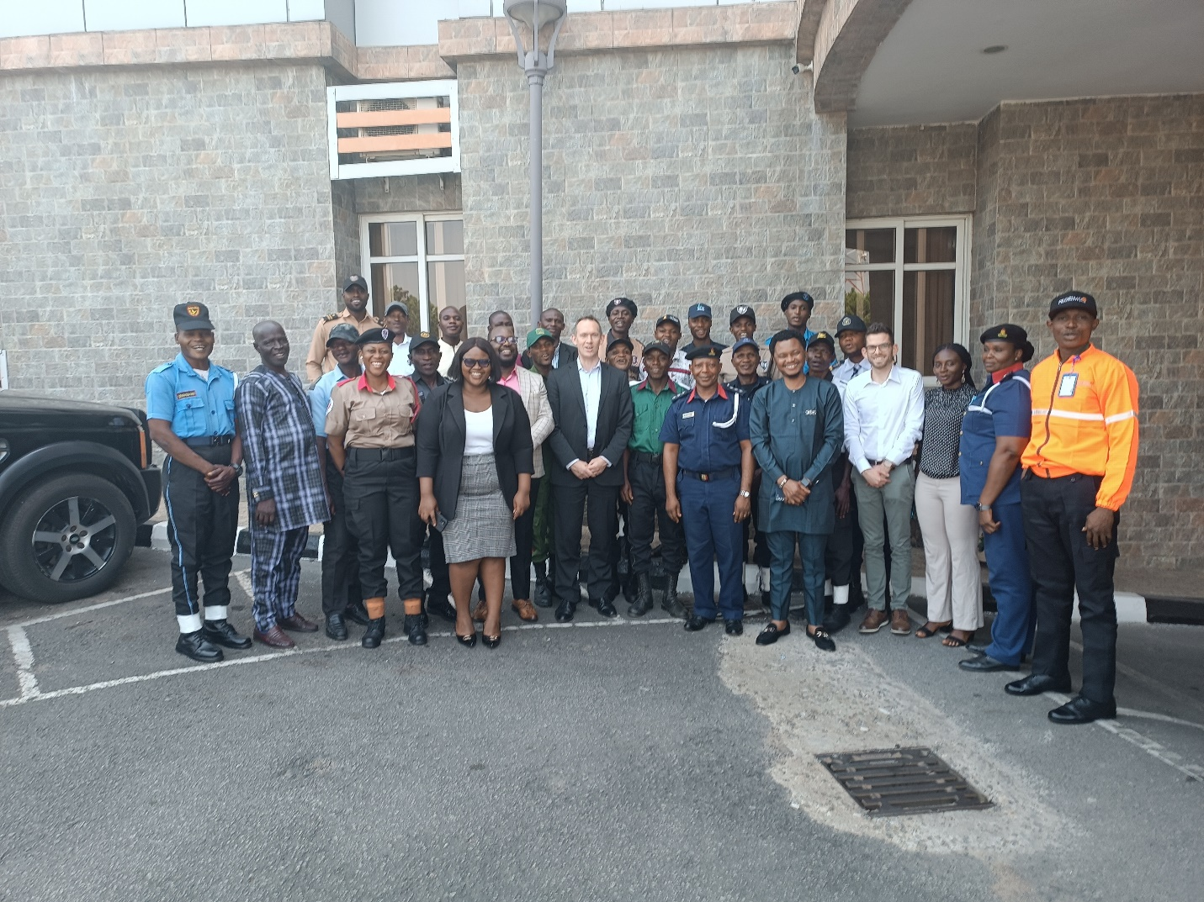
The Group Picture of the Training Workshop

PRESENTATION 1: Introduction to ICoCA & Code of conduct for PSCs, Respecting Human Rights by PSCs and Conducting Human Rights Impact Assessment by PSCs
Mr. Giuseppe Scirocco and Mr Christopher Galvin representatives of the ICoCA team who attended physically took the presentation. ICoCA and the code was introduced to the private security guards. They were also taught the principles regarding the conduct of private security personnel’s, covering issues such as: the use of force, preventing sexual exploitation and abuse, detention, apprehension, torture, human trafficking, child labor, discrimination and modern slavery. They were further taught the right principles on management and governance for PSCs which includes; selection and vetting of personnel, selection and vetting of subcontractors, training, management of weapons and ammunitions, incident reporting, health and safety, harassment, grievance procedures and meeting liabilities. A brief history on ICoCA was given as a governance and oversight mechanism to ensure the implementation of the code and once a private security company becomes a member, they agree to be monitored by the Association to ensure compliance with the code. They were briefed on current members of the Association both state members and private security companies who are members as well as observers of the Association. The purpose of the Association was highlighted which is to promote responsible private security, by strengthening human rights due diligence on private security providers
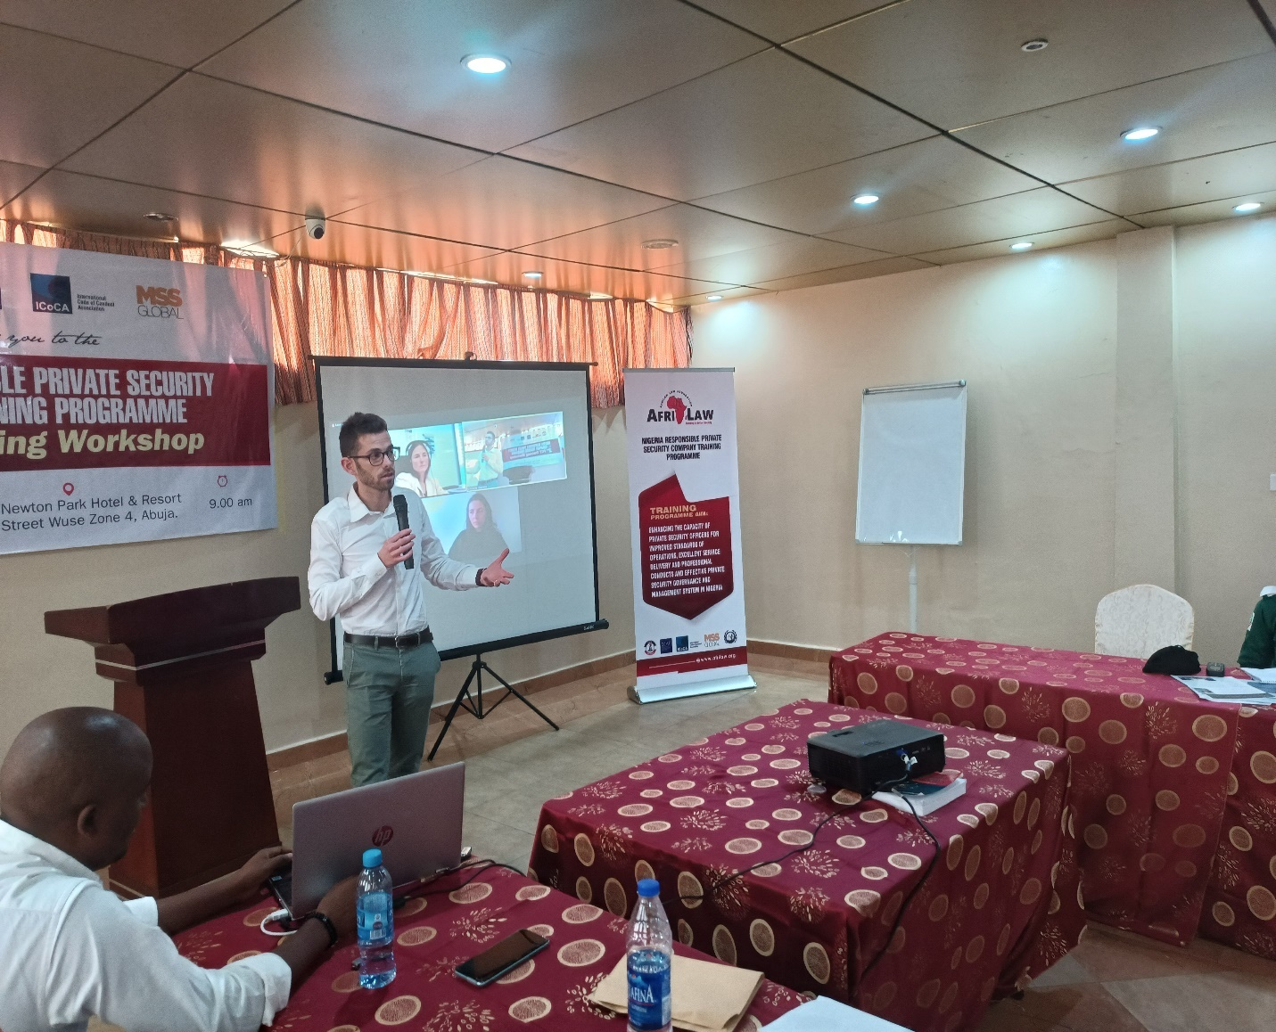
Mr. Giuseppe Scirocco of ICoCA making a presentation

The Association promotes capacity building by providing guidance which includes; human right impact assessment for PSCs, guidelines for PSCs on preventing and addressing sexual exploitation and abuse, developing and operating fair and accessible company grievance mechanism that offer effective remedies and trainings. They also carry out monitoring of PSC by visiting, tracking, reporting and creating a civil security network. The need for PSCs to be ICoCA certified was also discussed as PSCs who are certified represents gold standards who have submitted themselves to be monitored and verified by ICoCA mechanisms.
The reason why private security users care about human rights due diligence was also taught in the presentation. This is because of the many and rising abuses by PSCs contractors especially in the mining sites which will in turn be a reputational and financial damage for such company. Also the treatment of the private security personnel themselves was stated to be the biggest human right risk in the industry and the need for these PSCs to meet the mandatory human rights due diligence requirements was emphasized. The voluntary principles on business and human rights was also introduced to the private security guards.
The need for these PSCs to conduct human right impact assessment was explained as it helps companies understand how certain activity affects human rights. They were advised to start the assessment as early as when the company starts to plan operations. The phases of the assessment was also highlighted to include: planning and scoping, data collection, impact analysis, impact mitigation and management and evaluation and reporting.
The session was very enlightening for the PSC guards as they proceeded to ask questions on areas they needed clarifications on and how their companies could be part of ICoCA which all questions were answered satisfactorily by the resource persons and further stated that all resource materials used for the lecture would be made available for more clarifications as well as the organizations website was provided for all who needed it. The next thing on the program agenda after the first presentation was the tea break where all the guards were served with a light breakfast.

PRESENTATION 2: Introduction to Montreux Document and its benefits to PSCs in Nigeria, Introduction to VP on Security and Human Rights for PSCs and Basic Principles of the Use of Force by PSCs by DCAF Representatives
Immediately after the tea break, Ms. Valdes Cristina form DCAF began her presentation also via zoom, she started by introducing the Montreux Document as on which reaffirms the existing obligations of states under international law. The document is said to have two parts, Part I: recalls the relevant legal obligations of states towards PMSCs and Part II: contains a description of good practices that aim to provide guidance and assistance to states in the regulation of PMSCs. The benefits for PSCs was stated in the Legislative Guide produced by DCAF as this guide will help address the main challenges of implementation, offers recommendation and finally illustrates practical cases. The challenges were out left out which includes; staff training and capacity building, normative policies on the use of force and effective complaint and grievance mechanisms. On the introduction to Voluntary Principles on Security and Human Rights for PSCs, they discussed risk assessment, company relations with public safety suppliers and company relations with private security providers giving details on what it entails.
The use of force by PSCs was also discussed, it was pointed out that due to a lack of specific rules both PSCs and the regulators tend to apply force applicable to law enforcement and this leads to human right violations. It was stated that the force to be used by PSCs is very different form that used by law enforcement agencies and the force allowed for PSCs must be guided by personal self-defense like any other citizen. It was stated that these PSC guards do not have a general mandate to ensure public security beyond the objectives set out in the contract. They are not to use lethal force to protect property and they are not substitutes for public forces. They further stated that states are to impose limitations on the type of services PSCs can provide and weapons they can possess as well as the operational criteria they must meet. This was also a very interesting presentation as it spurred the attendees to ask question bothering on the protection of the rights of the guards. All questions were given satisfactory answers by the resources person who also stated that further questions could be sent across to her via email and also made available the resource materials used for the lecture for the attendees to access.
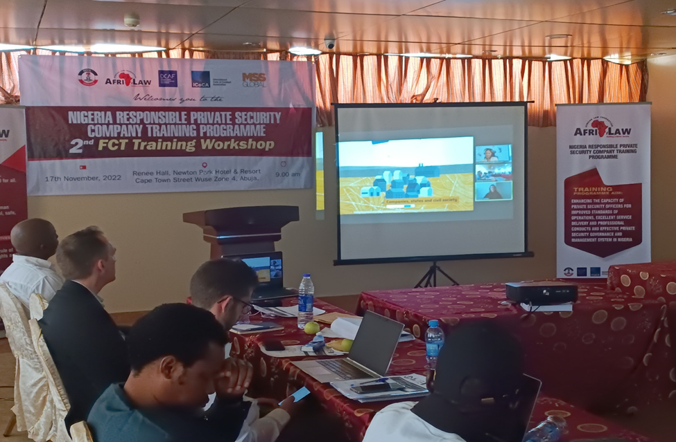
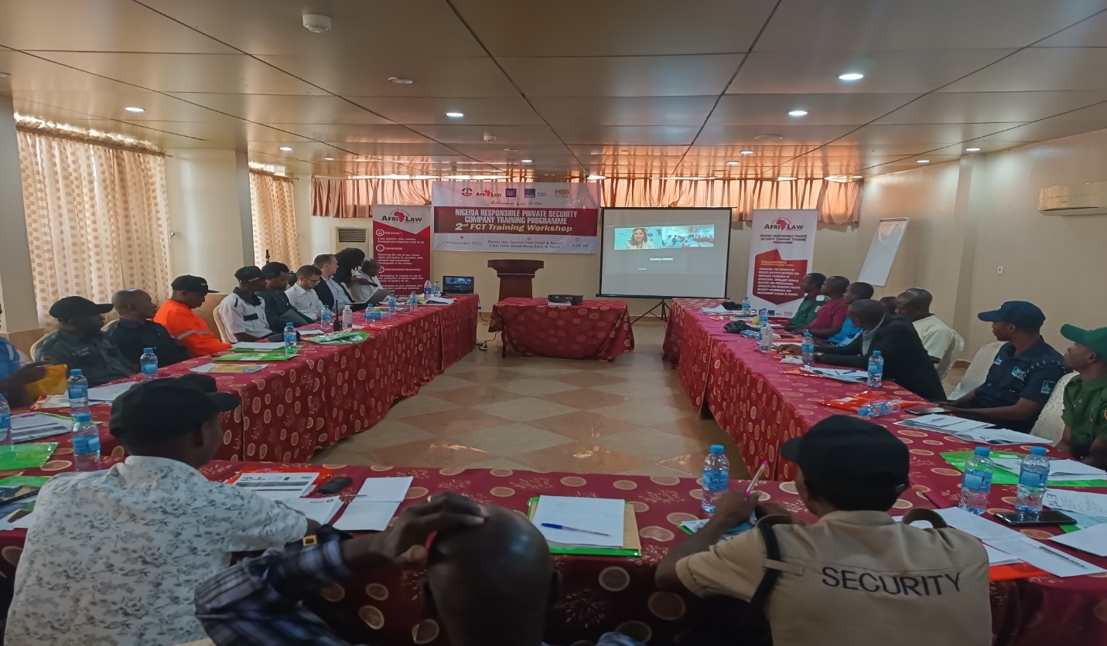
DCAF Representatives making their presentations
PRESENTATION 3: Functional Planning Support and Delivery of Security Operations Management System by PSCs, ICoCA Certification and 18788 for Nigeria PSCs by MSS Global Africa Director
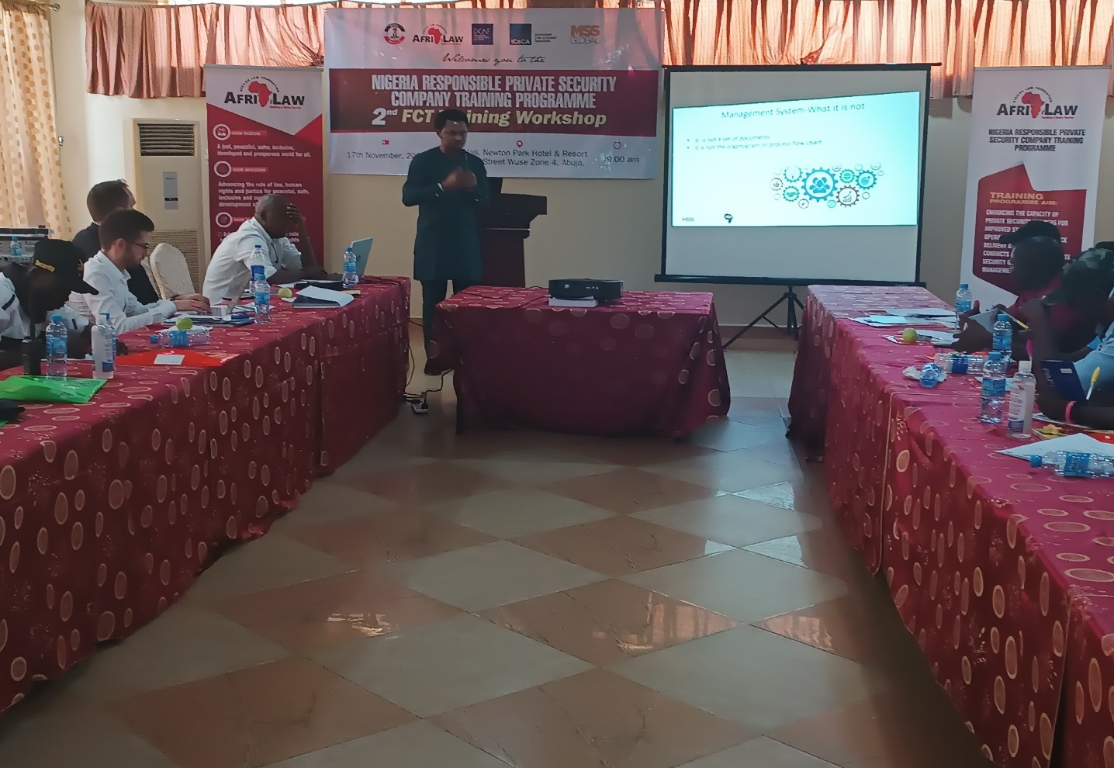
Mr. Jonah of MSS Global making his presentation

Mr Jonah Eromon a Director and the Africa Representative of MSS Global who was present physically took this presentation. He began by with a brief introduction of MSS Global afterwards he went to the crux of the presentation. He discussed the need for PSCs to plan and implement its objectives through a management system, security operations planning which sets out a timeframe for achieving the set goals. He pointed out that these can be done through the standard operating procedure of the PSCs, stating that operations cannot be devoid of risk and the need to manage this risk to the clients, organization and stakeholders. Also, he summarized by stating that all responsible PSC must first cascade its strategic objectives into operational task, do a supplier due diligence before signing a contract, identify and understand resources needed and finally plan the internal and external communication. He afterwards went into the second part of the presentation on how PSCs can achieve ICoCA certification in three simple steps. First by internal preparations, then an initial certification and finally contact the ICoCA secretariat and audit report review. He stated that becoming ICoCA certified comes with real commercial and operational benefits and urged the guards to inform their company on the need to get certified. The guards really enjoyed the presentation and some indicated interest in the certifications as well as asked question on areas they needed clarifications on which was satisfactorily answered. Afterwards the attendees proceeded for lunch break.
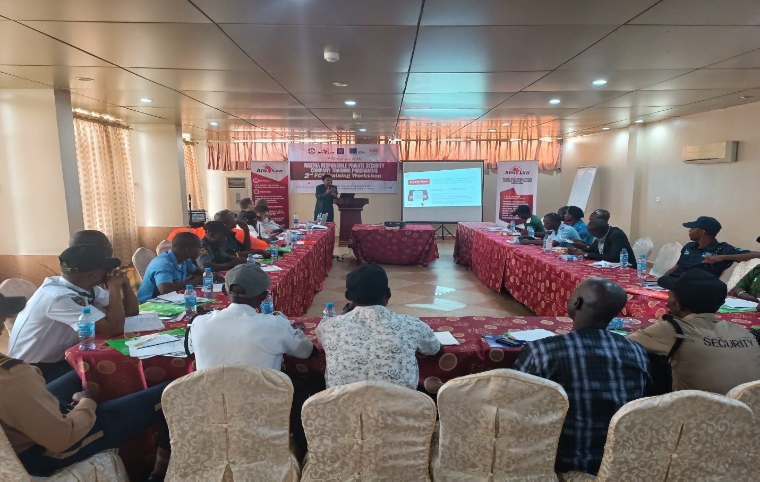
Cross Section of the Participants

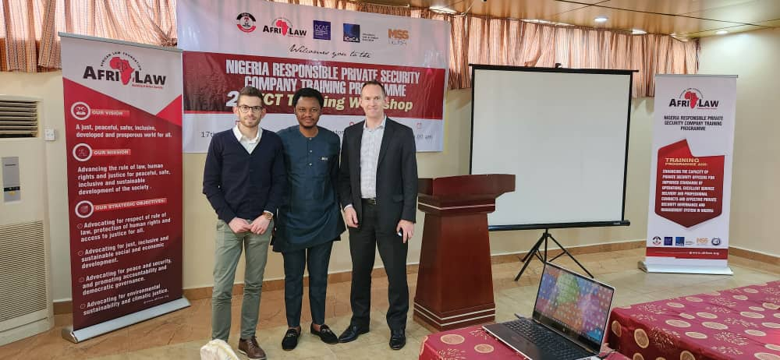
Mr. Jonah and ICoCA Representatives during the training Workshop
PRESENTATION 4: Understanding Nigeria Human Rights Law for PSCs, Gender Sensitization for PSCs and Preventing and Addressing Sexual Exploitation and Abuse (PSEA) by PSCs in Nigeria.
ARFILAW ED (Barr. Chinwike) took the presentation after the lunch break. He proceeded with the gender sensitization for the guards and began the presentation on preventing and addressing sexual exploitation and abuse by PSCs in Nigeria. He first discussed the UN guiding principles on business and human rights by pointing out UNGP 6 and 13 as important basis for effective procurement and contracting policies. He also defined gender concepts as well as equity and equality. He pointed out that gender equality is the absence of discrimination on the basis of a person’s sex in opportunities and the equal allocation of resources, benefits and in access to services. He stated that sexual and gender-based violence (SGBV) refers to all violence that are committed against a person based on their perceived or actual sex and or gender. It is a gross violation of human rights, and is both a cause and a consequence of gender inequality. The definition included physical, verbal or sexual violence against women and girls (VAWG), the victimization of people because of their masculine or feminine traits or sexual orientation, and any form of violence that stems from unequal power relations. He further listed the actions that comprise SGBV to include sexual threats, exploitation, humiliation, assault, molestation and rape, domestic violence and incest, involuntary prostitution, torture and or insertion of objects into genital openings, female genital cutting and attempted rape giving a detailed explanation of all of them.
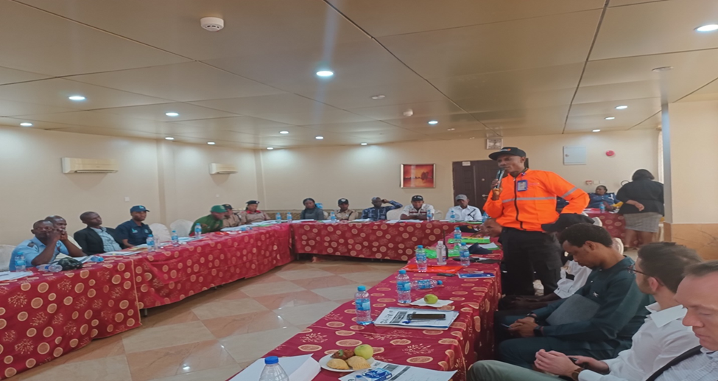
Participant asking question during the workshop
The second part of the presentation on preventing and addressing sexual exploitation and abuse by PSCs and started by defining sexual exploitation, sexual abuse and its impact on PSCs which could be serious reputational, operational, financial or legal detrimental consequences. He further discussed the need of integrating a gender perspective in PSCs services stating the necessary guidelines. It was an engaging topic for the guards as they shared their inputs on the topic. Due to time the first part of the presentation on understanding Nigeria Human Rights Law for PSCs was not taken.
Closing Session of the Workshop/Departure: The Training Workshop came to a successful end by 6:30pm with a closing remark by AFRILAW ED. He urged the guards to adhere to all they had learnt and practice them, also to educate their members on all they had learnt. After which, certificate of participation was presented to all who attended. Then the closing prayer was led by one of the PSC guards and they all departed.

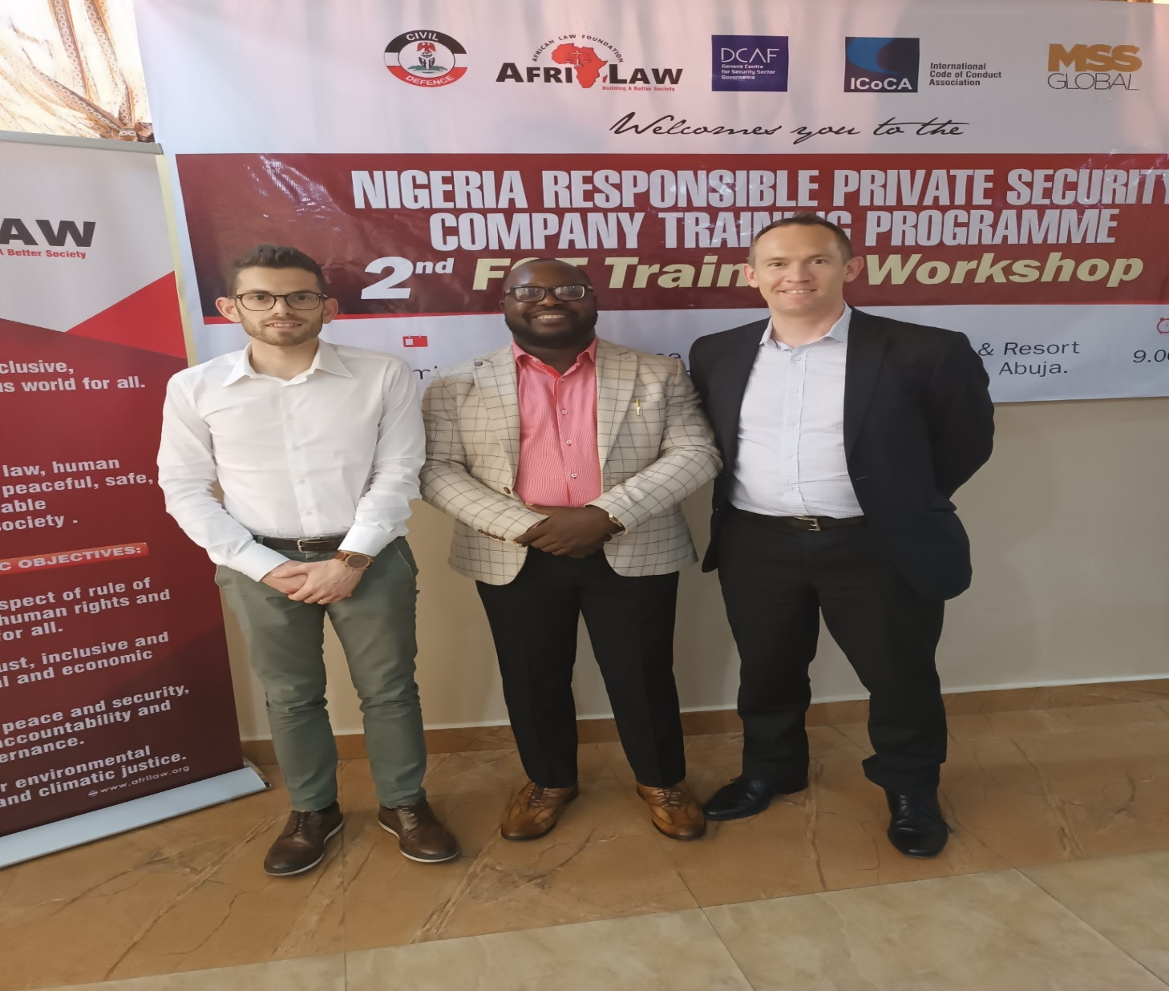
AFRILAW ED with ICoCA Representatives during the Workshop

3: ICoCA LUNCH MEETING WITH THE FCT ZONAL PSC EXECUTIVES AND KEY STAKEHOLDERS OF ALPSPN AT ABUJA:
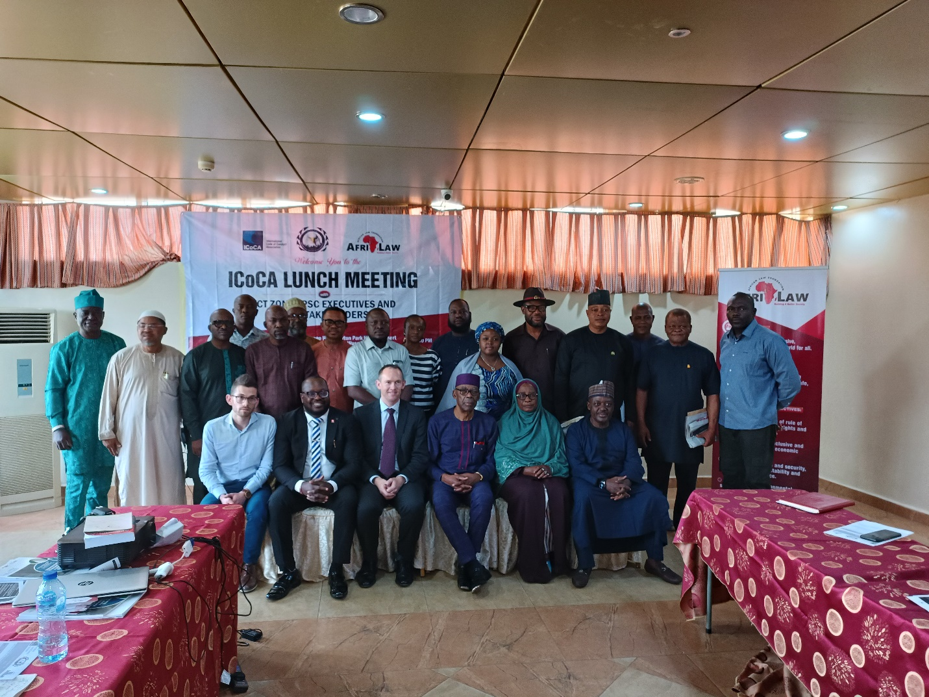
The Group Picture of the Meeting

The ICoCA Lunch Meeting with The FCT Zonal PSC Executives and Key Stakeholders Of ALPSPN was held on November 18th, 2022 at Newton Park Hotel & Resort, Abuja. There was about twenty-five (25) persons which comprised twenty (20) executives of various private security companies including the FCT Zonal Chairman, two (2) ICoCA representatives and (3) AFRILAW staff.
OPENING SESSION AND REMARKS: The Meeting began by 10:30am with one of the executives leading the opening prayer. The Executive Director of AFRILAW (Barr. Chinwike) welcomed all the executives in attendance and set out the agenda of the day. The zonal chairman of ALPSPN also gave his welcome remarks and thanked the executives for obeying the call for the meeting. ICoCA representatives who attended physically also gave their god will remarks.

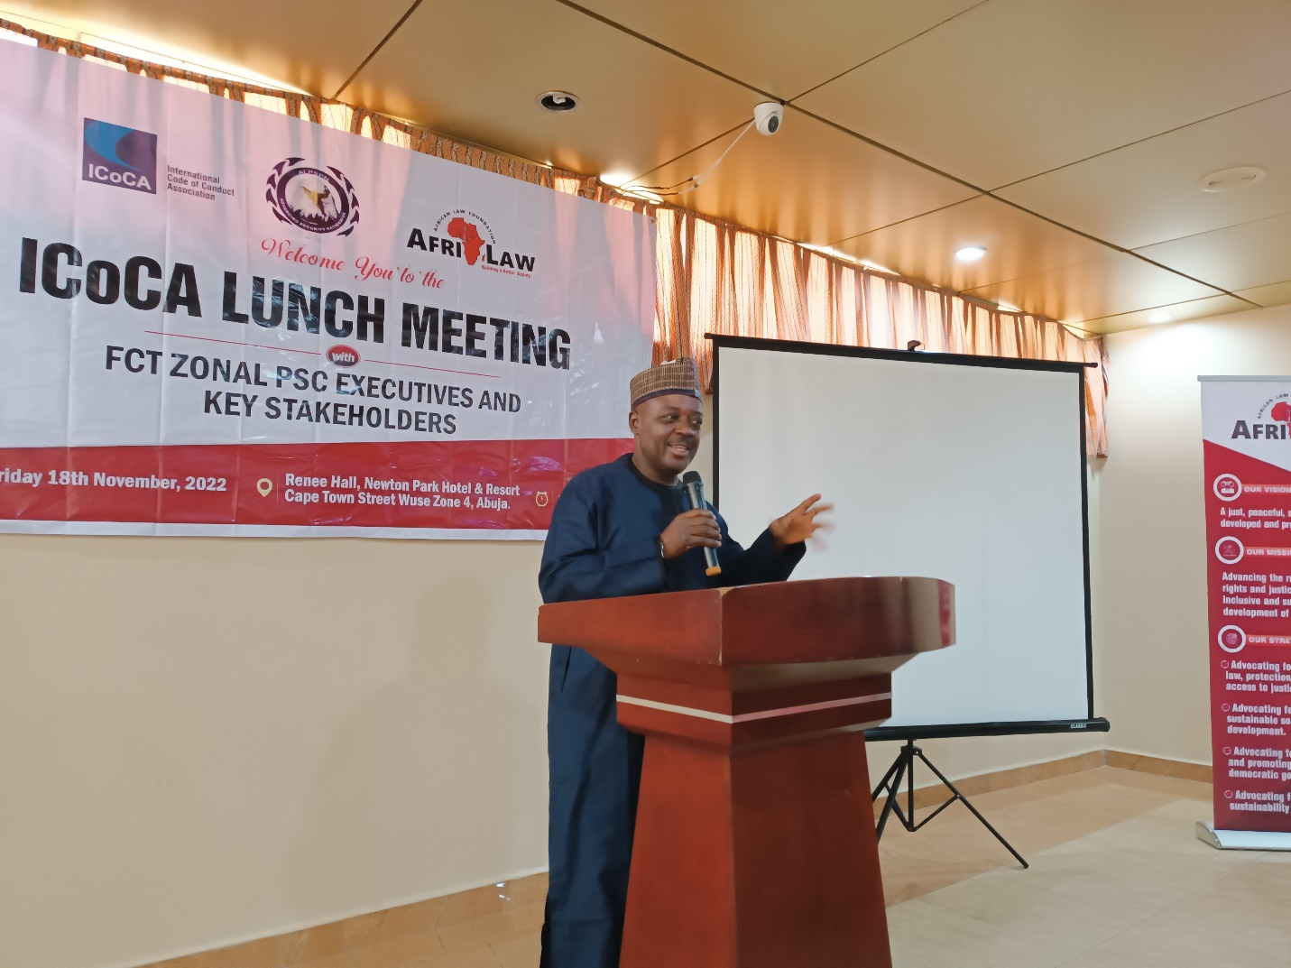
FCT Zonal Chairman of the ALPSPN giving his welcome and goodwill speech

PRESENTATION 1: INTRODUCTION TO ICOCA:
Mr. Christopher Galvin took the presentation on the ICoCA and the Code. A brief history on ICoCA was given as a governance and oversight mechanism to ensure the implementation of the code and once a private security company becomes a member, they agree to be monitored by the Association to ensure compliance with the code. They were briefed on current members of the Association both state members and private security companies who are members as well as observers of the Association. The purpose of the Association was highlighted which is to promote responsible private security, by strengthening human rights due diligence on private security providers. Furthermore, he stated that the Association promotes capacity building by providing guidance which includes; human right impact assessment for PSCs, guidelines for PSCs on preventing and addressing sexual exploitation and abuse, developing and operating fair and accessible company grievance mechanism that offer effective remedies and trainings. They also carry out monitoring of PSC by visiting, tracking, reporting and creating a civil security network.
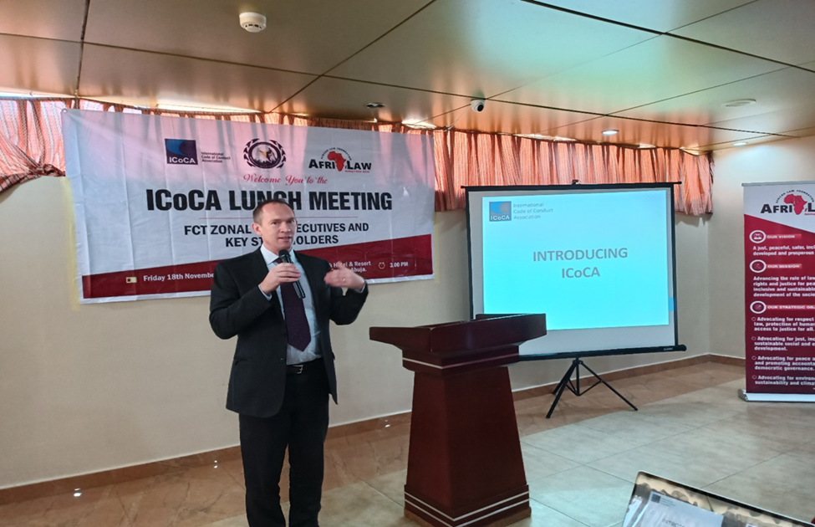
Mr. Gavin making a presentation

The need for PSCs to be ICoCA certified was also discussed as PSCs who are certified represents gold standards who have submitted themselves to be monitored and verified by ICoCA mechanisms. The reason why private security users care about human rights due diligence was also taught in the presentation. This is because of the many and rising abuses by PSCs contractors especially in the mining sites which will in turn be a reputational and financial damage for such company. Also the treatment of the private security personnel themselves was stated to be the biggest human right risk in the industry and the need for these PSCs to meet the mandatory human rights due diligence requirements was emphasized. The need for these PSCs to conduct human right impact assessment was explained as it helps companies understand how certain activity affects human rights. They were advised to start the assessment as early as when the company starts to plan operations. The phases of the assessment was also highlighted to include: planning and scoping, data collection, impact analysis, impact mitigation and management and evaluation and reporting.
Presentation 2: General Discussion and Questions and Answers Session: The session was very enlightening for the PSC executives as they proceeded to ask questions on areas, they needed clarifications on and how their companies could be part of ICoCA which all questions were answered satisfactorily by the resource persons and further provided the organizations website if they needed more clarifications. There was also a question was on the financial cost of joining and how interested executives could attend the upcoming ICoCA AGM in Switzerland in December. The ICoCA representatives addressed this as well as all questions that arose as regards the issue.
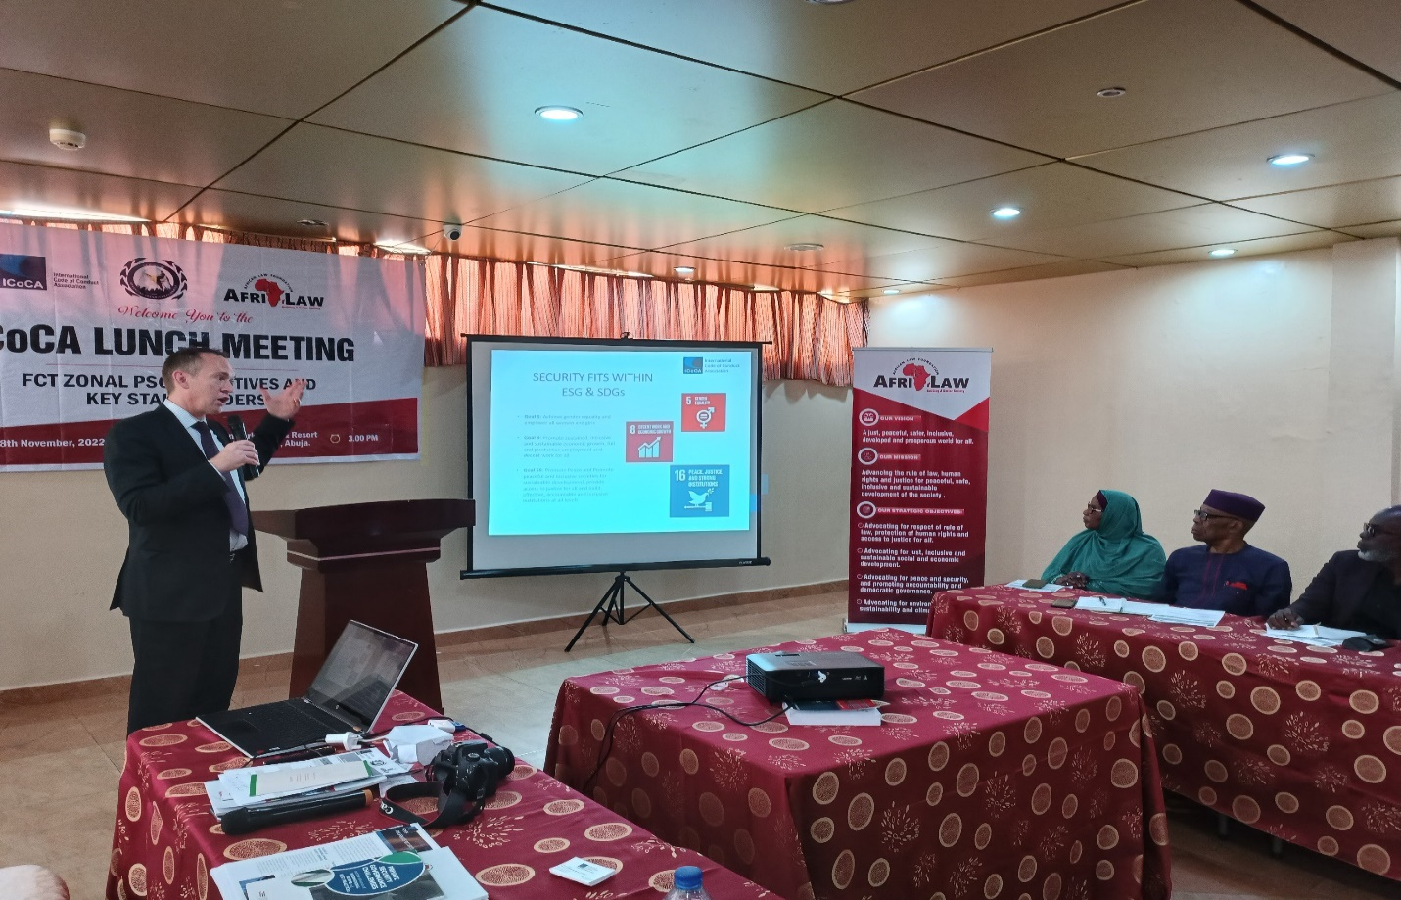
Mr. Chris Gavin making his presentation

Closing Session of the Workshop/Departure: The lunch meeting came to a successful end by 2:30pm with a closing remark by AFRILAW ED and the FCT Zonal chairman thanking ICoCA for the relationship and partnership. Then the closing prayer was led by one of the PSC executives and they all proceeded for lunch and afterwards departed.

4: ICOCA TEAM VISIT TO NIGERIA SECURITY AND CIVIL DEFENSE CORPS (NSCDC):
AFRILAW facilitated a Courtesy Visit and Meeting of ICOCA Representatives Mr Christopher Galvin (Team Lead) and Mr. Giuseppe Scirocco and with the Commandant General (CG) of the Nigeria Security and Civil Defense Corps (NSCDC), Dr. Ahmed Abubakar on November 18th, 2022. at the Head Office of the Nigeria Security and Civil Defense Corps (NSCDC) at Sauka, Abuja.
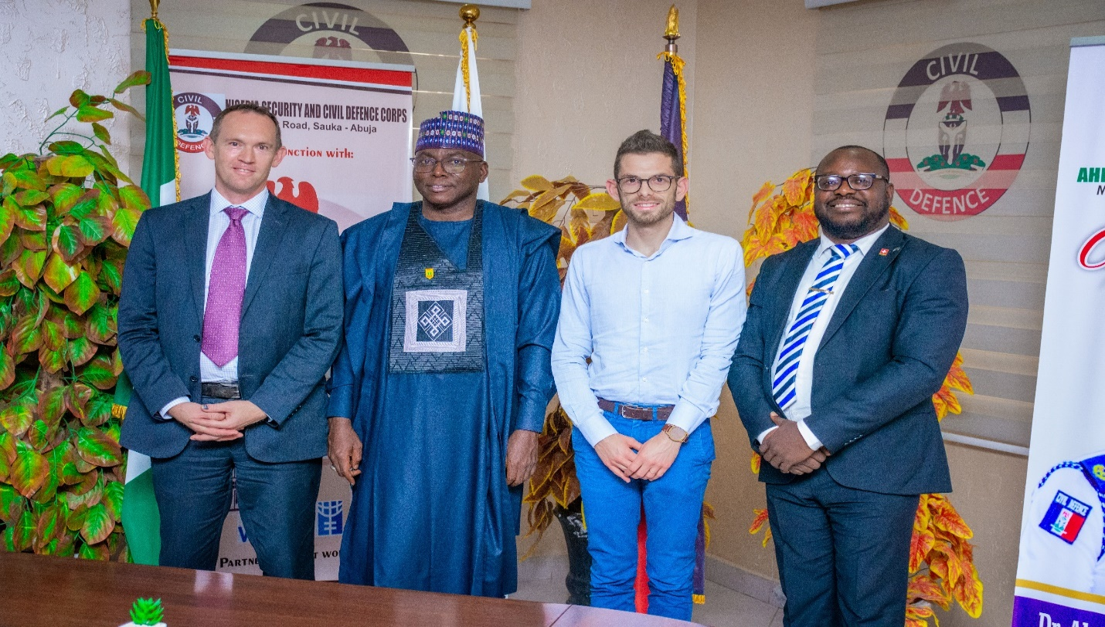
ICoCA Representatives and the CG of NSCDC with AFRILAW ED during the Courtesy Visit

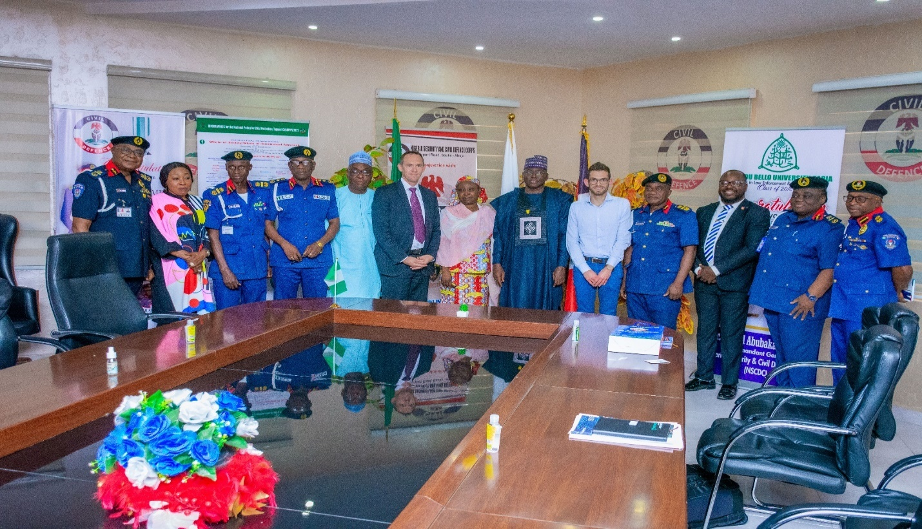
The Group Picture during the Courtesy Visit

5: TRAINING WORKSHOP FOR SOUTH-EAST REGION (ENUGU, ENUGU STATE)
INTRODUCTION: The Nigeria Responsible Private Security Company Training Programme training was held for PSC representative for the South-East region on January 27th, 2023 at Hotel Fidelma, Enugu, Enugu State with about Twenty-three (23) participants, which includes Seventeen (17) PSCs representatives and NSCDC representatives. The participants were issued certificate of participation endorsed by NSCDC and AFRILAW.
OPENING SESSION AND REMARKS: The Workshop started 11:30pm with the opening prayer said by a volunteer i.e one of the participants. After that the national anthem was said. Then the opening remarks held by the AFRILAW ED, he apologized to his partners for the lateness of the PSC representatives, and told them what the program was about. He then did a brief breakdown of the agenda as it was adjusted for the time so far. He introduced himself and AFRILAW. He also introduced the workshop, and said that during this training they’d be exposed to principles, standards and norms that would help them to be effective, productive and responsible. Responsible in the sense that they do things in line with human rights, ethics, and best practices.
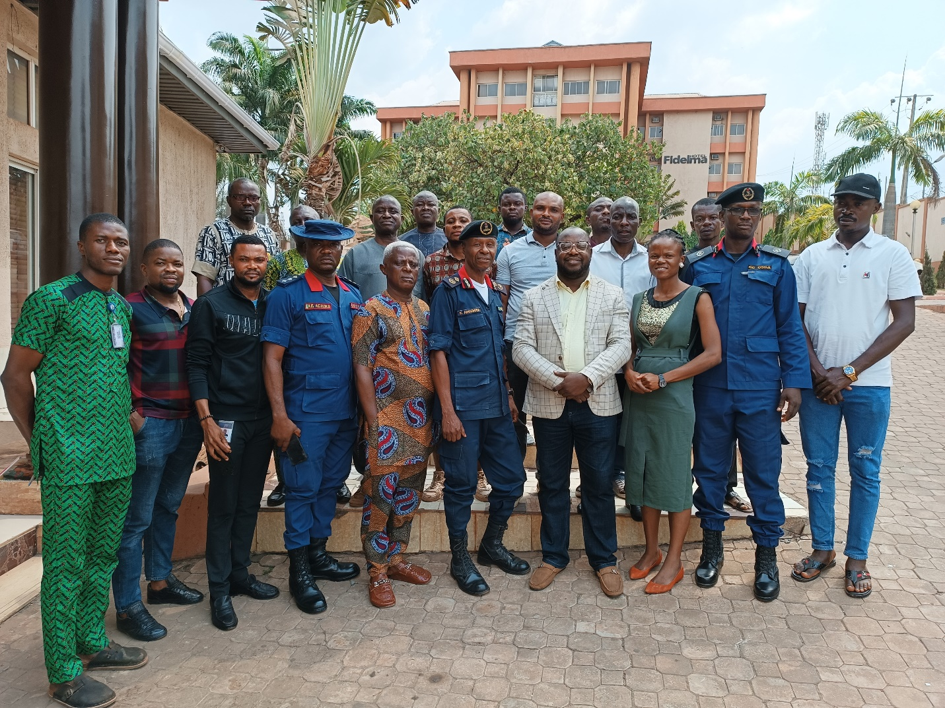
Group Picture of the Training Workshop

Also, in their goodwill messages, DCAF representative Ms. Gabrielle Priklopiova welcomed everyone and said that DCAF is a strategic partner of ICoCA and also partners with AFRILAW. She said that it’s a pleasure to have them present and to talk to them on issues of private security issues today. She said welcome to all the participants.The NSCDC Representative also gave the ACG-PGC remarks by appreciating AFRILAW and its partners for organizing the wonderful training workshop for the PSCs, and to the Private security Companies that honoured their invitation and hoped that their presence would be of great benefit to their individual organizations and that they’d be able to step down those trainings to other members of their office. He also appreciated the conveners and hoped that what they’d be trained on would be beneficial to them.
PRESENTATION 1: Introduction To ICOCA And Human Right Impact Assessment By MR GIUSEPPE SCIROCCO
He introduced the International Code of Conduct Association (ICoCA), and said that it came about as a result of the indiscriminate acts and the habitual abuse of human right by some private military and private security and private military groups. Upon that abuse, governments, industry and civil society came together to negotiate a way to better oversee the industry so that human rights and international humanitarian laws were respected. In other to do this they came up with the code which is a guide for private security operatives. He said that the code covers issues regarding the conduct of personnel covering the use of force, prevention pf sexual abuse and exploitation, detention, apprehension etc, management and governance of private security organizations including company policies, selection and vetting of personnel, training, management of weapons and ammunition etc. having made up these guidelines, there needed to be a way to monitor the implementation of the code. The ICoCA was therefore formed in 2013 as a governance and oversight mechanism to ensure implementation of the Code. All companies who join undertake to be continually monitored by the associations. He then spoke about the associations and what it does, the components of government, CSOs, companies and observers.
He said that the association’s purpose is to promote responsible private security, by strengthening human rights due diligence on private security providers. The association does this by capacity building, monitoring, certification and it also handles complaints. He said that in its role to provide capacity building it provides guidance including: human Rights Impact Assessment for Private Security Providers, Guidelines for Private Security Providers on Preventing and Addressing Sexual Exploitation and Abuse, developing and Operating Fair and Accessible Company Grievance Mechanisms that Offer Effective remedies online. Still within its capacity building function, the association also trains just as it is doing today and it also provides feedback where required. The association in its monitoring function, carries out in-country visits to the companies in the association, accepts reports from private security users, tracks companies and also monitors the activities of its other component through the CSOs within the association.

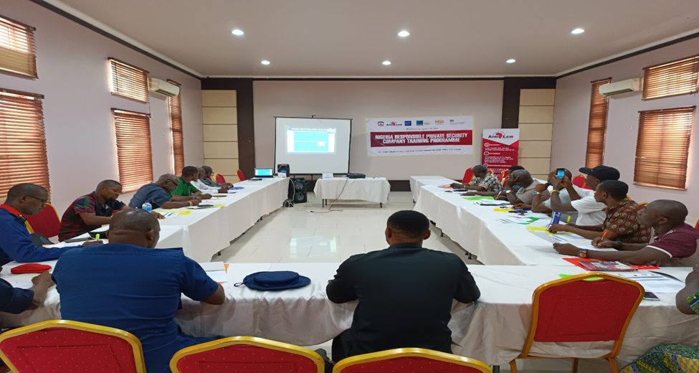
Presentation by ICOCA during the Workshop

Certification: On certification, he explained that ICoCA’s certification scheme has third party audit and verification built in. It recognises a limited number of international standards and only accept certification to these standards from Certification bodies whom which it has done its own due diligence on. The problem with certification is that certificates can be bought from the street-corner, sometimes with no, or very little audit. ICoCA therefore only accept certification from certification bodies IAF/MLA accredited to ISO 18788, PSC.1 and ISO 28007, 18788 being the most commonly used land-based standard. Where there are no IAF accredited CBs available, ICoCA accepts evidence of certification to these standards from ISO17021accredited certification bodies that meet ICoCA competency requirements. He then explained the various category of companies i.e: certified, affiliate and transitional and the distinguishing factor between them. It’s important to look at the scope of ICoCA certification, which is often limited in geography, all this is transparent and available on its Member listing on the ICoCA website. The approaches applied by the association is an integrated approach, these things are intertwined and work together. He further encouraged the participating PSCs to seek assistance and support from ICOCA toward becoming a member of ICoCA and that the MSS Global Uk who is ICOCA certification agent in Nigeria and start their certification process.
HUMAN RIGHT IMPACT ASSESSMENT BY MR. GUISEPPE OF ICOCA: Mr. Guiseppe said that human right impact assessment is to identify, understand, access and address the adverse human rights impacts of certain activity. He explained that just as risk assessment checks the extent of risk attached to the activities of a company or its assignment; human right impact assessment check how the activities and assignments of a company impacts on human rights of people with whom they engage. He said that it is important for companies to pay attention to human rights because PSCs are essentially business concerns and their clients pay attention to it and it generally affects businesses negatively and positively. He gave different instances of corporations who have been affected by a human right slip. Also he gave a graphic picture of development of laws relating to human rights due diligence and impact assessment as it relates to businesses and corporations. Also security issues are part of the sustainable goals especially goals 5, 8 and 16.
Conducting Human Rights Impact Assessment by PSCs: The question was when do we start? The response to this question is as soon as possible ideally before operation kicks off. Also this assessments would be reviewed regularly as other reviews are made. The phases of the development of the risk analysis include:
- Planning and scoping
- Data collection and baseline development
- Human right Impact analysis
- Human right impact mitigation and management
- Evaluation and reporting
Planning and Scoping: this he said involves getting to understand the operation, the context etc as it affects human rights in any aspect. Data collection and baseline development. Impact analysis: analyse the impacts identified to track the impact that stem either directly or indirectly from the operation. This also helps to determine the severity of the impact. He said that the key criteria to determine severity include: scope (number and profiles of people); scale (seriousness); remediability (possibility of restoring pre-existing state or an equivalent). Impact mitigation and management: during the impact mitigation and management the human rights impacts are prioritized on the basis of severity. An impact management plan is great to be developed in this stage to include assignment of roles, set timelines and budget, defining monitoring and reporting procedures. Evaluation and Reporting: at this stage organizations look back and analyse the effectiveness of the measures put in place. For further guidance on human right impact assessment he referred them to ICoCA website. He then called for questions:
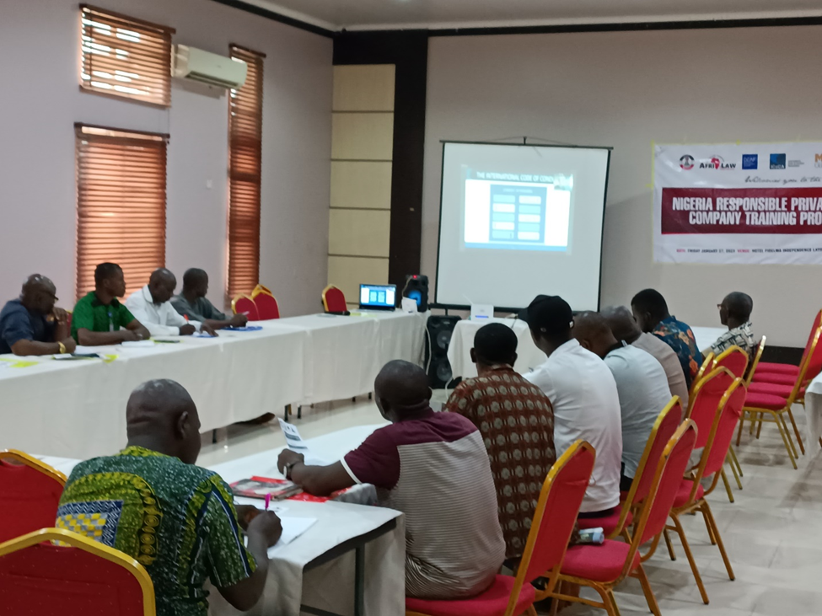
Cross Section of the participants during ICoCA presentation

The ED, of AFRILAW led the group to appreciate them for their presentation. He then asked them to explain to the group the way to become a member of ICoCA. Mr. Chris explained the procedure to be followed to become members of ICoCA and be ICoCA certified and the support and assistance they can get from the Certification Agency like MSS Global which is based in Nigeria. There were no questions for Mr. Chris after the presentation.

PRESENTATION 2 IMPORTANCE OF THE MONTREUX DOCUMENT /BASIC PRINCIPLES ON THE USE OF FORCE FOR PSCs BY DCAF REPRESENTTAIVE
The presentation was done by Ms Gabrielle of ICOCA, and she started by saying that there are three documents that regulate the operations of private security companies internationally. She said that she would play a short video to show how these three initiatives complement each other though they have differences.
The initiatives mentioned in the video include:
- The Montreux document (MD): the Montreux document clarifies the obligation of states to regulate the operations of Private Security Companies PSCs, and to share good practices.
- The International Code of Conduct for Private Security service Providers (ICoC): establishes standards based on human right. Companies, states and civil society organizations join the association to ensure that the code is enforced generally.
- The Voluntary Principle on security and human right: gives organizations in the commodity industry a road map to respect human right in their operations.

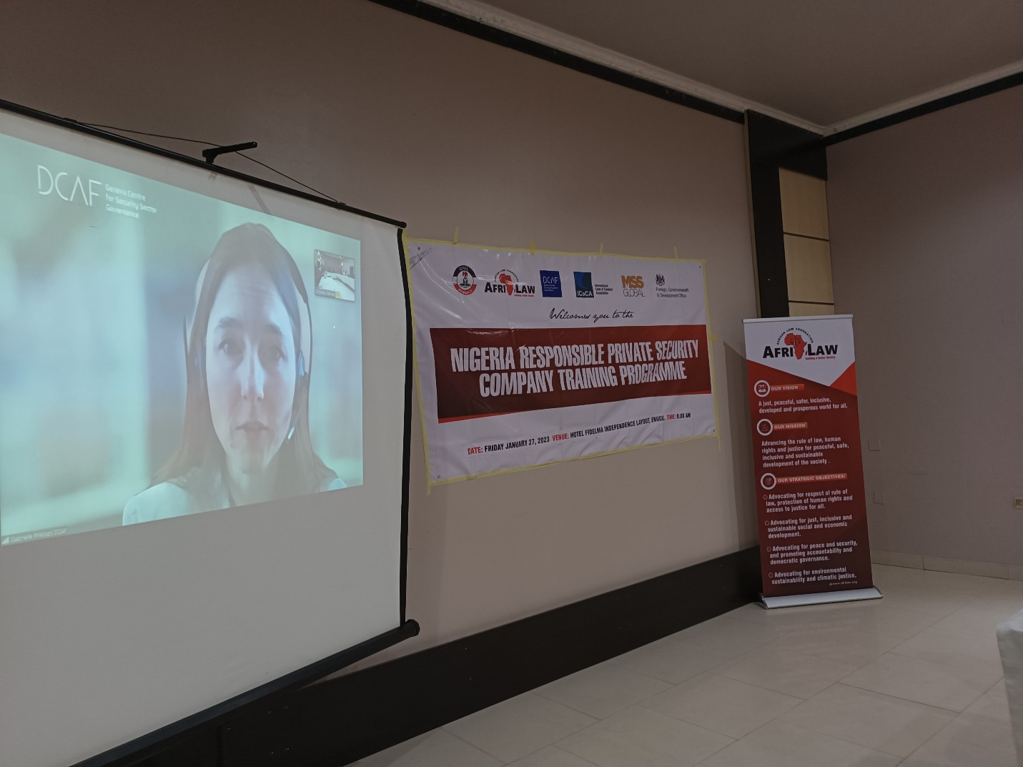
Ms. Gabrielle of DCAF making her presentation

According to the video, Geneva Centre for Security Sector Governance (DCAF), supports the vision of all three initiatives and its implementation. It also therefore jointly works with these initiatives to promote security, human rights and development. She then went ahead to buttress on the Montreux Document and the Voluntary Principles. The ICoC had been explained early. She said that it is important for private security companies to know of these initiatives because clients at this time demand more and more of compliance to standards. She said that though the Montreux Document doesn’t apply directly to Private Security Companies, it is in the interest of companies that standards are upheld and Montreux document provides the highest international standards. She said that the MD doesn’t make any new set of rules but it extract already existing rights and standards regarding the obligation of states in business and human rights and makes a compendium of them in the MD. She further described that the document describes the obligation of the different kinds of states that are recognised under the MD: contracting state (companies that buys private security), territorial states (the country where the PSC operates) and the host state (ie the country where the PSC has its headquarters). There is a MD Forum where states can exchange with experts on governance and regulation of security and human rights. The head quarter is hosted by DCAF in Switzerland.
The Voluntary Principles: The VP is a principle to guide extractive companies on how to structure their operations in line with human rights. She said the principles are divided into three parts: Risk assessments; company relations with private security providers and company relations with public safety providers. She then referred them to the DCAF toolkit on the voluntary principle.
THE USE OF FORCE BY PSCS: She said that it is almost obvious the reason why regulations are needed on the use of force. She said that at the base of regulation of the use of force is the protection of human rights. She said that the extent of use of force that PSCs are allowed to apply is limited and different from those that can be applied by public security providers for the following reasons:
- The use of force by private security providers must be guided by the personal right of self-defence.
- They do not have a general mandate to ensure public security beyond the objectives set out in the private security contract, even when the state is the client.
- Private security functions do not enjoy the legitimacy and oversight and accountability mechanisms applicable to state public security. Nor do they enjoy the same level of training and capacity building.
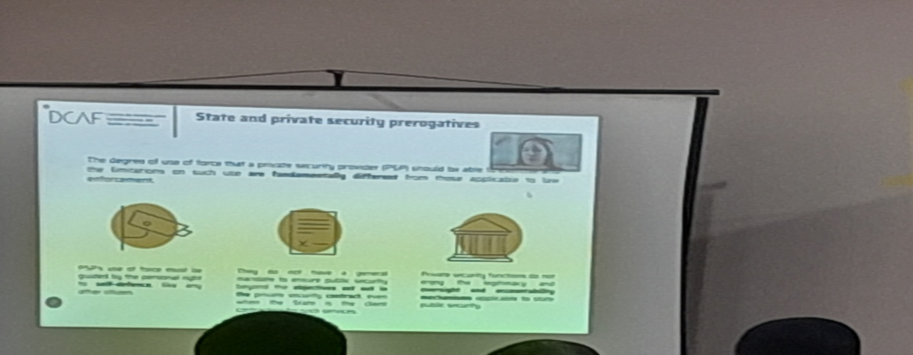
PowerPoint presentation on the use of force by PSCs

On the regulation of the use of force, she said that there should be provisions to pre-screen personnel; provide training on the use of force; register weapons. She said that additional provisions should be made on management and storage of weapons and firearms. States also should empower the judiciary to handle complaints on such issues and also provide judicial and non-judicial means for accountability and redress. The DCAF has modules on the use of force and she encouraged them to visit the website for more resources.

GROUP WORK ON THE USE OF FORCE: The participants were give a Case Study to discussed in pairs and share the answers as thus: Community members have organized a protest in front of a mining site; they carry tree branches and seem very angry. A small group of protesters try to force entry into the site. Private security guards assigned to the mining site pushed them back using sticks. What do international norms good practices say about the use of force?
QUESTIONS:
- Sometime in 2020 there was a riot in Nigeria. I experienced some rioters approaching the facility where i was guarding ie a bank. We were with the police who could but wouldn’t use force in the case. We tried to scare the rioters away but couldn’t do much to guard the property as we tried to guard our own lives.
Ans: this instance ie. Mass control is not the work of private security companies. In this instances public security takes the lead here and the first thing to do is to assess the risk. Private security can only try to de-escalate the situation.
- He narrated an experience where his company provides guard services at a hospital. One of the patients turned violent demanding his discharge. The management of the hospital called on them but still demanded that they call the police to handle the case.
Ans: de-escalation is the first step to take in this instance. People do not also realise how important it is important for the private security Companies to be trained in things like conflict management.
CONTRIBUTIONS AND DISCUSSIONS:
Some of the participants shared some of their experiences on the issue.
- When we had similar experience we knew that the lives of the guards were at risk and that we were responsible for the safety of our guards more than any other thing. Bearing this in mind we asked our guards to disguise themselves and not appear as security personnel. This was for their safety. Then we began to build rappourt with the rioters. It was upon doing this that we found out that they had intensions to destroy the property under our care. They started giving us information which we could then report to the police.
- Reacting to the last contribution he said that engaging with the police should be done with discretion. He then said shared his experience of sharing an intelligence with the police and the suspect comes back for him with the same intelligence he just shared with the police. He advised for them to work more frequently with the NSCDC, who are their regulating agency and their friends.
- The ED AFRILAW said that study has shown that PSCs engage with the police more than they do with their regulatory agency ie the NSCDC. Also individuals tend to interface with and report to the police issues relating to private security. He said that finding a way to improve working relationship with the police being the most popular law enforcement agency would help both the industry and their regulators.
- The reason for a greater relation between police and PSCs include: a. Availability of the police b. Age long awareness and popularity of the police among the citizens etc.
- The representative of the NSCDC said that though the police is the mother of all security infrastructures there are situations in which they come in handy e.g cases of emergency, intelligence gathering, domestic issues, in-house issues within Private Security Companies.
- The Head of Department NSCDC reassured the participants of the capabilities and trainings of their regulatory agency and their commitment to work with them with their corporation.
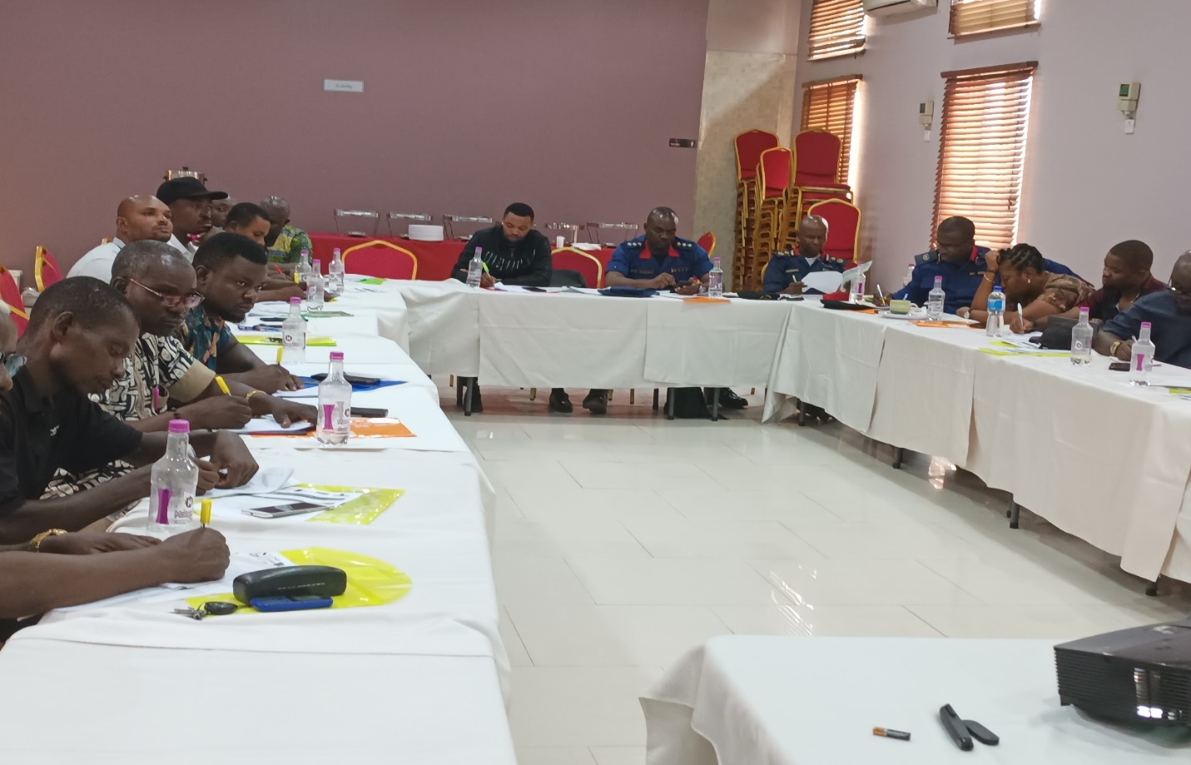
Cross Section of the Participants during the workshop

PRESENTATION 3: UNDERSTANDING HUMAN RIGHTS BY AFRILAW ED
Barr. Chinwike Okereke asked the participants to share what they know about the concept of human rights. One of the participant said that human rights is the basic right human beings have to exist. He described the various rights a person can have. Going further in the conversation he said that every human being has a right no matter who they are. He pointed out the principles that qualify human rights ie. Human rights core principles thus:
Universal/alienable: this means that human rights are the same for everybody no matter their status. Inalienable on the other hand means that they cannot be taken away from anyone.
Indivisible/ interdependent: no right can be enjoyed with the others. They all work together.
He further described the various types of rights that exist: moral right, natural rights, contractual rights, legal rights, human rights.
Types of human rights:
- Civil and Political Rights: This he said is provided for under Chapter 4 of the 1999 constitution.
- Economic, Social and Cultural Rights: these are rights that apply to us socially, economically and culturally. These rights are not justiciable under the Constitution of Nigeria. This is found in chapter 2 of the Nigerian Constitution. He said that these rights in his opinion are the essence of government and it is however unfortunate that these laws are not justicable in Nigeria though they are in developed countries.
- Environmental and Development Rights: talks about the environment and sustainable development.
He said that under the Universal Declaration on Human Rights there are 30 basic human rights and these 30 rights are where the different countries draw their rights from.
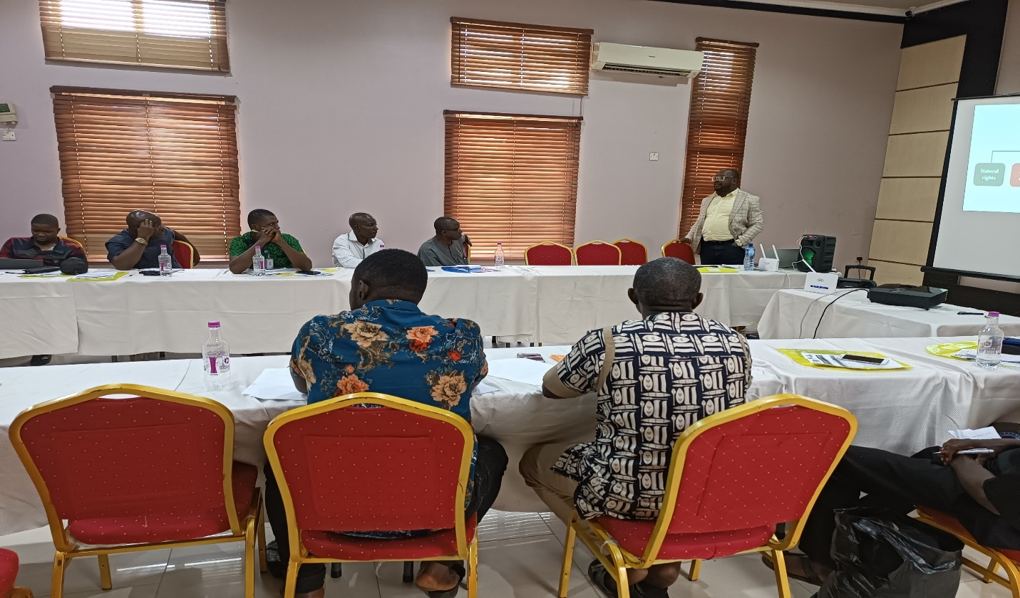
AFRILAW ED making a presentation during the workshop
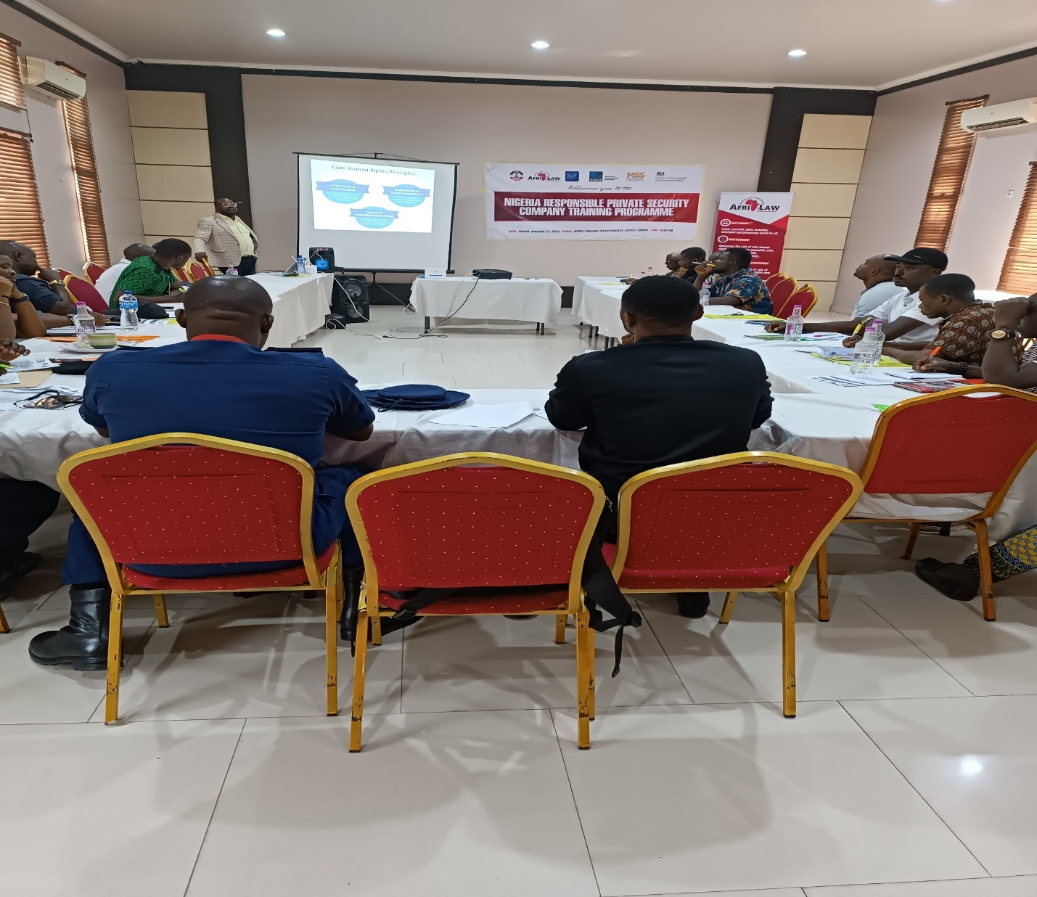
Cross section of the Participants during the presentation

International/Regional instruments and National HR laws in Nigeria:
National Human Rights in Nigeria: He stated this section by saying that human rights are not absolute that there are things that can be done and those rights will be taken away. He said that in Chapter 4 of the Nigerian Constitution there are a group of rights enshrined therein which every Nigerian is entitled to but not absolutely. These rights include: Right to life-Section 33, Right to dignity- Section 34, Right to personal liberty- Section 35, Right to fair hearing- Section 36, Right to privacy ad family life-Section 37, Right to freedom of thought, conscience and religion- Section 38, Right to freedom of expression and press- Section 39, Right to peaceful assembly and association- Section 40, Rights to freedom of movement- Section 41, and Rights to freedom from discrimination- Section 42, Rights to own property-Section 43 and Rights from expropriation Section 44. The fundamental right enforcement laws of Nigeria empower the state high court to prosecute fundamental rights and states that human rights grievances may be brought to the state high court.
He introduced them to the various international human rights laws such as the Universal Declaration of Human Rights (UDHR), adopted by the UN General Assembly in 1948, International Covenant on Civil and Political Rights (ICCPR) of 1966: according to him this law is the main instrument that informed the chapter 4 of the 1994 Nigerian Constitution. International Covenant on Social and Economic Rights (ICSR) of 1966, Optional Protocol to the Covenant on Economic Social and Cultural Rights, Convention on Elimination of All Forms of Discrimination Against Women (CEDAW), 1979 and Optional protocol to the Convention on the elimination of all forms of discrimination against Women (CEDAW-OP), The Convention Against Torture and other Cruel, Inhuman or Degrading Treatment (Convention Against Torture), 1984 and among others.
The Universal Declaration of Human Rights (UDHR); Covenant on Civil and Political Rights (CCPR); Covenant on Economic Social and Cultural Rights (CESCR) and the First Optional Protocol to the ICCPR, make up the international bill of rights. He also introduced them to some regional human right instruments, but carefully pointed out that most of these documents have not been ratified in Nigeria, hence they do not have the force of law in Nigeria.
Nigeria Human rights laws: he listed the various human rights laws in existence in Nigeria and laid much emphasis on Nigeria Labour Act, 1971, Pensions Reform Act, industrial act, 2011; National Minimum Wage Act, etc. On Relevance of HR to Security Personnel: He said that security personnel have a duty to protect, respect, promote and ensure human rights of every person they deal with regardless of who they are. they also have the potential to limit the human rights of people in the cause of the operations. Because of this, an understanding of human rights is important to them.
When deciding to act and limit the rights of persons, security personnel must always apply the PLAN Principle: P: proportionality: only use the minimum force or action that is necessary to solve the situation
L: Legality: all acts should be done within the ambits of the laws
A: Accountability: act ethical way knowing that you’d be accountable for your actions
N: Necessity: Only act when it is necessary to act
Human Rights in times of Civil Emergency and Armed Conflict: Even during times of civil or public emergencies, “States of Emergency”, or armed conflict, all security personnel have a responsibility to respect and protect the basic human rights of all people. Rights like the Right to life, Freedom from torture; cruel inhuman or degrading, Treatment or punishment; and from medical or scientific experimentation, without free consent; Freedom from slavery or involuntary servitude; Right not to be imprisoned for contractual debt; Right not to be convicted or sentenced to a heavier penalty by virtue of retroactive criminal legislation; Right to recognition as a person before the law; Freedom of thought, conscience and religion; are not suspended during times of armed conflict. Also in times of war, international humanitarian laws (laws of war), are not suspended and are meant to protect people who are affected by war whether they are actively taking part in the hostilities or not. Company and private security personnel are considered non-combatants and will not participate in public emergencies.
International Standards on Business and Human Rights: Here he brought to their notice human rights instruments that are important to businesses to guide their operations.
- United Nations Guiding Principles on Business and Human Rights: They are the global standard for preventing and addressing the risk of adverse impacts on human rights involving business activity, and they provide the internationally-accepted framework for enhancing standards and practices with regard to business and human rights.
The UN Guiding Principles on Business and Human Rights has enshrined in it the protect, respect and remedy framework where it is places a duty on states to protect the human rights of people, places a duty on companies to respect and a framework where both companies and governments to access remedy against human right infringements.
- Principles for Responsible Contracts: They provide 10 key principles to help integrate the management of human rights risks into contract negotiations on investment projects between host State entities and foreign business investors.
- Tripartite Declaration of Principles concerning Multinational Enterprises and Social Policy (MNE Declaration): They are principles concerning multinational enterprises and social policy is the International Labour Organization (ILO). The aim of this Declaration is to encourage the positive contribution which multinational enterprises can make to economic and social progress and the realization of decent work for all, and to minimize and resolve the difficulties to which their various operations may give rise.
- OECD Guidelines for Multinational Enterprises: They are recommendations addressed by governments to multinational enterprises operating in or from adhering countries. They provide non-binding principles and standards for responsible business conduct in a global context consistent with applicable laws and internationally recognised standards.
- UN Global Compact: they are derived from core United Nations conventions and declarations covering areas like :human rights, labour, environment, anti-corruption etc
Human Rights in the Extractive Industry: Consistent activities of extractive companies amongst communities raise the issues of their roles and responsibilities as it relates to human rights. He then spoke about the Voluntary Principles on Security and Human Rights (VP) which has clear provisions on the responsibilities of companies operating in extractive industries. According to him, the VP helps companies identify human rights risks and take meaningful steps to address those risks in a manner that helps ensure respect for human rights in their operations.
He said that the Voluntary Principles provide a framework for companies to manage risk effectively by:
- Conducting a comprehensive assessment of human rights risks associated with security
- Engaging appropriately with public and private security service providers and surrounding communities in complex environments
- Instituting human rights screenings of and trainings for public and private security forces
- Developing systems for reporting and investigating allegations of human rights abuses
The VP concentrates most on the right to Life, arbitrary arrest or exile, Liberty and Security of Persons, and Freedom from Torture.
Monitoring and Reporting on Allegations and Violations of Human Rights: Companies have a corporate responsibility to provide, cooperate, and compensate persons for any impacts to their human rights using legitimate processes. They also have a corporate responsibility to report, monitor, and follow up on investigations that involve business related human rights violations and human rights violations committed in support of security operations that involve the use of their internal, private or public security providers. He listed the names of the various governmental and non-governmental groups that monitor human rights eg. National human rights commission (NHRC).All security personnel working with the company have an individual and ethical responsibility to ensure that any human rights violations are reported to the appropriate authorities. He then took them through the steps to report on allegations or incidents of human rights.
Presentation of Certificates to the Participants by HOD of PGC Department:
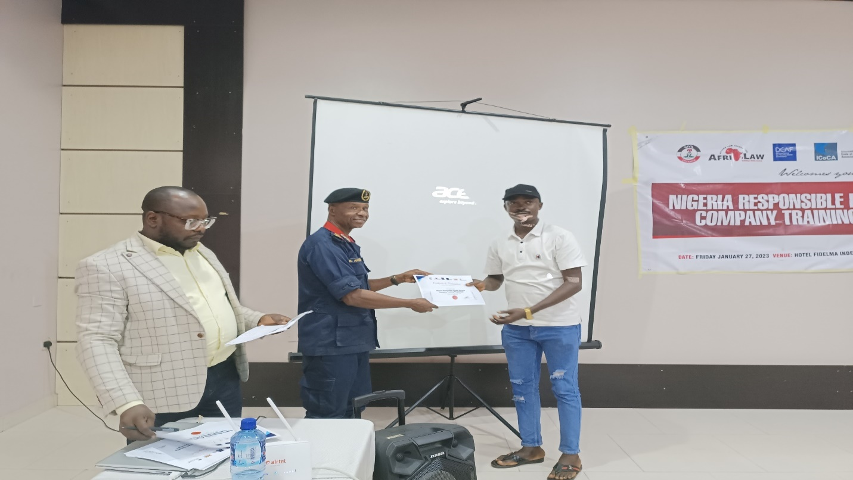
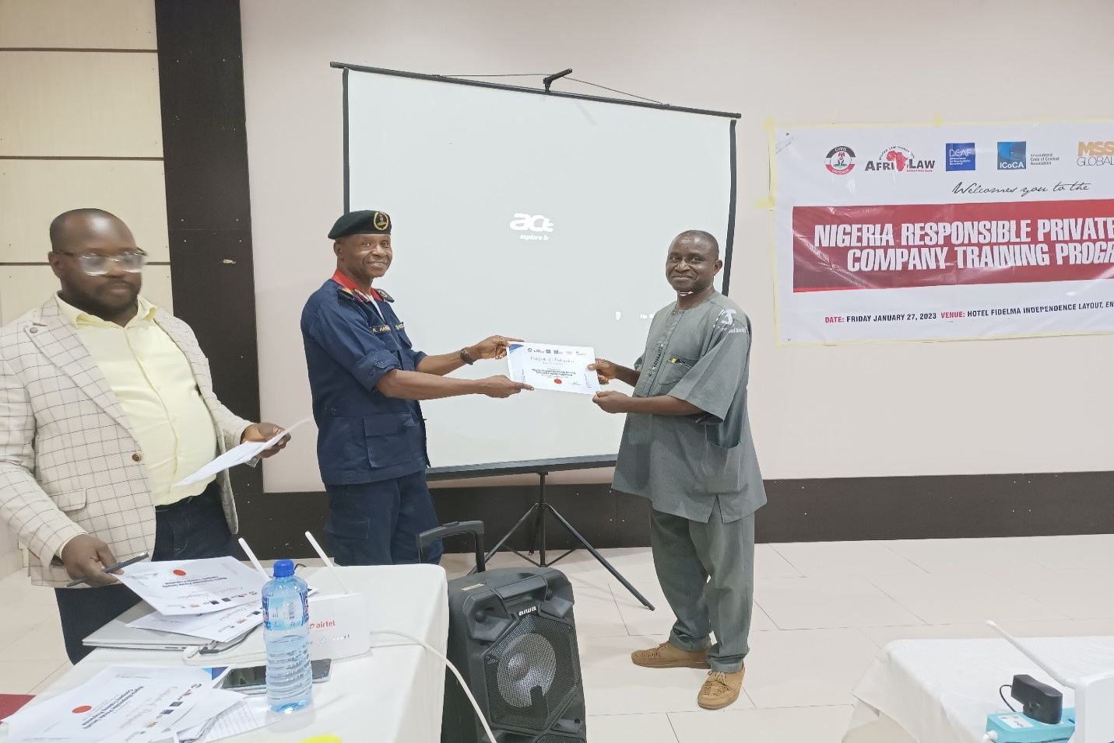

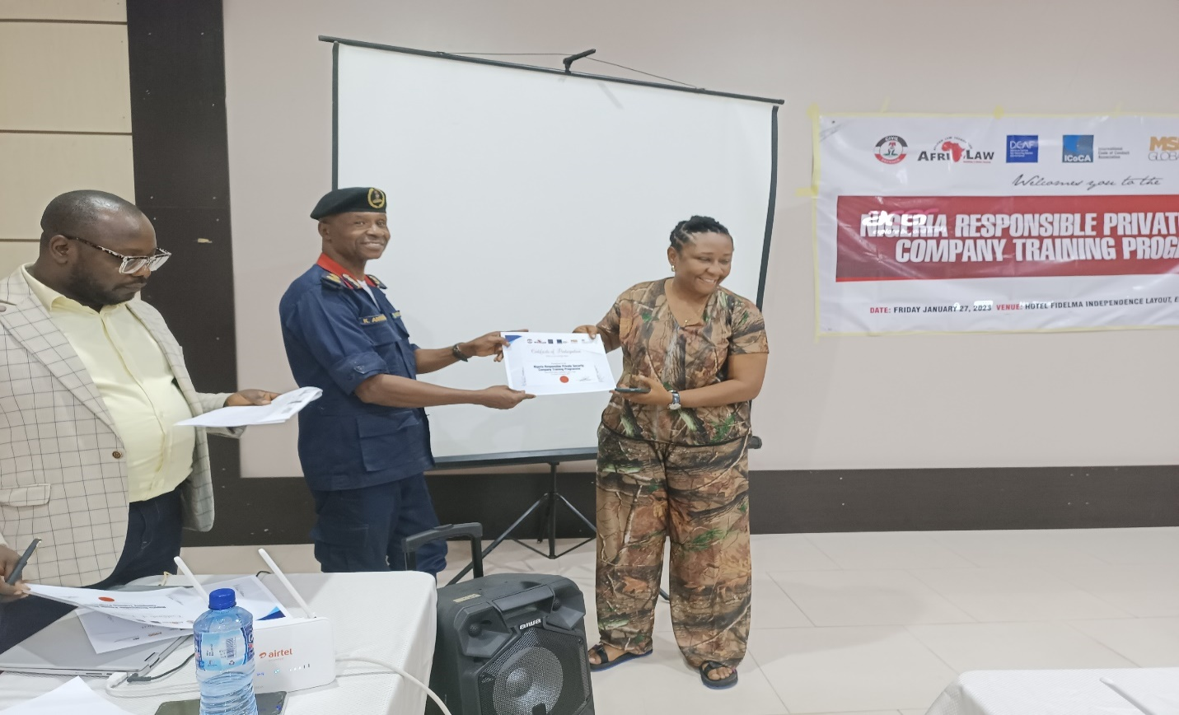
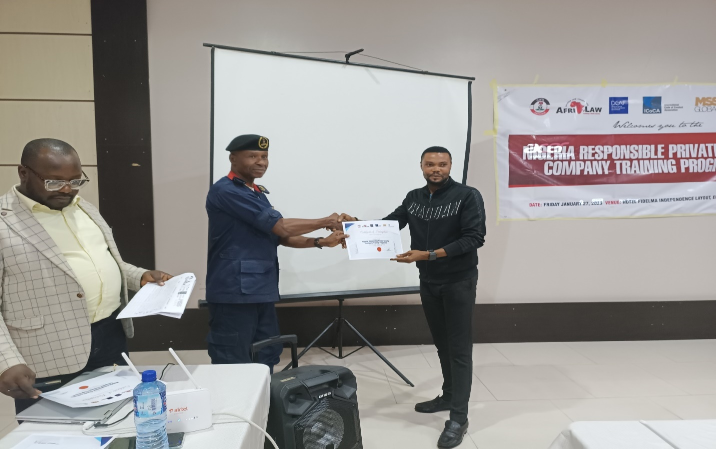
CLOSING SESSION: The Executive Director AFRILAW appreciated them for making it to the training and then invited the Head of Department Private Guards Companies to present their certificates of participation. After the presentation of certificate the programme ended at about 5:30 pm.

5.TRAINING WORKSHOP FOR SOUTH-WEST REGION (LAGOS, LAGOS STATE)
INTRODUCTION: This is the report of the South-West training workshop on the Nigeria Responsible Private Security Company Training being implemented by African Law Foundation (AFRILAW) in partnership with the NSCDC, DECAF, MSS Global with funding from ICoCA. The aim of the training is to continue to educate private security companies to be responsible and conform to best practices. The training was held on February 9th, 2023 at Governors Hotel, Ikeja Lagos State, and there are about twenty-eight (28) participants with twenty-three (23) Private PSC representatives, three (3) NSCDC officers and two (2) AFRILAW staff.
OPENING SESSION AND REMARKS: The Workshop began by 11:00am with one of the private security executive leading the opening prayer and afterwards the National anthem was taken. The Executive Director of AFRILAW (Barr. Chinwike) welcomed all the private security executives in attendance and set out the agenda of the day as well as his opening speech. This was followed by the welcome remarks of the ICoCA representative which was done virtually, followed by the welcome remark of the DCAF representative which was also done virtually. The (Zone A) ALPSPN Chairman gave his welcome remark as well and afterwards, the ACG-PGC NSCDC who attended physically and represented the Commandant-General NSCDC also gave his goodwill remarks.
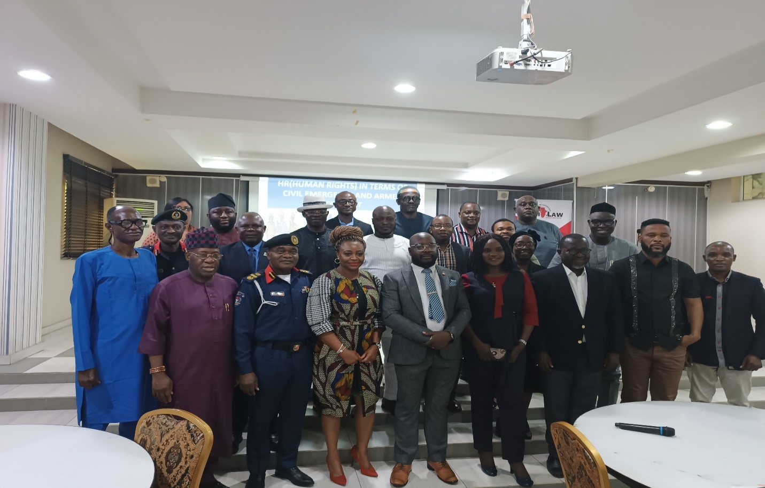
Group Picture of the Workshop participants with ACG-PGC
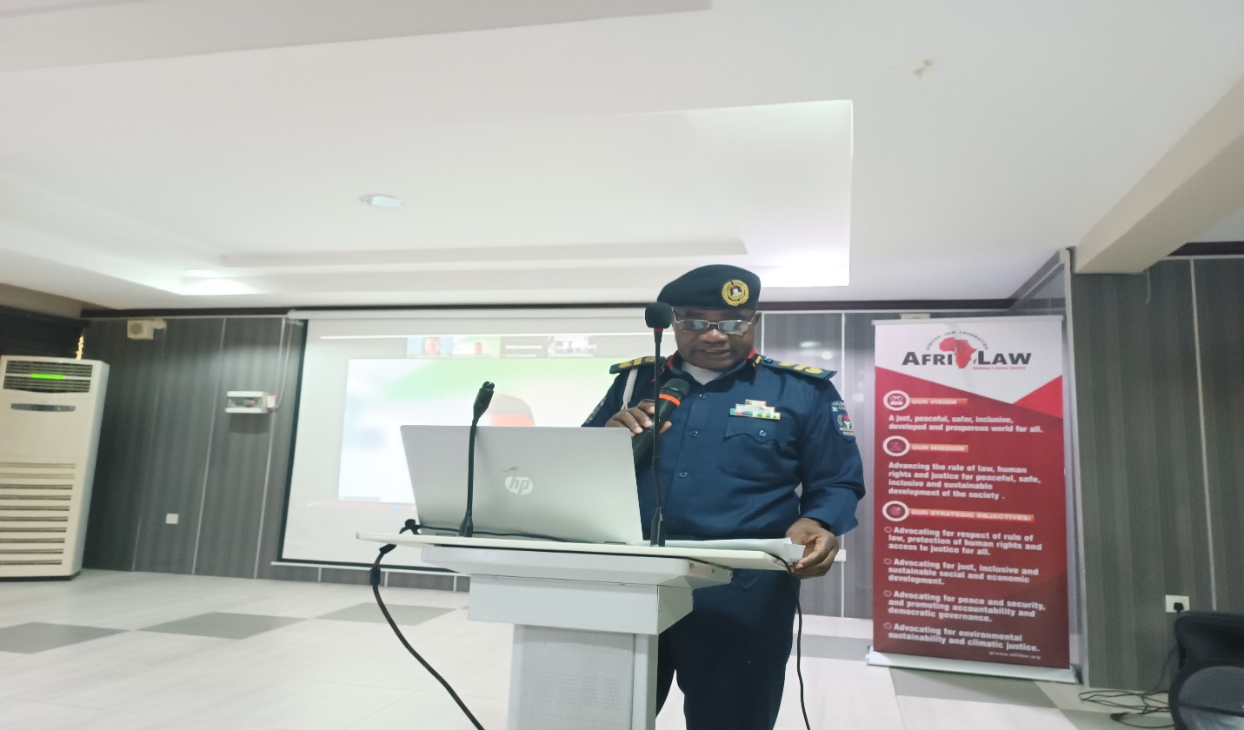
ACG-PGC giving his Welcome and Good will remarks
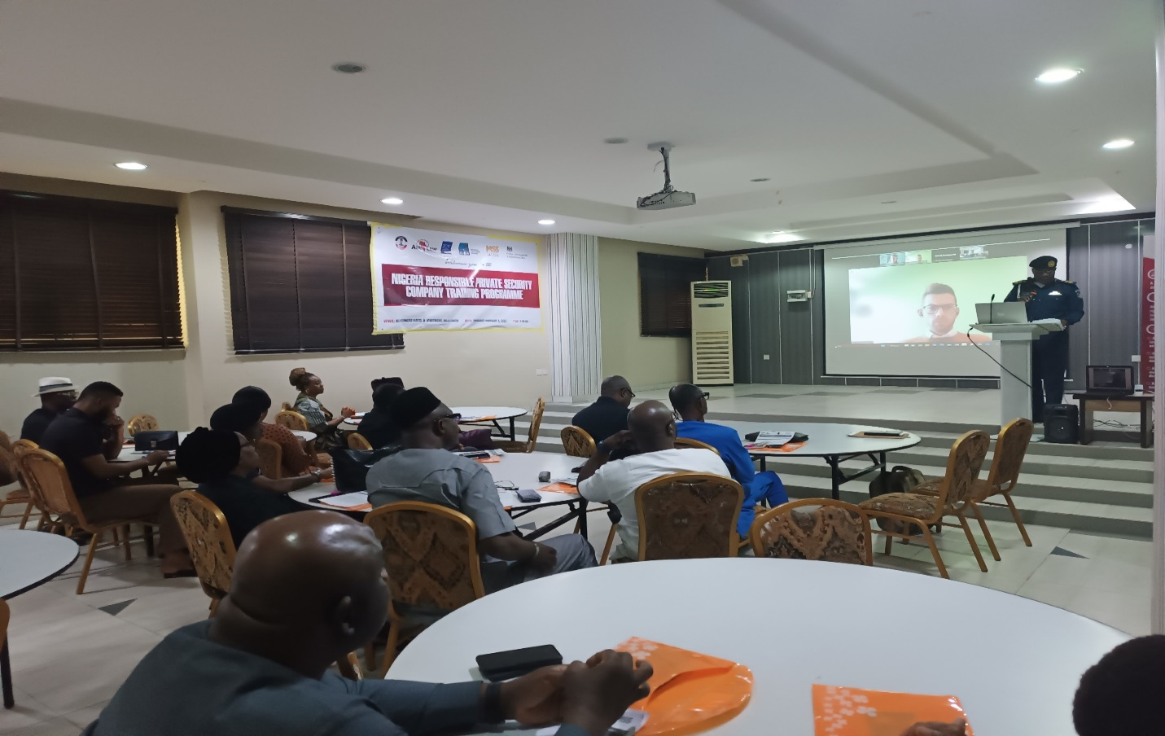
Cross Section of the participants during the workshop

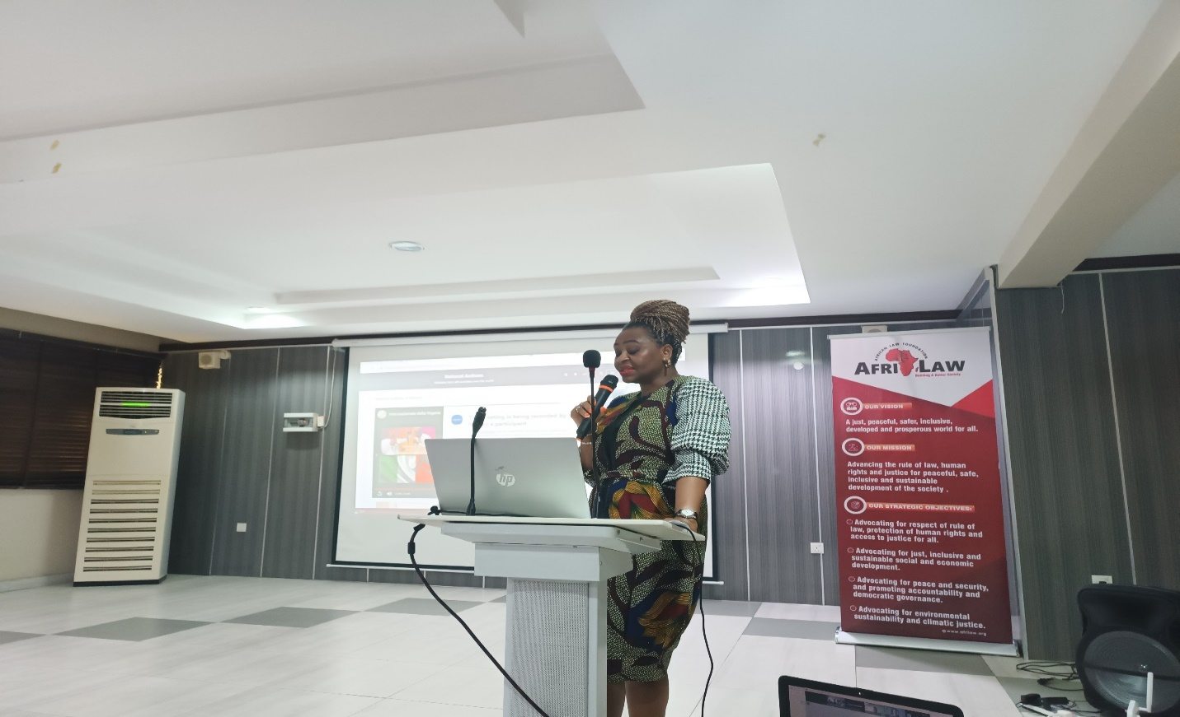
The National Secretary of the ALPSPN giving her Goodwill Remark on behalf of the National President
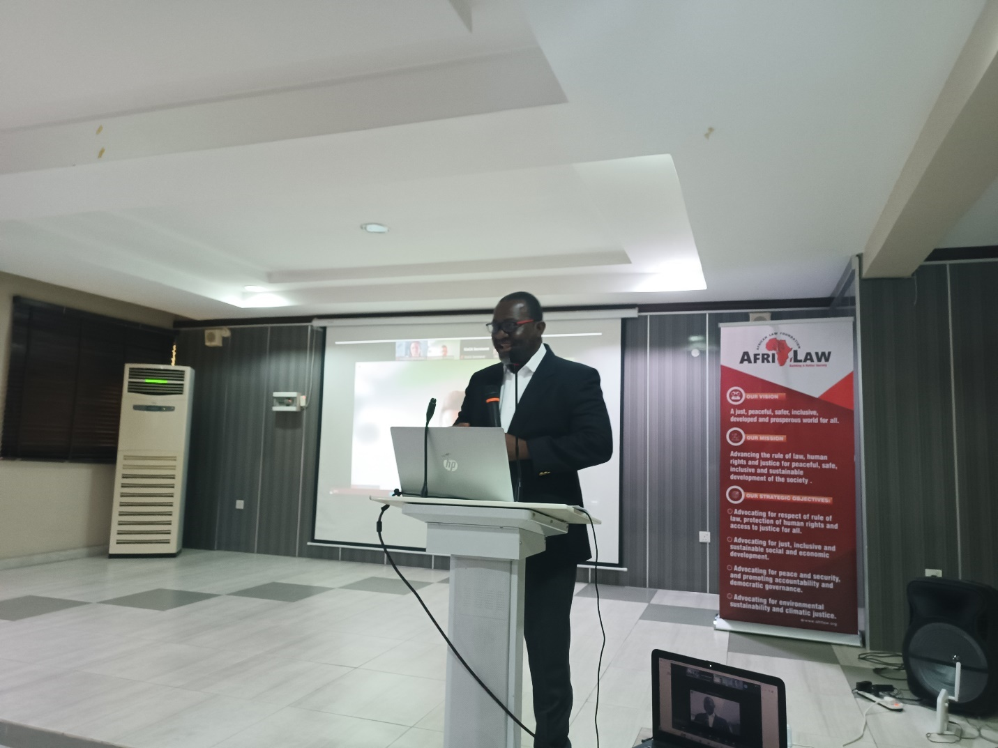
The Zonal Chairman of ALPSPN giving his Goodwill Remarks

PRESENTATION 1: Human Rights Frameworks Relevant to Private Security Services.
The ED AFRILAW (Barr. Chinwike) took the first presentation. This presentation started by giving a background understanding of Human Rights as rights inherent to all human beings. Highlighting the core values of human rights and the types of human rights. The fundamental human rights provided for in Chapter 4 of the Nigerian Constitution was also discussed and differentiated form the fundamental objectives and directive principles provided for under Chapter 2 of the Constitution which are non-justiciable. The International/ Regional Instruments as well as the National Human Rights Laws in Nigeria was also discussed, pointing out the relevance of these laws to Private Security personnel. They were taught Human Rights in terms of Civil Emergency and Armed Conflicts. Rights that are not negotiable any under condition were highlighted, the Guiding Principles on Business and Human Rights (UNGPs) which is the global standard for preventing and addressing the risk of adverse impacts on human rights involving business activity, and provides the internationally-accepted framework for enhancing standards and practices with regard to business and human rights was also discussed and the three pillars highlighted.
Human Rights in the Extractive Industry was a section taught in the presentation where the Voluntary Principles was introduced to the participants which is a guide to companies in conducting a comprehensive human rights risk assessment in their engagement with public and private security providers to ensure human rights are respected in the protection of company facilities and premises. Monitoring and Reporting of Allegations and Violations of Human Rights was also part of the presentation where it was taught that all security personnel’s working with the company have an individual and ethical responsibility to ensure that any human rights violations are reported to the appropriate authorities as well as stating the steps to be followed in reporting these allegations. The session was very enlightening for the PSC executives as they proceeded to ask questions and make comments on the presentation.
Comment: The ACG-PGC NSCDC stated that guards cannot be allowed to form trade unions and added that the major issue is the enforcement of existing laws and a procedure for the termination of employment of guards. He further stated that the regulators are on the verge of enacting a code of conduct for the guards.
Question 1: One of the participants asked that in a situation where there is a signed agreement between the company and the guard which states that if a guard abandons his post, that would amount to an immediate termination. If such guards approaches the court is that right.
Answer: The ED AFRILAW responded that yes it would and it is part of the hazards of the business and not within the control of the company. He urged the company to educate the guards on the procedures when they intend to stop work with the company.
Question 2: Does Human Right apply separately to the people in the North/South as there have been so many incident.
Answer: The ED AFRILAW stated that Human Right is the same around the world.
Question 3: I am familiar with Human Right but we are living in a different type of country where most of the practices applicable internationally are not applicable here. I would like to know if there is a way for AFRILAW to liaise with the regulators and the Association to come up with best practices that will be applicable to Nigeria.
Comment: Another participant added that it will be good if AFRILAW liaises with the Regulators and the Association to come up with adaptable, practicable Human Right principles as so many principles that apply in developed countries does not apply in Nigeria and AFRILAW needs to take into consideration, culture, religion in coming up with these principles.
Question 4: In the PLAN what does A and N stand for?
Answer: Accountability and Necessity.
Comment: The participant who asked the above question, further stated that there is a guiding principle existing and it should be followed. He condemned companies who place just one guard in a post and advised that 2 guards should be stationed at a post at all times as when one guar is placed in a station for 24hrs, such company must be ready to bear the risk.
The next thing on the program agenda after the first presentation was the tea break where all executives were served with a light breakfast.
PRESENTATION 2: Human Rights due Diligence and Impact Assessment by PSCs by ICOCA Rep
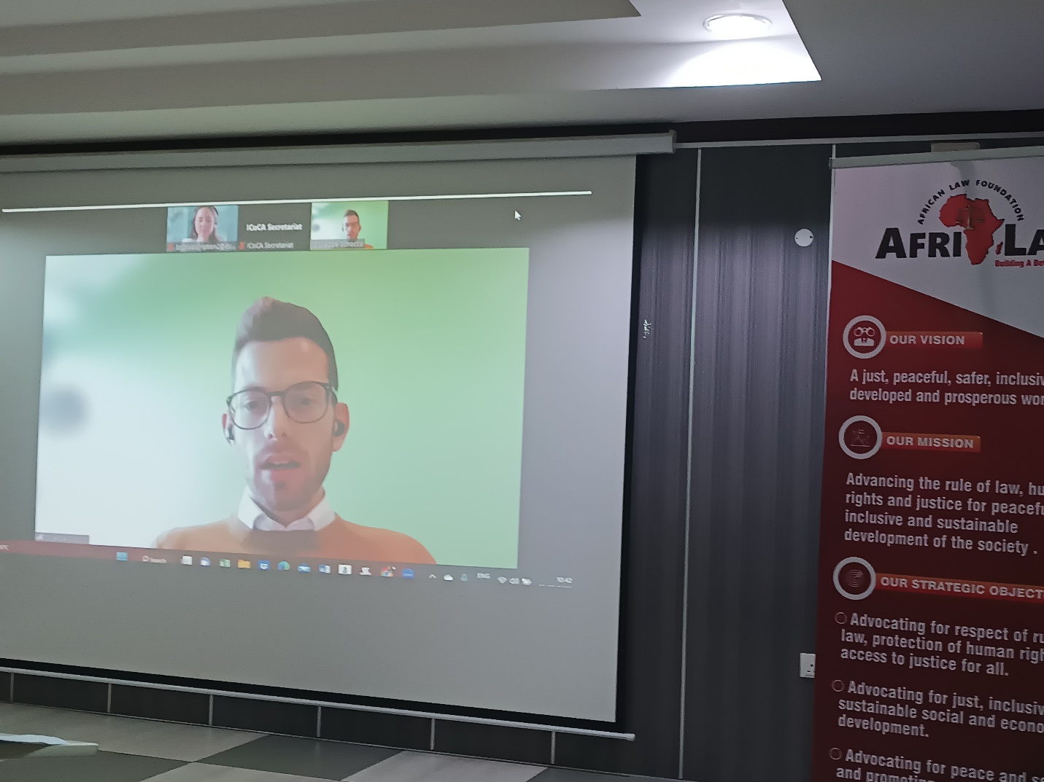
Mr. Giuseppe making his presentation

Mr. Giuseppe Scirocco representative of ICoCA took this presentation virtually. He began the presentation by first introducing ICoCA and the code. He explained what the organization does which includes Capacity Building, Monitoring, Certification and Handling complaints as well as how to become a member. He then delved into the presentation proper on why private security users care about human right due diligence. Stating sexual abuse, the reputational and financial damage of the story for the company adding that the biggest human rights risk in the industry is the treatment of private security personnel themselves citing Qatar, where guards are recruited through bonded labor, paying recruiting fees, having passports taken, earning very little, living in squalid conditions. The second part of the presentation was on conducting human rights risks and impact assessment. He started by explaining that it is the process to identify, understand, assess and address the adverse human rights impacts of a certain activity and starting early to conduct the human rights risk and impact assessment is key and is expected to be done before operations begins, which will provide a means for the company to be able to ‘prevent and mitigate’ adverse human rights impacts rather than ‘remedy’ them. The Phases of HRIAs was also discussed which includes; Planning and scoping, Data collection and baseline development, Impact analysis, Impact mitigation and management and Evaluation and reporting.
Question: Is there room for private companies to join ICoCA?
Answer: Yes there is, but there is a process and agencies such as MSS Global which can help facilitate the membership and certification process.

PRESENTATION 3: International Good Practices and Private Security and Human Rights and The Use of Force by DCAF Rep:
Immediately after the tea break, Ms. Gabrielle of DCAF began her presentation virtually, she started by reviewing the three key international good practices relating to Private Security which are the Montreux Document which reaffirms the existing obligations of states under international law, the International Code of Conduct for private security service providers which articulates responsibilities of private security companies under human rights and international humanitarian law to ensure the responsible provision of private security services, particularly when operating in complex environments. It went further to introduce ICoCA as the governance and oversight mechanism of the International Code of Conduct for Private Security Service Providers (the “Code”) and the Voluntary Principles on Security and Human Rights which covers Risk Assessment, Company relations with public safety suppliers and Company relations with private security providers. Ms. Gabby started the second part of her presentation by stating that the degree of use of force that a private security provider (PSP) should be able to exercise and the limitations on such use are fundamentally different from those applicable to law enforcement. Scenarios for use of force was given such as self-defense or defense of others, property defense and mass control. She further stated the legislative criteria which is provides that States are to impose limitations on the type of services a PSP can provide, the type of weapons such PSPs can possess and use, and the operational criteria they must meet.
Comment: The ACG-PGC stated that the guards are incapacitated as they are only allowed to blow whistles. They are not allowed to use any type of force. He added that it is often times the guards that are being molested as they are vulnerable.
Question 1: One of the participants first expressed her delight that the issue of use of force is being discussed by a foreigner and went ahead to ask when there is a situation where a trespasser comes into a compound guarded by a PS guard and both engage in a fight while trying to send him out of the compound. Then upon arrest, the guards are being detained or even asked to first provide treatment for the trespasser. Where do we begin from when the professionalism and the rights of our guards are being threatened? Furthermore, what is the best practice in this case, when the law enforcement agencies who are supposed to protect the guards are not doing so.
Answer: Ms Gabby responded stating that there have to be a dialogue between PSCs and the public security agencies on how to protect them as well as support them. Although it is known that both agencies do not have a cordial relationship.
Comment:
- The ED AFRILAW stated that it was discovered in the baseline study that both agencies do not have a cordial relationship and this cooperation is fundamental. He further stated that the regulators as well as the association need to meet with them for collaboration.
- The ACG-PGC further added that they are aware but they are ready to discharge their duties and responsibilities as provided for and promised that in no time they would ensure that the PS guard would start bearing arms as they are already working on it.
- The zonal chairman also thanked the ACG and acknowledged their works citing the COVID-19 period where the President in his speech recognized the PSCs.
- Another participant added that as CEOs of these PSCs, they must inculcate in their training manual the use of force which must not be abused. They are to be trained on the use of force and the justification for it.

PRESENTATION 4: Gender Perspectives and Preventing and Addressing Sexual Exploitation and Abuse (PSEA) by PSCs
ARFILAW ED (Barr. Chinwike) took the presentation on Gender Perspectives and Preventing and Addressing Sexual Exploitation and Abuse (PSEA) by PSCs. He started by first defining key gender concepts, differentiated between equity and equality. He further discussed Sexual and gender-based violence (SGBV) as all violence that is committed against a person based on their perceived or actual sex and/or gender and being a gross violation of human rights, and is both a cause and a consequence of gender inequality. He further stated that the definition of SGBV includes physical, verbal or sexual violence against women and girls (VAWG); the victimization of people because of their masculine or feminine traits or sexual orientation; and any form of violence that stems from unequal power relations. Actions that comprised of SGBV was also listed to include; Sexual threats, Exploitation, Humiliation, Assault, molestation and rape, Domestic violence and incest, Involuntary prostitution, Torture and/or insertion of objects into genital openings, Female Genital Cutting, Attempted rape. He discussed the need for the integrating gender perspective in PSC as it enables one to make women’s as well as men’s concerns and experiences an integral dimension of the design, implementation, monitoring and evaluation of policies and programmes, so that women and men benefit equally, and inequality is not perpetuated and the guidelines for doing so. He enumerated and explained the Guidelines on Preventing and Addressing Sexual Exploitation and Abuse (PSEA) for PSCs as provided in the ICOCA Preventing and Addressing Sexual Exploitation and Abuse (PSEA).

PRESENTATION 5: Functional Planning Support and Delivery of Security Operations Management System by PSCs, ICoCA Certification and 18788 for Nigeria PSCs by AFRILAW ED
AFRILAW ED on behalf of Mr. Jonah Eromon of the Africa Director of MSS Global UK who is unavoidably absent made a presentation using the PowerPoint Presentation prepared for the programe and used previously by Mr Jonah. He started with the introduction of MSS Global UK and as a key partner for the Programme. He explained the importance of effective management system and security operations planning for the PSCs in Nigeria, and the need to manage this risk to the clients, organization and stakeholders. He further explained how PSCs can achieve ICoCA certification in three simple steps and the benefits of ICoCA Certifications. He concluded by explaining kind of the services and support MSS Global can offer PSCs in Nigeria in getting ICoCA certification.
Closing Session of the Workshop/Departure: The Training Workshop came to a successful end by 6:30pm with a closing remark by AFRILAW ED after which, certificate of participation were presented to all participants. Then the closing prayer was led by one of the PSC executives, they had their lunch and departed.

6: TRAINING WORKSHOP FOR SOUTH-SOUTH REGION (PORT-HARCOURT , RIVERS STATE:

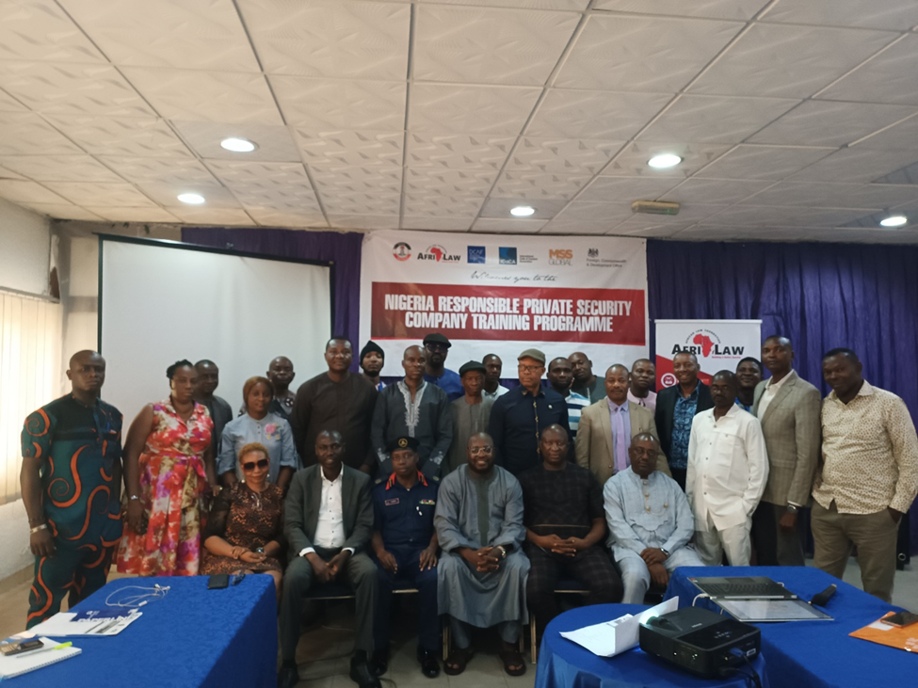
The Group Picture of the Training Workshop

INTRODUCTION: The South-South Regional training workshop was held on March 2, 2023 at Aldgate Congress Resort, Port-Harcourt, Rivers State with about Thirty (30) participants including Twenty-seven (27) PSCs representatives and NSCDC representatives.

OPENING SESSION AND REMARKS: The program started at about 10: 30 am with the opening prayer said by one of the participants. The national anthem followed next. Welcome Remarks/Speech and Setting the Agenda by AFRILAW ED. AFRILAW ED. welcomed everyone present and introduced himself. He then went ahead to explain to that that AFRILAW is a national NGO specialized in security sector reforms. He said that since 2018, in partnership with the Nigeria Security and Civil Defence Corp (NSCDC), it has been engaging with the private security industry. He also introduced the AFRILAW’s programme partners including ICoCA, DCAF and MSS Global UK and their areas of private security works and services. He xplained the goal and objective of the programme and its benefits to PSCs in Nigeria. He appreciated them for coming and welcomed them asking them to be open minded assuring them that they would gain information that would be beneficial to them and thereafter set the agenda.

Goodwill Remarks by NSCDC Representative: He said that the topic of discuss in today’s program is a very crucial. He said that it become a disturbing occurrence among law enforcement and security personnel do not respect human rights. He then said that it is expected that at the end of this training their knowledge on human right and security would be improved and they’d become better for it. He said that this knowledge is sure to make a company better since the aim is to professionalize the industry. He finally welcomed everyone on behalf of the commandant general NSCDC.
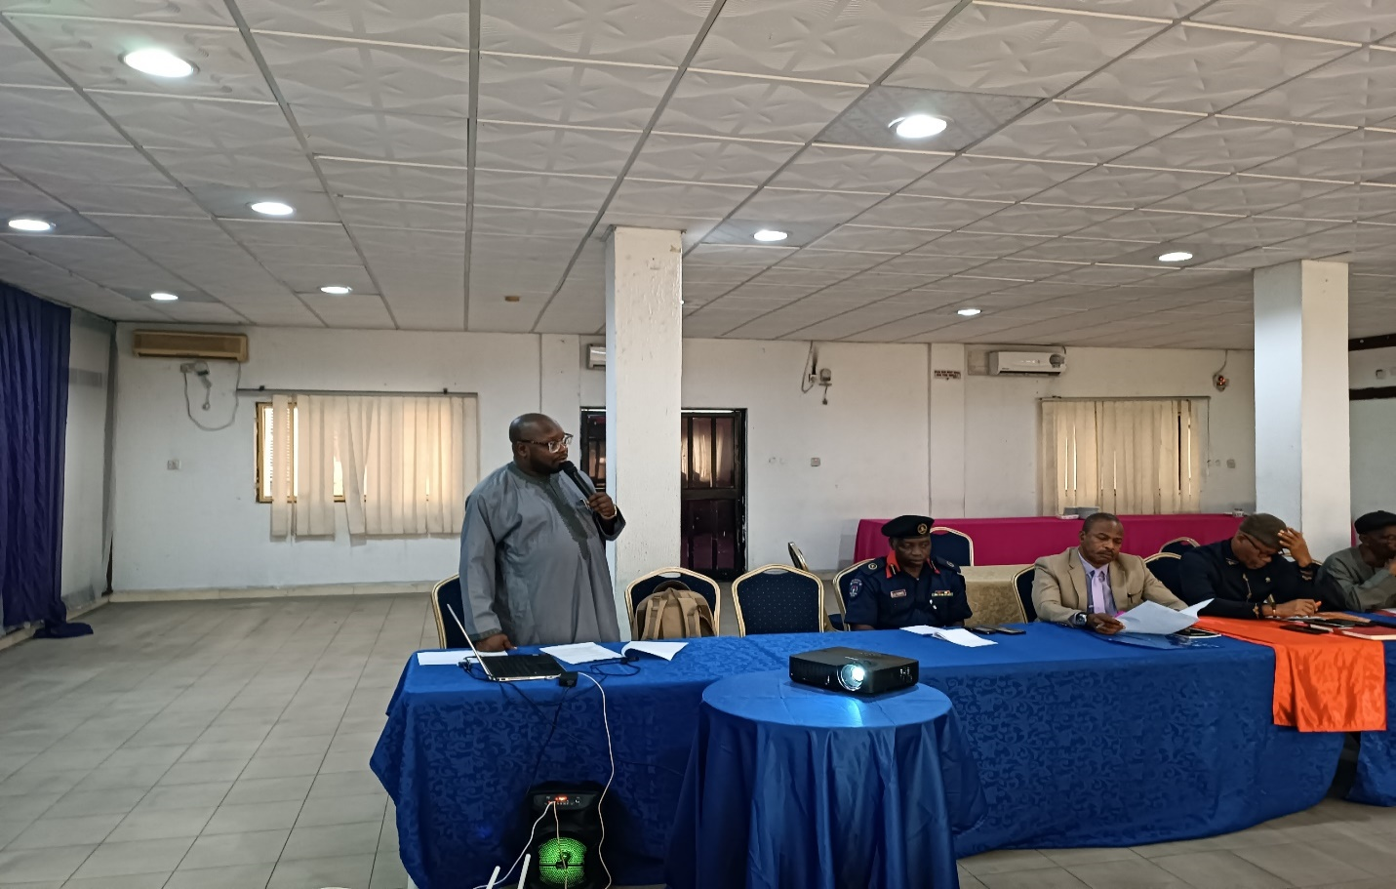
AFRILAW ED making a speech during the workshop

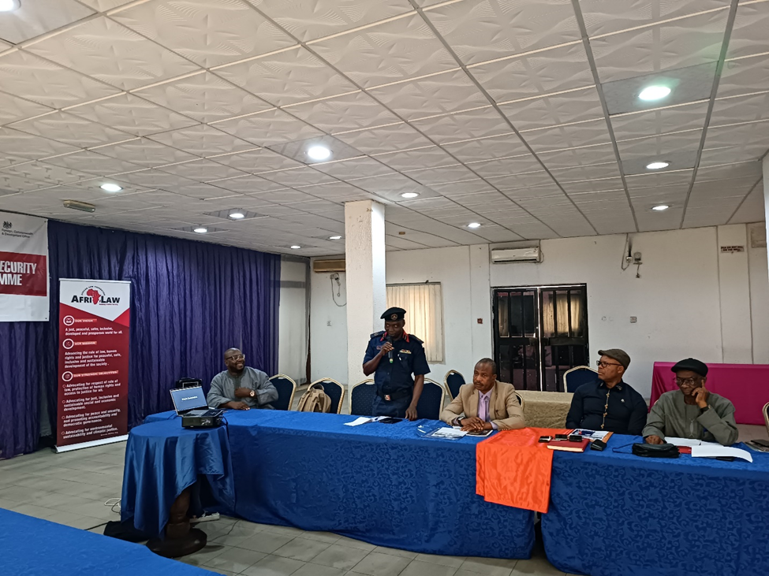
Representative of HOD-PGC Rivers State Command making a speech during the workshop

PRESENTATION 1: Human Rights Frameworks Relevant To Private Security Service By AFRILAW ED:

Understanding Human Rights: AFRILAW ED, Barr. Chinwike Okereke asked them to share their knowledge on the concept of human rights. One of the participants said that human rights is the basic right human beings have to exist. He described the various rights a person can have. Going further in the conversation, Barr Okereke said that every human being has a right no matter who they are. He pointed out the principles that qualify human rights ie. Human rights core principles thus: Universal/alienable: this means that human rights are the same for everybody no matter their status. Inalienable on the other hand means that they cannot be taken away from anyone. Indivisible/ interdependent: no right can be enjoyed with the others. They all work together. He further described the various types of rights that exist: moral right, natural rights, contractual rights, legal rights, human rights and the categories of human rights such as the Civil and Political Rights, Economic, Social and Cultural Rights and Environmental Rights and Development rights. He said that under the Universal Declaration on Human Rights there are 30 basic human rights and these 30 rights are where the different countries draw their rights from.

International/Regional Instruments and National HR Laws In Nigeria:
National Human Rights in Nigeria: He stated this section by saying that human rights are not absolute that there are things that can be done and those rights will be taken away. He said that in Chapter 4 of the Nigerian Constitution there are a group of rights enshrined therein which every Nigerian is entitled to but not absolutely and he listed and explained all the 10 fundamental human rights provided under the Nigeria constitution.The fundamental right enforcement laws of Nigeria empower the state high court to prosecute fundamental rights and states that human rights grievances may be brought to the state high court. He introduced them to the various international human rights laws. The Universal Declaration of Human Rights (UDHR); Covenant on Civil and Political Rights (CCPR); Covenant on Economic Social and Cultural Rights (CESCR) and the First Optional Protocol to the ICCPR, make up the international bill of rights. He also introduced them to some regional human right instruments, but carefully pointed out that most of these documents have not been ratified in Nigeria, hence they do not have the force of law in Nigeria. On Nigeria Human Rights Laws, He listed the various human rights laws in existence in Nigeria and laid much emphasis on Nigeria Labour Act, 1971, Pensions Reform Act, National Minimum Wage Act, etc.

Relevance of HR to Security Personnel: he said that security personnel have a duty to protect, respect, promote and ensure human rights of every person they deal with regardless of who they are. they also have the potential to limit the human rights of people in the cause of the operations. Because of this, an understanding of human rights is important to them. When deciding to act and limit the rights of persons, security personnel must always apply the PLAN Principle: P: proportionality: only use the minimum force or action that is necessary to solve the situation
L: Legality: all acts should be done within the ambits of the laws
A: Accountability: act ethical way knowing that you’d be accountable for your actions
N: Necessity: Only act when it is necessary to act.

Human Rights in times of Civil Emergency and Armed Conflict: Even during times of civil or public emergencies, “States of Emergency”, or armed conflict, all security personnel have a responsibility to respect and protect the basic human rights of all people. Rights like the Right to life, Freedom from torture; cruel inhuman or degrading, Treatment or punishment; and from medical or scientific experimentation, without free consent; Freedom from slavery or involuntary servitude; Right not to be imprisoned for contractual debt; Right not to be convicted or sentenced to a heavier penalty by virtue of retroactive criminal legislation; Right to recognition as a person before the law; Freedom of thought, conscience and religion; are not suspended during times of armed conflict. Also in times of war, international humanitarian laws (laws of war), are not suspended and are meant to protect people who are affected by war whether they are actively taking part in the hostilities or not. Company and private security personnel are considered non-combatants and will not participate in public emergencies.

International Standards on Business and Human Rights: Here he brought to their notice human rights instruments that are important to businesses to guide their operations such as the United Nations Guiding Principles on Business and Human Rights, Principles for Responsible Contracts, Tripartite Declaration of Principles concerning Multinational Enterprises and Social Policy (MNE Declaration), and OECD Guidelines for Multinational Enterprises, and UN Global Compact..

Human Rights in the Extractive Industry: Consistent activities of extractive companies amongst communities raise the issues of their roles and responsibilities as it relates to human rights. He then spoke about the Voluntary Principles on Security and Human Rights (VP) which has clear provisions on the responsibilities of companies operating in extractive industries. According to him, the VP helps companies identify human rights risks and take meaningful steps to address those risks in a manner that helps ensure respect for human rights in their operations. He said that the Voluntary Principles provide a framework for companies to manage risk effectively by Conducting a comprehensive assessment of human rights risks associated with security; engaging appropriately with public and private security service providers and surrounding communities in complex environments; Instituting human rights screenings of and trainings for public and private security forces; Developing systems for reporting and investigating allegations of human rights abuses. The VP concentrates most on the right to Life, arbitrary arrest or exile, Liberty and Security of Persons, and Freedom from Torture.

Monitoring and Reporting on Allegations and Violations of HR: Companies have a corporate responsibility to provide, cooperate, and compensate persons for any impacts to their human rights using legitimate processes. They also have a corporate responsibility to report, monitor, and follow up on investigations that involve business related human rights violations and human rights violations committed in support of security operations that involve the use of their internal, private or public security providers. He listed the names of the various governmental and non-governmental groups that monitor human rights eg. National Human Rights Commission (NHRC). All security personnel working with the company have an individual and ethical responsibility to ensure that any human rights violations are reported to the appropriate authorities. He then took them through the steps to report on allegations or incidents of human rights abuses. After the 1st presentation participants took a break for tea and also took a group photograph.

PRESENTATION 2 – International Good Practices and Private Security /Basic Principles Of The Use Of Force By PSCs By Gabrielle Prinklopilova

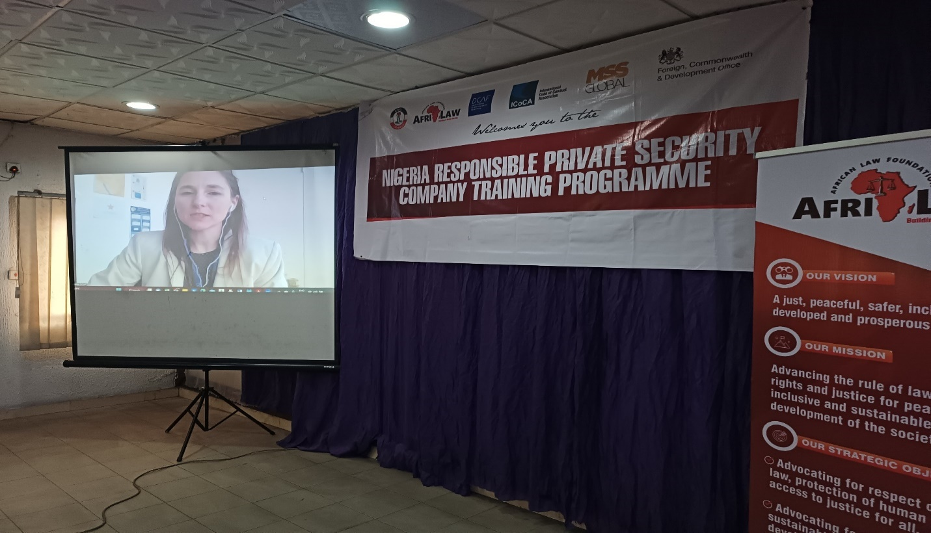
Ms Gabrielle making her presentation
She started by saying that there are three documents that regulate the operations of private security companies internationally. She said that she would play a short video to show how these three initiatives complement each other though they have differences.

The initiatives mentioned in the video include:
The Montreux Document (MD): the Montreux document clarifies the obligation of states to regulate the operations of Private Security Companies PSCs, and to share good practices. The International Code of Conduct for Private Security service Providers (ICoC): establishes standards based on human right. Companies, states and civil society organizations join the association to ensure that the code is enforced generally. The Voluntary Principle on security and human right: gives organizations in the commodity industry a road map to respect human right in their operations. According to the video, Geneva Centre for Security Sector Governance (DCAF), supports the vision of all three initiatives and its implementation. It also therefore jointly works with these initiatives to promote security, human rights and development.

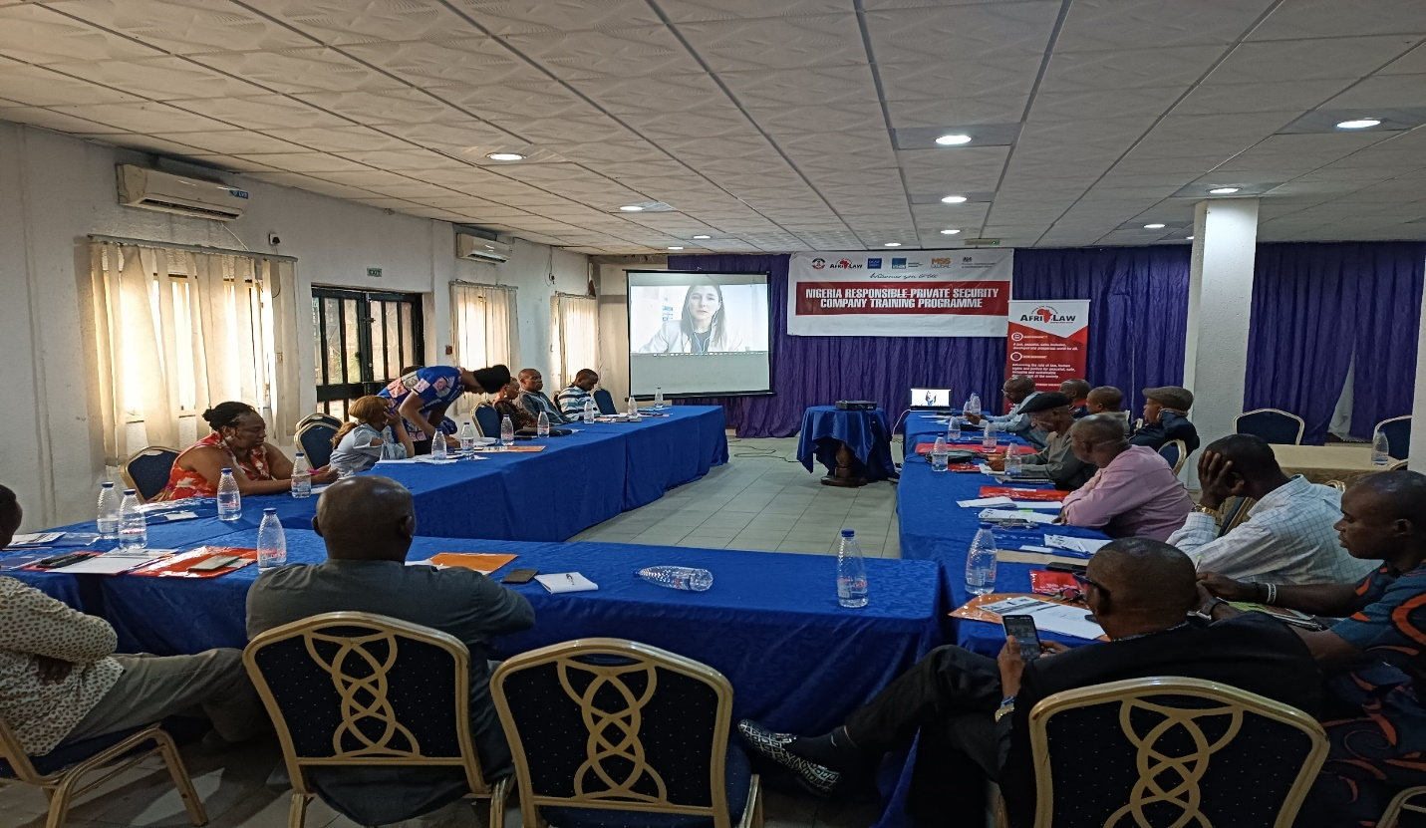

Gabrielle then went ahead to buttress on the Montreux Document and the Voluntary Principles. The ICoC had been explained early. She said that it is important for private security companies to know of these initiatives because clients at this time demand more and more of compliance to standards. She said that though the Montreux Document doesn’t apply directly to Private Security Companies, it is in the interest of companies that standards are upheld and Montreux document provides the highest international standards. She said that the MD doesn’t make any new set of rules but it extract already existing rights and standards regarding the obligation of states in business and human rights and makes a compendium of them in the MD. She further described that the document describes the obligation of the different kinds of states that are recognised under the MD: contracting state (companies that buys private security), territorial states (the country where the PSC operates) and the host state (ie the country where the PSC has its headquarters). There is a MD Forum where states can exchange with experts on governance and regulation of security and human rights.

The Voluntary Principles: The VP is a principle to guide extractive companies on how to structure their operations in line with human rights. She said the principles are divided into three parts: Risk assessments; company relations with private security providers and company relations with public safety providers. She then referred them to the DCAF toolkit on the voluntary principle.

PRESENTATION 3: Human Rights and The Use Of Force BY Gabriella Prinklopilova:

She said that it is almost obvious the reason why regulations on the use of force. She said that at the base of regulation of the use of force is the protection of human rights. She said that the extent of use of force that PSCs are allowed to apply is limited and different from those that can be applied by public security providers for the following reasons: The use of force by private security providers must be guided by the personal right of self-defence. They do not have a general mandate to ensure public security beyond the objectives set out in the private security contract, even when the state is the client.

She stated that Private security functions do not enjoy the legitimacy and oversight and accountability mechanisms applicable to state public security. Nor do they enjoy the same level of training and capacity building. On when private security can use force, She said that PSCs can use force in the following instances: For the protection of self of others; For the protection of property in which case the use of lethal weapons for the protection of property is not proportionate; Mass Control. In this case it is best to report to the public security frameworks since they have better trainings for this. On the regulation of the use of force, she said that there should be provisions to pre-screen personnel; provide training on the use of force; register weapons. She said that additional provisions should be made on management and storage of weapons and firearms. States also should empower the judiciary to handle complaints on such issues and also provide judicial and non-judicial means for accountability and redress. The DCAF has modules on the use of force and she encouraged them to visit the website for more resources.

GROUP WORK ON THE USE OF FORCE: The participants were given a case study to discuss and give their responses and opinions based on their understanding of use of force training.
Case Study: Community members have organized a protest in front of a mining site; they carry tree branches and seem very angry. A small group of protesters try to force entry into the site. Private security guards assigned to the mining site pushed them back using sticks. What do international norms good practices say about the use of force?

Some Responses and Contributions
This scenario is very similar to what happens on a daily basis of the participants. One of them said that in order to handle the situation they first build a relationship among community member and these people inform them of any potential attacks or protests and they plan towards keeping the gates locked and not allowing the protesters come in at all. However in a particular case they came threaten to pull the gates down if they didn’t open up. In this case they invite the public security they are working with to come in and take over here. And usually they begin to negotiate with the leaders of the communities and the protesters and though issues may not be resolved immediately, the immediate conflict is de-escalated.
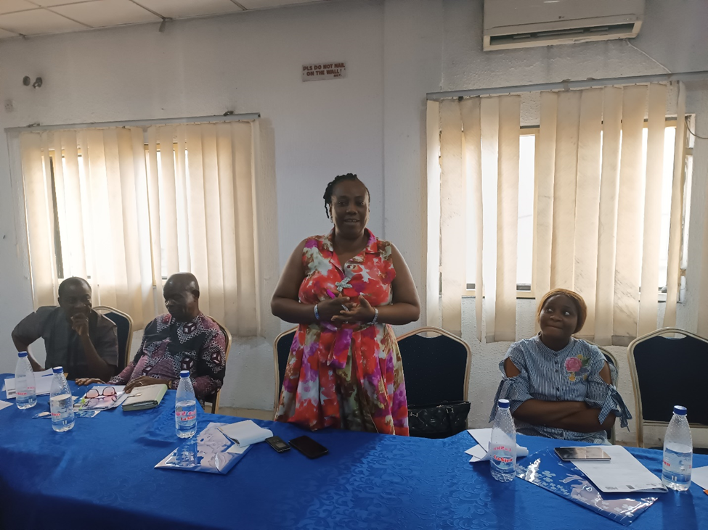
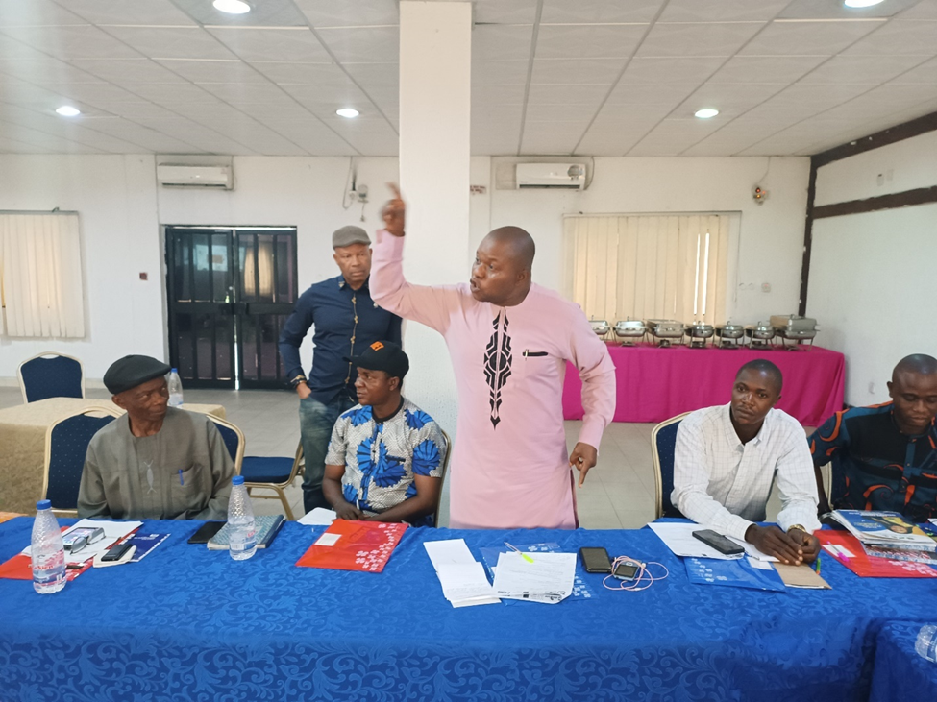Participants making contributions during the workshop

Furthermore, another participant shared his own experience on the issues raised by the group work. He said that the clients who were trying to contract him told him that the area that he will be assigned has a history of protests and ask how he intends to approach the issue of repeated and recurrent protests. He stated that he’d handle the issue by 1) Local contenting/Engagement of local stakeholder and traditional institutions: He offered the leaders of the community a chance to provide about 90% of staff needed to guard the site. This was a tactic to ensure that community members felt a sense of belonging and therefore reduced the chances of protests. 2) the management of international oil companies should do more to improve the welfare of their staff and commit to corporate social responsibility since some of the host communities still live in abject poverty. The extent of force used by the private security company in the case study is proportional. He then went ahead to raise the issue of vigilante groups saying that the vigilante groups bear arms and because they are not adequately trained they begin to shoot in the air and because the protesters come prepared they too start shooting and this could lead to lose of lives. He said that there should be a means stated by law to regulate them for the general good of communities.

Contributing to that the ED, AFRILAW, said that its interesting that the subject of vigilante groups are brought up here. He said that vigilante groups are referred to as other forms of private security since they are essentially private though they enjoy the support of government being attached to the police. However, they are prone to excessive use of force, abuses etc. He said that issues of vigilante groups is a big issue and AFRILAW is committed to see that something is done to empower them to work better. He advised them to find a way to build corporation and good relationship with them just as they do with their regulators, and the police since they’d always meet with them. Ms. Gabrielle said in conclusion that the issue of vigilante is a big issue that would take greater time to discuss this. She however said that it’s great to see that the private security industry in Nigeria is willing to take the initiative to check and regulate the vigilante issues.

PRESENTATION 4: Human Rights Due Diligence And Impact Assessment By Pscs By AFRILAW ED

AFRILAW ED introduced the International Code of Conduct Association (ICoCA), and said that it came about as a result of the indiscriminate acts and the habitual abuse of human right by some private military and private security and private military groups. Upon that abuse, governments, industry and civil society came together to negotiate a way to better oversee the industry so that human rights and international humanitarian laws were respected. In other to do this they came up with the code which is a guide for private security operatives. He said that the code covers issues regarding the conduct of personnel covering the use of force, prevention pf sexual abuse and exploitatn, detention, apprehension etc, management and governance of private security organizations including company policies, selection and vetting of personnel, training, management of weapons and ammunition etc. having made up these guidelines, there needed to be a way to monitor the implementation of the code. The ICoCA was therefore formed in 2013 as a governance and oversight mechanism to ensure implementation of the Code. All companies who join undertake to be continually monitored by the associations. He then spoke about the associations and what it does, the components of government, CSOs, companies and observers.
He said that the association’s purpose is to promote responsible private security, by strengthening human rights due diligence on private security providers. The association does this by capacity building, monitoring, certification and it also handles complaints. He said that in its role to provide capacity building it provides guidance including: human Rights Impact Assessment for Private Security Providers, Guidelines for Private Security Providers on Preventing and Addressing Sexual Exploitation and Abuse, developing and Operating Fair and Accessible Company Grievance Mechanisms that Offer Effective remedies online. Still within its capacity building function, the association also trains just as it is doing today and it also provides feedback where required. The association in its monitoring function, carries out in-country visits to the companies in the association, accepts reports from private security users, tracks companies and also monitors the activities of its other component through the CSOs within the association.

Certification: ICoCA’s certification scheme has third party audit and verification built in. It recognises a limited number of international standards and only accept certification to these standards from Certification bodies whom which it has done its own due diligence on. The problem with certification is that certificates can be bought from the street-corner, sometimes with no, or very little audit. ICoCA therefore only accept certification from certification bodies IAF/MLA accredited to ISO 18788, PSC.1 and ISO 28007, 18788 being the most commonly used land-based standard. Where there are no IAF accredited CBs available, ICoCA accepts evidence of certification to these standards from ISO17021accredited certification bodies that meet ICoCA competency requirements. He then explained the various category of companies i.e: certified, affiliate and transitional and the distinguishing factor between them. It’s important to look at the scope of ICoCA certification, which is often limited in geography, all this is transparent and available on its Member listing on the ICoCA website. The approaches applied by the association is an integrated approach, these things are intertwined and work together. He further explained the assistance and support MSS Global UK can provide interested PSCs in Nigeria through the African office at Lago, Lagos State.

Human Right Impact Assessment: AFRILAW ED stated that human right impact assessment is to identify, understand, access and address the adverse human rights impacts of certain activity. He explained that just as risk assessment checks the extent of risk attached to the activities of a company or its assignment; human right impact assessment check how the activities and assignments of a company impacts on human rights of people with whom they engage. He said that it is important for companies to pay attention to human rights because PSCs are essentially business concerns and their clients pay attention to it and it generally affects businesses negatively and positively. He gave different instances of corporations who have been affected by a human right slip. Also he gave a graphic picture of development of laws relating to human rights due diligence and impact assessment as it relates to businesses and corporations. Also security issues are part of the sustainable goals especially goals 5, 8 and 16.

Conducting Human Rights Impact Assessment By PSCs: The question was when do we start? The response to this question is as soon as possible ideally before operation kicks off. Also this assessments would be reviewed regularly as other reviews are made. The phases of the development of the risk analysis include:Planning and scoping; Data collection and baseline development; Human right Impact analysis; Human right impact mitigation and management
Evaluation and reporting.
On Planning and Scoping: this he said involves getting to understand the operation, the context etc as it affects human rights in any aspect. Data collection involves gathering information and materials. Impact analysis: analyse the impacts identified to track the impact that stem either directly or indirectly from the operation. This also helps to determine the severity of the impact. He said that the key criteria to determine severity include: scope (number and profiles of people); scale (seriousness); remediability (possibility of restoring pre-existing state or an equivalent).
On Impact mitigation and management: during the impact mitigation and management the human rights impacts are prioritized on the basis of severity. An impact management plan is great to be developed in this stage to include assignment of roles, set timelines and budget, defining monitoring and reporting procedures. Evaluation and Reporting: at this stage organizations look back and analyse the effectiveness of the measures put in place. For further guidance on human right impact assessment, he referred them to ICoCA website. There were no questions for after the presentation; however AFRILAW ED was asked that anyone who needed any further clarification in the course of the training should contact him for further engagement and support were necessary.

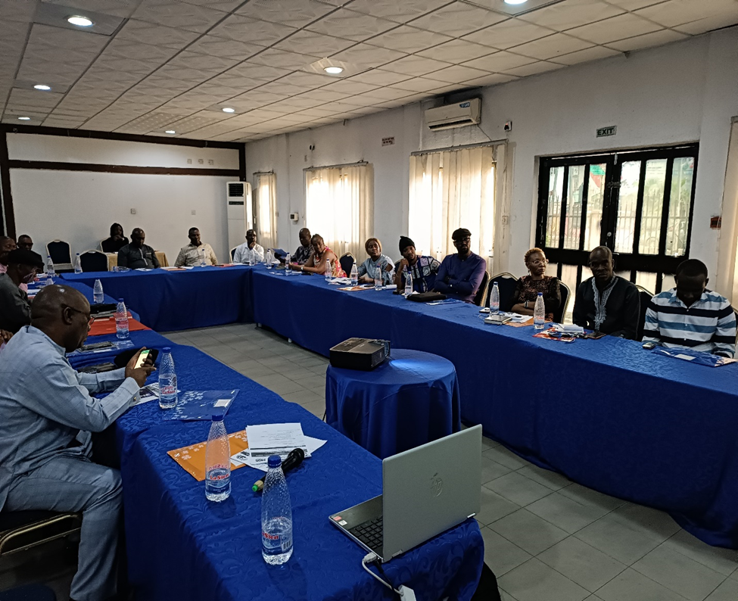
Cross Section of the Participants during the workshop

PRESENTATION 5: PREVENTING AND ADDRESSING SEXUAL EXPLOITATION ABUSE BY PSC (PSEA) BY PSCS IN NIGERIA BY AFRILAW ED:

In this presentation, AFRILAW ED covered topics such as the roles and responsibilities of private security Operatives, Gender approach to private security service, Preventing and addressing sexual exploitation, abuse and harassment (PSEAH) and Dealing with vulnerable groups. He started by saying that issues found in this particular discussion are so important and he needs them to understand why companies pay attention to issues relating to Sexual Exploitation and Abuse (SEA). He said that the issues surrounding SEA usually have a ripple effect on companies since most clients do not want to be associated with such issues and the fact that they and their clients can lose business just for being associated with such things. He clarified terms like gender equity, gender equality etc. He said that to achieve equality must pay attention to difference that may not allow us participate equally. Finding ways to breach the gaps and make up these differences so that we can achieve equality. This is called equity. He said it is important to adopt a gender perspective to their operations. Doing this involves finding out how the activities and operations of a company affects the needs of men and women respectively. He suggests that this can be incorporated in the human rights impact analysis to ensure that the gender issues raised are put into consideration.

On Guidelines on Implementing Preventing Sexual Exploitation Abuse and Harassment (PSEA): The following guidelines were adopted from the ICoCA Guidelines on PSEAH.
- Guideline 1: Declare and Disseminate PSEAH requirements in internal policies and process that are developed in consideration with personnel and adopt and implementation plan
- Guideline 2: Explicitly prohibit Sexual Exploitation and Abuse your Code of Conduct and set out responsibility of employee with respect to it.
- Guideline 3: Embed this in recruitment and performance appraisal process and establish a disciplinary procedure for response to violation
- Guideline 4: Provide initial and recurrent training for the security personnel
- Guideline 5: identify and address the risk in advance. Identify in advance the ability of partners and subcontractors to respond to and respect PSEAH.
- Guideline 6: Adopt a Survivor Centred Approach
- Guideline 7: consider providing adequate assistance to survivors of SEA to mitigate its harmful effects.

Some Questions from the Participants: It is against human rights to disengage private security personnel without following due process, is it not a breach of human right for the personnel to abscond from their duty post and causing the business a loss of business. Answer: He said that PSCs should check their recruitment process and ensure that adequate procedures are followed. This will put the employee on check and help the PSC management to enforce discipline where necessary.

Closing Session: One of the participants gave a vote of thanks on behalf of the industry. NSCDC also appreciated the conveners of the training. The certificates of participation were presented and group lunch followed.

Presentation of Certificates to the Participants by Rep of HOD-PGC:

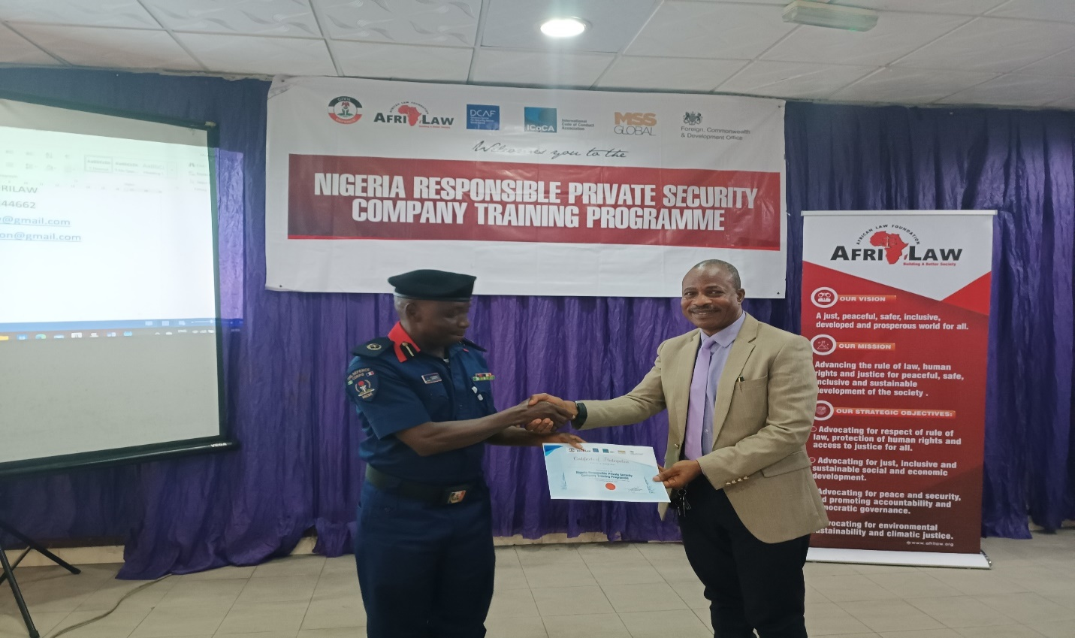

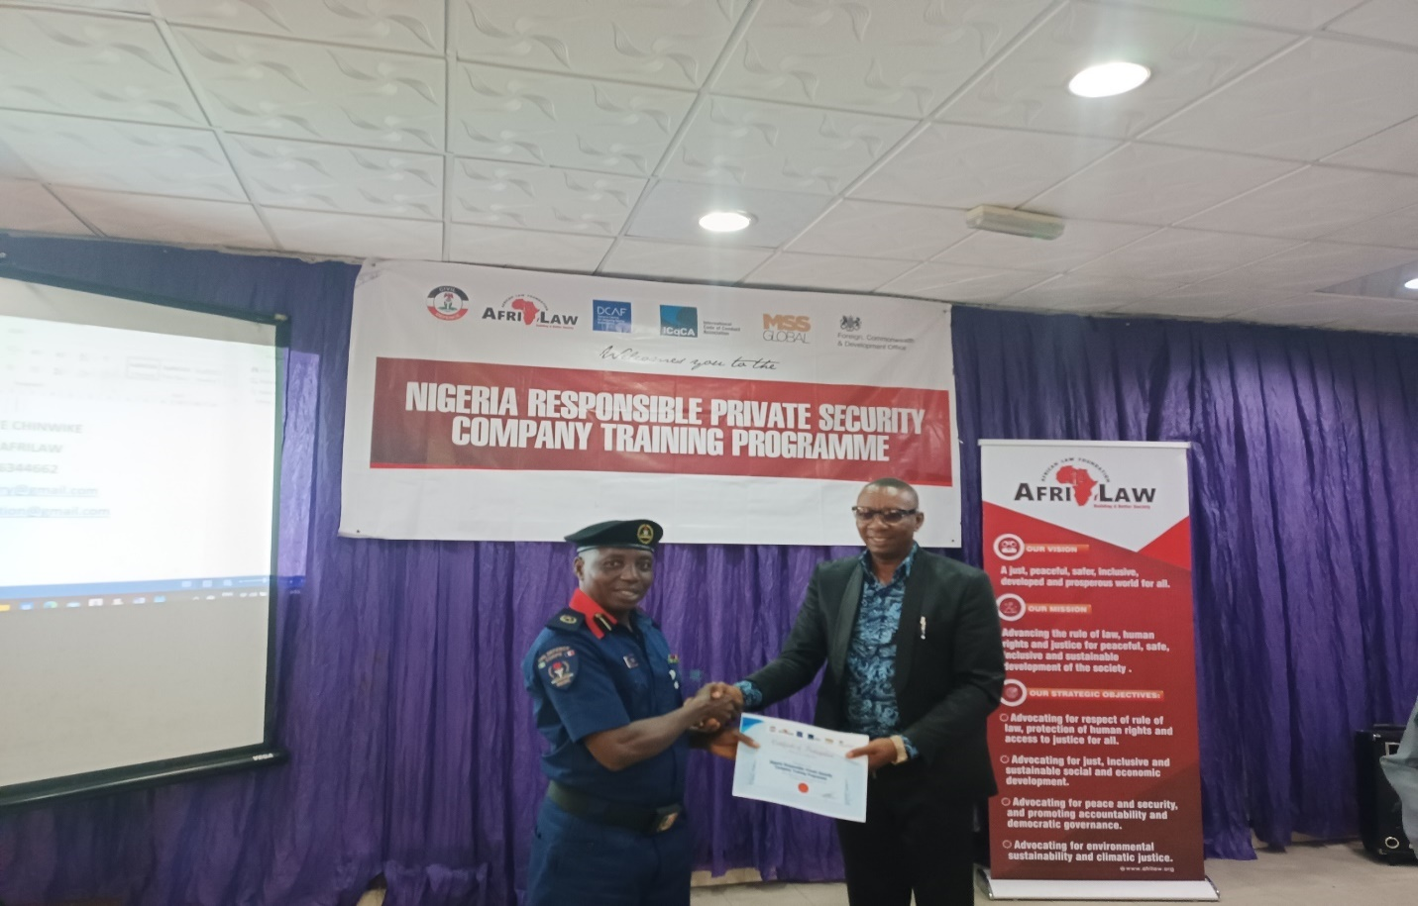
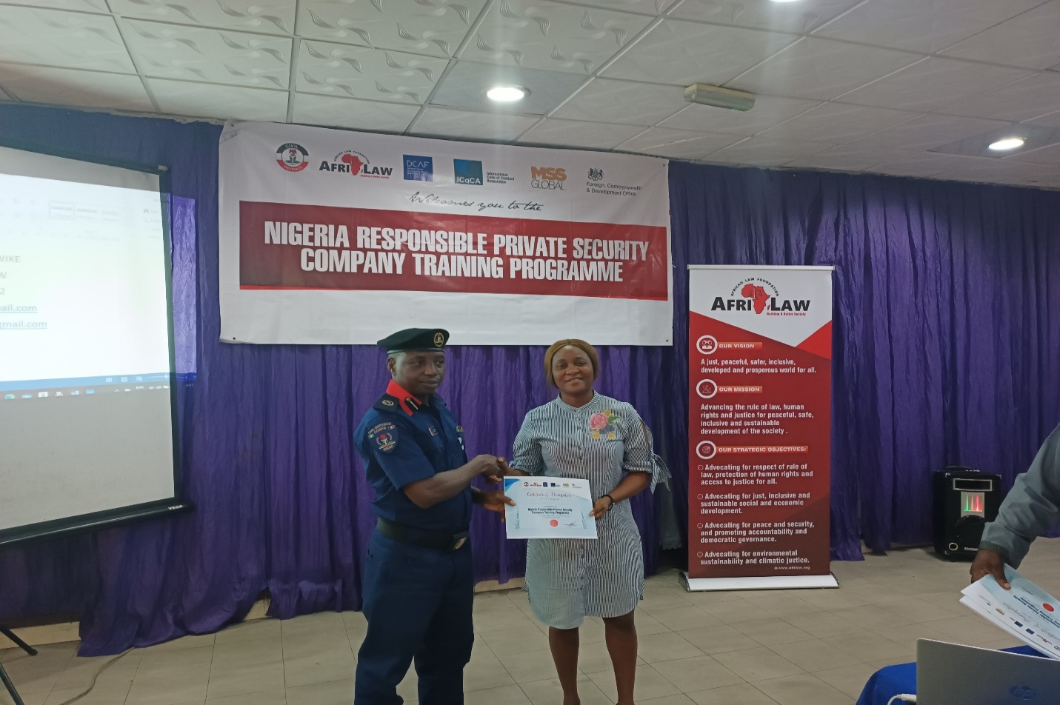

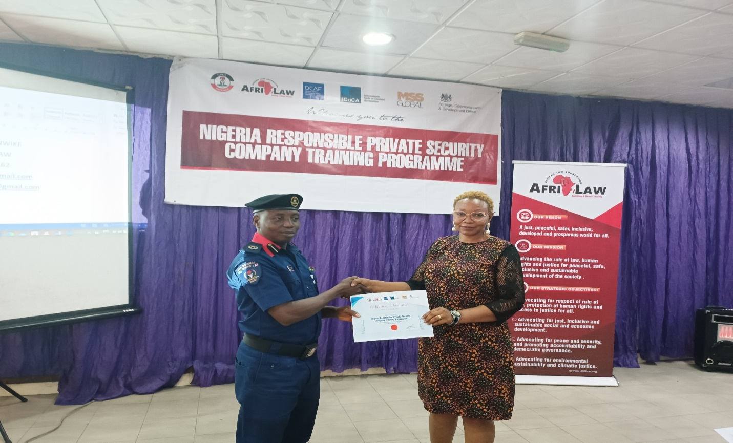
The Programme Key Results and Achievements So Far:
- Increased awareness and knowledge of human right frameworks, ethics and code conducts relevant to private security services, existing obligation and international norms and best practices.
- About participated 117 PSCs gained specific expertise on inter-sectional thematic areas of use of force, ICOCA and its Certification process, ethics and the code of conduct for private security service providers, human rights risk impact assessment, gender equality and preventing sexual exploitation and abuse.
- The participated PSCs were assured of support for long-term development of a culture that respects and seeks to protect human rights within their company and how to address human rights challenges in complex environments.
- There is a good promotion and highlights of integrated and effective private security governance and management system and responsible private security services in Nigeria
- The participated PSCs learnt the benefits and how to become ICoCA member and get ICoCA certification in Nigeria and the level of support and services they can get from ICOCA and MSS Global in this regard.
- Some participated PSCs expressed interest to join ICOCA and getting ICoCA certification.
- The conduct of Courtesy Visit and 5 free Training Workshops for about 117 PSCs members of the Association of Licensed Private Security Practitioners of Nigeria (ALPSPN) in 5 states of Nigeria.
- Participants confirmed that the training content is relevant to their work and expect that it strengthens respect of human rights within their companies and operations.
- Some participated PSC expressed interest for AFRILAW support and partnership to conduct human rights risk impact assessment.
- The ICoCA Team visit and meeting with the Commandant-General (CG) of the NSCDC and the CGs public support to ICOCA and expression of willingness to work toward and ensure Nigeria membership of ICoCA.

RECOMMEDNATIONS/NEXT STEPS/FURTHER ACTION:
- Seek for funding and expand the training programme to other States in Nigeria. The pilot training programme was done in 5 out of 36 states in Nigeria for about 117 out of more than 1000 registered PSCs in Nigeria.
- Develop and carry out a separated and specialized full day training programme on HRIA and PSEA for interested PSCs in Nigeria and support them in developing the required systems.
- Develop Legislative Advocacy Programme for PS Industry Law Reform. There is need for new PSI regulatory framework in Nigeria.
- Develop Nigeria ICOCA Membership Advocacy Programme to promote Nigeria official membership of ICoCA. There is a big support for Nigeria membership from NSCDC and ALPSPN and the need to build on the momentum.
- To encourage and provide necessary support to PSCs who expressed interest on conducting HRIA and developing some management and operational policies.
- To encourage and provide necessary support to PSCs who expressed interest on the opportunities of joining ICOCA and getting ICOCA Certification.
- Partner with NSCDC and ALPSPN to develop and launch a National Code of Conduct for PSCs in Nigeria.
- Partner with NSCDC and strengthen the capacity of the NSCDC in their Registration, Supervision, Monitoring and Documentation functions as the industry Regulator.

Submitted by AFRILAW:

Okereke Chinwike ESQ.
Executive Director
15/05/2023.

