RULE OF LAW AND JUSTICE SECTOR REFORM PROGRAMME

- Monitoring the Criminal Justice Administration Reform Process in Nigeria Project in partnership with CLEEN Foundation in Enugu State
The CLEEN Foundation with funding from MacArthur Foundation is implementing the Monitoring the Criminal Justice Administration Reform Process in Nigeria Project. In this regard, AFRILAW was selected as an implementing Partner and a member of the CSOs Observatory on Administration of Criminal Justice in Nigeria in Enugu State. The activity started Stakeholders' Summit on Administration of Criminal Justice held on Wednesday, 9th and Thursday, 10th August, 2017 at the Denis Hotel, Abuja. The Summit was organized by CLEEN Foundation (with support from MacArthur Foundation) in collaboration with the Administration of Criminal Justice Monitoring Committee (ACJMC).

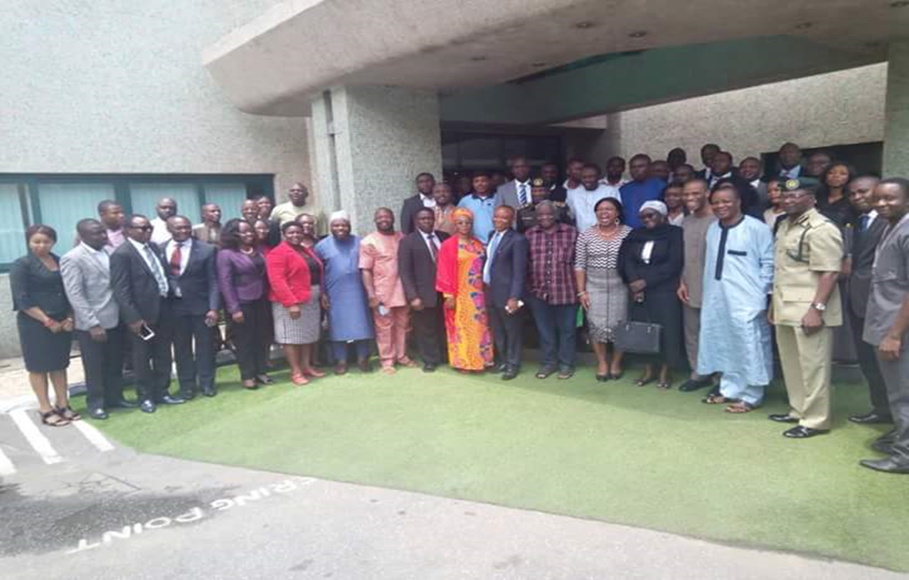
Group picture of participants at the Stakeholders Summit

The Summit drew participants from government agencies- Nigeria Police Force, Prisons, Immigrations, Federal Ministry of Justice, Nigeria Law Reform Commission, Institute of Advanced Legal studies, EFCC, NDLEA, NAPTIP, NHRC, Amnesty International, development partners including United Nations on Drug and Crime (UNODC), European Union, Open Society Initiative for West Africa(OSIWA) and Civil Society Organizations.
- Civil Society Observatory on Criminal Justice Administration in Nigeria
AFRILAW is a member of twelve member Observatory committee inaugurated during theStakeholders' Summit on Administration of Criminal Justice held on Wednesday, 9th and Thursday, 10th August, 2017. The Terms of Reference for the Observatory include to contribute to the development of an indicator system for monitoring the implementation of the Administration of Criminal Justice (ACJ) Act;Report and create public awareness on the provisions and implementation of the ACJ Act;Drive advocacy with relevant stakeholders in the criminal justice process to encourage compliance with the Act through working with the Administration of Criminal Justice Monitoring Committee(ACJMC), and Meeting on a quarterly basis to review progress and challenges in the implementation of the ACJ Act.
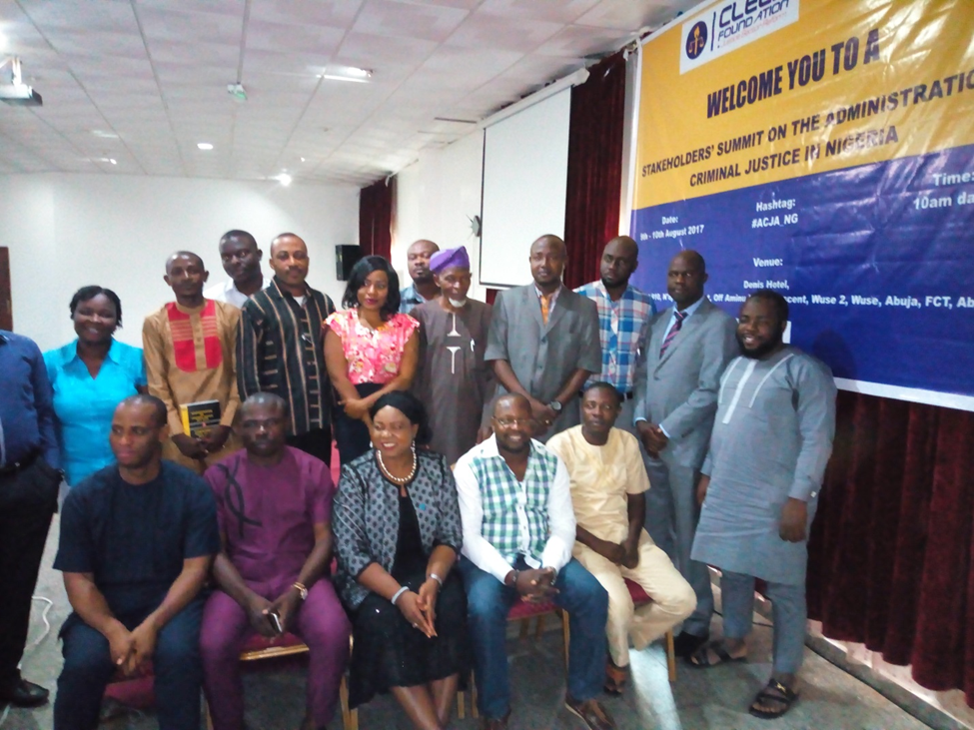
Members of the CSOs Observatory on Administration of Criminal Justice in Nigeria during their inauguration

- Promoting Water Rights and Security through Research on Water Law in Nigeria in partnership with the Center for Water Security and Cooperation (CWSC) USA and The International Association for Water Law (AIDA)
AFRILAW is partnering the Center for Water Security and Cooperation (CWSC) USA and The International Association for Water Law (AIDA) for the Research and Evaluation of Nexuses of the Exploitation of Water in African Law (RENEWAL) Project in Nigeria. The law underpins and drives the advancement of development priorities, including guaranteeing access to clean, safe water and improving the health of the river basins which serve as the lifeblood for communities. In order to fulfill SDG6, along with many of the other SDGs, Africa must achieve water security. To build and strengthen the foundation upon which the achievement of the SDGs depend, RENEWAL analyzes and evaluates the state of water governance in Africa, by first determining and understanding the existing state of water governance and second evaluating the effectiveness of the water governance framework in place.
This project will Collect and catalogue the Nigerian laws, regulations and policies directly and indirectly shaping and influencing water governance, Provide a clear summary and description of each law, regulation and policy to make this information accessible to decisions-makers and the public,Identify the intersections and connections between water and the laws of sectors who affect and use water; Graphically illustrate the applicability of the laws, identified intersections and the administrative structure for designing, implementing and enforcing identified laws, andEvaluate the water governance for Nigeria based on a clear, well-supported metric.

- National Advocacy for effective Access to Justice through Pro Bono Legal Aid Service in Nigeria in partnership with the Legal Aid Council of Nigeria

AFRILAW works with the Legal Aid Council of Nigeria and was engaged during theprocess and the Validation Workshop for the Development of 5 years National Legal Aid Strategy.

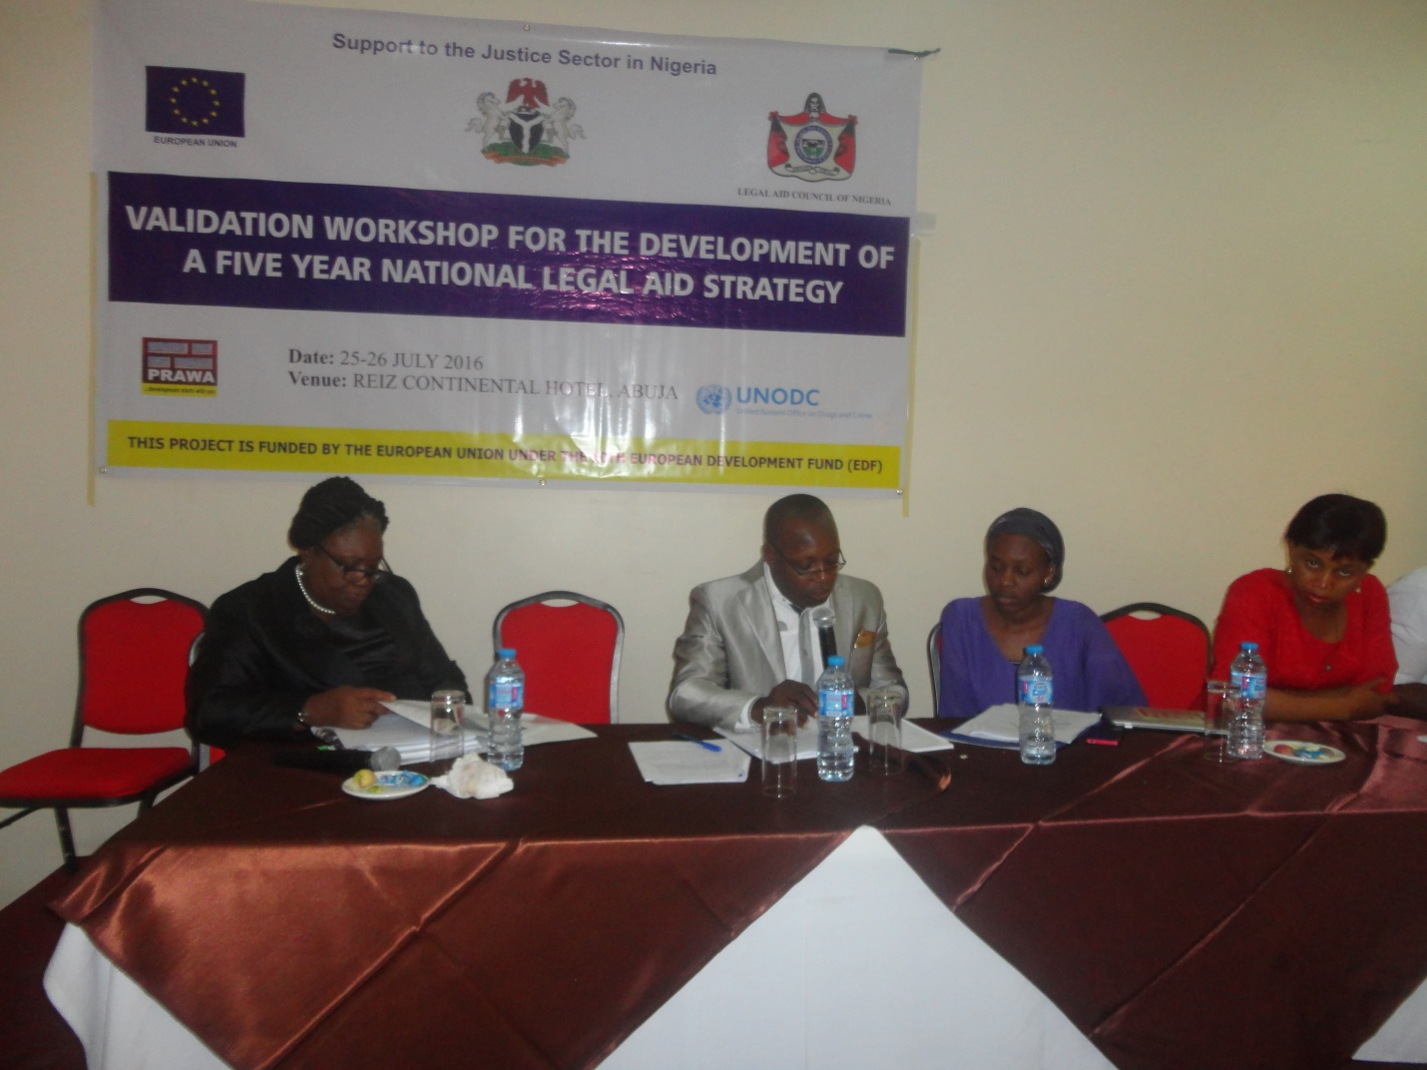
AFRILAW Director making a presentation during the Validation Workshop for the Development of 5 years National Legal Aid Strategy
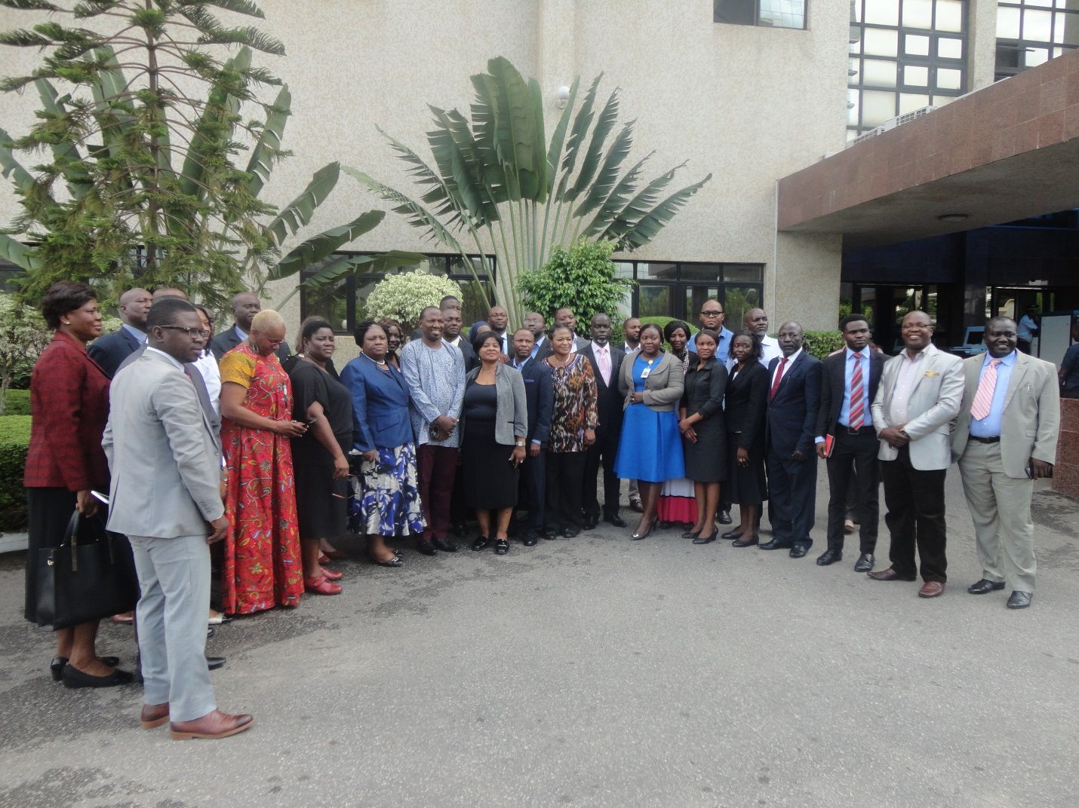
Group Picture of Participants at the Validation Workshop

Promoting Legal Empowerment for the Poor in partnership with Namati: Innovations for Legal Empowerment (USA) and Global Legal Empowerment Network
AFRILAW is a member of the Global Legal Empowerment Network. The network brings together 1147 organizations and 4500 individuals, all dedicated to grassroots justice. We are lawyers and community paralegals, human rights activists and grassroots organizers, health advocates and educators, researchers, journalists and public servants. We collaborate across regions and across disciplines. We campaign on issues that affect us globally and nationally. Together we are building a global network of people working to advance justice in our communities and the world. Namati: Innovations for Legal Empowerment (USA) is convening the Global Legal Empowerment Network. See https://namati.org/network.
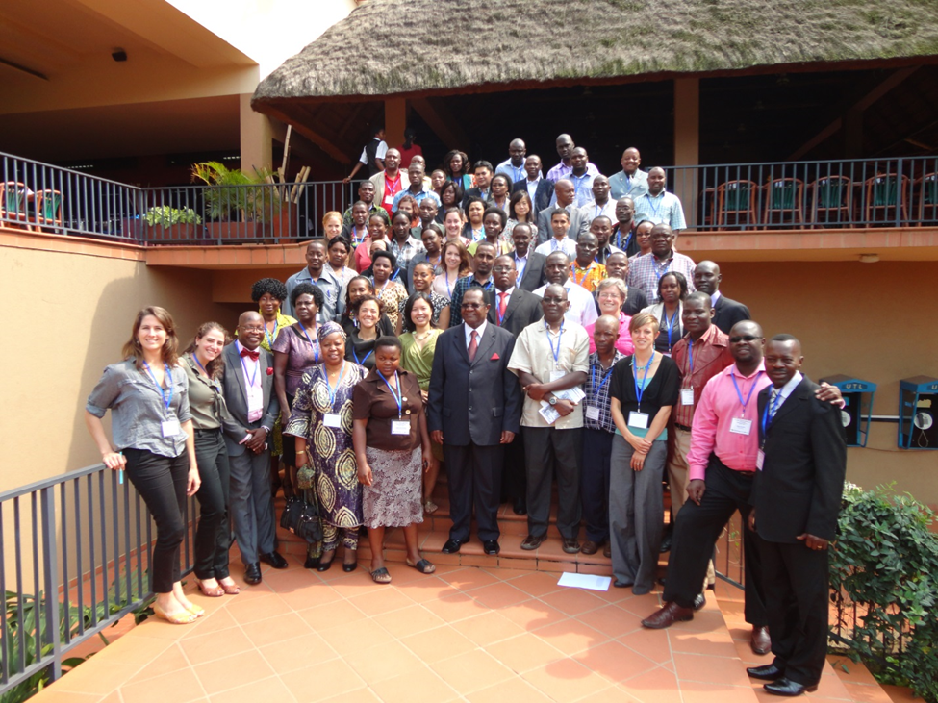
AFRILAW Director participated in the Africa Regional Conference on Community-Based Paralegal Programme organized by Namati in collaboration with Global Rights in Kampala, Uganda.
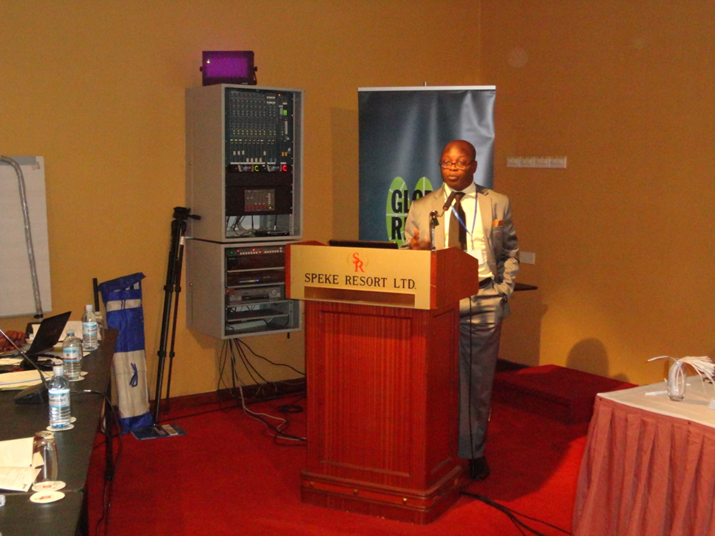
AFRILAW Director making a presentation at the Regional Conference

.

